A year in the life of a North Atlantic seabird: behavioural and energetic adjustments during the annual cycle
Ruth E Dunn, Sarah Wanless, Francis Daunt, Mike P Harris, Jonathan A Green
Supplementary information

Supplementary Table S1
Table S1| Results of generalised additive mixed models (GAMMs). Significant P-values are highlighted in bold.
Response | Model term | df | F | P-value
DEE | s(dDay) | 6.64 | 14.87 | <0.001
DEE | Sex | 2 | 0.22 | 0.81
SST | s(dDay) | 8.06 | 311.5 | <0.001
Time spent diving | s(dDay) | 6.92 | 6.00 | <0.001
Time spent diving | Sex | 2 | 0.62 | 0.54
Time spent flying | s(dDay) | 7.54 | 18.39 | <0.001
Time spent flying | Sex | 2 | 0.75 | 0.48
Energetic cost of diving | s(dDay) | 2.12 | 3.07 | 0.04
Energetic cost of diving | Sex | 2 | 0.18 | 0.83
Energetic cost of flying | s(dDay) | 7.54 | 18.39 | <0.001
Energetic cost of flying | Sex | 2 | 0.75 | 0.48
Response | Model term | df | χ² | P-value
Diving activity occurring during daylight | s(dDay) | 8.99 | 223521 | <0.001
Diving activity occurring during daylight | Sex | 2 | 6.57 | 0.06
Diving activity occurring during twilight | s(dDay) | 8.99 | 56996 | <0.001
Diving activity occurring during twilight | Sex | 2 | 5.20 | 0.07
Diving activity occurring during night | s(dDay) | 8.99 | 197079 | <0.001
Diving activity occurring during night | Sex | 2 | 1.81 | 0.40

Supplementary Figure S2
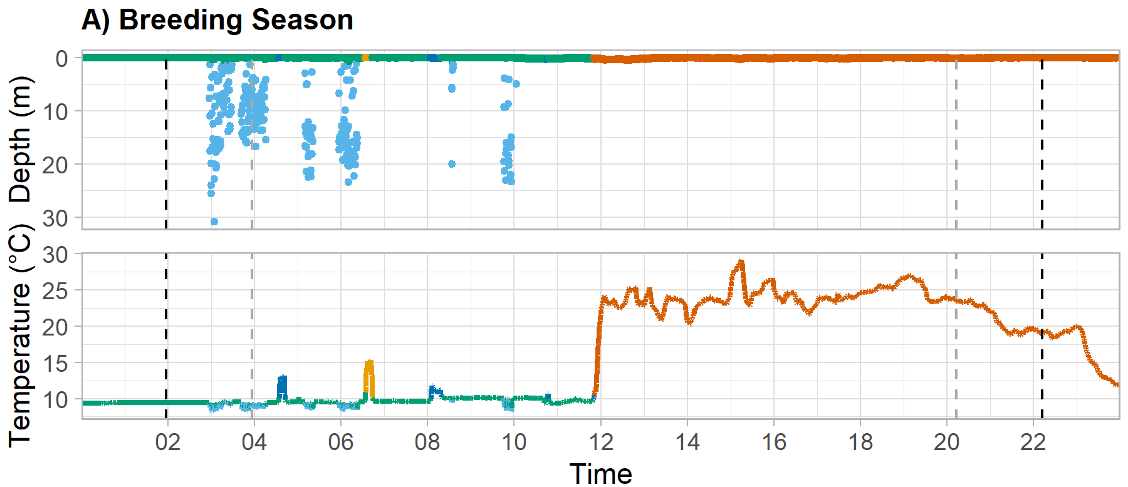
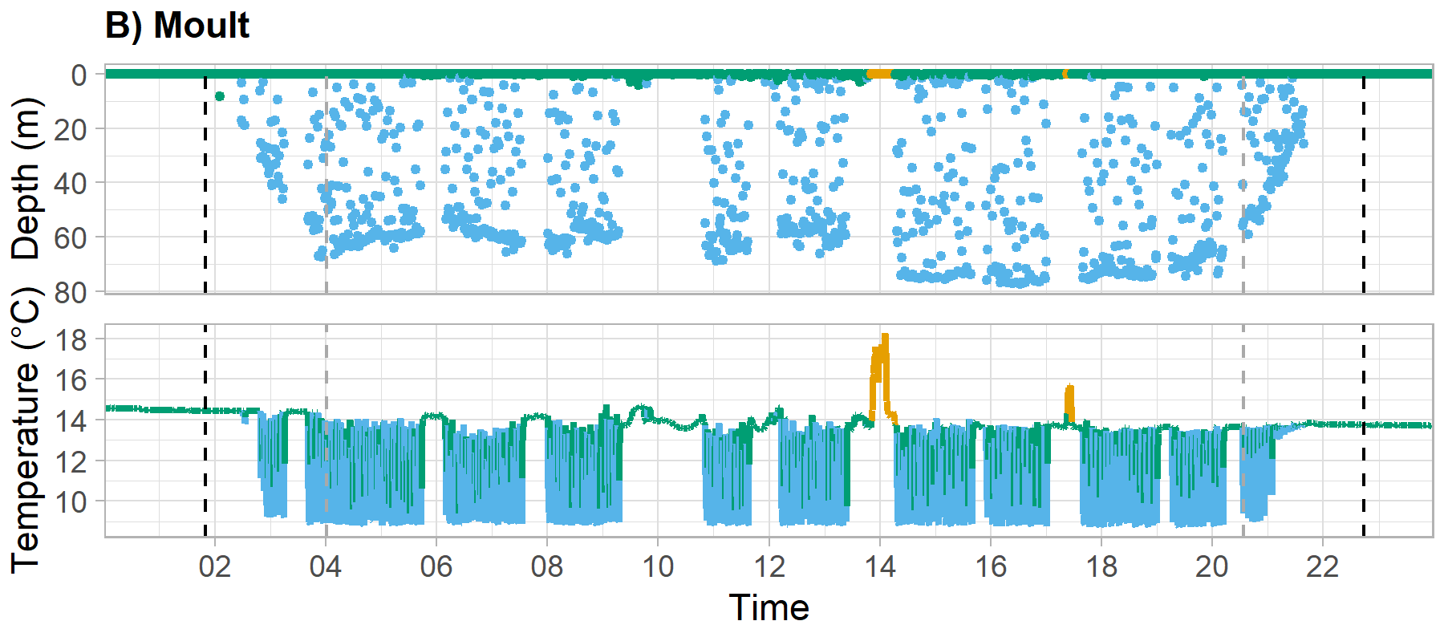
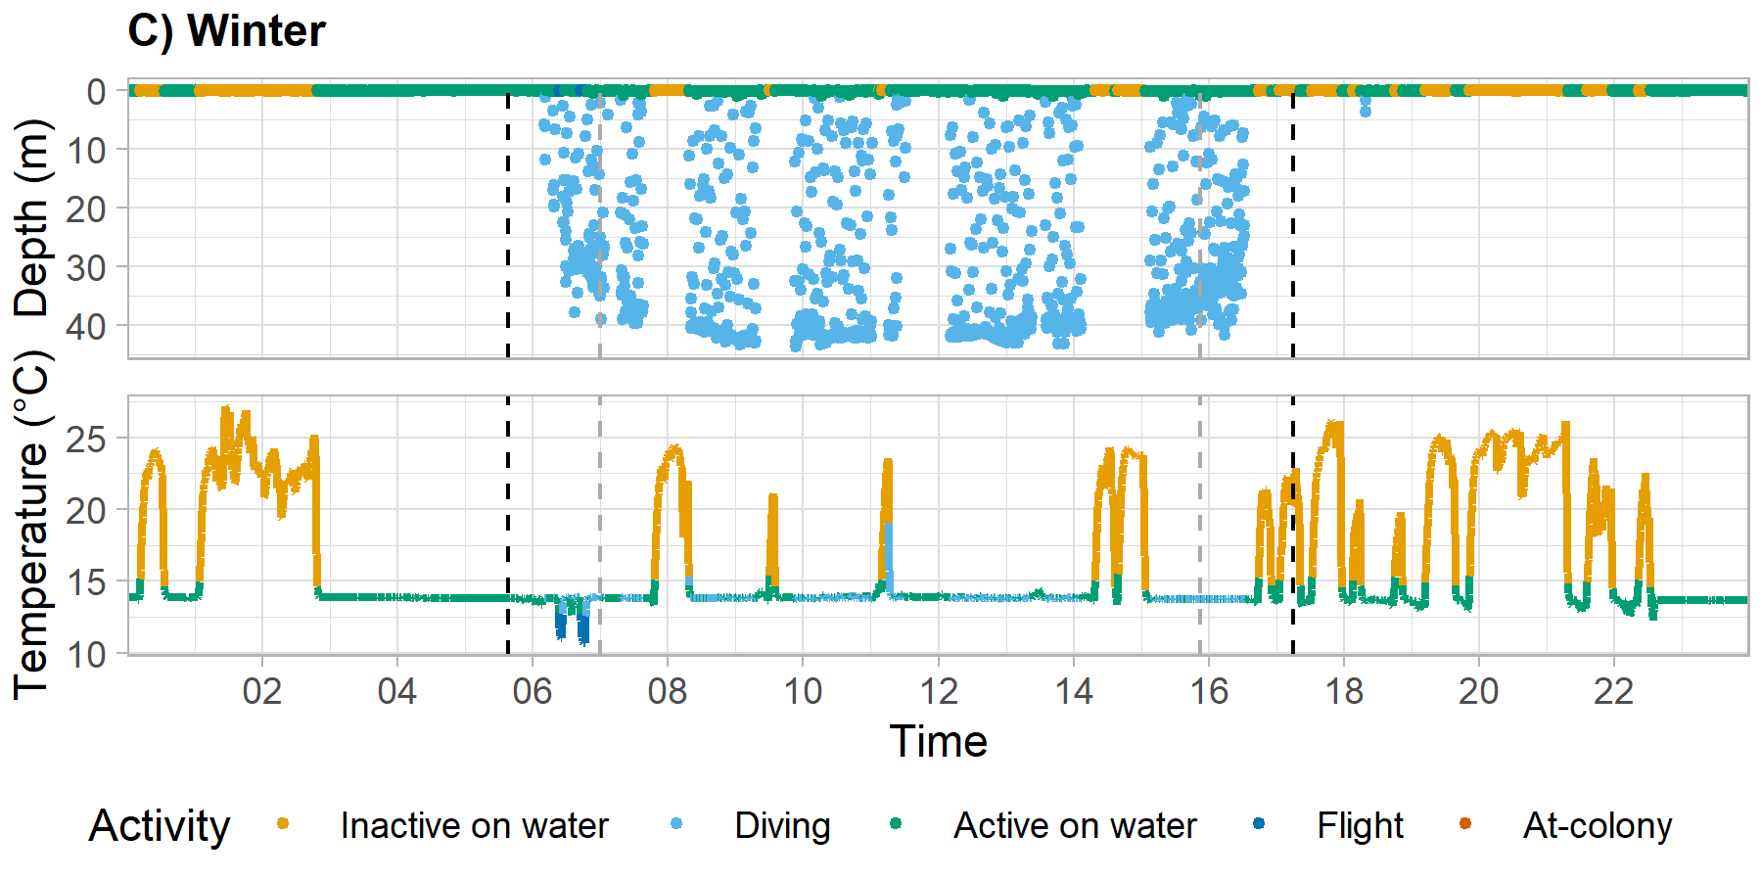
Figure S2| Examples of results of the classification of guillemot activity from depth and temperature profiles during three key periods of the annual cycle. Grey dashed vertical lines indicate the start of day and dusk respectively; Black dashed vertical lines indicate the start of dawn and night respectively.

Supplementary Figure S3
We assessed the classification of logger temperature data into flight behaviour ($T_{f}$) and inactive on water ($T_{i}$) by fitting a mixed model using the lmer function in the lme4 package (Bates et al. 2015). The interaction between log-transformed time-in-activity (a continuous variable) and behavioural classification (a two-level categorical variable) was fitted as a predictor of log-transformed maximum temperature. Individual bird ID was included as a random factor to account for potential non-independence.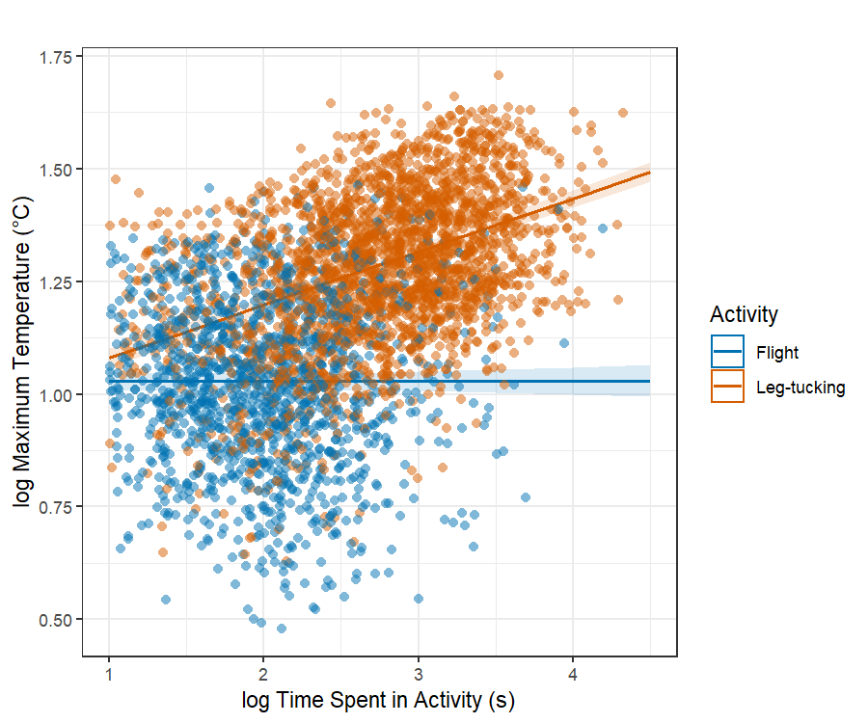
Figure S3| The log of the relationship between the amount of time spent in activity (s) and behavioural classification on maximum temperature (ºC) for common guillemots throughout the annual cycle.
There was a significant interaction between behaviour and bout duration (ANOVA F = 238.97, P < 0.01; Fig. S3), confirming that the nature of the relationship and hence the time taken to reach maximum temperature differed between leg-tucking and flight behaviour. For leg-tucking ($T_{i}$), longer times incurred higher temperatures but with an asymptote due to temperature approaching body surface temperature. For flight ($T_{f}$), there was no clear relationship because air temperature, and hence ∆T, varied substantially between flights, independent of their duration.

