Genome-wide association mapping and accuracy of predictions for amoebic gill disease in Atlantic salmon (Salmo salar)

Muhammad L Aslam ^{*1}, Solomon A Boison ^{1,2}, Marie Lillehammer ¹, Ashie Norris ², Bjarne Gjerde ¹
¹ Department of Breeding and Genetics, Nofima AS, P.O. Box 210, N-1431 Ås, Norway
² Marine Harvest Ireland ASA (old name) with new name Mowi Genetics AS, 5035 Bergen

Figure S1.1: Q-Q plot for GWAS analysis.
$$λ=1.094(se=7.8e^{05})$$

Figure S1.2: P-values and position of top 2 significant SNPs of chromsome2.

Figure S1.3: Genes around the highest significant SNP of chromsome2.
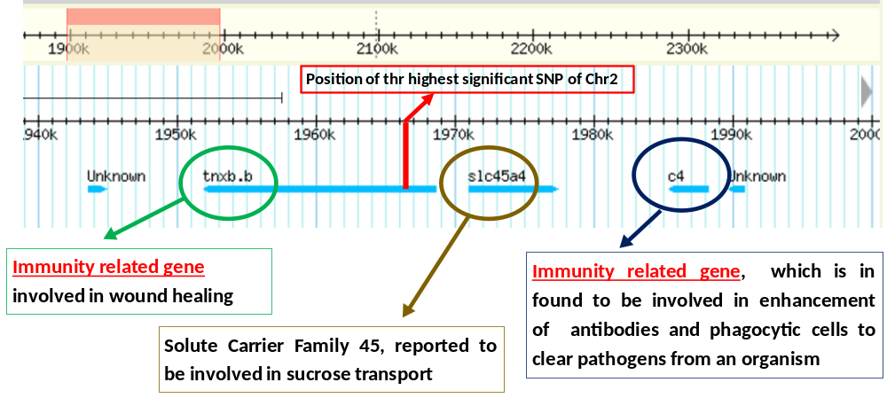

Figure S1.4: Heat map of Linkage disequilibrium values for the top 5 significant markers in GWAS analysis.
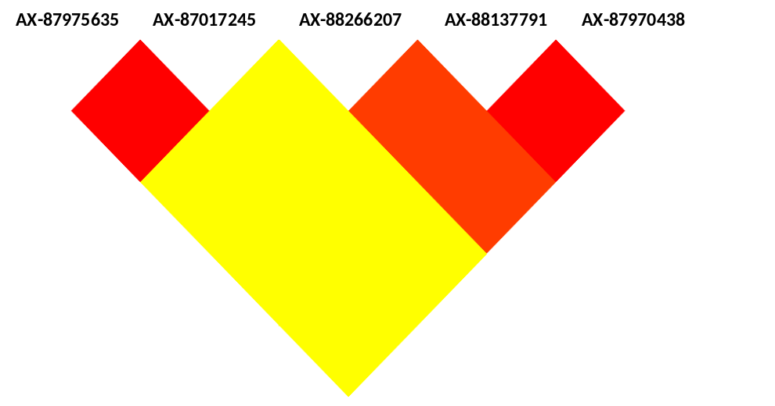
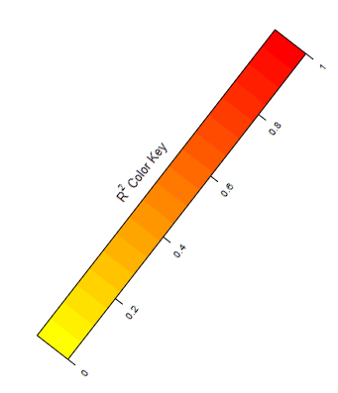

Table S1.1: Linkage disequilibrium values of top 5 significant SNPs of GWAS analysis.
SNP-Ids | AX-87975635 | AX-87017245 | AX-88266207 | AX-88137791 | AX-87970438
AX-87975635 | 1,00 | 0,99 | 0,00 | 0,00 | 0,00
AX-87017245 |  | 1,00 | 0,00 | 0,00 | 0,00
AX-88266207 |  |  | 1,00 | 0,77 | 0,77
AX-88137791 |  |  |  | 1,00 | 1,00
AX-87970438 |  |  |  |  | 1,00

Figure S1.5: Manhattan plot after correcting positions using linkage and LD information
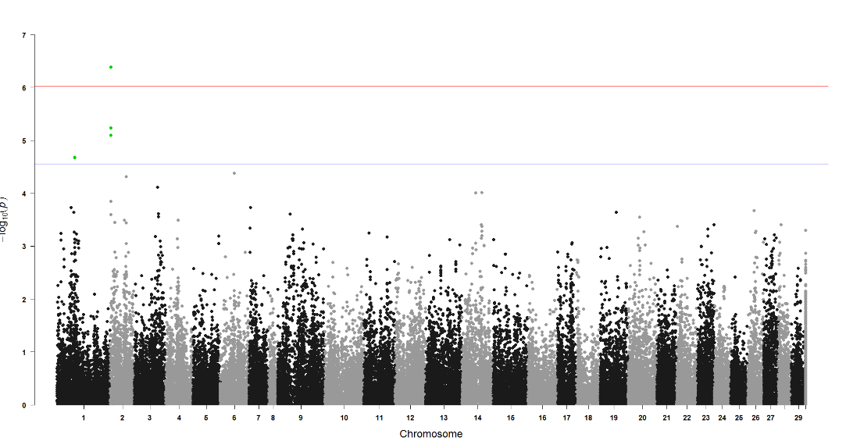

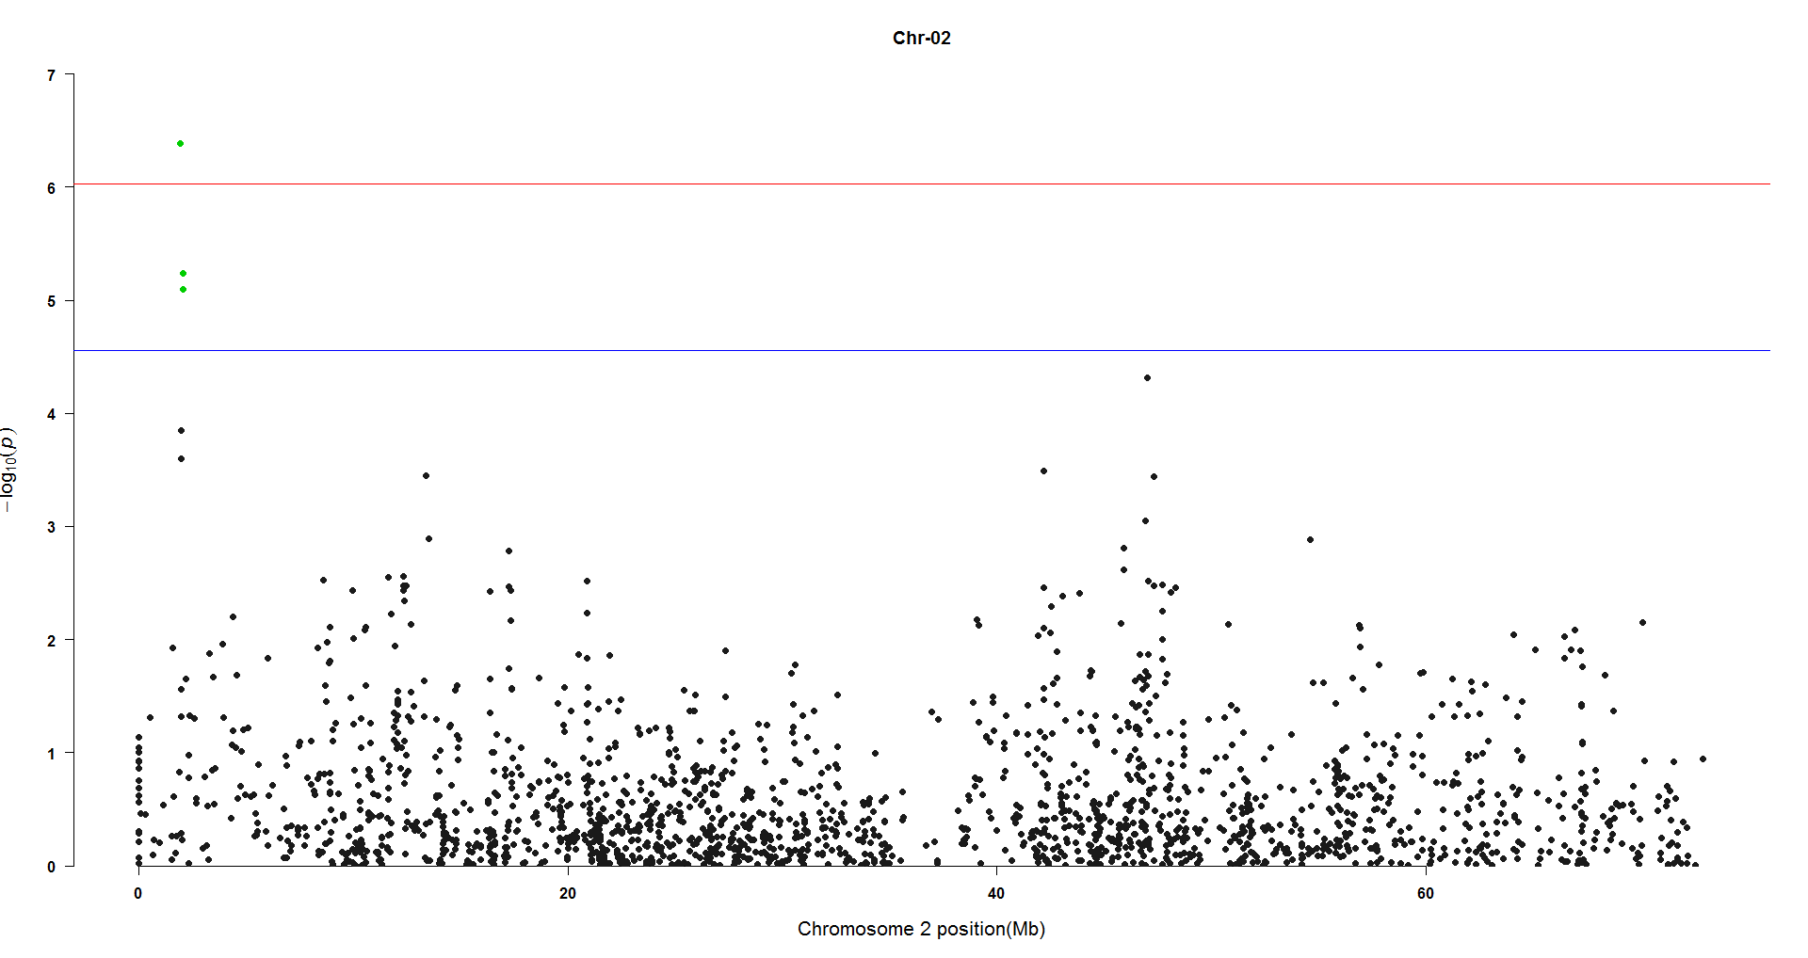
Figure S1.6: Distribution of P-values at chromosome 2 (Ssa02) after correcting positions.

Figure S1.7: Manhattan plot showing shrinkage of p-values using model with the addition of top significant SNP used as fixed effect.
