Supplementary information

TITLE
Establishment of macaque trophoblast stem cell lines derived from cynomolgus monkey blastocysts.

AUTHORS
Shoma Matsumoto¹, Christopher J. Porter², Naomi Ogasawara¹, Chizuru Iwatani³, Hideaki Tsuchiya³, Yasunari Seita³, Yu-Wei Chang⁴, Ikuhiro Okamoto^{5, 6, 7}, Mitinori Saitou^{5, 7, 8}, Masatsugu Ema^{3, 7}, Theodore J. Perkins², William L. Stanford^{2, 9}, and Satoshi Tanaka^{1, *}

¹ Department of Animal Resource Sciences, Graduate School of Agricultural and Life Sciences, The University of Tokyo, Tokyo 113-8657, Japan;
² The Ottawa Hospital Research Institute, Ottawa ON K1H 8L6, Canada;
³ Department of Stem Cells and Human Disease Models, Research Center for Animal Life Sciences, Shiga University of Medical Sciences, Shiga 520-2192, Japan;
⁴ Department of Veterinary Physiology, Graduate School of Agricultural and Life Sciences, The University of Tokyo, Tokyo 113-8657, Japan;
⁵ Department of Anatomy and Cell Biology, Graduate School of Medicine, Kyoto University, Kyoto 606-8501, Japan;
⁶ Japan Science and Technology (JST), Exploratory Research for Advanced Technology (ERATO), Kyoto, Japan;
⁷ Institute for Advanced Study of Human Biology (WPI-ASHBi), Kyoto University, Kyoto 606-8501, Japan;
⁸ Center for iPS Cell Research and Application (CiRA), Kyoto 606-8507, Japan;
⁹ Department of Cellular and Molecular Medicine, University of Ottawa, Ottawa K1H 8M5, Canada;

* To whom correspondence should be addressed: Satoshi Tanaka.
Department of Animal Resource Sciences, Graduate School of Agricultural and Life Sciences, The University of Tokyo, Tokyo 113-8657, Japan
TEL/FAX: +81-3-5841-5472/+81-3-5841-8189
Email: asatoshi@mail.ecc.u-tokyo.ac.jp

Table S1-S6
Figure S1-S12
Supplementary Table S1. Top 30 list of > 2-fold over-represented genes in RNA-seq data of all macTSCs* compared to that of ESC.
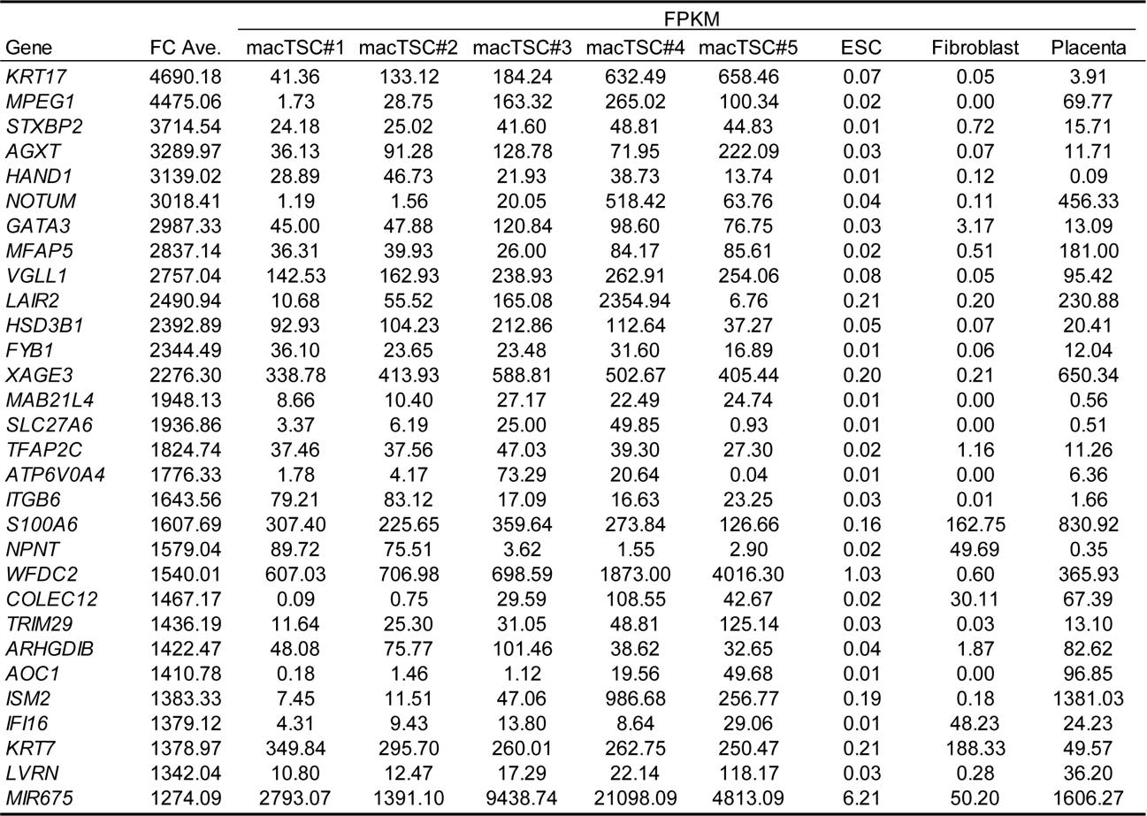
*, in AFHBY (#1, 2) or FHBY (#3-5) conditions; FC, fold-change

Supplementary Table S2. FPKM value of trophoblast markers from RNA-seq data.
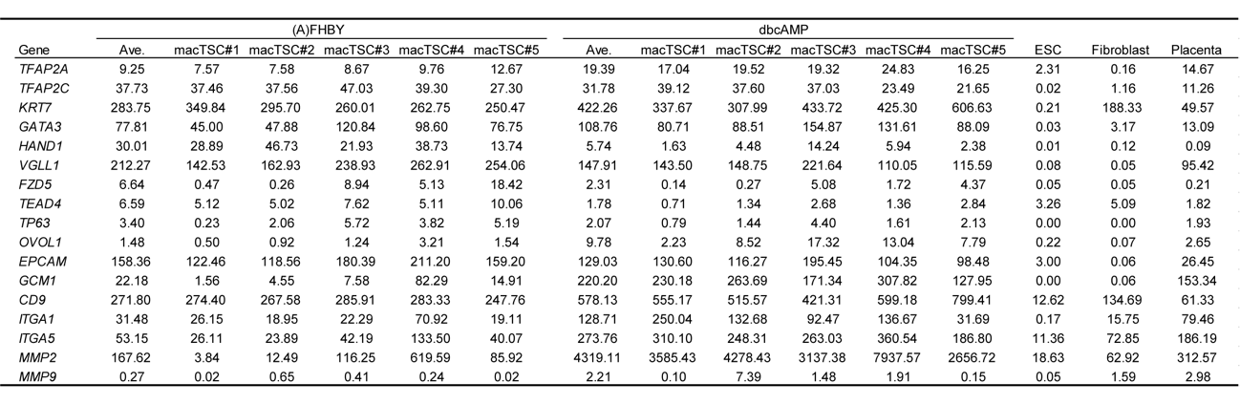

Supplementary Table S3. The number of single and multinucleated (≥ 3 nuclei) cells.
* N, the number of nuclei in the multinucleated cells; C, the number of multinucleated cells; T, the total number of nuclei.
** Fusion index = (N-C)/T

Supplementary Table S4. Top 30 list of 2-fold up-regulated genes by dbcAMP treatment in macTSCs.
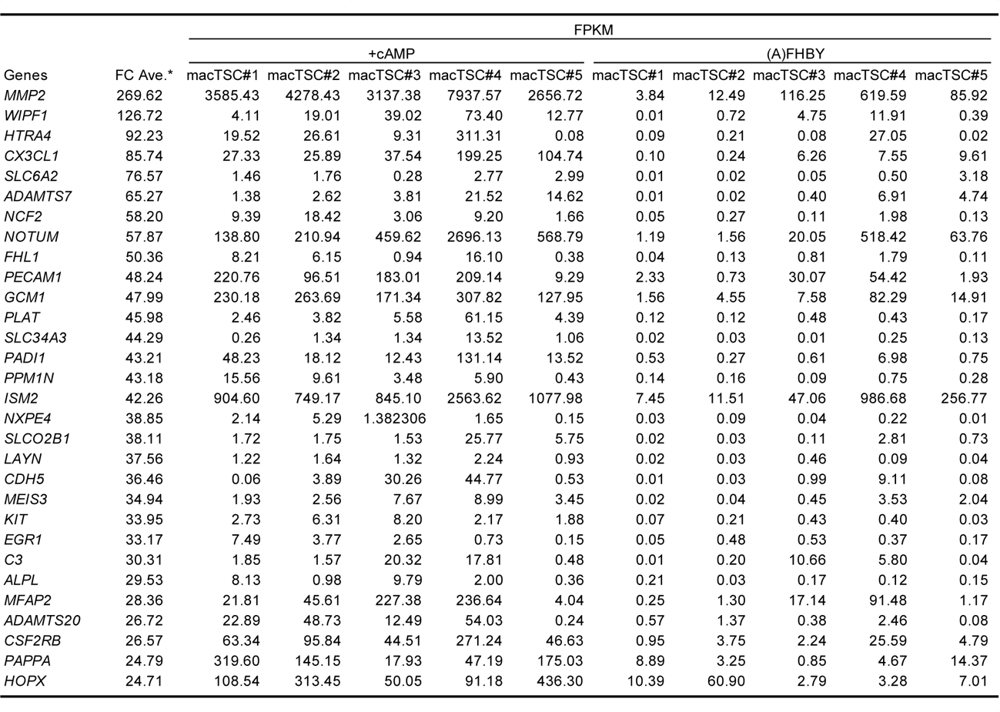
*, +cAMP vs AFHBY (#1, 2) or FHBY (#3-5); FC, fold-change

Supplementary Table S5. Primers list.
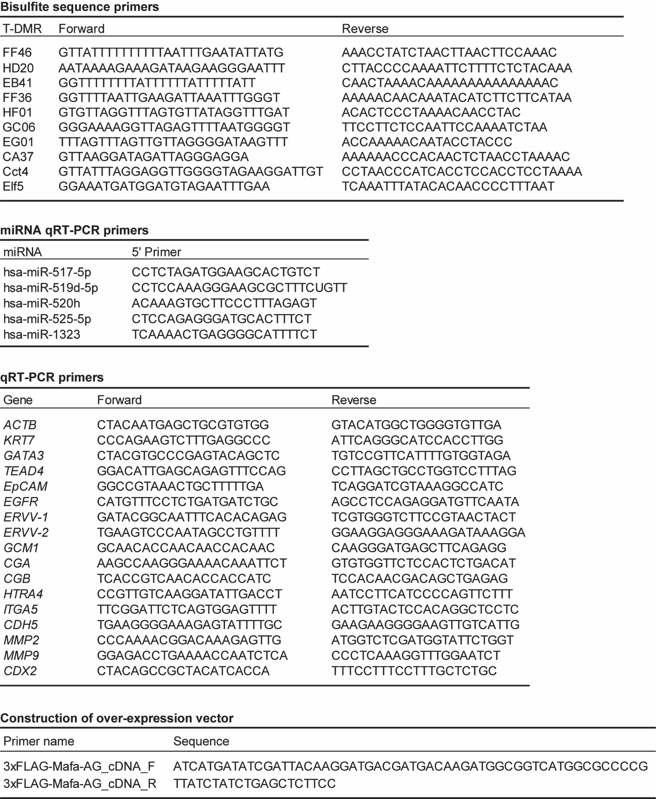
Supplementary Table S6. Antibody list.
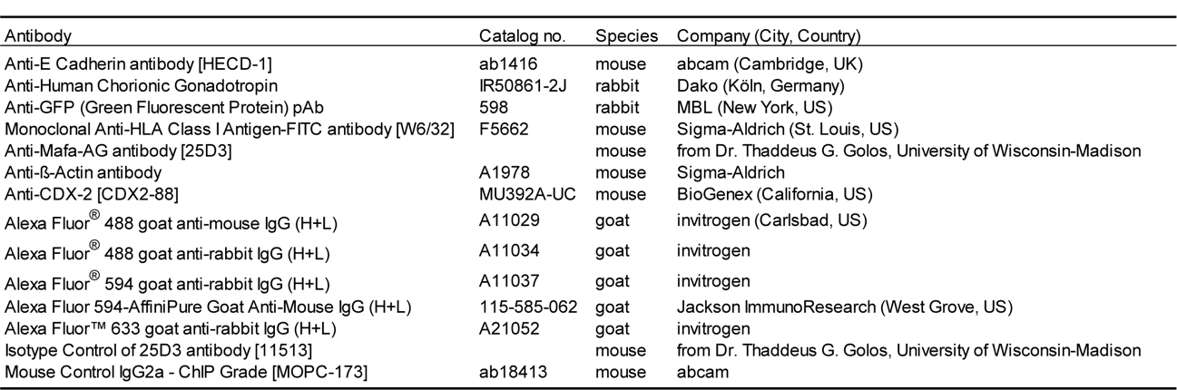

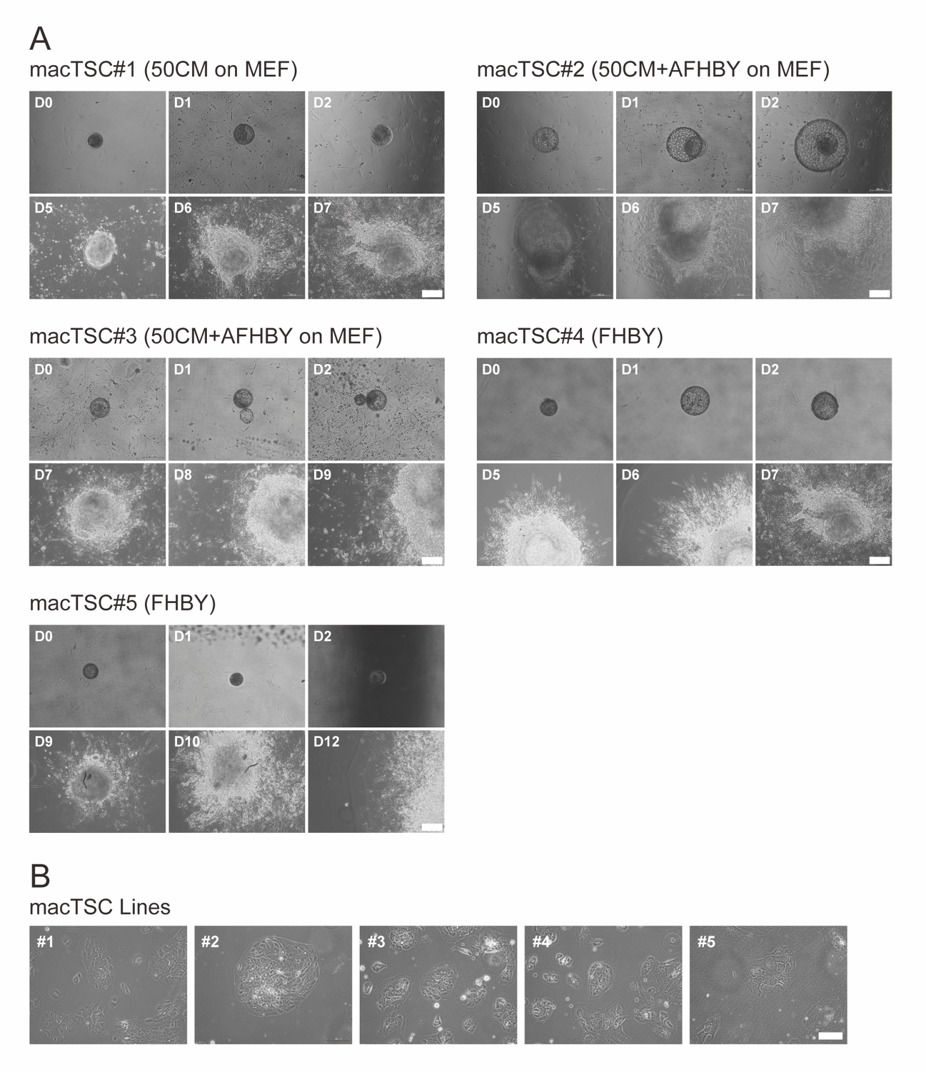
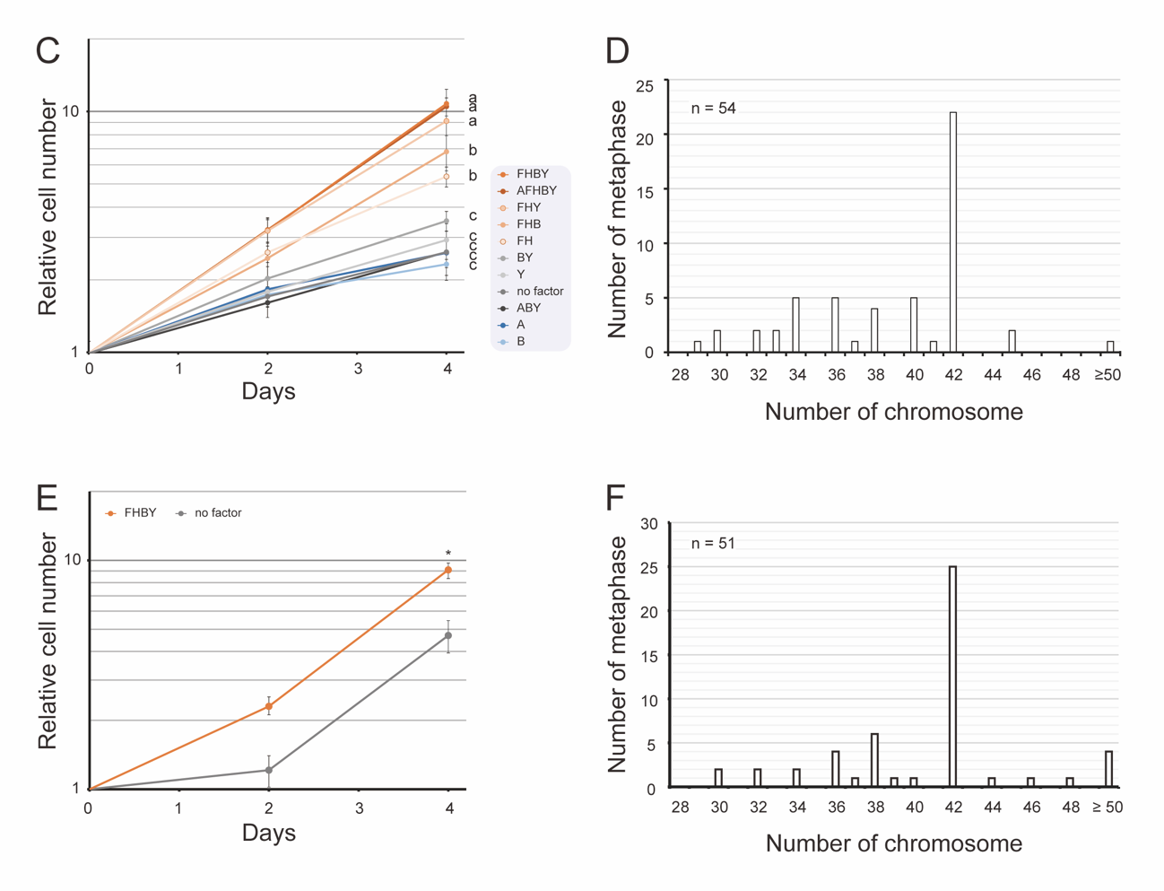
Supplementary Figure S1. Establishment of cynomolgus monkey trophoblast stem cell lines (macTSC) from blastocysts. (A) All of the blastocysts used in the present study displayed attachment by day 5 of cell culture (D5), formed cell outgrowth, and eventually gave rise to stably growing cell lines. See the main text for the specific culture conditions. Scale bar = 200 μm. (B) The appearance of the five macTSC lines. Scale bar = 200 μm. (C) Growth of macTSC#2 in different culture conditions; related to Figure 1C. (D) The number of chromosomes in macTSC#2. Chromosome spreads were prepared from the colcemid-treated cells, and the number of chromosomes in fluorescent images of 54 spreads were counted. (E) Growth of macTSC#1 line. (F) The number of chromosomes in macTSC#1. The fluorescent images of 51 spreads were counted.

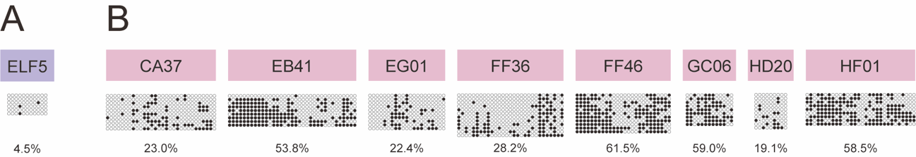
Supplementary Figure S2. (A and B) DNA methylation status of the ELF5 promoter (A) in T-E T-DMRs (B) in macTSC#1. Open and filled circles represent unmethylated and methylated cytosines, respectively. Overall methylation percentage (the number of methylated CpGs per number of total CpGs) is shown under each part.

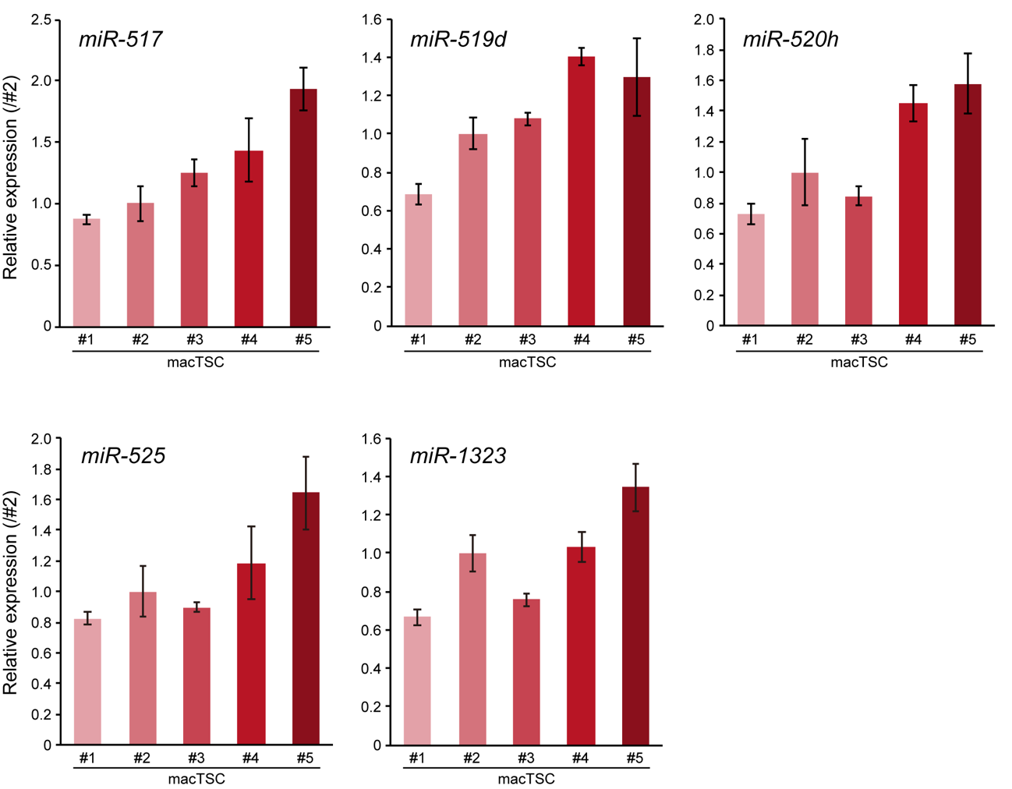
Supplementary Figure 3. The relative expression levels of five C19MC miRNAs in macTSC#1-5. The mean expression level (± SD) was normalized to that of U6 snRNA. Value of each miRNA in macTSC#2 was arbitrary set as 1. *; p < 0.05 (technical triplicates for biological duplicates).

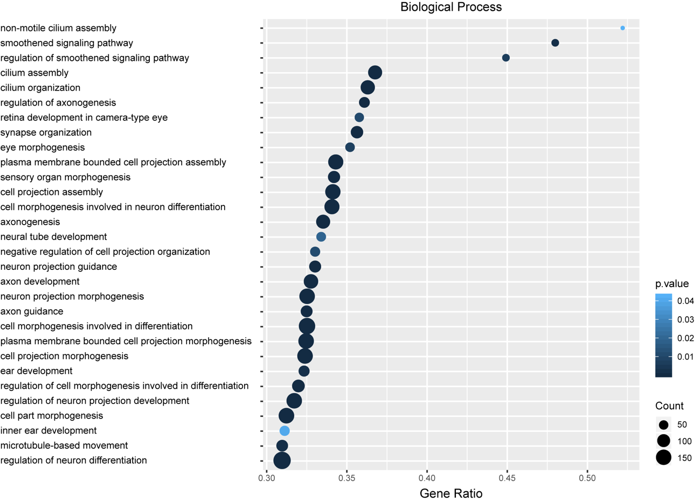
Supplementary Figure S4. The GO term enrichment analysis of the genes with < 2-fold lower expression in the all macTSCs than in ESC. For GO analyses, PANTHER (www.panther.org) was used. P-values were calculated by Fisher’s exact test and Bonferroni corrected.
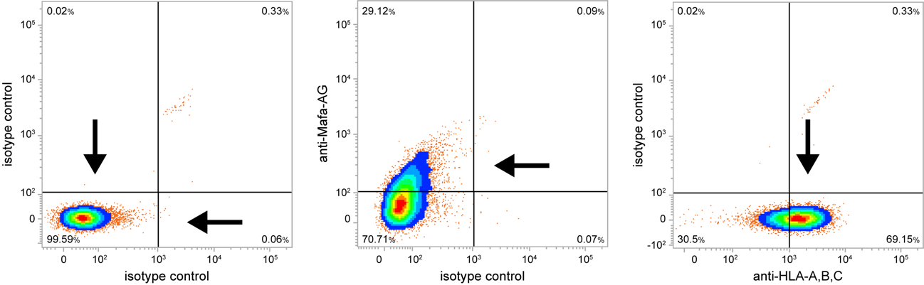
Supplementary Figure S5. Determination of the thresholds in flow cytometric analyses. The combination of antibodies and their isotype controls were used to draw threshold lines (arrows), so that a majority (> 99%) of double-negative controls distribute under the threshold lines.

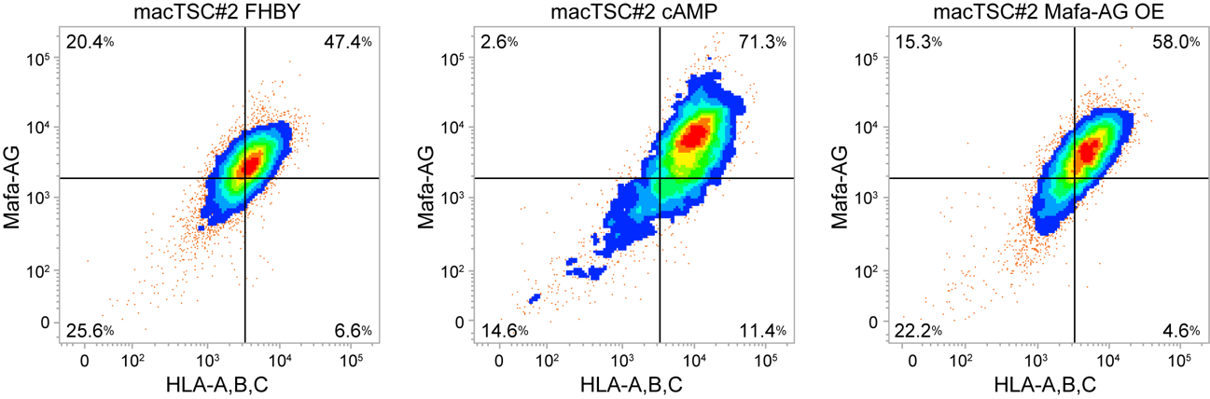
Supplementary Figure S6. Flow cytometric analysis in biological duplication; related to Figure 6C. PI staining-positive dead cells were gated out.

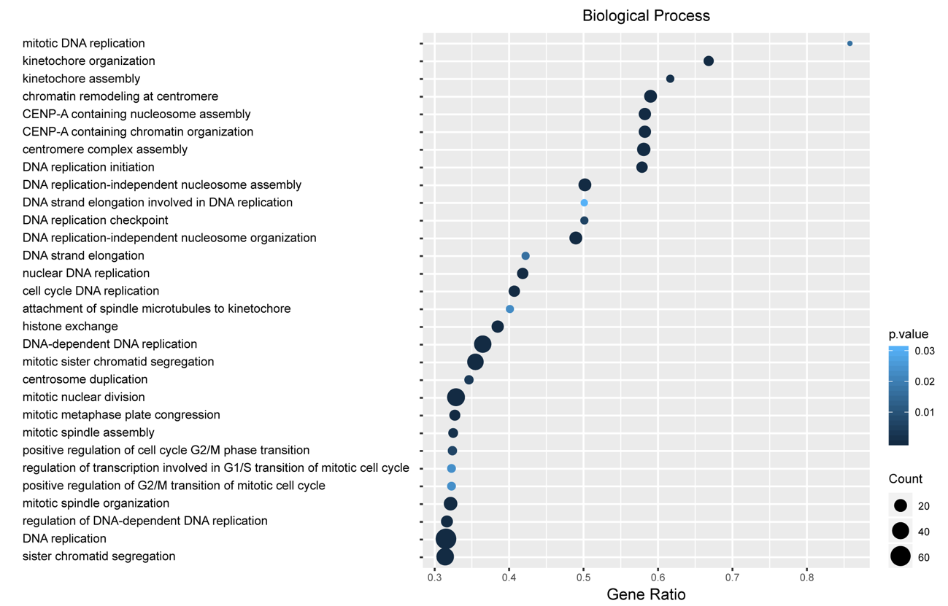
Supplementary Figure S7. The GO term enrichment analysis of the genes with < 2-fold lower expression in the all macTSCs in +cAMP than FHBY condition. For GO analyses, PANTHER (www.panther.org) was used. P-values were calculated by Fisher’s exact test and Bonferroni corrected.

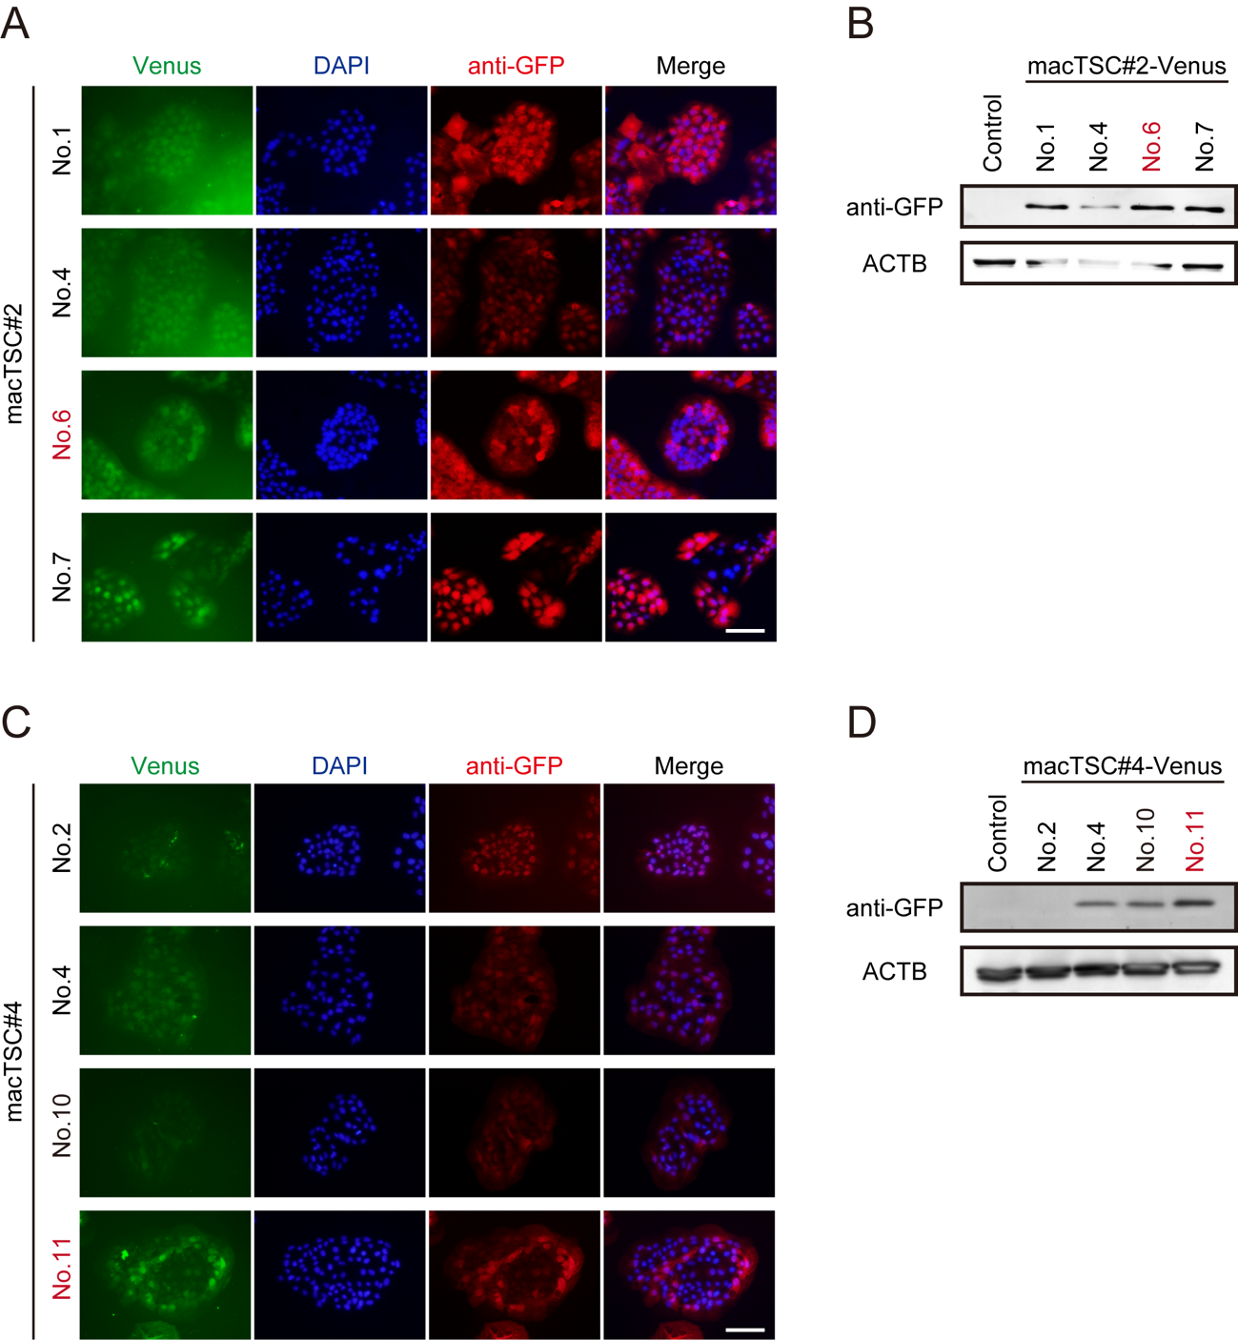
Supplementary Figure S8. Establishment of Venus-overexpressing macTSC lines. Detection of Venus in macTSC#2-Venus (A and B) and macTSC#4-Venus lines (C and D) by immunofluorescence (A and C) and western blotting (B and D). Scale bars in A and C = 100 μm. ACTB was used as an internal control for western blotting. Control, the original macTSC#2 (B) and macTSC#4 (D) cells. Based on the expression levels of Venus, macTSC#2-Venus No. 6 and macTSC#4-Venus No. 11 were chosen for the xenogeneic chimera assay.

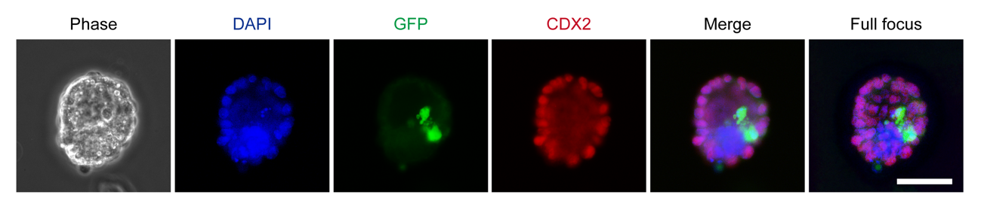
Supplementary Figure S9. Failure of aggregation in xenogeneic chimera blastocyst. macTSC#2-Venus cells dropped to the embryonic cavity. Scale bar = 50 µm.

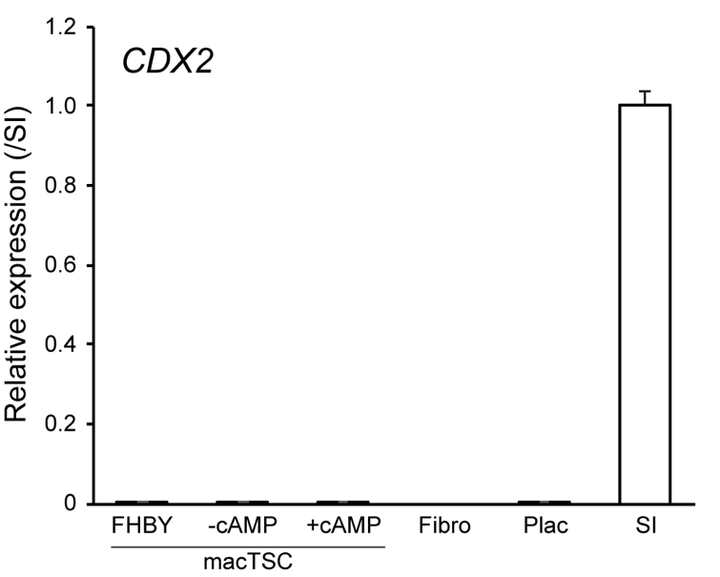
Supplementary Figure S10. qRT-PCR for analyzing the expression of CDX2 in macTSC. The mean values (± SD) of technical triplicates for biological duplicates, normalized by the expression of ACTB, were shown relative to that of small intestine (SI; arbitrarily set as 1).

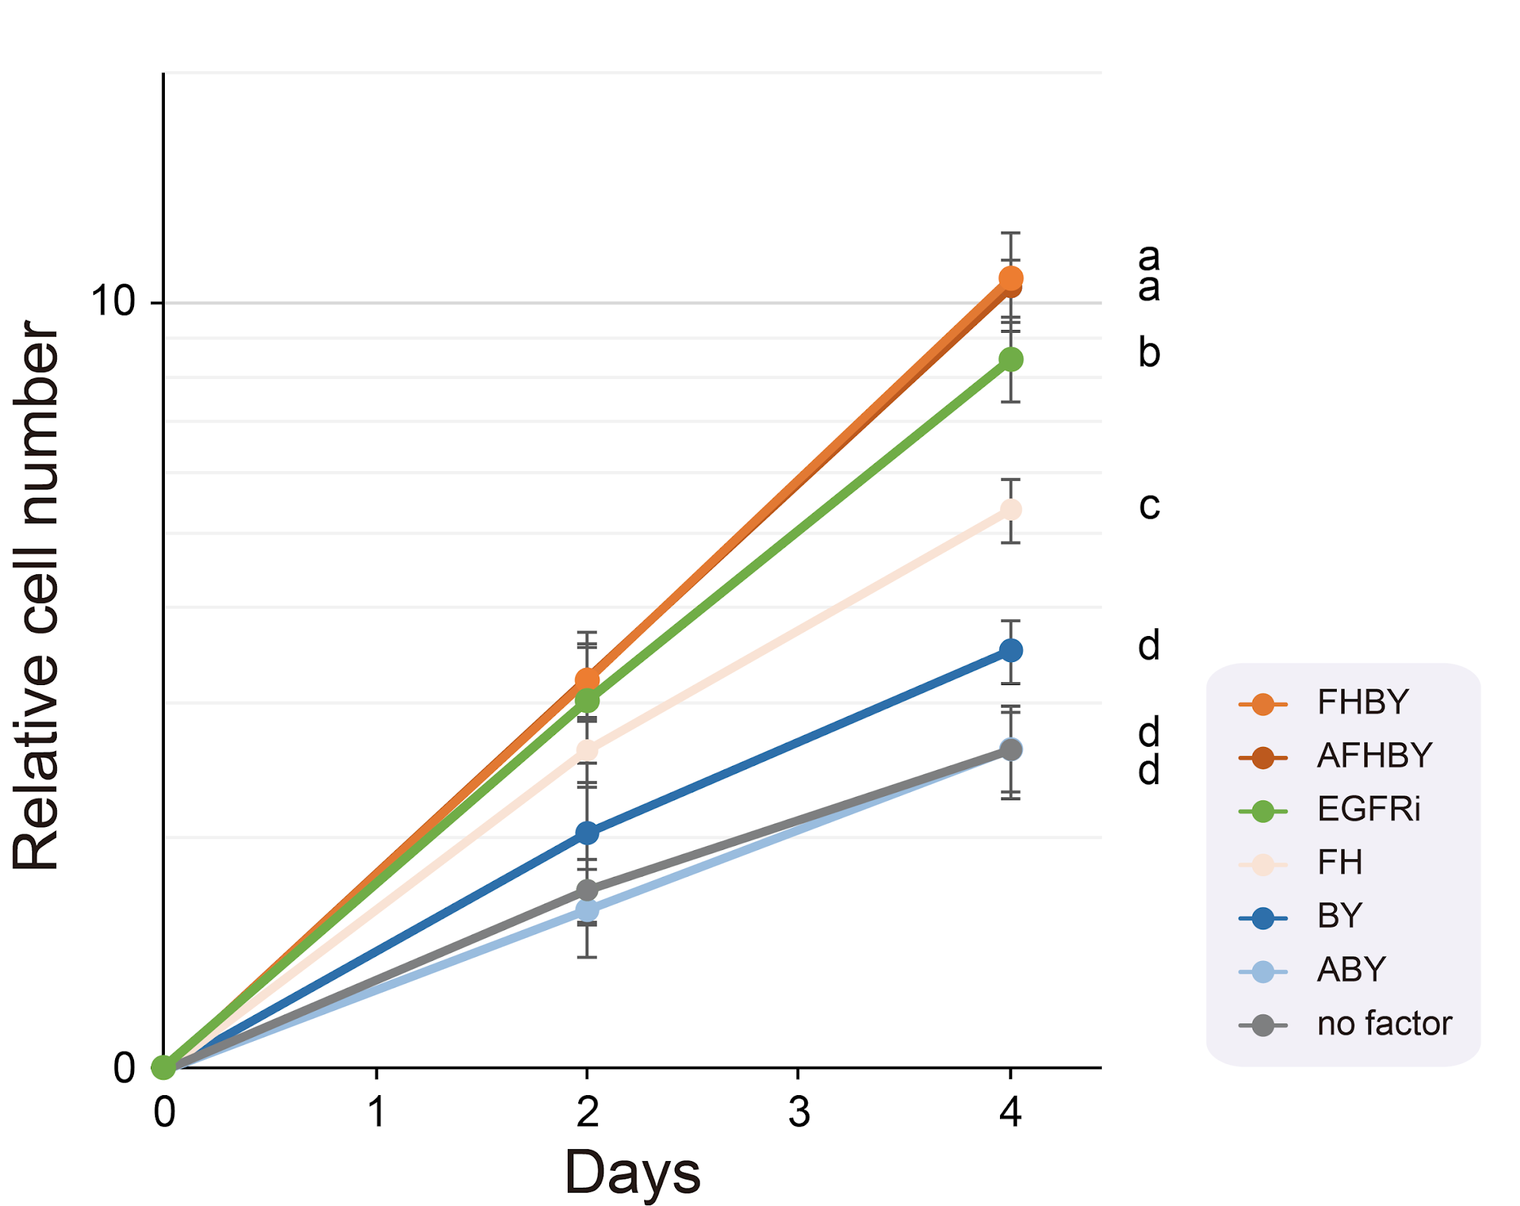
Supplementary Figure S11. Growth of macTSC#2 treated with 1 µM of EGFR inhibitor, PD153035 (EGFRi) (TCI, Tokyo, Japan); related to Figure 1D. The number of cells normalized to that at day 0 and arbitrarily set as 1. The mean values (± SD) of technical triplicates for biological duplicates are shown. P < 0.05 between different characters on day 4 (The Tukey-Kramer test).

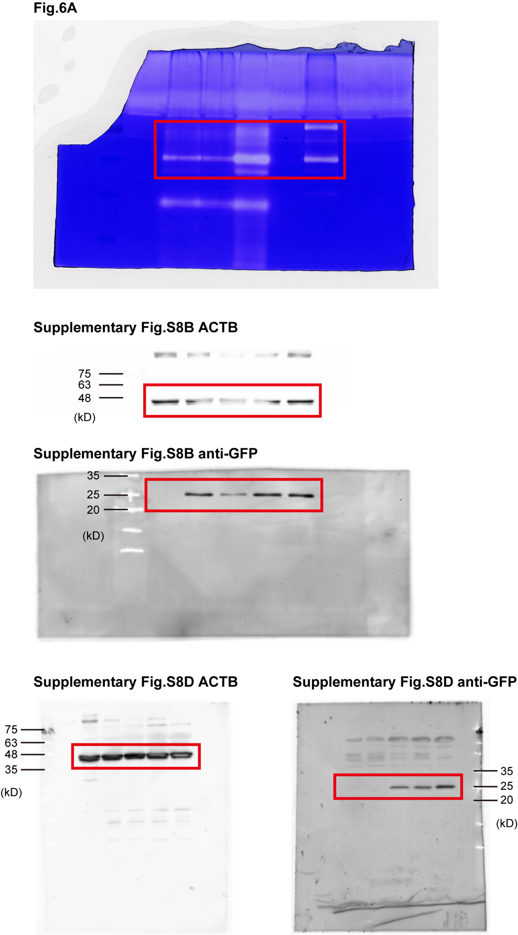
Supplementary Figure S12. Uncut blot images.

