Circ-camk4 involved in cerebral ischemia/reperfusion induced neuronal injury
Zhao-huan Zhang^{1#}, Yue-rong Wang^{2#} Fei Li^{1#}, Xiu-ling Liu², Hui Zhang², Zhong-zheng Zhu³, Hai Huang², Xiao-hui Xu¹*
1, School of Preclinical Medicine, Wannan Medical College, Wuhu 241001, China. School of Life Sciences, Shanghai University, Shanghai 200444, China. Department of Neurology, Changzheng Hospital, 200003, Shanghai, China.
2, School of Life Sciences, Shanghai University, Shanghai, 200444, China.
3, Department of Oncology, Shanghai Tenth People's Hospital, Tongji University School of Medicine, Shanghai 200072, China.

# These authors contribute equally to this work.
*Corresponding to Xiao-hui Xu: xxhxxh@shu.edu.cn
Word Count: 4700.
Authors Contribution
Xiao-hui Xu designed experiments; Zhao-huan Zhang carried out the primary neuron culture, SD rat MACO experiments; Yue-rong Wang ,Hui Zhang and Zhao-huan Zhang done the RT-PCR assay experiments. Yue-rong Wang and Xiao-hui Xu analyzed the data. Hui Zhang did the GO and KEEG analysis. Xiu-ling Liu, Zhong-zheng Zhu and Hai Huang did the SH-SY5Y cells transfection and PI assay experiments. Fei Li for RNA-pull down assay and the following RT-PCR. Xiao-hui Xu, Zhao-huan Zhang and Hui Zhang wrote the manuscript.
Table S1: Summary of differential expression of circRNAs (Fold change indicated with logFC).
circ_ID | log2FC(LI/RC) |  | Host gene
circ_ID | FC | p-value | gene_name | gene_id
Up-regulated differentiation
rno_circ6505 | 3.008180113 | 0.014413706 | Strn | ENSRNOG00000004806
rno_circ5942 | 2.578259368 | 0.022208097 | Oprk1 | ENSRNOG00000007647
rno_circ2217 | 2.490948098 | 0.007459433 | Phactr1 | ENSRNOG00000014264
rno_circ7641 | 2.459764716 | 0.013538161 | Dock3 | ENSRNOG00000014576
rno_circ2671 | 2.435701539 | 0.00235859 | Camk4 | ENSRNOG00000020478
rno_circ4167 | 2.400834768 | 0.039696281 | Zfr | ENSRNOG00000011627
rno_circ5371 | 2.400834768 | 0.039696281 | Cadps2 | ENSRNOG00000007636
rno_circ6381 | 2.272044126 | 0.045651874 | Ubap2 | ENSRNOG00000052087
rno_circ5421 | 2.272044126 | 0.045651874 | Ppp1r9a | ENSRNOG00000008869
rno_circ8295 | 2.152753524 | 0.023635458 | St6gal2 | ENSRNOG00000046515
rno_circ1527 | 2.005621338 | 0.011618237 | Cobl | ENSRNOG00000004281
rno_circ3634 | 2.002248302 | 0.040093587 | Dlg2 | ENSRNOG00000022635
rno_circ4511 | 1.81323047 | 0.04127558 | Pcdh10 | ENSRNOG00000031974
rno_circ3116 | 1.797358969 | 0.034765337 | Prkcb | ENSRNOG00000012061
rno_circ4226 | 1.589545601 | 0.034456631 | Mctp1 | ENSRNOG00000013282
rno_circ6213 | 1.536551621 | 0.039195221 | Rere | ENSRNOG00000017940
Down-regulated differentiation
rno_circ3780 | -3.449636294 | 0.000168571 | Stambpl1 | ENSRNOG00000050224
rno_circ6733 | -2.391591026 | 0.018258403 | Efr3b | ENSRNOG00000012950
rno_circ3730 | -2.391591026 | 0.018258403 | Ttyh1 | ENSRNOG00000032699
rno_circ3376 | -2.316570798 | 0.002510452 | Zranb1 | ENSRNOG00000017294
rno_circ4991 | -2.305263591 | 0.023239034 | Chd6 | ENSRNOG00000016744
rno_circ5115 | -2.264685322 | 0.005545191 | Kiz | ENSRNOG00000025141
rno_circ7545 | -2.221840613 | 0.002831698 | Hmgcll1 | ENSRNOG00000011193
rno_circ6993 | -2.129181175 | 0.008221656 | Rims2 | ENSRNOG00000004201
rno_circ6856 | -2.119504102 | 0.009186799 | Ralgapa1 | ENSRNOG00000046256
rno_circ353 | -2.070508471 | 0.028743676 | Acadvl | ENSRNOG00000018114
rno_circ3753 | -2.057046674 | 0.028123146 | Vti1a | ENSRNOG00000042786
rno_circ260 | -2.010148987 | 0.049335813 | Tlk2 | ENSRNOG00000006285
rno_circ1963 | -2.010148987 | 0.049335813 | Acsl1 | ENSRNOG00000010633
rno_circ7171 | -1.993528797 | 0.033540426 | Tcf20 | ENSRNOG00000009585
rno_circ7294 | -1.988377815 | 0.02695136 | Mapk12 | ENSRNOG00000031233
rno_circ3380 | -1.937689517 | 0.008205229 | Zranb1 | ENSRNOG00000017294
rno_circ2640 | -1.909116881 | 0.020188708 | Htr4 | ENSRNOG00000019134
rno_circ7426 | -1.862140583 | 0.00742541 | Ephb1 | ENSRNOG00000007865
rno_circ229 | -1.81974046 | 0.029463659 | Crebbp | ENSRNOG00000005330
rno_circ7964 | -1.669226967 | 0.024581445 | Tnfrsf21 | ENSRNOG00000011517
rno_circ7326 | -1.642637067 | 0.027317469 | Nav3 | ENSRNOG00000052157
rno_circ6195 | -1.641690159 | 0.019292489 | RGD1310951 | ENSRNOG00000016780
rno_circ3820 | -1.636494297 | 0.03444143 | Sptbn2 | ENSRNOG00000058842
rno_circ6676 | -1.625583522 | 0.045254176 | Ttll5 | ENSRNOG00000009318
rno_circ3379 | -1.625583522 | 0.045254176 | Zranb1 | ENSRNOG00000017294
rno_circ2220 | -1.620715238 | 0.021000858 | Gli3 | ENSRNOG00000014395
rno_circ8138 | -1.618087791 | 0.021106829 | Epb41l3 | ENSRNOG00000016724
rno_circ2462 | -1.562767169 | 0.042739234 | Adarb2 | ENSRNOG00000030775

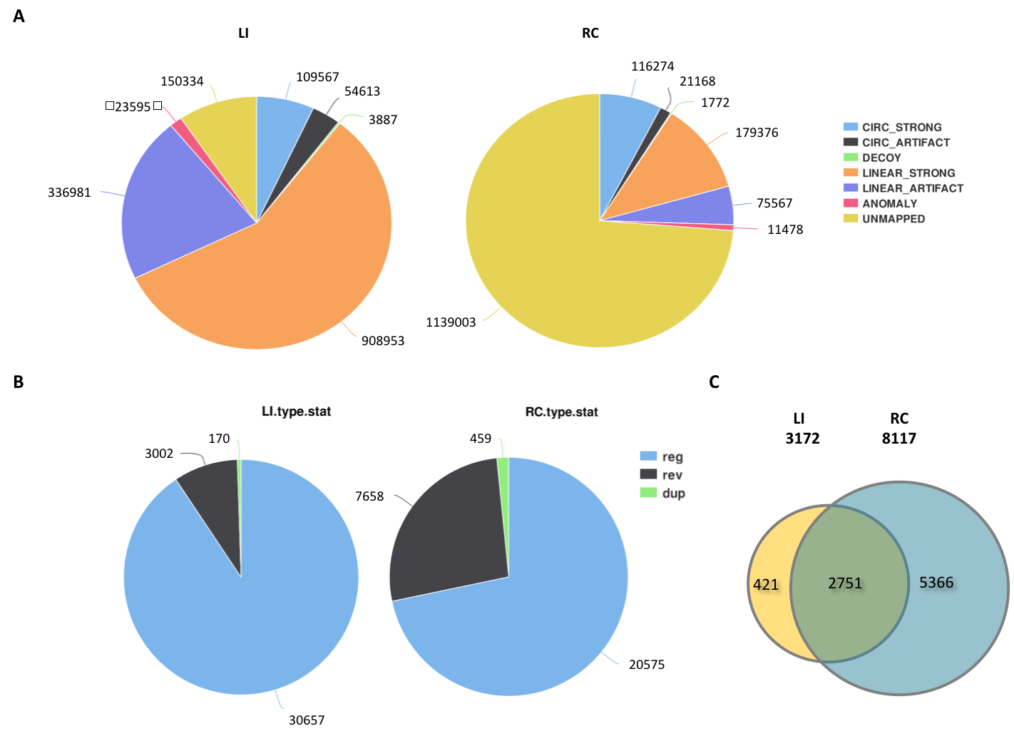
Figure S1. Statistics of annotation of reads predicted by KNIEF. A. Pie chart to show types of the pair-end reads annotation on split site by KNIEF, with individual meaning of the aberration as following: CIRC_STRONG, reads mapped to circular split site and p-value > = 0.9 ; CIRC_ARTIFACT, reads mapped to circular split site and p-value < 0.9 ; DECOY, Read1 mapped to the circular split site, read2 does not support the two reads form a circle structure. LINER_STRONG, reads mapped to linear split site and p-value > = 0.9; LINER_ARTIFACT, reads mapped to circular split site and p-value < 0.9 ; ANOMALY, Read1 mapped to the linear split site, read2 does not in line with read1; UNMAPPED, Read1 mapped to the linear cutting site, read2 does not mapped on any exon; B. Pie chart to show types of junctions overall annotated. Abbreviations: reg, regular split junctions; rev, circular split junctions formed by more than 2 exons; dup, circular split junctions formed by a single exon; LI, Left injury side; RC, right control side. C, Venn diagram shows the circular junctions identified in LI and RC, respectively, and the intersection area indicating the junctions identified in both LI and RC.

Figure S2. The GO annotations for target genes mediated by the miRNAs potentially regulated by circ-camk4. The GO analysis categorized the mRNAs into different groups under the theme of biological process (BP), cellular component (CC), and molecular function (MF). (A) Scatter plot showing the fold enrichment values of the top 20 most significantly enriched terms for the BP. (B) Scatter plot showing the fold enrichment values of the top 20 most significantly enriched terms for the CC. (C) Scatter plot showing the fold enrichment values of the top 20 most significantly enriched terms for the MF. Rich factor represented the ratio of enriched differential genes to annotated genes in each pathway. The area of each node represented the number of enriched differential genes. The p-value was indicated by different color changes from green to red.

Figure S3. Full gels for Figure 4B.

RNA oligo sequences:
rno-miR-212-3p mimics: | Sense strand | UAACAGUCUCCAGUCACGGCCA
rno-miR-212-3p mimics: | Antisense strand: | GCCGUGACUGGAGACUGUUAUU
rno-miR-27a-3p mimics: | Sense strand | UUCACAGUGGCUAAGUUCCGC
rno-miR-27a-3p mimics: | Antisense strand | GGAACUUAGCCACUGUGAAUU
rno-miR-504 mimics: | Sense strand | AGACCCUGGUCUGCACUCUGUC
rno-miR-504 mimics: | Antisense strand | CAGAGUGCAGACCAGGGUCUUU
rno-miR-324-3p mimics: | Sense strand | CCACUGCCCCAGGUGCUGCUGG
rno-miR-324-3p mimics: | Antisense strand | AGCAGCACCUGGGGCAGUGGUU
rno-circ-camk4 AS: | Antisense probe | CUUUCUCCACAAUCCACAGUACCCC
Negative control: | Sense strand | UUCUCCGAACGUGUCACGUTT
 | Antisense strand | ACGUGACACGUUCGGAGAATT

