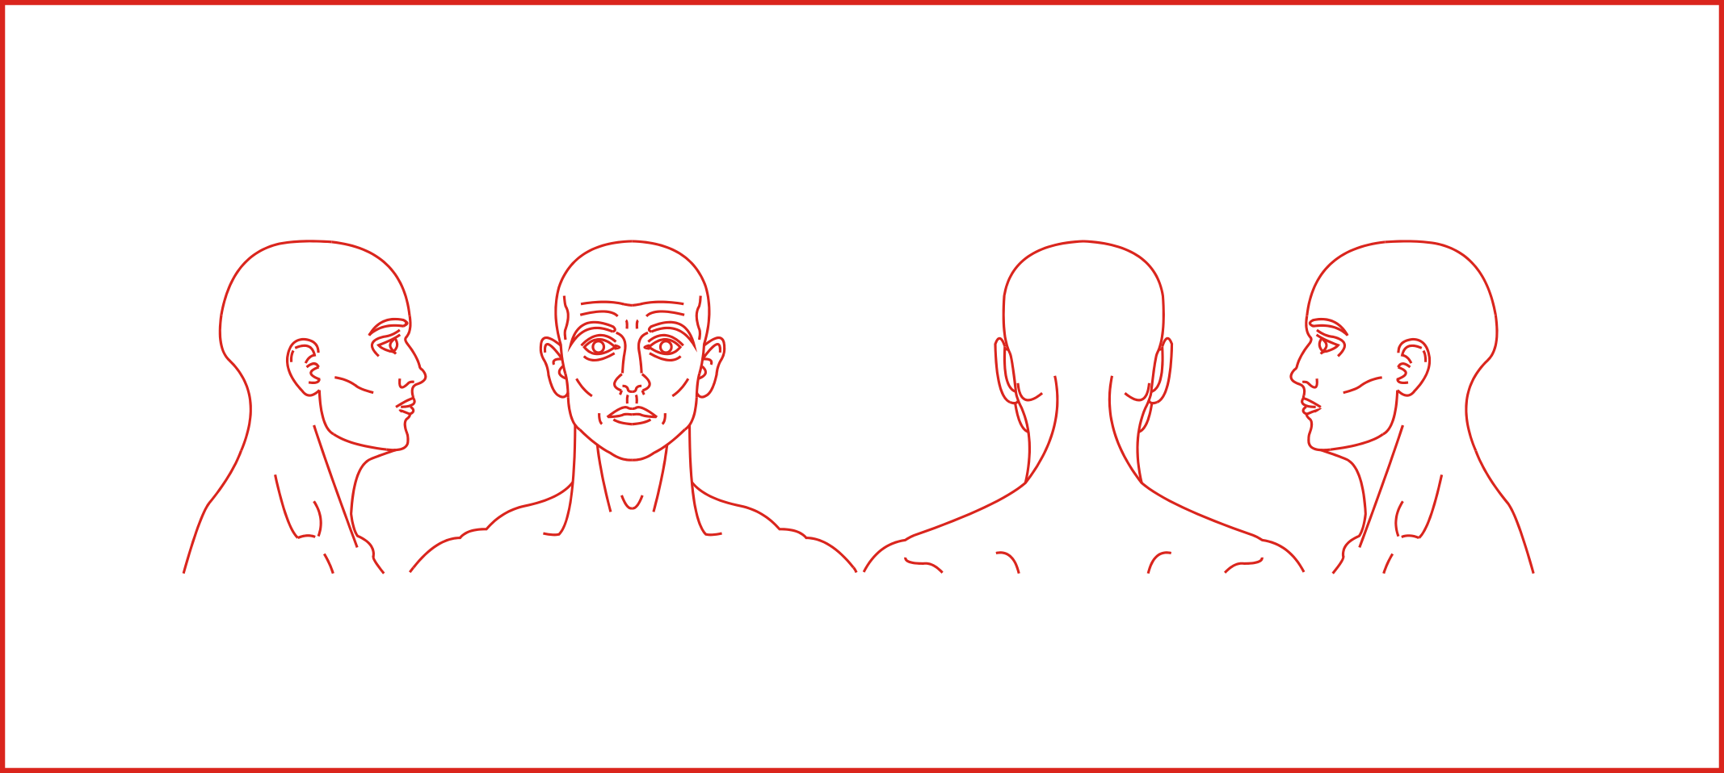
INSTRUCTIONS
There are two sections in this questionnaire;
  - Section A requires completion at intervals.
  - Section B should be completed at the end of the test
Assessment of Cervical Collar
Post-modification (3rd iteration)
On the following page there are four sets of images, identical to the example pictured below. Please could you circle on the images the areas you felt discomfort during the specified periods, and also indicate the severity of discomfort on the scale below the images.
Example image.
✓
No
discomfort
Severe
Pain
A little
painful
A little
discomfort
Very
uncomfortable
Very
painful
Extremely uncomfortable
After 4 hours
No
discomfort
Severe
Pain
A little
painful
A little
discomfort
Very
uncomfortable
Very
painful
Extremely uncomfortable
After 3 hours
No
discomfort
Severe
Pain
A little
painful
A little
discomfort
Very
uncomfortable
Very
painful
Extremely uncomfortable
After 2 hours
No
discomfort
Severe
Pain
A little
painful
A little
discomfort
Very
uncomfortable
Very
painful
Extremely uncomfortable
After 1 hour
No
discomfort
Severe
Pain
A little
painful
A little
discomfort
Very
uncomfortable
Very
painful
Extremely uncomfortable
Please fill in this section at one hourly intervals. Indicating your level of comfort and any sites of discomfort.
SECTION A

Strongly
agree
Disagree
Agree
Disagree
somewhat
Strongly
disagree
neither
agree or disagree
Agree
somewhat
I found it very hard to breath wearing this collar.
✓
Strongly
agree
Disagree
Agree
Disagree
somewhat
Strongly
disagree
neither
agree or disagree
Agree
somewhat
Strongly
agree
Disagree
Agree
Disagree
somewhat
Strongly
disagree
neither
agree or disagree
Agree
somewhat
Strongly
agree
Disagree
Agree
Disagree
somewhat
Strongly
disagree
neither
agree or disagree
Agree
somewhat
Strongly
agree
Disagree
Agree
Disagree
somewhat
Strongly
disagree
neither
agree or disagree
Agree
somewhat
Strongly
agree
Disagree
Agree
Disagree
somewhat
Strongly
disagree
neither
agree or disagree
Agree
somewhat
Strongly
agree
Disagree
Agree
Disagree
somewhat
Strongly
disagree
neither
agree or disagree
Agree
somewhat
SECTION B
Please read the following statements and place a mark on the circle you feel best describes your response, as shown in the example below.
I experienced no problems drinking whilst wearing this collar.
I experienced no difficulties eating whilst wearing this collar.
This collar caused no restriction to my natural breathing.
This collar caused no restriction to my natural swallowing.
I felt that this collar offered support.
I experienced no perspiration around my head, shoulders or neck whilst wearing this collar.
Strongly
agree
Disagree
Agree
Disagree
somewhat
Strongly
disagree
neither
agree or disagree
Agree
somewhat
I find this collar visually attractive.
I felt no frustration at all whilst wearing this collar.
Strongly
agree
Disagree
Agree
Disagree
somewhat
Strongly
disagree
neither
agree or disagree
Agree
somewhat
Please feel free to write any other comments or observations you have regarding your experience of wearing the collar.

