Transcriptome profiling reveals insertional mutagenesis suppressed the expression of candidate pathogenicity genes in honeybee fungal pathogen, Ascosphaera apis

Awraris Getachew^{1,2+}, Tessema Aynalem Abejew^{1,2+}, Jiangli Wu¹, Jin Xu¹, Huimin Yu¹, Jing Tan¹, Pengjie Wu¹, Yangyang Tu¹, Weipeng Kang¹, Zheng Wang¹, Shufa Xu¹*

¹Key Laboratory of Pollinating Insect Biology, Ministry of Agriculture; Institute of Apicultural Research, Chinese Academy of Agricultural Sciences, 100093, Beijing, China

²College of Agriculture and Environmental Sciences, Bahir Dar University, Bahir Dar, Ethiopia

*corresponding author: xushufa@caas.cn
⁺these authors contributed equally to this work and listed as first authors

Supplementary information legends

Supplementary information, Fig. S1. Principal Component Analysis (PCA) of mutants and wild-type. PCA analysis showed the mutant samples clearly separated from wild-type, indicating a visible variation among the different samples.

Supplementary information, Fig. S2. KOG functional classification of the annotated genes. A total of 230 annotated unigenes were assigned to 23 classification categories. The KOG categories are shown on the x-axis and gene proportions are plotted on the y-axis.

Supplementary information, Fig. S3. Summary of fungal specific transcription factor unigenes of A. apis. The vertical axis shows the number of unigenes and the horizontal axis represents TF families to annotated to A. apis.

Supplementary information, Fig. S4. Volcano plot showing the distribution of differentially expressed genes: a/ SPE2-SPE1, b/ SPE3-SPE1, and c/ SPE4-SPE1. Each point represents a single gene. The red dots are representing the up-regulated differentially expressed genes between mutant and wild type strains, green dots are representing the down-regulated differentially expressed genes, and black dots are representing non-differentially expressed genes.

Supplementary information, Fig. S5. Enriched Fructose and mannose metabolism pathway with EC numbers found down-regulated in A. apis mutant SPE4 compared to wild type (SPE1) shown in red color. EC numbers sown in green color are present in Trichophyton verrucosum KEGG database, but not identified in A. apis transcriptome¹.

Supplementary information, Fig. S6. Enriched sulfur metabolism pathway with EC numbers found down-regulated in A. apis mutant SPE3 compared to wild type (SPE1) shown in red color. EC numbers sown in green color are present in Trichophyton verrucosum KEGG database, but not identified in A. apis transcriptome¹.

Supplementary information, Fig. S7. Enriched proteasome pathway found commonly down-regulated in all the three A. apis mutants (SPE2, SPE3 and SPE4) compared to wild type (SPE1) shown in red color¹.

Supplementary information, Fig. S8. Enriched SNARE interactions in vesicular transport pathway found down-regulated in two A. apis mutants (SPE3 and SPE4) in comparison to wild type (SPE1) shown in red color¹.

Supplementary information, Table S1. Down-regulated genes associated with pathogenicity of A. apis

Supplementary information, Table S2. Top 10 GO enriched functions of down-regulated genes in SPE2-SPE1separated in to 3 GO term categories. DEGs-Size, number of differentially expressed genes that contribute to the enrichment of the term. Size, number of expressed genes associated with the term. FDR, false discovery rate., RF, rich factor.

Supplementary information, Table S3. Top 10 GO enriched functions of down-regulated genes in SPE3-SPE1separated in to 3 GO term categories. DEGs-Size, number of differentially expressed genes that contribute to the enrichment of the term. Size, number of expressed genes associated with the term. FDR, false discovery rate., RF, rich factor.

Supplementary information, Table S4. Top 10 GO enriched functions of down-regulated genes in SPE4-SPE1separated in to 3 GO term categories. DEGs-Size, number of differentially expressed genes that contribute to the enrichment of the term. Size, number of expressed genes associated with the term. FDR, false discovery rate., RF, rich factor.

Supplementary information, Table S5. Top 10 GO enriched functions of up-regulated genes in SPE2-SPE1separated in to 3 GO term categories. DEGs-Size, number of differentially expressed genes that contribute to the enrichment of the term. Size, number of expressed genes associated with the term. FDR, false discovery rate., RF, rich factor.

Supplementary information, Table S6. Top 10 GO enriched functions of up-regulated genes in SPE3-SPE1separated in to 3 GO term categories. DEGs-Size, number of differentially expressed genes that contribute to the enrichment of the term. Size, number of expressed genes associated with the term. FDR, false discovery rate., RF, rich factor.

Supplementary information, Table S7. Top 10 GO enriched functions of up-regulated genes in SPE4-SPE1separated in to 3 GO term categories. DEGs-Size, number of differentially expressed genes that contribute to the enrichment of the term. Size, number of expressed genes associated with the term. FDR, false discovery rate., RF, rich factor.

Supplementary information, Table S8. Protein families detected in protein-protein interaction network analysis

Supplementary information

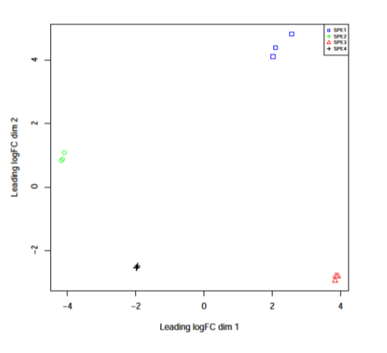
Supplementary information, Fig. S1.

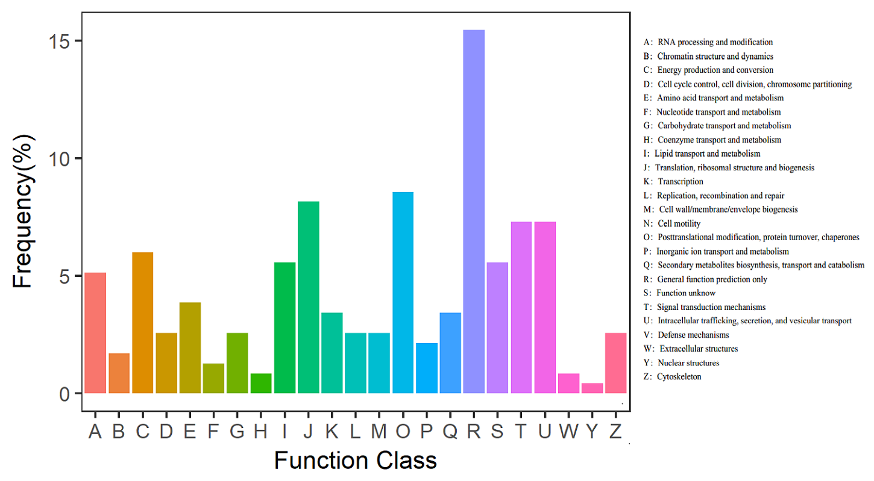
Supplementary information, Fig. S2.

Supplementary information, Fig. S3.

Supplementary information, Fig. S4.

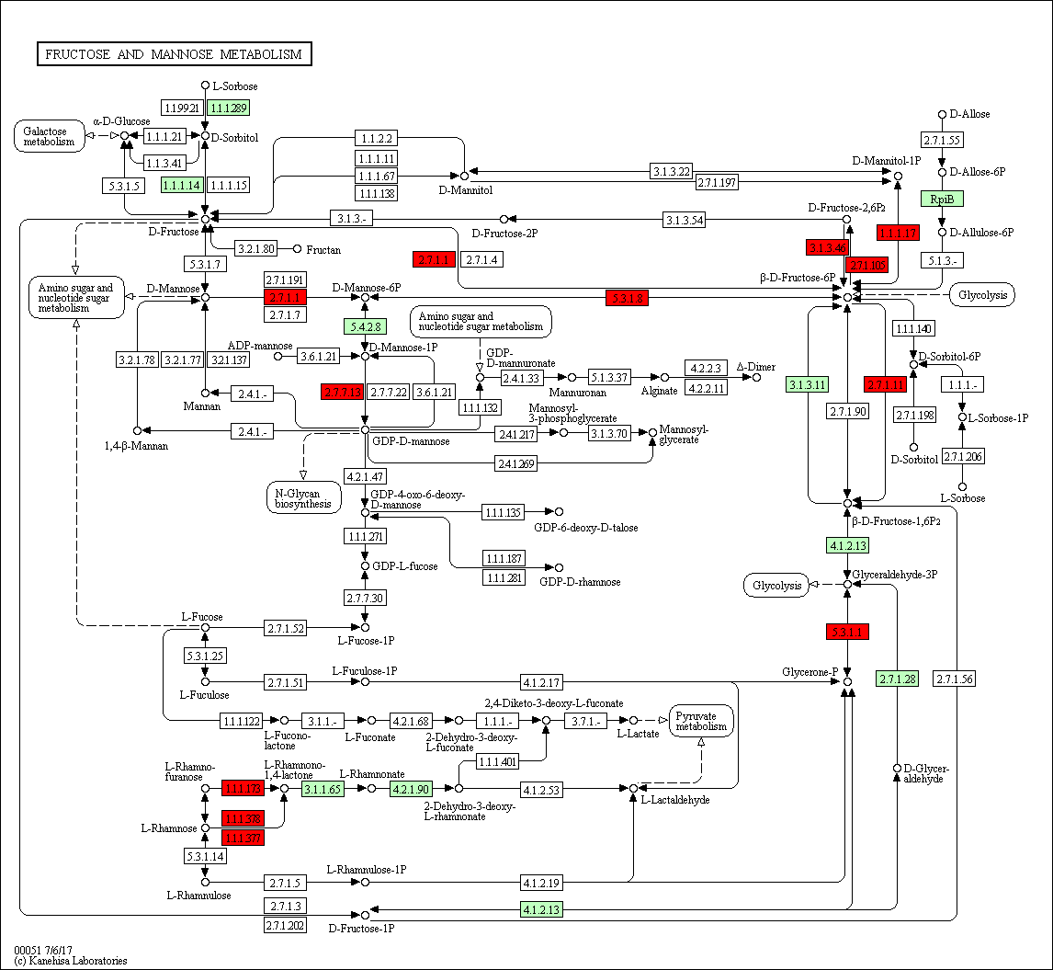
Supplementary information, Fig. S5.

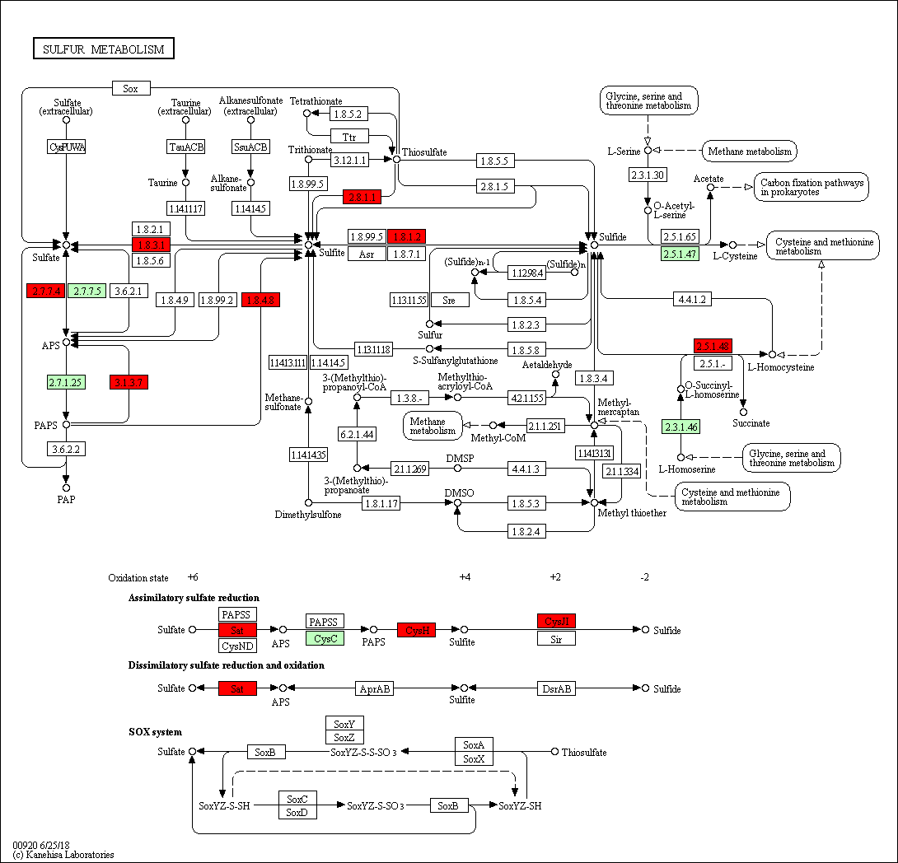
Supplementary information, Fig. S6.

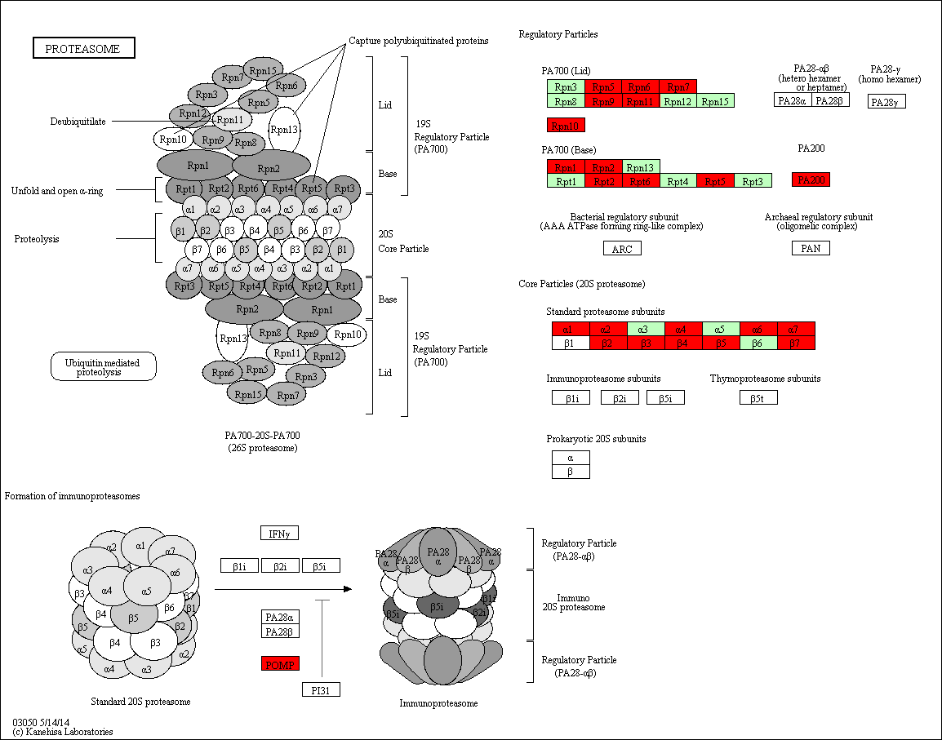
Supplementary information, Fig. S7.

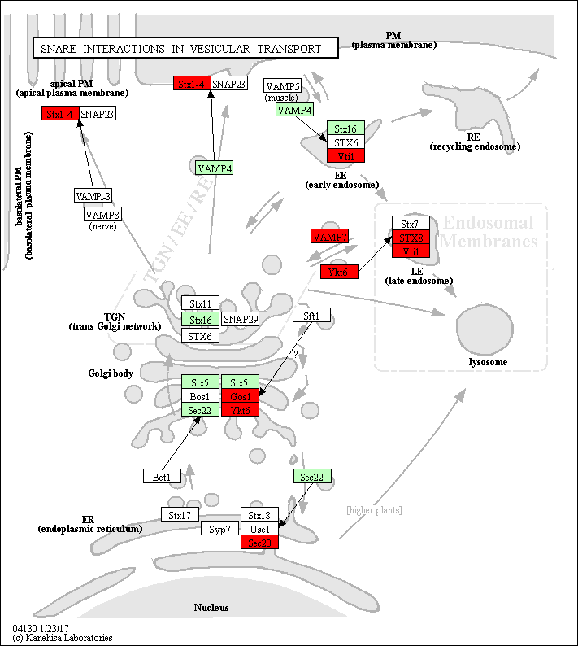
Supplementary information, Fig. S8.

Supplementary information, Table S1.
Gene | Description | Regulated
Gene | Polyketides | SPE2 | SPE3 | SPE4
Cluster-6084.0 | A0A179GXW7, Malonyl CoA-acyl carrier protein trans.. | Down
Cluster-7845.0 | A0A179HFX8, Alcohol dehydrogenase, zinc-containing | Down
Cluster-9540.0 | A0A179HGJ7, Zinc-binding dehydrogenase | Down
Cluster-5644.0 | A0A179H392, Polyketide synthase | Down
Cluster-5644.1 | A0A179H392, Polyketide synthase | Down
Cluster-5644.1 | A0A179H392, Polyketide synthase | Down
Cluster-6005.0 | A0A179HSY7, Nonribosomal siderophore peptide synthase | Down
Cluster-6406.0 | A0A179H502, Amidase | Down
Cluster-7555.0 | A0A179GJJ4, Zinc-binding dehydrogenase | Down
Cluster-9355.0 | A0A179H593, Cyclase/dehydrase family protein | Down
Cluster-7878.0 | A0A179GJS0, Protein TOXD | Down | Down
Cluster-5629.1 | Q2UH45, Uncharacterized protein | Down | Down | Down
Cluster-5972.0 | I8AD10, Alcohol dehydrogenase, class V | Down | Down | Down
Cluster-6333.0 | Q5VDF2, PksA | Down | Down | Down
Cluster-6655.0 | B8NL80, Fatty acid synthase beta subunit, putative | Down | Down | Down
Cluster-6835.0 | Q2UG06, Uncharacterized protein | Down | Down | Down
Cluster-7091.0 | I8U9N6, Uncharacterized protein | Down | Down | Down
Cluster-7644.0 | I8U3N1,3-oxoacyl-[acyl-carrier protein] reductase | Down | Down | Down
Cluster-7904.0 | B8MZZ4, Uncharacterized protein | Down | Down | Down
Cluster-8088.0 | I8TXN3, Quinone reductase | Down | Down | Down
Cluster-8189.0 | I8A836, Enoyl reductase domain of FAS1 | Down | Down | Down
Cluster-8231.0 | Q2UMH7, Uncharacterized protein | Down | Down | Down
Cluster-8231.0 | I8TH45, NADPH quinone reductase | Down | Down | Down
Cluster-8356.0 | B8NI04, AflC / pksA / pksL1 / polyketide synthase | Down | Down | Down
Cluster-8356.1 | B8NI04, AflC / pksA / pksL1 / polyketide synthase | Down | Down | Down
Cluster-8356.2 | Q5VDF2, PksA | Down | Down | Down
Cluster-8394.0 | I7ZMR3, Zinc-binding oxidoreductase | Down | Down | Down
Cluster-8878.0 | B8NI12, Hybrid PKS/NRPS enzyme, putative | Down | Down | Down
Cluster-9411.0 | I8A576, Polyketide synthase module | Down | Down | Down
Cluster-9411.1 | Q2UB00, Uncharacterized protein | Down | Down | Down
Cluster-9292.0 | A0A179HXF3, Alcohol dehydrogenase superfamily, zinc-containing | Down |  | Down
Cluster-9292.0 | A0A179HXF3, Alcohol dehydrogenase superfamily, zinc-containing | Down |  | Down
Cluster-7091.1 | I8U9N6, Uncharacterized protein |  | Down | Down
Cluster-8413.1 | B8NAC6, Quinone oxidoreductase, putative |  | Down | Down
Genes | Amidases
Cluster-5114.0 | A0A179HEL8, Amidase signature | Down
Cluster-6588.0 | A0A179H506, GPI transamidase component PIG-S | Down
Cluster-6406.0 | A0A179H502, Amidase | Down
Gene | Description | Regulated
Gene | Amidases | SPE2 | SPE3 | SPE4
Cluster-9107.0 | A0A179GZY2, Peptide-N4- | Down
Cluster-8716.0 | A0A179GTP5, Amidase signature domain-containingprotein | Down
Cluster-8387.0 | A0A179GMK1, Glutamyl-tRNA | Down
Cluster-8621.0 | A0A179GK75, Beta-alanine synthase | Down
Cluster-8354.0 | A0A179GFV2, N-acylethanolamine amidohydrolase | Down
Cluster-8094.0 | A0A179GFI4, Pyrazinamidase/nicotinamidase | Down
Cluster-8094.1 | A0A179GFI4, Pyrazinamidase/nicotinamidase | Down
Cluster-8716.1 | A0A179GDL3, Amidase signature domain-containingprotein | Down
Cluster-6230.0 | A0A179G2N5, Amidase | Down
Cluster-5114.0 | A0A179HEL8, Amidase signature | Down
Cluster-9686.0 | B8NVX6, Muramidase, putative | Down | Down | Down
Cluster-9189.0 | A0A0L1J869, Alkaline phytoceramidase | Down | Down | Down
Cluster-6476.0 | A0A0L1J4N3, Alkaline phytoceramidase | Down | Down | Down
Cluster-7361.0 | A0A179GKR1, Fatty-acid amide hydrolase | Down |  | Down
 | Esterases
Cluster-2557.1 | A0A179HC52,Purple acid phosphatase | Down
Cluster-3119.0 | A0A179HGH9,Phosphoinositide phospholipase C | Down
Cluster-4051.2 | A0A179GKD1,Phosphoinositide phospholipase C | Down
Cluster-5387.1 | A0A179HTD1,Acyl-CoA thioesterase | Down
Cluster-5589.0 | A0A1T3CI52,Thioesterase family protein | Down
Cluster-6190.0 | A0A179H0S0,Carboxylic ester hydrolase | Down
Cluster-6190.0 | A0A179H0S0,Carboxylic ester hydrolase | Down
Cluster-6774.0 | A0A0F7ZIQ1,Uncharacterized protein | Down
Cluster-7432.0 | A0A179GDA7,Ankyrin repeat protein | Down
Cluster-7634.0 | A0A179HGH8,Lariat debranching enzyme | Down
Cluster-8036.0 | A0A179HCI3,Phosphoethanolamine transferase class O | Down
Cluster-8136.0 | A0A179HHA0,Type I phosphodiesterase / nucleotide pyrophosphatase family protein | Down
Cluster-8507.0 | A0A179FQN0,Tat pathway signal sequence | Down
Cluster-8507.1 | A0A179FQN0,Tat pathway signal sequence | Down
Cluster-8507.1 | A0A179FQN0,Tat pathway signal sequence | Down
Cluster-8713.0 | A0A179GLQ8,Thioesterase superfamily protein | Down
Cluster-8920.0 | A0A0C2FPA0,tRNA ligase | Down
Cluster-9274.0 | A0A179H347,PLC-like phosphodiesterase | Down
Cluster-9315.0 | A0A179GVJ0,Carbohydrate esterase family 3 | Down
Cluster-5176.0 | Q2UGA2,Sphingomyelin phosphodiesterase | Down | Down | Down
Cluster-5615.1 | B8N3K0,Ser/Thr protein phosphatase family protein | Down | Down | Down
Cluster-5818.0 | Q2U2Y0,Endopolyphosphatase | Down | Down | Down
Cluster-6121.0 | A0A0D9NBJ7,Palmitoyl protein thioesterase | Down | Down | Down
Gene | Description | Regulated
Gene | Esterases | SPE2 | SPE3 | SPE4
Cluster-6333.0 | Q5VDF2,PksA | Down | Down | Down
Cluster-6767.0 | I8A3Y4, Cell division control protein/putative DNA repair exonuclease | Down | Down | Down
Cluster-6835.0 | Q2UG06, Uncharacterized protein | Down | Down | Down
Cluster-6912.0 | A0A0D9N5X2, Serine/threonine-protein phosphatase | Down | Down | Down
Cluster-7169.0 | A0A0D9MNT2, Calcineurin-like phosphoesterase | Down | Down | Down
Cluster-7720.0 | B8N652, PAF acetylhydrolase family protein | Down | Down | Down
Cluster-7759.0 | Q2UED0, Uncharacterized protein | Down | Down | Down
Cluster-8356.0 | B8NI04, AflC / pksA / pksL1 / polyketide synthase | Down | Down | Down
Cluster-8356.1 | B8NI04, AflC / pksA / pksL1 / polyketide synthase | Down | Down | Down
Cluster-8356.2 | Q5VDF2, PksA | Down | Down | Down
Cluster-8686.0 | B8MYF1, Lipase, putative | Down | Down | Down
Cluster-8776.0 | A0A0D9N3H8, PolyA polymerase central domain protein | Down | Down | Down
Cluster-5615.0 | Q2UK83, Uncharacterized protein | Down |  | Down
Cluster-5724.0 | A0A179H6J0, Glycerophosphoryl diester phosphodiesterase | Down |  | Down
Cluster-8801.0 | A0A0D9MYX8, Protein phosphatase methylesterase 1 | Down |  | Down
Cluster-9859.2 | A0A0D9MZX5, Cation efflux family protein |  | Down | Down
Genes | Proteases | SPE2 | SPE3 | SPE4
Cluster-10044.0 | A0A0P6J7Q6, Transitional endoplasmic reticulum ATPase | Down
Cluster-10545.0 | A0A2C5Z078, Uncharacterized protein | Down
Cluster-10545.1 | A0A179GTF0, Ubiquitinyl hydrolase 1 | Down
Cluster-5986.0 | A0A179H877, SnRNP assembly factor | Down
Cluster-5986.1 | A0A179GHN5, SnRNP assembly factor | Down
Cluster-6401.0 | A0A179GXF1, Ubiquitin carboxyl-terminal hydrolase | Down
Cluster-6616.0 | A0A179H511, Aspartyl protease domain-containing protein | Down
Cluster-7513.1 | A0A179GR97, Cysteine protease PalB | Down
Cluster-7513.1 | A0A179HEV0, Cysteine protease PalB | Down
Cluster-7823.0 | A0A179GBZ4, Eukaryotic aspartyl protease | Down
Cluster-8873.0 | A0A179HL28, COP9 signalosome complex subunit 5 | Down
Cluster-6984.1 | A0A0L0NDT3, LON peptidase N-terminal domain and RING finger protein 1 | Down | Down
Cluster-5723.0 | A0A0D9MTN8, Ulp1 protease family C-terminal catalytic domain protein | Down | Down | Down
Cluster-5763.0 | B8NS01, Aspartic endopeptidase | Down | Down | Down
Cluster-5980.0 | B8NVB0, Cysteine protease | Down | Down | Down
Cluster-6154.0 | B8NNS3, Ubiquitin carboxyl-terminal hydrolase | Down | Down | Down
Cluster-6779.0 | Q2UTS7, Uncharacterized protein | Down | Down | Down
Cluster-7022.0 | B8N3A1, ADAM family of metalloprotease ADM-B | Down | Down | Down
Cluster-7170.0 | B8NWT9, Aspartic-type endopeptidase, putative | Down | Down | Down
Cluster-7170.1 | B8NWT9, Aspartic-type endopeptidase, putative | Down | Down | Down
Cluster-7748.0 | I8U9S6, Uncharacterized protein | Down | Down | Down
Cluster-7826.0 | I8IU94, Cytosolic Ca2+-dependent cysteine protease, large subunit | Down | Down | Down
Gene | Description | Regulated
Gene | Proteases | SPE2 | SPE3 | SPE4
Cluster-7896.0 | B8NGC1, Lon protease homolog, mitochondrial | Down | Down | Down
Cluster-8007.0 | B8NLQ9, Lon protease homolog 2, peroxisomal | Down | Down | Down
Cluster-8373.0 | B8NKF3, Ubiquitin C-terminal hydrolase, putative | Down | Down | Down
Cluster-8627.0 | B8NFR0, Mitochondrial inner membrane AAA protease Yta12, putative | Down | Down | Down
Cluster-8910.0 | B8NS75, Yapsin, putative | Down | Down | Down
Cluster-9119.0 | I8TNH9, Ubiquitin carboxyl-terminal hydrolase | Down | Down | Down
Cluster-9221.2 | I8AB24, DNA damage inducible protein | Down | Down | Down
Cluster-9291.0 | I8U106, Ubiquitin-specific protease | Down | Down | Down
Cluster-9753.0 | Q2U6G4, Uncharacterized protein | Down | Down | Down
Cluster-9774.0 | A0A0D9MX53, Eukaryotic aspartyl protease | Down | Down | Down
Gene | Lipases
Cluster-4051.2 | A0A179GKD1, Phosphoinositide phospholipase C | Down
Cluster-3119.0 | A0A179HGH9, Phosphoinositide phospholipase C | Down
Cluster-6333.0 | Q5VDF2, PksA | Down | Down | Down
Cluster-8356.2 | Q5VDF2, PksA | Down | Down | Down
Cluster-6835.0 | Q2UG06, Uncharacterized protein | Down | Down | Down
Cluster-8356.0 | B8NI04, AflC / pksA / pksL1 / polyketide synthase | Down | Down | Down
Cluster-8356.1 | B8NI04, AflC / pksA / pksL1 / polyketide synthase | Down | Down | Down
 | Chitinases
Cluster-5693.0 | A0A0D9MQQ2, Glycosyl hydrolases family 18 | Down | Down | Down
Cluster-7899.1 | A0A024HW64, Chitinase 18-5 | Down
Cluster-7899.1 | A0A179HU36, Glycoside hydrolase family 18 | Down
 | Cellulases
Cluster-262.0 | A0A179I0H1, Cellulase family protein | Down
Cluster-8512.0 | A0A179HVM4, Exo-beta-1,3-glucanase | Down
Genes | Glucanases | SPE2 | SPE3 | SPE4
Cluster-4337.0 | A0A179HK19, Concanavalin A-like lectin/glucanase | Down
Cluster-4337.0 | A0A179HK19, Concanavalin A-like lectin/glucanase | Down
Cluster-8030.0 | A0A179HIZ8, Xylanase 3 | Down
Cluster-8381.0 | A0A179HVQ6, Endo-1,3-beta-glucanase Engl1 | Down
Cluster-8512.0 | A0A179HVM4, Exo-beta-1,3-glucanase | Down
Cluster-10594.0 | I8TSM5, SPRY domain-containing protein | Down | Down | Down
Cluster-6461.0 | B8N3J2, Endo-1,3-beta-glucanase Engl1 | Down | Down | Down
Cluster-6858.1 | Q2UEY5, Uncharacterized protein | Down | Down | Down
Cluster-7469.0 | I8AD97, Uncharacterized protein | Down | Down | Down
Cluster-8315.0 | I8A7F0, SPRY domain-containing protein | Down | Down | Down
Cluster-8315.0 | B8MZI6, Endosomal SPRY domain protein, putative | Down | Down | Down
Cluster-6858.0 | B8NH97, Lectin family integral membrane protein, putative | Down |  | down
Genes | Description | Regulated
 | Glucan | SPE2 | SPE3 | SPE4
Cluster-7809.0 | A0A179GSE2,1,3-beta-glucanosyltransferase | Down
Cluster-6133.0 | A0A179GRX2, Protein related to glucan 1, 4-alpha-glucosidase | Down
Cluster-4337.0 | A0A179HK19, Concanavalin A-like lectin/glucanase | Down
Cluster-4337.0 | A0A179HK19, Concanavalin A-like lectin/glucanase | Down
Cluster-8030.0 | A0A179HIZ8, Xylanase 3 | Down
Cluster-8381.0 | A0A179HVQ6, Endo-1,3-beta-glucanase Engl1 | Down
Cluster-8512.0 | A0A179HVM4, Exo-beta-1,3-glucanase | Down
Cluster-10594.0 | I8TSM5, SPRY domain-containing protein | Down | Down | Down
Cluster-5948.0 | B8MW03, Uncharacterized protein | Down | Down | Down
Cluster-6044.0 | I8TXP1, Glucan endo-1,3-beta-glucosidase eglC | Down | Down | Down
Cluster-6461.0 | B8N3J2, Endo-1,3-beta-glucanase Engl1 | Down | Down | Down
Cluster-6858.1 | Q2UEY5, Uncharacterized protein | Down | Down | Down
Cluster-7469.0 | I8AD97, Uncharacterized protein | Down | Down | Down
Cluster-8315.0 | I8A7F0, SPRY domain-containing protein | Down | Down | Down
Cluster-9650.0 | I8A653,1,3-beta-glucanosyltransferase | Down | Down | Down
Cluster-6858.0 | B8NH97, Lectin family integral membrane protein, putative | Down |  | Down
Genes | GPI
Cluster-6826.0 | A0A179GF44, GPI mannosyltransferase | Down
Cluster-6826.0 | A0A179GF44, GPI mannosyltransferase | Down
Cluster-3738.2 | A0A179HU98, N-acetylglucosaminyl transferase component Gpi1 | Down
Cluster-6588.0 | A0A179H506, GPI transamidase component PIG-S | Down
Cluster-7407.0 | A0A179HU40, GPI anchored protein | Down
Cluster-8032.0 | A0A179HSM3, GPI anchored protein | Down
Cluster-8036.0 | A0A179HCI3, Phosphoethanolamine transferase class O | Down
Cluster-8422.0 | A0A151GE42, GPI-GlcNAc transferase complex | Down
Cluster-6968.0 | A0A179GNR8, Gpi-anchored cell surface glycoprotein | Down
Cluster-5189.0 | A0A179GPI3, L-fucose permease | Down
Cluster-9968.0 | A0A179GE82, Subunit P of phosphatidylinositol N-acetylglucosaminyltransferase | Down | Down
Cluster-10695.0 | Q2UGA5, Uncharacterized protein | Down | Down | Down
Cluster-6069.0 | B8NEX1, GPI-anchor biosynthesis protein | Down | Down | Down
Cluster-7438.1 | B8NR36, GPI anchored glycoprotein, putative | Down | Down | Down
Cluster-7898.0 | I8A801, GPI mannosyltransferase 2 | Down | Down | Down
Cluster-8196.0 | B8NMZ7, GPI anchored cell wall protein, putative | Down | Down | Down
Cluster-8364.0 | B8MZR2, Glycan biosynthesis protein | Down | Down | Down
Cluster-9380.1 | B8MYF3, Uncharacterized protein | Down | Down | Down
Cluster-6112.1 | B8NSI9, Mannosyltransferase | Down |  | Down
Genes | Description | Regulated
Genes | P450 | SPE2 | SPE3 | SPE4
Cluster-6775.1 | A0A179HCU6, Cytochrome P450 | Down
Cluster-9599.0 | A0A179GM99, Uncharacterized protein | Down
Cluster-4738.0 | A0A179HPG3, Cytochrome P450 52A11 | Down
Cluster-4738.0 | A0A179GW37, Cytochrome P450 52A11 | Down
Cluster-6645.0 | A0A179GGA6, Cytochrome P450 | Down
Cluster-6645.0 | W9CLP6, Putative cytochrome p450 | Down
Cluster-10339.0 | A0A179G171, Linoleate diol synthase | Down
Cluster-10339.0 | A0A179HSZ2, Linoleate diol synthase | Down
Cluster-10340.0 | A0A179GG21, Cytochrome P450 alkane hydroxylase | Down
Cluster-5908.0 | A0A179HS32, Benzoate 4-monooxygenase | Down
Cluster-6808.0 | A0A179HVY0, Sulfite reductase flavoprotein alpha-component | Down
Cluster-7112.1 | A0A179GXD3, Cytochrome P450 | Down
Cluster-8197.0 | A0A179H948, Cytochrome P450 family protein | Down
Cluster-9244.1 | A0A179H4A0, Cytochrome P450 52E1 | Down
Cluster-9244.1 | A0A179H4A0, Cytochrome P450 52E1 | Down
Cluster-8280.0 | A0A179FKC6, Cytochrome P450 | Down | Down
Cluster-5498.0 | I7ZSL3, NADPH--cytochrome P450 reductase | Down | Down | Down
Cluster-6362.0 | B8NYC3, Glutathione S-transferase family protein, putative | Down | Down | Down
Cluster-6621.0 | A0A0D9N965, Cytochrome P450 | Down | Down | Down
Cluster-6797.0 | B8N8Y9, NADPH--cytochrome P450 reductase | Down | Down | Down
Cluster-6819.0 | B8NKB3, Cytochrome P450 alkane hydroxylase, putative | Down | Down | Down
Cluster-7028.0 | B8N9G1, Aldehyde dehydrogenase, putative | Down | Down | Down
Cluster-7474.0 | B8NHY2, AflV/ cypX/ cytochrome P450 monooxygenase | Down | Down | Down
Cluster-7575.0 | B8N0G5, Cytochrome p450, putative | Down | Down | Down
Cluster-7895.0 | I8A827, Cytochrome protein | Down | Down | Down
Cluster-8585.0 | B8N5A3, Cytochrome P450, putative | Down | Down | Down
Cluster-8599.0 | I8THZ9, Cytochrome protein | Down | Down | Down
Cluster-8690.0 | B8NYC5, Cytochrome P450 oxidoreductase, putative | Down | Down | Down
Cluster-8768.0 | A0A1S9E1P5, Cytochrome P450 | Down | Down | Down
Cluster-9134.0 | B8NBF2, Cytochrome P450 family protein, putative | Down | Down | Down
Cluster-9345.0 | I8U156, Cytochrome protein | Down | Down | Down
Cluster-9530.0 | B8NXA4, Benzoate 4-monooxygenase cytochrome P450, putative | Down | Down | Down
Cluster-9627.0 | A0A0D9MWU8, FAD binding domain protein | Down | Down | Down
Cluster-9909.0 | Q2UIY1, Uncharacterized protein | Down | Down | Down
Cluster-9909.1 | B8N0G4, Cytochrome P450, putative | Down | Down | Down
Cluster-5498.2 | R8BI90, NADPH--cytochrome P450 reductase | Down |  | Down
Cluster-6586.0 | Q2TXT8, Uncharacterized protein | Down |  | Down
Cluster-9134.1 | Q2TZU9, Uncharacterized protein | Down |  | Down
Genes | Membrane proteins | Regulated
Cluster-5478.0 | A0A179GY80, Iron-regulated transporter | Down
Cluster-6209.1 | A0A179GW32, Pheromone-regulated membrane protein | Down
Cluster-8659.0 | A0A2C5YYV4, Uncharacterized protein | Down
Cluster-192.0 | A0A179HVN4, Ascus development protein 3 | Down
Cluster-5107.0 | A0A179HQX4, GTPase-activator protein for ras-like GTPase containing protein | Down
Cluster-5289.1 | A0A179GID1, Amino-acid permease inda1 | Down
Cluster-5431.0 | A0A179GMA0, MFS sugar transporter | Down
Cluster-6434.0 | A0A179GDP9, Amino acid transporter | Down
Cluster-6446.0 | A0A179GH45, Trk family potassium uptake protein | Down
Cluster-6446.0 | A0A0F8A280, Uncharacterized protein | Down
Cluster-6756.0 | A0A179GUD8, NCS1 nucleoside transporter family protein | Down
Cluster-6846.0 | A0A0L0N8S8, Putative chromate transport protein | Down
Cluster-7265.0 | A0A179GX70, Phosphate transporter | Down
Cluster-7265.1 | A0A179GX70, Phosphate transporter | Down
Cluster-7414.1 | A0A179HJ59, General amino-acid permease GAP1 | Down
Cluster-7414.2 | A0A179HJ59, General amino-acid permease GAP1 | Down
Cluster-7432.0 | A0A179GDA7, Ankyrin repeat protein | Down
Cluster-7616.1 | A0A179HMA5, Phosphate transporter | Down
Cluster-7662.0 | A0A179GU17, Sugar porter | Down
Cluster-7662.0 | A0A179GU17, Sugar porter | Down
Cluster-7732.0 | A0A179I086, ZIP metal ion transporter | Down
Cluster-8384.0 | A0A179HEZ8, Sugar porter | Down
Cluster-8555.0 | A0A179HQX4, GTPase-activator protein for ras-like GTPase containing protein | Down
Cluster-8565.0 | A0A179HXR0, Uncharacterized protein | Down
Cluster-8765.0 | A0A179GT23, Sulfate permease | Down
Cluster-8836.3 | A0A179GEQ2, Ctr copper transporter family protein | Down
Cluster-8923.0 | A0A179FWA5, MFS phospholipid transporter | Down
Cluster-8950.0 | A0A179GHQ8, Uracil permease | Down
Cluster-8950.0 | A0A179GHQ8, Uracil permease | Down
Cluster-9390.0 | A0A179HDU1, Quinate permease | Down
Cluster-9390.0 | A0A179HDU1, Quinate permease | Down
Cluster-9489.0 | A0A179FRW1, Urea transport protein | Down
Cluster-192.0 | A0A179GLU6, Ascus development protein | Down
Cluster-5195.0 | A0A179HCN1, Hexose carrier protein | Down | Down
Cluster-10089.0 | A0A0D9N5K7, Amino acid permease | Down | Down | Down
Cluster-10145.0 | I8IC73, Amino acid transporter | Down | Down | Down
Cluster-10233.0 | B8NKK0, Ctr copper transporter, putative | Down | Down | Down
Cluster-10297.0 | A0A1F7ZV76, V-type proton ATPase proteolipid subunit | Down | Down | Down
Cluster-10407.0 | A0A0D9N8T6, Amino acid permease | Down | Down | Down
Cluster-5155.0 | A0A0M9D7H4, Branched-chain amino acid transport system carrier protein | Down | Down | Down
Genes | Membrane proteins | Regulated
Cluster-5486.0 | A0A087EP12, Uncharacterized protein | Down | Down | Down
Cluster-5652.0 | A0A0D9N834, Amino acid permease | Down | Down | Down
Cluster-5911.0 | B8NW99, Amino acid transporter, putative | Down | Down | Down
Cluster-5961.0 | Q2UHC3, Uncharacterized protein | Down | Down | Down
Cluster-6041.0 | B8NRN9, Choline transport protein, putative | Down | Down | Down
Cluster-6280.0 | I7ZTZ8, H+/oligopeptide symporter | Down | Down | Down
Cluster-6280.1 | Q2TX98, Uncharacterized protein | Down | Down | Down
Cluster-6872.0 | I8A3S8, Putative transporter | Down | Down | Down
Cluster-7208.0 | I7ZQV8, Amino acid transporter | Down | Down | Down
Cluster-7329.0 | B8MX22, Mitochondrial carrier protein, putative | Down | Down | Down
Cluster-7434.0 | I8IRR4, Nucleoside transporter | Down | Down | Down
Cluster-7632.0 | B8N3B7, V-type proton ATPase subunit a | Down | Down | Down
Cluster-7632.0 | B8N3B7, V-type proton ATPase subunit a | Down | Down | Down
Cluster-8080.0 | A0A0F0IN39, Sugar and other transporter | Down | Down | Down
Cluster-8098.0 | A0A1F8AF16, Uncharacterized protein | Down | Down | Down
Cluster-8156.0 | A0A0L1J7X1, Molybdenum cofactor biosynthesis protein Gephyrin | Down | Down | Down
Cluster-8169.0 | B8N052, Ctr copper transporter family protein | Down | Down | Down
Cluster-8211.0 | A0A0D9MUM0, POT family protein | Down | Down | Down
Cluster-8211.1 | I7ZNW4, H+/oligopeptide symporter | Down | Down | Down
Cluster-8211.1 | B8NXG7, Oligopeptide transporter, putative | Down | Down | Down
Cluster-8331.0 | I8A849, Amino acid transporter | Down | Down | Down
Cluster-8358.0 | B8NDG0, Bicyclomycin resistance protein, putative | Down | Down | Down
Cluster-8358.1 | B8NDG0, Bicyclomycin resistance protein, putative | Down | Down | Down
Cluster-8525.0 | B8NR56, V-type proton ATPase proteolipid subunit | Down | Down | Down
Cluster-8758.0 | Q2UHF7, Uncharacterized protein | Down | Down | Down
Cluster-8758.1 | I8TL96, Amino acid transporter | Down | Down | Down
Cluster-8796.0 | A0A0D9MRF9, Sugar and other transporter | Down | Down | Down
Cluster-9026.0 | B8MZ34, Mitochondrial F1F0-ATP synthase g subunit, putative | Down | Down | Down
Cluster-9090.0 | A0A0D9N3X7, Sugar and other transporter | Down | Down | Down
Cluster-9143.0 | I8IK89, V-type proton ATPase subunit | Down | Down | Down
Cluster-9168.0 | B8NL23, Sugar transporter, putative | Down | Down | Down
Cluster-9859.0 | A0A0F0I1K7, Cation efflux family protein | Down | Down | Down
Cluster-9859.1 | I8TYQ6, Zn2+ transporter ZNT1 | Down | Down | Down
Cluster-9963.0 | Q2UJ08, Uncharacterized protein | Down | Down | Down
Cluster-9963.1 | B8N0J3, CorA family metal ion transporter, putative | Down | Down | Down
Cluster-5166.0 | A0A0F0I4Q8, Stretch-activated Ca2+-permeable channel component | Down |  | Down
Cluster-5706.0 | Q2U189, Uncharacterized protein | Down |  | Down
Cluster-8778.0 | I8A2U3, Zinc transporter | Down |  | Down
Cluster-9859.2 | A0A0D9MZX5, Cation efflux family protein |  | Down | Down
Cluster-6564.0 | Q2U422, Uncharacterized protein |  |  | Down
Cluster-9659.0 | A0A0F0I635, Mitochondrial carrier protein |  |  | Down
Genes | Sporulation | Regulated
Cluster-2133.1 | A0A179HI08, Sporulation-specific protein | Down
Cluster-4509.1 | A0A179HX56, Spo7-like protein | Down
Cluster-6039.0 | A0A179HCL8,5-azacytidine resistance protein azr1 | Down | Up
Cluster-7510.0 | Q2UC20, Uncharacterized protein | Down | Down | Down
 | Melanogenesis
Cluster-7739.0 | A0A179H3B5, cAMP-dependent protein kinase type 2 | Down | Up | Up
Cluster-6021.1 | Q2UCG4, Uncharacterized protein | Down | Down | Down
Cluster-6021.2 | Q2UCG4, Uncharacterized protein | Down | Down | Down
Cluster-5303.0 | A0A0D9MRC5, MAGE family protein | Down | Down | Down
Cluster-10013.0 | B8N223, Mitogen-activated protein kinase |  | Down | Down
 | Toxin
Cluster-9806.0 | A0A179HAP5, Zeta toxin family protein | Down
Cluster-6333.0 | Q5VDF2, PksA | Down | Down | Down
Cluster-8356.2 | Q5VDF2, PksA | Down | Down | Down
Cluster-6835.0 | Q2UG06, Uncharacterized protein | Down | Down | Down
Cluster-9644.0 | Q2NNG0, AFLR | Down | Down | Down
Cluster-7579.0 | I7ZW85, Uncharacterized protein | Down | Down | Down
Cluster-6655.0 | B8NL80, Fatty acid synthase beta subunit, putative | Down | Down | Down
Cluster-8356.0 | B8NI04, AflC / pksA / pksL1 / polyketide synthase | Down | Down | Down
Cluster-8356.1 | B8NI04, AflC / pksA / pksL1 / polyketide synthase | Down | Down | Down
Cluster-10013.0 | B8N223, Mitogen-activated protein kinase |  | Down | Down
 | Mycotoxin
Cluster-7579.0 | I7ZW85, Uncharacterized protein | Down | Down | Down
 | Detoxification
Cluster-10339.0 | A0A179G171, Linoleate diol synthase | Down
Cluster-10339.0 | A0A179HSZ2, Linoleate diol synthase | Down
Cluster-10339.0 | A0A2C6A6C3, Uncharacterized protein | Down
Cluster-10607.0 | Q2UGZ1, Peroxidase | Down | Down | Down
Cluster-5901.0 | B8NN64,4-carboxymuconolactone decarboxylase, putative | Down | Down | Down
Cluster-6493.0 | B8N9G4, Mitochondrial peroxiredoxin Prx1, putative | Down | Down | Down
Cluster-6602.0 | B8MZ48, Glutathione oxidoreductase Glr1, putative | Down | Down | Down
Cluster-7392.0 | I7ZXW6, Uncharacterized protein | Down | Down | Down
Cluster-8216.0 | B8NTF4, /TSA family thioredoxin peroxidase, putative | Down | Down | Down
Cluster-6601.0 | B8NQM9, Uncharacterized protein | Down |  | Down
 | Virulence
Cluster-3852.0 | A0A179GQ24, CAS1 protein | Down | Up | Up
Cluster-10704.1 | A0A1S9DI86, Uncharacterized protein | Down | Down | Down
Cluster-6303.0 | A0A179GCZ8, Cell surface protein | Down
Cluster-6478.1 | A0A179GIV1, LysM domain-containingprotein | Down
Cluster-9228.0 | A0A0D9MMV0, Lysophospholipase NTE1 | Down | Down | Down
Cluster-7702.0 | I8A662, Pectate lyase | Down | Down | Down
Genes | Effector | Regulated
Cluster-6543.2 | A0A179GX33, Dynamin family protein | Down | Up | Up
Cluster-7741.0 | A0A179GJ91, Vacuolar sorting protein 1 | Down
Cluster-8730.1 | A0A0F0IIW7, Dynamin central region | Down | Down | Down
Cluster-7437.0 | A0A0D9MUP9, Dynamin central region | Down | Down | Down
Cluster-8730.0 | B8NX83, Dynamin-like GTPase Dnm1, putative | Down | Down | Down
 | Pathogen
Cluster-7574.0 | A0A179GQI1, Actin-related protein 2/3 complex subunit 5 | Down
Cluster-7930.0 | A0A179GGY1, Sgs | Down
Cluster-9858.0 | B8N3W5, Actin-related protein 2/3 complex subunit 5 | Down | Down | Down
Cluster-5719.0 | A0A0P7J0X4, Chaperone protein ClpB | Down | Down | Down
Cluster-6125.0 | Q2UJ67, Actin-related protein 2/3 complex subunit 3 | Down | Down | Down
 | Secreted proteins
Cluster-9574.0 | A0A179GQM7, Proteinrelated to secreted protein-sviceus | Down | Down | Up
Cluster-7445.0 | A0A179HD86, Secreted protein | Down | Up | Up
Cluster-8800.0 | A0A179H3C1, Secreted protein NIS1 | Down
Cluster-8953.0 | A0A179HJ41, Conserved secreted protein | Down
Cluster-6219.0 | I8AD83, Cysteine-rich secreted protein | Down | Down | Down
Cluster-9656.0 | A0A224Y3C5, Putative secreted protein | Down | Down | Down

Supplementary information, Table S2.
GO.ID | Term | DEGs size | Size | RF | P value | FDR
 | Biological process
GO:0044260 | Cellular macromolecule metabolic process | 1516 | 4259 | 0.782 | 0.036 | 0.046
GO:0071840 | Cellular component organization or bioge... | 953 | 2625 | 0.798 | 0.017 | 0.033
GO:0006996 | Organelle organization | 552 | 1493 | 0.812 | 0.020 | 0.036
GO:0044085 | Cellular component biogenesis | 491 | 1321 | 0.817 | 0.019 | 0.036
GO:0051641 | Cellular localization | 405 | 1093 | 0.814 | 0.038 | 0.047
GO:1902589 | Single-organism organelle organization | 362 | 965 | 0.824 | 0.025 | 0.037
GO:0051649 | Establishment of localization in cell | 340 | 902 | 0.828 | 0.023 | 0.036
GO:0007049 | Cell cycle | 301 | 789 | 0.838 | 0.016 | 0.033
GO:0046907 | Intracellular transport | 291 | 754 | 0.848 | 0.010 | 0.031
GO:0034660 | ncrna metabolic process | 288 | 706 | 0.896 | 0.000 | 0.013
 | Cellular component
GO:0005623 | Cell | 3106 | 8775 | 0.773 | 0.000 | 0.007
GO:0044464 | Cell part | 3098 | 8758 | 0.772 | 0.000 | 0.007
GO:0005737 | Cytoplasm | 2228 | 6282 | 0.774 | 0.042 | 0.045
GO:0044444 | Cytoplasmic part | 1614 | 4415 | 0.798 | 0.001 | 0.007
GO:0005634 | Nucleus | 1150 | 3110 | 0.807 | 0.001 | 0.008
GO:0032991 | Macromolecular complex | 957 | 2535 | 0.824 | 0.000 | 0.007
GO:0043234 | Protein complex | 724 | 1910 | 0.828 | 0.001 | 0.007
GO:0031090 | Organelle membrane | 612 | 1656 | 0.807 | 0.026 | 0.039
GO:0031974 | Membrane-enclosed lumen | 567 | 1510 | 0.820 | 0.009 | 0.021
GO:0044428 | Nuclear part | 566 | 1502 | 0.823 | 0.007 | 0.020
 | Molecular function
GO:0015631 | Tubulin binding | 50 | 107 | 1.050 | 0.004 | 0.048
GO:0016765 | Transferase activity, transferring alkyl... | 48 | 108 | 0.999 | 0.014 | 0.048
GO:0008017 | Microtubule binding | 40 | 85 | 1.058 | 0.008 | 0.048
GO:0050661 | NADP binding | 40 | 93 | 0.967 | 0.040 | 0.048
GO:0061630 | Ubiquitin protein ligase activity | 33 | 75 | 0.989 | 0.042 | 0.048
GO:0043022 | Ribosome binding | 16 | 30 | 1.199 | 0.022 | 0.048
GO:0051087 | Chaperone binding | 15 | 29 | 1.163 | 0.035 | 0.048
GO:0016408 | C-acyltransferase activity | 14 | 22 | 1.430 | 0.004 | 0.048
GO:0019783 | Ubiquitin-like protein-specific protease... | 14 | 24 | 1.311 | 0.012 | 0.048
GO:0004298 | Threonine-type endopeptidase activity | 13 | 19 | 1.538 | 0.002 | 0.046

Supplementary information, Table S3.
GO.ID | Term | DEGs size | Size | RF | P value | FDR
 | Biological process
GO:0044711 | Single-organism biosynthetic process | 463 | 1915 | 0.822 | 0.023 | 0.038
GO:0051234 | Establishment of localization | 462 | 1911 | 0.822 | 0.023 | 0.038
GO:0006810 | Transport | 456 | 1871 | 0.829 | 0.014 | 0.028
GO:1902578 | Single-organism localization | 392 | 1614 | 0.826 | 0.028 | 0.041
GO:0044765 | Single-organism transport | 368 | 1515 | 0.826 | 0.033 | 0.044
GO:0044085 | Cellular component biogenesis | 323 | 1321 | 0.831 | 0.033 | 0.044
GO:0051641 | Cellular localization | 275 | 1093 | 0.856 | 0.013 | 0.027
GO:0051649 | Establishment of localization in cell | 237 | 902 | 0.893 | 0.002 | 0.017
GO:0006396 | RNA processing | 221 | 842 | 0.892 | 0.004 | 0.019
GO:0046907 | Intracellular transport | 205 | 754 | 0.924 | 0.001 | 0.010
 | Cellular component
GO:0044464 | Cell part | 2004 | 8758 | 0.773 | 0.000 | 0.002
GO:0005737 | Cytoplasm | 1479 | 6282 | 0.796 | 0.000 | 0.002
GO:0043227 | Membrane-bounded organelle | 1333 | 5627 | 0.801 | 0.000 | 0.002
GO:0044444 | Cytoplasmic part | 1059 | 4415 | 0.811 | 0.000 | 0.003
GO:0032991 | Macromolecular complex | 624 | 2535 | 0.832 | 0.001 | 0.005
GO:0043234 | Protein complex | 462 | 1910 | 0.817 | 0.021 | 0.031
GO:0031090 | Organelle membrane | 428 | 1656 | 0.873 | 0.000 | 0.002
GO:0012505 | Endomembrane system | 345 | 1414 | 0.825 | 0.029 | 0.039
GO:0005739 | Mitochondrion | 305 | 1152 | 0.895 | 0.000 | 0.003
GO:0098588 | Bounding membrane of organelle | 301 | 1183 | 0.860 | 0.005 | 0.012
 | Molecular function
GO:0004842 | Ubiquitin-protein transferase activity | 37 | 132 | 0.975 | 0.049 | 0.050
GO:0015171 | Amino acid transmembrane transporter act... | 23 | 64 | 1.250 | 0.006 | 0.048
GO:0061630 | Ubiquitin protein ligase activity | 23 | 75 | 1.067 | 0.043 | 0.049
GO:0042625 | Atpase activity, coupled to transmembran... | 23 | 76 | 1.053 | 0.050 | 0.050
GO:0019200 | Carbohydrate kinase activity | 14 | 33 | 1.476 | 0.006 | 0.048
GO:0000149 | SNARE binding | 14 | 36 | 1.353 | 0.014 | 0.049
GO:0016408 | C-acyltransferase activity | 13 | 22 | 2.055 | 0.000 | 0.005
GO:0044769 | Atpase activity, coupled to transmembran... | 13 | 30 | 1.507 | 0.006 | 0.048
GO:0016846 | Carbon-sulfur lyase activity | 13 | 34 | 1.330 | 0.021 | 0.049
GO:0004298 | Threonine-type endopeptidase activity | 12 | 19 | 2.197 | 0.000 | 0.005

Supplementary information, Table S4.
GO.ID | Term | DEGs size | Size | RF | P value | FDR
 | Biological process
GO:0044711 | Single-organism biosynthetic process | 487 | 1915 | 0.816 | 0.026 | 0.042
GO:0051234 | Establishment of localization | 486 | 1911 | 0.816 | 0.026 | 0.042
GO:0006810 | Transport | 479 | 1871 | 0.821 | 0.018 | 0.035
GO:1902578 | Single-organism localization | 410 | 1614 | 0.815 | 0.044 | 0.045
GO:0044765 | Single-organism transport | 385 | 1515 | 0.815 | 0.049 | 0.049
GO:0051641 | Cellular localization | 287 | 1093 | 0.842 | 0.020 | 0.037
GO:0051649 | Establishment of localization in cell | 246 | 902 | 0.875 | 0.005 | 0.022
GO:0006396 | RNA processing | 234 | 842 | 0.891 | 0.002 | 0.019
GO:0046907 | Intracellular transport | 212 | 754 | 0.902 | 0.002 | 0.018
GO:0034660 | ncrna metabolic process | 197 | 706 | 0.895 | 0.004 | 0.022
 | Cellular component
GO:0043227 | Membrane-bounded organelle | 1416 | 5627 | 0.802 | 0.000 | 0.002
GO:0044422 | Organelle part | 987 | 3852 | 0.817 | 0.000 | 0.002
GO:0044446 | Intracellular organelle part | 975 | 3788 | 0.821 | 0.000 | 0.002
GO:0032991 | Macromolecular complex | 651 | 2535 | 0.819 | 0.006 | 0.015
GO:0043234 | Protein complex | 486 | 1910 | 0.811 | 0.033 | 0.044
GO:0098588 | Bounding membrane of organelle | 318 | 1183 | 0.857 | 0.005 | 0.014
GO:0031975 | Envelope | 220 | 756 | 0.928 | 0.000 | 0.002
GO:0031967 | Organelle envelope | 211 | 718 | 0.937 | 0.000 | 0.002
GO:0005783 | Endoplasmic reticulum | 202 | 750 | 0.859 | 0.021 | 0.033
GO:0030529 | Ribonucleoprotein complex | 199 | 711 | 0.892 | 0.004 | 0.013
 | Molecular function
GO:0005198 | Structural molecule activity | 109 | 411 | 0.870 | 0.049 | 0.049
GO:0098772 | Molecular function regulator | 85 | 309 | 0.903 | 0.034 | 0.042
GO:0042625 | Atpase activity, coupled to transmembran... | 27 | 76 | 1.166 | 0.009 | 0.031
GO:0019829 | Cation-transporting atpase activity | 24 | 65 | 1.212 | 0.008 | 0.031
GO:0015171 | Amino acid transmembrane transporter act... | 23 | 64 | 1.179 | 0.013 | 0.031
GO:0003743 | Translation initiation factor activity | 22 | 67 | 1.077 | 0.042 | 0.043
GO:0009055 | Electron carrier activity | 21 | 63 | 1.094 | 0.039 | 0.042
GO:0043021 | Ribonucleoprotein complex binding | 19 | 56 | 1.113 | 0.041 | 0.043
GO:0019200 | Carbohydrate kinase activity | 16 | 33 | 1.591 | 0.001 | 0.017
GO:0000149 | SNARE binding | 14 | 36 | 1.276 | 0.024 | 0.042

Supplementary information, Table S5.
GO.ID | Term | DEGs size | Size | RF | P value | FDR
 | Biological process
GO:0044237 | Cellular metabolic process | 93 | 6629 | 0.789 | 0.032 | 0.046
GO:0006807 | Nitrogen compound metabolic process | 70 | 4721 | 0.834 | 0.031 | 0.046
GO:0034641 | Cellular nitrogen compound metabolic pro... | 65 | 4141 | 0.883 | 0.011 | 0.045
GO:0010467 | Gene expression | 46 | 2671 | 0.969 | 0.009 | 0.045
GO:0071840 | Cellular component organization or bioge... | 45 | 2625 | 0.964 | 0.010 | 0.045
GO:0016043 | Cellular component organization | 39 | 2262 | 0.970 | 0.017 | 0.045
GO:0006996 | Organelle organization | 31 | 1493 | 1.168 | 0.003 | 0.022
GO:1901566 | Organonitrogen compound biosynthetic pro... | 29 | 1692 | 0.964 | 0.045 | 0.049
GO:1902589 | Single-organism organelle organization | 21 | 965 | 1.224 | 0.009 | 0.045
GO:0006396 | RNA processing | 18 | 842 | 1.202 | 0.017 | 0.045
 | Cellular component
GO:0005622 | Intracellular | 121 | 7901 | 0.856 | 0.012 | 0.021
GO:0044424 | Intracellular part | 120 | 7818 | 0.858 | 0.012 | 0.021
GO:0043229 | Intracellular organelle | 100 | 6044 | 0.925 | 0.004 | 0.014
GO:0043226 | Organelle | 100 | 6109 | 0.915 | 0.006 | 0.015
GO:0005737 | Cytoplasm | 98 | 6282 | 0.872 | 0.044 | 0.044
GO:0043231 | Intracellular membrane-bounded organelle | 92 | 5567 | 0.924 | 0.009 | 0.019
GO:0043227 | Membrane-bounded organelle | 92 | 5627 | 0.914 | 0.013 | 0.023
GO:0044422 | Organelle part | 73 | 3852 | 1.059 | 0.001 | 0.004
GO:0044446 | Intracellular organelle part | 72 | 3788 | 1.063 | 0.001 | 0.004
GO:0043234 | Protein complex | 41 | 1910 | 1.200 | 0.002 | 0.011
 | Molecular function
GO:0003723 | RNA binding | 21 | 1087 | 1.112 | 0.021 | 0.040
GO:0005198 | Structural molecule activity | 11 | 411 | 1.540 | 0.011 | 0.037
GO:0003735 | Structural constituent of ribosome | 10 | 243 | 2.368 | 0.001 | 0.032
GO:0015077 | Monovalent inorganic cation transmembran... | 5 | 157 | 1.832 | 0.043 | 0.048
GO:0016820 | Hydrolase activity, acting on acid anhyd... | 5 | 160 | 1.798 | 0.046 | 0.048
GO:0042626 | Atpase activity, coupled to transmembran... | 5 | 160 | 1.798 | 0.046 | 0.048
GO:0042625 | Atpase activity, coupled to transmembran... | 4 | 76 | 3.028 | 0.014 | 0.040
GO:0015078 | Hydrogen ion transmembrane transporter a... | 4 | 85 | 2.708 | 0.020 | 0.040
GO:0043566 | Structure-specific DNA binding | 4 | 112 | 2.055 | 0.048 | 0.048
GO:0046933 | Proton-transporting ATP synthase activit... | 3 | 18 | 9.589 | 0.001 | 0.032

Supplementary information, Table S6.
GO.ID | Term | DEGs size | Size | RF | P value | FDR
 | Biological process
GO:0006996 | Organelle organization | 490 | 1493 | 0.795 | 0.046 | 0.049
GO:0071702 | Organic substance transport | 379 | 1125 | 0.816 | 0.018 | 0.043
GO:0008104 | Protein localization | 292 | 862 | 0.820 | 0.028 | 0.043
GO:0046907 | Intracellular transport | 254 | 754 | 0.816 | 0.049 | 0.049
GO:0045184 | Establishment of protein localization | 248 | 718 | 0.836 | 0.017 | 0.043
GO:0015031 | Protein transport | 241 | 698 | 0.836 | 0.019 | 0.043
GO:1902582 | Single-organism intracellular transport | 236 | 681 | 0.839 | 0.017 | 0.043
GO:0055086 | Nucleobase-containing small molecule met... | 206 | 604 | 0.826 | 0.045 | 0.049
GO:0042592 | Homeostatic process | 140 | 400 | 0.847 | 0.042 | 0.049
GO:0044802 | Single-organism membrane organization | 116 | 327 | 0.859 | 0.041 | 0.049
 | Cellular component
GO:0005623 | Cell | 2747 | 8775 | 0.753 | 0.023 | 0.037
GO:0044464 | Cell part | 2742 | 8758 | 0.753 | 0.023 | 0.037
GO:0005622 | Intracellular | 2514 | 7901 | 0.766 | 0.000 | 0.005
GO:0044424 | Intracellular part | 2487 | 7818 | 0.765 | 0.000 | 0.005
GO:0005737 | Cytoplasm | 2021 | 6282 | 0.774 | 0.000 | 0.005
GO:0044422 | Organelle part | 1267 | 3852 | 0.791 | 0.001 | 0.005
GO:0044446 | Intracellular organelle part | 1246 | 3788 | 0.791 | 0.001 | 0.005
GO:0031090 | Organelle membrane | 568 | 1656 | 0.825 | 0.001 | 0.005
GO:0012505 | Endomembrane system | 494 | 1414 | 0.841 | 0.000 | 0.005
GO:0098588 | Bounding membrane of organelle | 416 | 1183 | 0.846 | 0.001 | 0.005
 | Molecular function
GO:0050660 | Flavin adenine dinucleotide binding | 72 | 189 | 0.943 | 0.020 | 0.039
GO:0016879 | Ligase activity, forming carbon-nitrogen... | 66 | 163 | 1.003 | 0.006 | 0.039
GO:0015291 | Secondary active transmembrane transport... | 64 | 173 | 0.916 | 0.050 | 0.050
GO:0016830 | Carbon-carbon lyase activity | 52 | 136 | 0.947 | 0.040 | 0.043
GO:0015293 | Symporter activity | 39 | 91 | 1.061 | 0.010 | 0.039
GO:0016831 | Carboxy-lyase activity | 39 | 91 | 1.061 | 0.010 | 0.039
GO:0016667 | Oxidoreductase activity, acting on a sul... | 33 | 80 | 1.022 | 0.032 | 0.039
GO:0031406 | Carboxylic acid binding | 29 | 65 | 1.105 | 0.014 | 0.039
GO:0043177 | Organic acid binding | 29 | 65 | 1.105 | 0.014 | 0.039
GO:0015295 | Solute: proton symporter activity | 21 | 47 | 1.107 | 0.032 | 0.039

Supplementary information, Table S7.
GO.ID | Term | DEGs size | Size | RF | P value | FDR
 | Biological process
GO:0044712 | Single-organism catabolic process | 49 | 753 | 0.968 | 0.031 | 0.050
GO:0044282 | Small molecule catabolic process | 26 | 306 | 1.265 | 0.005 | 0.050
GO:1901565 | Organonitrogen compound catabolic proces... | 23 | 273 | 1.254 | 0.009 | 0.050
GO:0016054 | Organic acid catabolic process | 21 | 214 | 1.460 | 0.002 | 0.050
GO:0046395 | Carboxylic acid catabolic process | 21 | 214 | 1.460 | 0.002 | 0.050
GO:0019748 | Secondary metabolic process | 18 | 161 | 1.664 | 0.001 | 0.039
GO:0044272 | Sulfur compound biosynthetic process | 17 | 206 | 1.228 | 0.028 | 0.050
GO:0044550 | Secondary metabolite biosynthetic proces... | 16 | 124 | 1.920 | 0.000 | 0.029
GO:0008202 | Steroid metabolic process | 12 | 141 | 1.267 | 0.049 | 0.050
GO:0006694 | Steroid biosynthetic process | 11 | 103 | 1.589 | 0.013 | 0.050
 | Cellular component
GO:0015630 | Microtubule cytoskeleton | 22 | 308 | 1.057 | 0.046 | 0.050
GO:0032153 | Cell division site | 16 | 162 | 1.461 | 0.005 | 0.050
GO:0098687 | Chromosomal region | 14 | 173 | 1.197 | 0.043 | 0.050
GO:0032155 | Cell division site part | 7 | 69 | 1.501 | 0.050 | 0.050
GO:0000779 | Condensed chromosome, centromeric region | 6 | 55 | 1.614 | 0.050 | 0.050
GO:0016323 | Basolateral plasma membrane | 5 | 32 | 2.311 | 0.018 | 0.050
GO:0005871 | Kinesin complex | 4 | 18 | 3.287 | 0.010 | 0.050
GO:0005937 | Mating projection | 4 | 24 | 2.465 | 0.027 | 0.050
GO:0033267 | Axon part | 4 | 25 | 2.367 | 0.031 | 0.050
GO:0005968 | Rab-protein geranylgeranyltransferase co... | 3 | 4 | 11.094 | 0.000 | 0.016
 | Molecular function
GO:0003824 | Catalytic activity | 375 | 6377 | 0.895 | 0.002 | 0.016
GO:0016491 | Oxidoreductase activity | 87 | 1287 | 1.029 | 0.013 | 0.028
GO:0003677 | DNA binding | 71 | 1062 | 1.018 | 0.030 | 0.039
GO:0046914 | Transition metal ion binding | 60 | 848 | 1.077 | 0.016 | 0.028
GO:0008270 | Zinc ion binding | 41 | 567 | 1.101 | 0.032 | 0.039
GO:0048037 | Cofactor binding | 40 | 548 | 1.111 | 0.030 | 0.039
GO:0001071 | Nucleic acid binding transcription facto... | 33 | 366 | 1.373 | 0.002 | 0.016
GO:0003700 | Transcription factor activity, sequence-... | 33 | 366 | 1.373 | 0.002 | 0.016
GO:0000981 | RNA polymerase II transcription factor a… | 27 | 267 | 1.540 | 0.001 | 0.016
GO:0043565 | Sequence-specific DNA binding | 25 | 262 | 1.453 | 0.004 | 0.016

Supplementary information, Table S8.
Pathway | Pfam | Genes | Description
Aminoacyl-  tRNA biosynthesis | PF03950 | Cluster-6812.0 | B8NQF7, Glutamyl-tRNA synthetase
Aminoacyl-  tRNA biosynthesis | PF00579 | Cluster-8450.0 | B8NCZ6, Tryptophanyl-tRNA synthetase, putative
Aminoacyl-  tRNA biosynthesis | PF00579 | Cluster-8933.0 | A0A0F0IH15, Uncharacterized protein
Aminoacyl-  tRNA biosynthesis | PF09334 | Cluster-10095.0 | A0A0F0IE09, Uncharacterized protein
Aminoacyl-  tRNA biosynthesis | PF09334 | Cluster-10095.1 | Q2UCY8, Uncharacterized protein
Aminoacyl-  tRNA biosynthesis | PF03129 | Cluster-5651.0 | A0A179GPZ6, Threonyl-tRNA synthetase
Aminoacyl-  tRNA biosynthesis | PF03129 | Cluster-6833.0 | B8NSH4, Glycyl-tRNA synthetase
Aminoacyl-  tRNA biosynthesis | PF03129 | Cluster-6873.0 | A0A179GVD1, Prolyl-tRNA synthetase 1
Aminoacyl-  tRNA biosynthesis | PF03129 | Cluster-8882.0 | A0A0D9N8A5, tRNA synthetase class II core domain protein
Aminoacyl-  tRNA biosynthesis | PF03129 | Cluster-9310.0 | B8NSH4, Glycyl-tRNA synthetase
Aminoacyl-  tRNA biosynthesis | PF01409 | Cluster-6043.0 | I8IIQ1, Phenylalanyl-tRNA synthetase, beta subunit
Aminoacyl-  tRNA biosynthesis | PF01409 | Cluster-8311.0 | A0A179HGV5, Phenylalanyl-tRNA synthetase alpha subunit
Aminoacyl-  tRNA biosynthesis | PF00152 | Cluster-10092.0 | Q2URG4, Uncharacterized protein
Aminoacyl-  tRNA biosynthesis | PF00152 | Cluster-10092.1 | I8A678, Aspartyl-tRNA synthetase
Aminoacyl-  tRNA biosynthesis | PF00152 | Cluster-10092.3 | I8A678, Aspartyl-tRNA synthetase
Aminoacyl-  tRNA biosynthesis | PF00152 | Cluster-6909.0 | B8MZN2, Asparaginyl-tRNA synthetase Slm5, putative
Aminoacyl-  tRNA biosynthesis | PF01425 | Cluster-5114.0 | A0A179HEL8, Amidase signature
Aminoacyl-  tRNA biosynthesis | PF01425 | Cluster-5114.0 | A0A179HEL8, Amidase signature
Aminoacyl-  tRNA biosynthesis | PF01406 | Cluster-6615.0 | A0A179GR23, Leucyl-tRNA synthetase
Aminoacyl-  tRNA biosynthesis | PF01406 | Cluster-7403.0 | B8MXX8, Valyl-tRNA synthetase
Aminoacyl-  tRNA biosynthesis | PF01406 | Cluster-7598.0 | A0A0F0IEB8, Uncharacterized protein
Glycine, serine and threonine | PF00291 | Cluster-5300.1 | A0A0F0IAL3, Threonine synthase N terminu
Glycine, serine and threonine | PF00291 | Cluster-6965.0 | A0A0D9MPM9, Tryptophan synthase
Glycine, serine and threonine | PF00291 | Cluster-6965.1 | B8MZR1, Trytophan synthase alpha subunit, putative
Glycine, serine and threonine | PF00291 | Cluster-9734.0 | B8NBZ9, Cystathionine beta-synthase
Glycine, serine and threonine | PF00291 | Cluster-9734.0 | Q2TZA8, Uncharacterized protein
Glycine, serine and threonine | PF01053 | Cluster-6456.1 | Q2TYY9, Uncharacterized protein
Glycine, serine and threonine | PF03447 | Cluster-6168.0 | A0A0F0IGP7, Homoserine dehydrogenase
Glycine, serine and threonine | PF03447 | Cluster-9118.0 | A0A179GXS1, Homoserine dehydrogenase
Glycine, serine and threonine | PF00696 | Cluster-8789.0 | A0A179GKI4, Aspartokinase
Glycine, serine and threonine | PF00155 | Cluster-10322.0 | A0A179HIF1,5-aminolevulinate synthase
Glycine, serine and threonine | PF00155 | Cluster-10322.0 | A0A179H388,5-aminolevulinate synthase
Glycine, serine and threonine | PF00155 | Cluster-7924.0 | I7ZL47,5-aminolevulinate synthase
Glycine, serine and threonine | PF00155 | Cluster-7924.1 | I7ZL47,5-aminolevulinate synthase
Glycine, serine and threonine | PF02826 | Cluster-6258.0 | B8N947, D-lactate dehydrogenase, putative
Glycine, serine and threonine | PF01066 | Cluster-9667.0 | A0A0D9N7N4, CDP-diacylglycerol--serine O-phosphatidyltransferase
Glycine, serine and threonine | PF01066 | Cluster-9667.0 | A0A0E9NA45, Uncharacterized protein
Proteasome | PF00004 | Cluster-5912.0 | I8THB2,26S proteasome regulatory complex, ATPase RPT5
Proteasome | PF00004 | Cluster-7309.0 | B8NNC8, Proteasome regulatory particle subunit Rpt5, putative
Proteasome | PF00004 | Cluster-8804.0 | A0A0D9MMT6, ATPase
Proteasome | PF01399 | Cluster-6019.0 | Q2UM28, Uncharacterized protein
Proteasome | PF01399 | Cluster-8912.1 | B8N2F8, Proteasome regulatory particle subunit
Proteasome | PF01399 | Cluster-9362.0 | B8N227, Proteasome regulatory particle subunit
Proteasome | PF01399 | Cluster-9368.0 | I7ZN25,26S proteasome regulatory complex, subunit RPN6/PSMD11
Proteasome | PF01399 | Cluster-9692.0 | Q2U4H8, Uncharacterized protein
Proteasome | PF01399 | Cluster-9692.1 | A0A0D9MUM9, PCI domain protein
Proteasome | PF13519 | Cluster-8342.0 | B8N6T8,26S proteasome regulatory subunit S5A
Sulfur metabolism | PF01507 | Cluster-6254.0 | A0A0F0ILC3, Phosphoadenosine phosphosulfate reductase family protein
Sulfur metabolism | PF01507 | Cluster-6254.1 | A0A0D9MUE5, Phosphoadenosine phosphosulfate reductase family protein
Sulfur metabolism | PF00459 | Cluster-8383.1 | B8NPA7,3'
Sulfur metabolism | PF01053 | Cluster-9333.0 | A0A075X3C4, Cystathionine gamma-synthase
Fatty acid metabolism | PF00501 | Cluster-5733.0 | I8A0K3, Acyl-CoA synthetase
Fatty acid metabolism | PF00108 | Cluster-7517.0 | Q2TZ23, Uncharacterized protein
Fatty acid metabolism | PF00108 | Cluster-7517.1 | I8I934, Acetyl-CoA acetyltransferase
Fatty acid metabolism | PF00108 | Cluster-8386.0 | I8U219,3-oxoacyl CoA thiolase
Fatty acid metabolism | PF00107 | Cluster-9292.0 | A0A179HXF3, Alcohol dehydrogenase superfamily, zinc-containing
Fatty acid metabolism | PF00107 | Cluster-9292.0 | A0A179HXF3, Alcohol dehydrogenase superfamily, zinc-containing
Fructose and mannose | PF00121 | Cluster-7978.1 | I8A3M4, Triosephosphate isomerase
Fructose and mannose | PF01238 | Cluster-7638.0 | B8N4V5, Mannose-6-phosphate isomerase
Fructose and mannose | PF01238 | Cluster-7703.0 | Q2UGT5, Uncharacterized protein
Ribosome biogenesis | PF01479 | Cluster-3749.0 | T0KCX0, Uncharacterized protein
Ribosome biogenesis | PF01479 | Cluster-9199.1 | A0A179HM25, U3 small nucleolar ribonucleoprotein IMP3
Ribosome biogenesis | PF01479 | Cluster-9199.2 | A0A179HM25, U3 small nucleolar ribonucleoprotein IMP3
Ribosome biogenesis | PF01479 | Cluster-9199.2 | A0A179H0S5, U3 small nucleolar ribonucleoprotein IMP3
Ribosome biogenesis | PF01479 | Cluster-9199.3 | A0A179H0S5, U3 small nucleolar ribonucleoprotein IMP3
Spliceosome | PF00076 | Cluster-10387.0 | A0A162CQ50, U2 snRNP auxiliary factor large subunit

Reference
1. Kanehisa, M. & Goto, S. KEGG: Kyoto encyclopedia of genes and genomes. Nucleic Acids Res. 28, 27–30 (2000).

