Ability of the post-operative ALBI grade to predict the outcomes of hepatocellular carcinoma after curative surgery

Wei-Ru Cho¹, Chao-Hung Hung¹, Chien-Hung Chen¹, Chih-Che Lin², Chih-Chi Wang², Yueh-Wei Liu², Yi-Ju Wu², Chee-Chien Yong² , Kuang-Den Chen⁴, Yu-Chieh Tsai³, Tsung-Hui Hu¹, Ming-Chao Tsai^{1,5}

^{1.}Division of Hepato-Gastroenterology, Department of Internal Medicine, Kaohsiung Chang Gung Memorial Hospital and Chang Gung University College of Medicine, Kaohsiung, Taiwan; ^{2.}Liver Transplantation Center and Department of Surgery, Kaohsiung Chang Gung Memorial Hospital and Chang Gung University College of Medicine, Kaohsiung, Taiwan; ^{3.}Center for Translational Research in Biomedical Sciences, Liver Transplantation Program and Department of Surgery, Kaohsiung Chang Gung Memorial Hospital and Chang Gung University College of Medicine, Kaohsiung, Taiwan ^{4.}Department of Internal Medicine, Kaohsiung Chang Gung Memorial Hospital; ^{5.} Graduate Institute of Clinical Medical Sciences, Chang Gung University College of Medicine, Taiwan

Correspondence to
Ming-Chao Tsai
Division of Hepato-Gastroenterology, Department of Internal Medicine, Kaohsiung Chang Gung Memorial Hospital, 123 Ta Pei Road, Kaohsiung, Taiwan
Tel: +886-7-731-7123, ext. 8310; Fax: +886-7-732-2402;
E-mail: tony0779@gmail.com

Figure S1: Recurrence-free survival (A) and liver-related survival (B) in HCC patients after curative resection according to the operation year
(A)
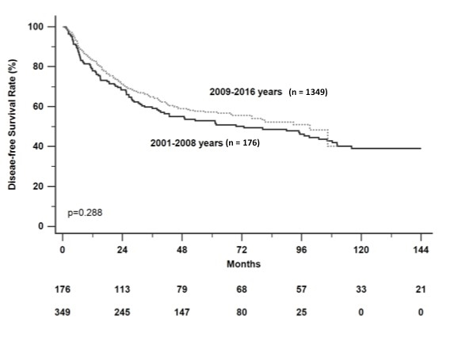
(B)
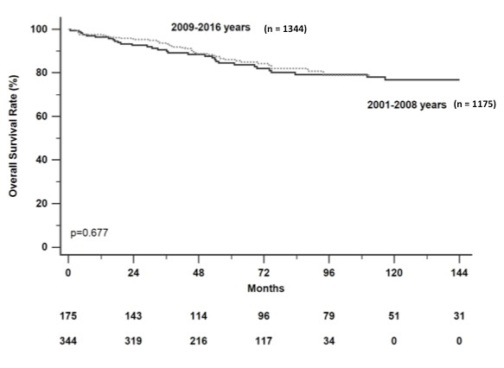

Figure S2: The distribution of pre- operation Child-Pugh score and pre-operation ALBI score

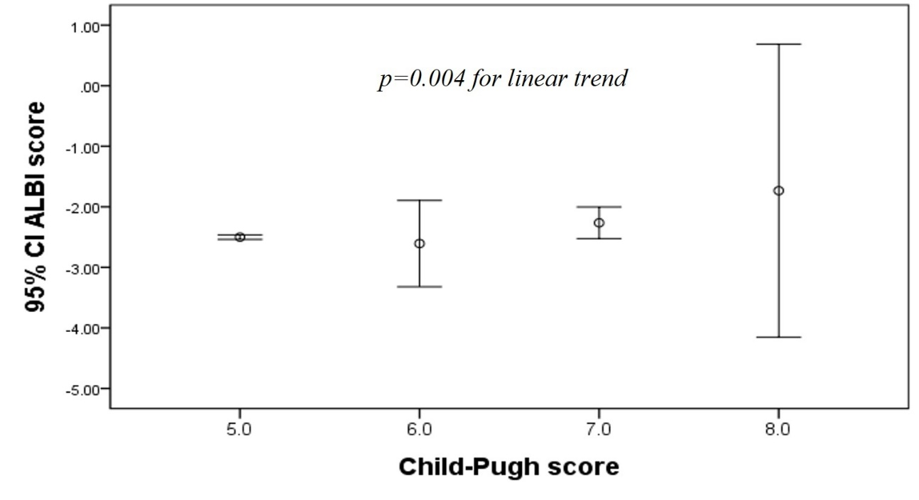

The mean ALBI score increases with higher Child Pugh score (p=0.004 for linear trend). Error bars indicate standard deviation.

Figure S3: Recurrence-free survival (A) and liver-related survival (B) in HCC patients with different anti-HBV therapy after curative resection according to the operation year
(A)
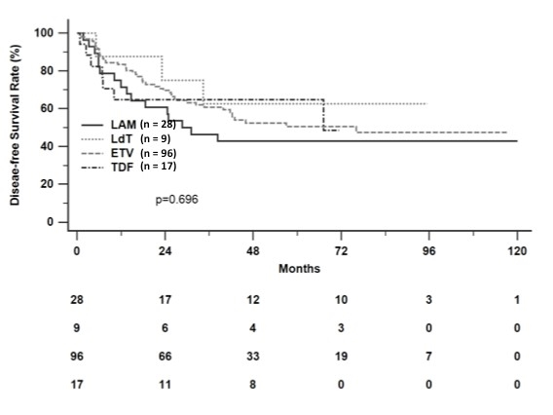

(B)
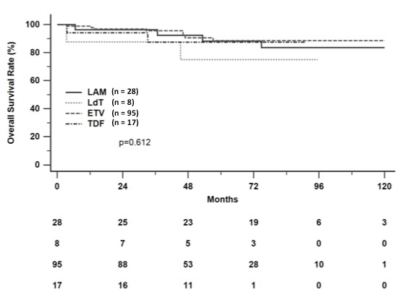
LAM = lamivudine, LdT = telbivudine, ETV = entecavir, TDF = tenofovir
Figure S4: The association between ALBI grade at recurrence and the treatment strategies for recurrence
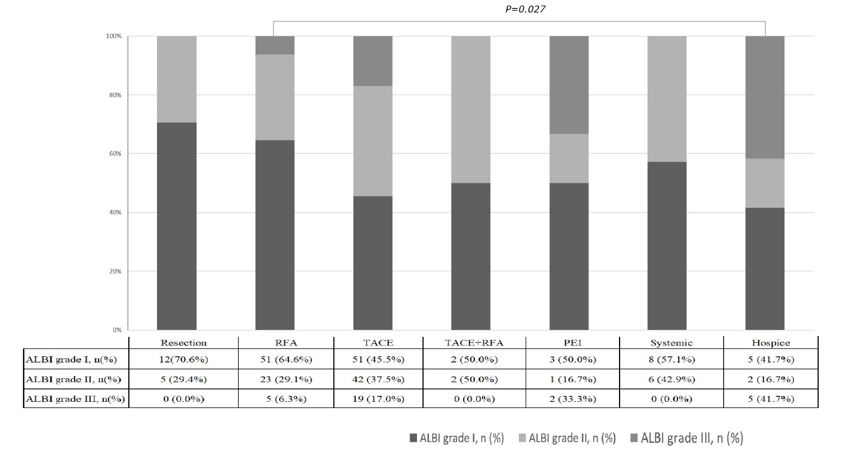
RFA = Radiofrequency ablation, TACE= Trans-arterial chemoembolization, PEI= Percutaneous ethanol injection, ALBI = albumin-bilirubin.
Treatment plans are associated with the different ALBI grades at recurrence. The RFA group has lower percentage of ALBI grade III than in hospice.( p=0.027)
Chi square test and Donferroni correction for multiple comparison.

Figure S5: Kaplan-Meier curves by treatment for recurrences
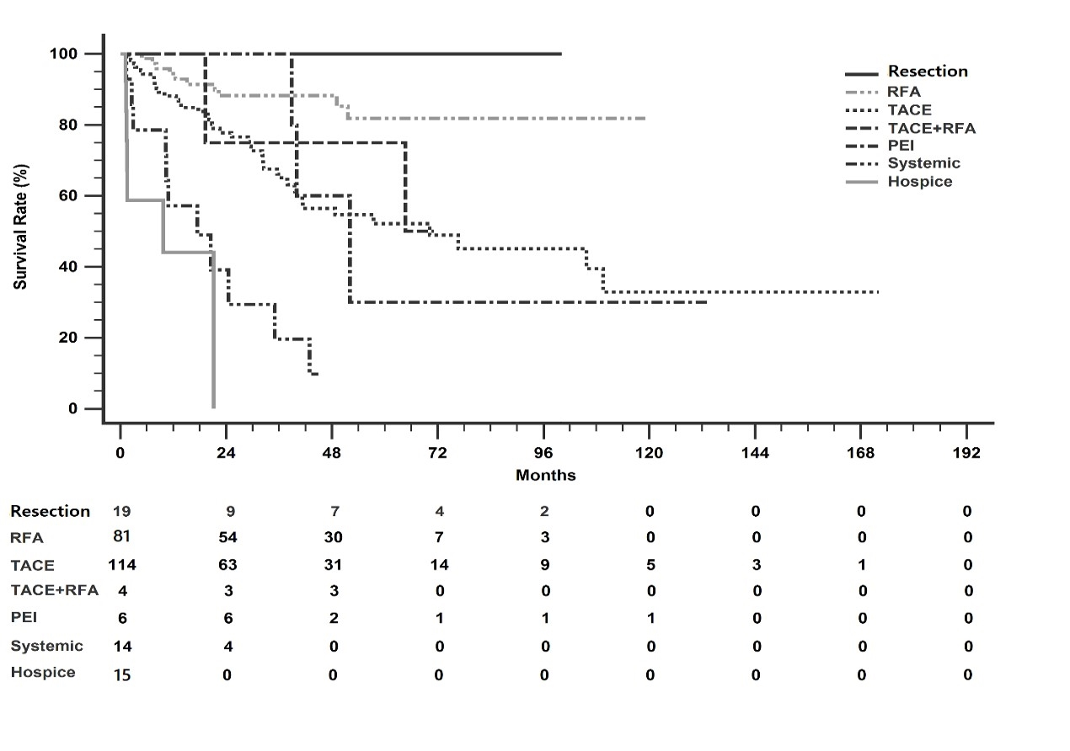
Table S1: P value between treatment at recurrence
 | Resection | RFA | TACE | TACE/RFA | PEI | Systemic
RFA | ns
TACE | 0.008 | <0.001
TACE/RFA | 0.043 | ns | ns
PEI | 0.014 | ns | ns | ns
Systemic | <0.001 | <0.001 | <0.001 | 0.045 | 0.013
Hospice | <0.001 | <0.001 | <0.001 | ns | 0.007 | ns
RFA = Radiofrequency ablation, TACE= Trans-arterial chemoembolization, PEI= Percutaneous ethanol injection, ALBI = albumin-bilirubin. p>0.05, ns
Treatment with resection or RFA when recurrence have better survival than systemic therapy or hospice care. (p<0.001)

Table S2: The correlations between pre-OP serum albumin levels and pre-OP ALBI score, and post-OP 1 year ALBI score and post-OP 1 year serum albumin levels
Spearman’s correlation coefficient | pre-OP albumin | pre-OP ALBI score | post-OP albumin | post-OP ALBI score
pre-OP albumin | 1 | -0.969** | 0.112 | -0.114
pre-OP ALBI score |  | 1 | -0.108 | 0.142*
post-OP albumin |  |  | 1 | -0.938**
post-OP ALBI score |  |  |  | 1
The inverse correlation between pre-operation albumin and pre-operation ALBI score, post-operation albumin and post-operation ALBI score are significant (p<0.001). Spearman’s correlation coefficient. Statistical significance indicated by * (p < 0.05), **(p < 0.001)

Table S3 Association between pre- and post-operative ALBI grades
 |  | Pre-OP ALBI Grade I | Pre-OP ALBI Grade II | Total
Post-operative first year | ALBI Grade I | 80 (76.2%) | 89 (69.0%) | 169 (72.2%)
 | ALBI Grade II | 24 (22.9%) | 37 (28.7%) | 61 (26.0%)
 | ALBI Grade III | 1 (1.0%) | 3 (2.3%) | 4 (1.3%)
 |  | 105 | 129 | 234

