Supplementary Information
Controlling Electronic States of Few-walled Carbon Nanotube Yarn via Joule-annealing and p-type Doping Towards Large Thermoelectric Power Factor
May Thu Zar Myint^{a,b}, Takeshi Nishikawaª, Kazuki Omotoª, Hirotaka Inoueª, Yoshifumi Yamashitaª, Aung Ko Ko Kyaw^{c}*,Yasuhiko Hayashiª*

ª Graduate School of Natural Science and Technology, Okayama University, Okayama, 700-8530, Japan.
^{b} Faculty of Advanced Materials Engineering, University of Technology (Yatanarpon Cyber City), Pyin Oo Lwin District, Mandalay Division, Myanmar.
^{c} Department of Electrical and Electronic Engineering, Southern University of Science and Technology, Shenzhen 518055, P. R. China.
E-mail: hayashi.yasuhiko@okayama-u.ac.jp and aung@sustech.edu.cn

Contents
Figures
Figure S1: SEM images of pristine, Joule-annealed and Joule-annealed followed by F4TCNQ doped CNT yarn.
Figure S2: Fitted curves of the temperature dependence Seebeck coefficient for pristine, Joule-annealed and Joule-annealed followed by F4TCNQ doped CNT yarn.
Figure S3: Relationship between the amount of joule-annealing and the intensity of 2D band to G band.
Figure S4: Possible mechanism of morphology-change after Joule-annealing and doping.
Figure S5: Raman spectrum of F4TCNQ.
Figure S6: TEM images of pristine, Joule-annealed and Joule-annealed followed by
F4TCNQ doped CNT yarn.
Figure S7: TGA analysis of the CNT yarn before and after Joule-annealing.

Tables
Table S1: The values of the intensity ratio of I_{G}/I_{D} and I_{2D}/I_{G}.

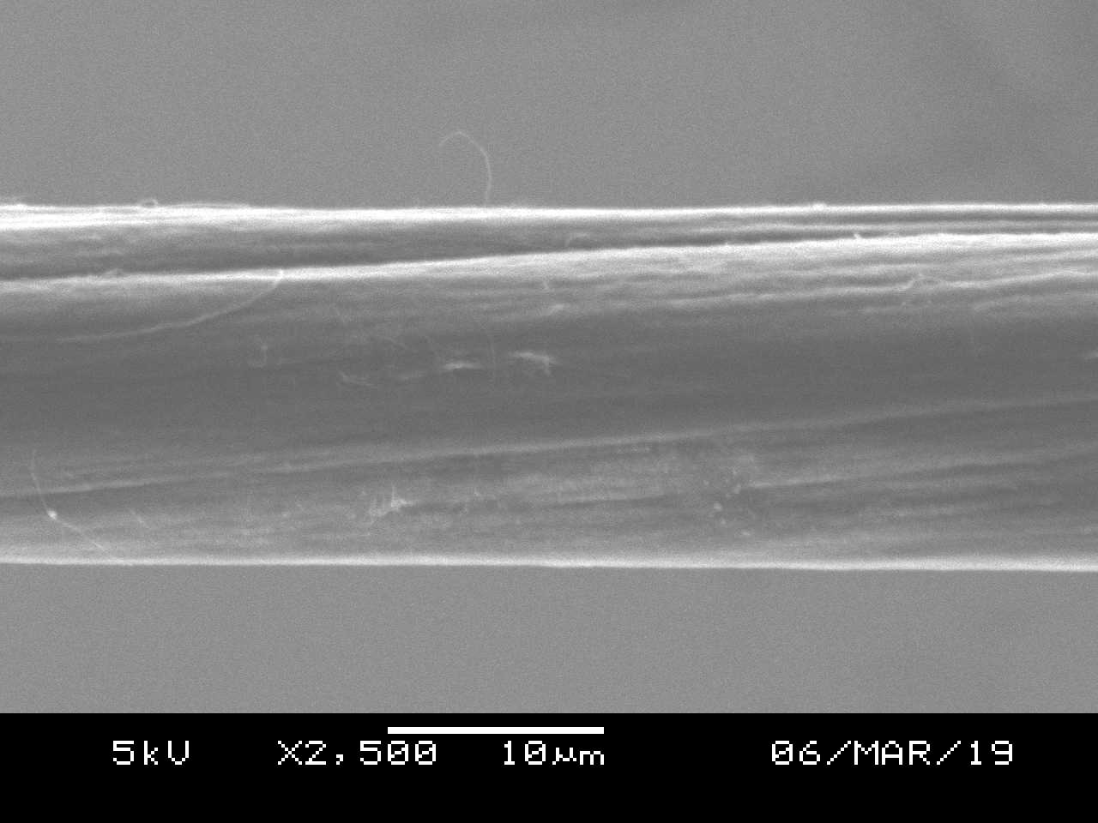
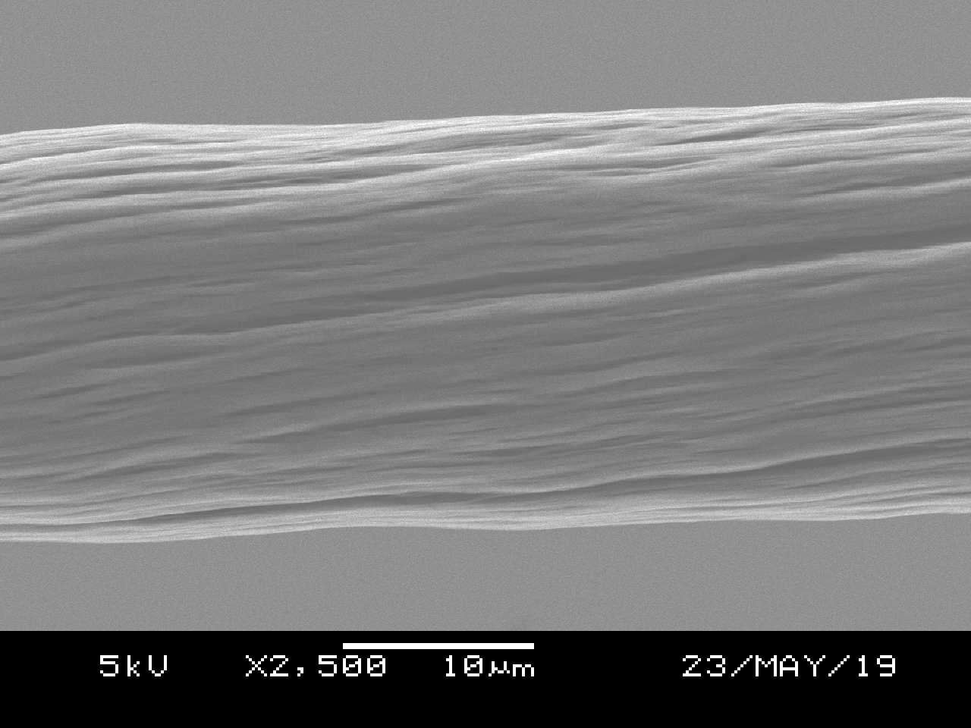
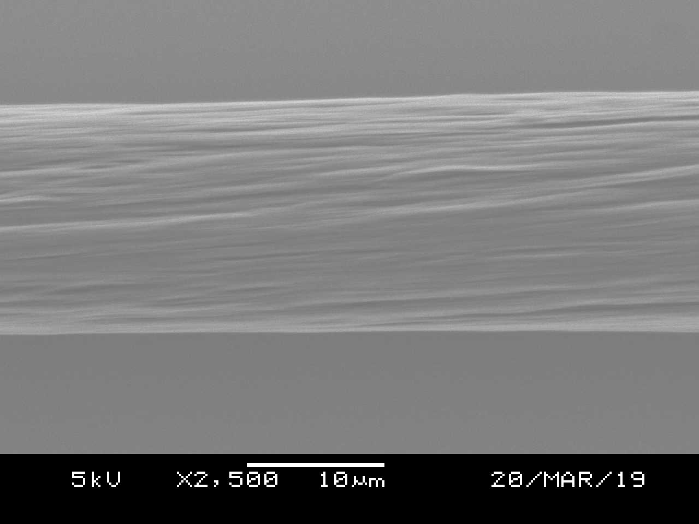
Pristine
(a)
Joule-annealing
(b)
2.5 mg/ml F4TCNQ doped
(c)
10 mg/ml F4TCNQ doped
(d)
Figure S1: SEM images of (a) pristine, (b) Joule-annealed, (c) Joule-annealed followed by 2.5 mg/ml F4TCNQ doped, and (d) Joule-annealed followed by 10 mg/ml F4TCNQ doped FWCNT yarns.

Table S1: The values of the intensity ratio of IG/ID and I2D/IG.
Joule Heat (W) | I_{G}/I_{D} | I_{2D}/I_{G}
0 (pristine) | 1 | 0.3
1 | 1.6 | 0.5
2 | 5 | 0.5
3 | 11.2 | 0.5
3.4 | 15.7 | 0.4
4 | 17.8 | 0.7

Figure S2: Fitted curves of the temperature dependent Seebeck coefficient for (a) pristine, (b) Joule-annealed and (c) Joule-annealing followed by F4TCNQ doped FWCNT yarns.
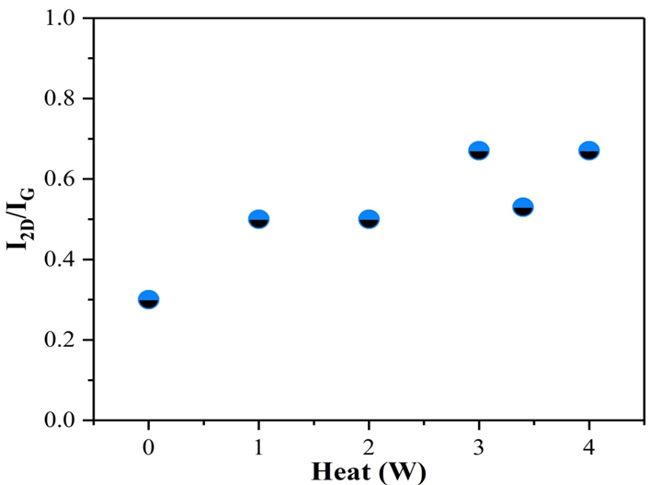

Figure S3: Relationship between the amount of joule-annealing and the intensity of 2D band to G band in Raman spectroscopy, indication of the formation of multi-layered graphene structure on the surface of FWCNT yarn.

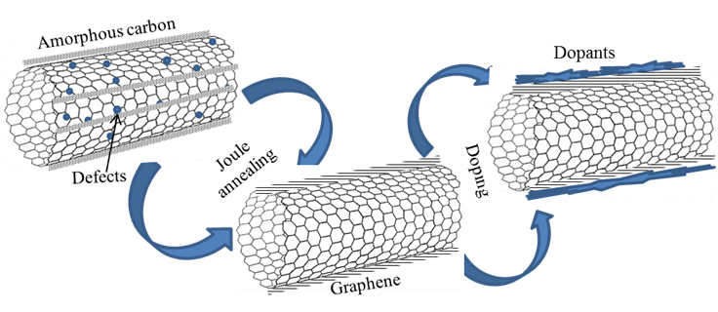

Figure S4: Possible mechanism of morphology-change after Joule-annealing and doping.

Figure S5: Raman spectrum of F4TCNQ.

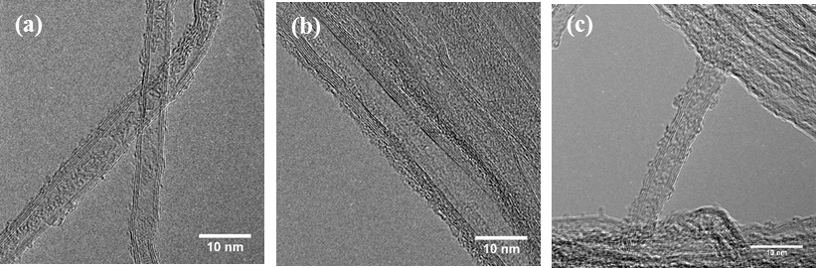

Figure S6: TEM images of (a) pristine, (b) Joule-annealed, and (c) Joule-annealing followed by 2.5 mg/ml F4TCNQ doped FWCNT yarns.

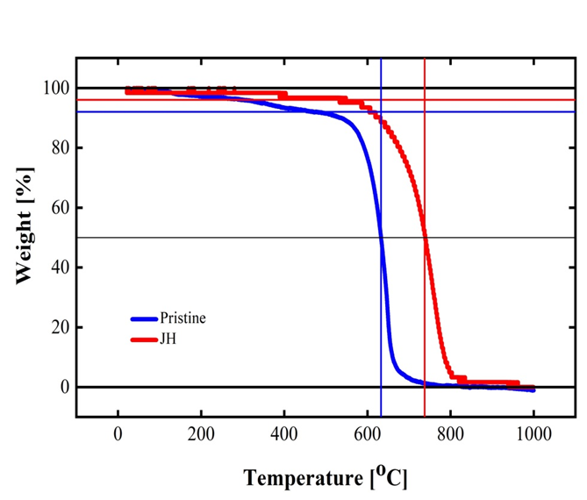

Figure S7: TGA analysis of the FWCNT yarn before and after Joule-annealing.

