Supplementary information
AN EX VIVO BRAIN SLICE CULTURE MODEL OF CHRONIC WASTING DISEASE: IMPLICATIONS FOR DISEASE PATHOGENESIS AND THERAPEUTIC DEVELOPMENT

Naveen Kondru,¹ Sireesha Manne,¹ Robyn Kokemuller,^{1,2} Justin Greenlee,² M. Heather West Greenlee,¹ Tracy Nichols,³ Qingzhong Kong,⁴ Vellareddy Anantharam,¹ Arthi Kanthasamy,¹ Patrick Halbur,^{1,5} and Anumantha G. Kanthasamy^{1*}

¹Department of Biomedical Sciences, College of Veterinary Medicine, Iowa State University, Ames, IA, USA.
²Virus and Prion Research Unit, National Animal Disease Center, Agricultural Research Service, United States Department of Agriculture, Ames, IA, USA.
³Surveillance, Preparedness and Response Services, Veterinary Services, United States Department of Agriculture, Fort Collins, CO, USA.
⁴Departments of Pathology and Neurology, Case Western Reserve University, Cleveland, OH, USA.
⁵Veterinary Diagnostic and Production Animal Medicine, College of Veterinary Medicine, Iowa State University, Ames, IA, USA.
*Correspondence to: akanthas@iastate.edu

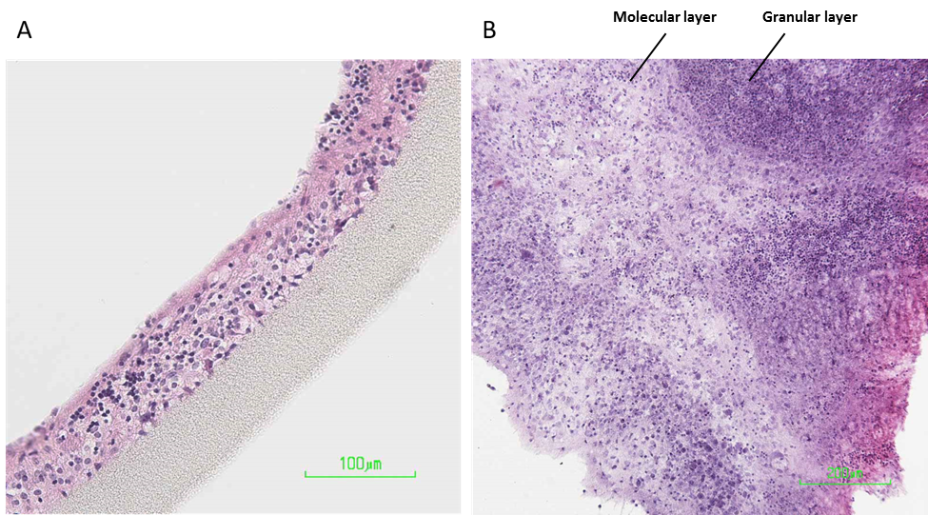
Supplementary Fig. 1. H&E staining of the cerebellar brain slices that were cultured for 42 days prior to paraffin embedding and sectioning to visualize the cellular architecture. Slices were sectioned both (A) perpendicular to the membrane and (B) parallel to membrane.

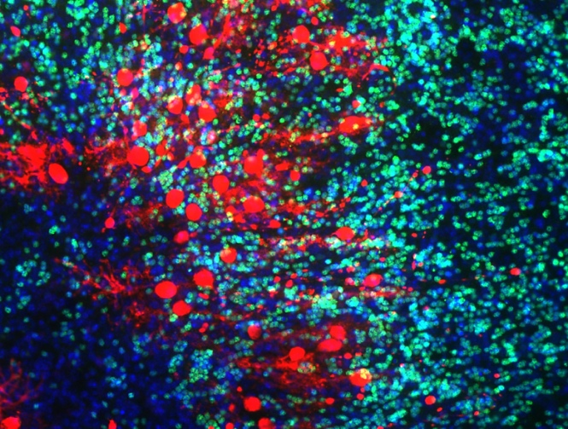
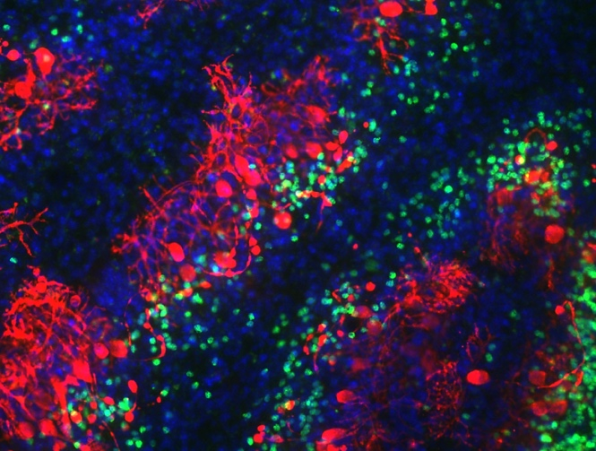
NBH
CWD
NeuN Calbindin Hoechst
A
B

Supplementary Fig. 2. Immunohistochemistry of the cerebellar slices that were cultured for 42 days prior to fixation and staining. The slices were stained for neurons (NeuN antibody, Green) and purkinje cells (Calbindin, Red), and nuclei were counterstained with (Hoechst, blue).

