Supplementary Information

Formulation of Sugar/Hydrogel Inks for Rapid Thermal Response 4D Architectures with Sugar-Derived Macropores

Hyojin Ko¹, Monica Cahyaning Ratri^{1,2}, Kihoon Kim¹, Yeongheon Jung¹, Giyoong Tae³, and Kwanwoo Shin^{1,*}

¹Department of Chemistry and Institute of Biological Interfaces, Sogang University, Seoul 04107, Republic of Korea
²Department of Chemistry Education, Sanata Dharma University, Yogyakarta 55281, Republic of Indonesia
³School of Materials Science and Engineering, Gwangju Institute of Science and Technology, Gwangju 61005, Republic of Korea

Movie S1. Video of a programmed, reshaping hydrogel architecture.

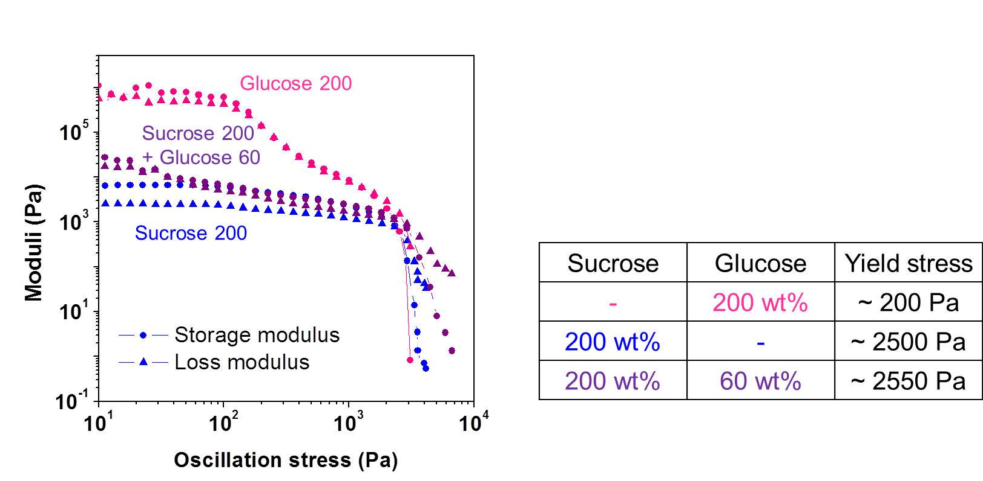
Figure S1. Storage and loss moduli as functions of the oscillation stress for inks with different sucrose and glucose concentrations.

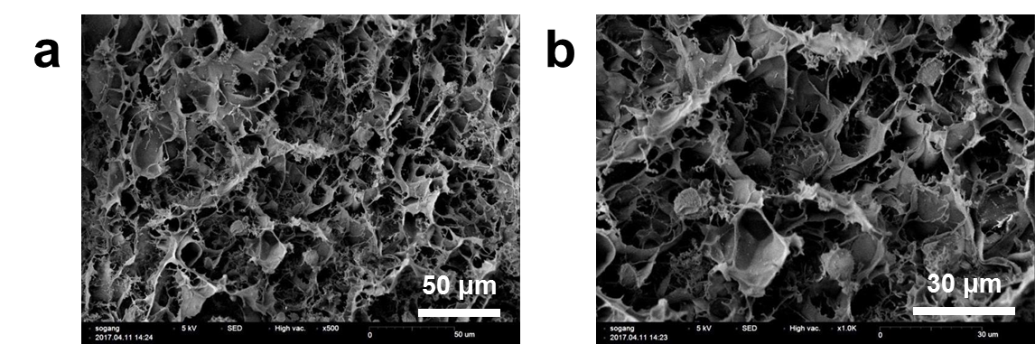

Figure S2. (a) SEM image of 3-M PNIPAAm hydrogels with 200 wt% of sucrose. (b) A higher-magnification view of the image in (a).

