Supplement to:
Sex- and age-specific variations, temporal trends and metabolic determinants of serum uric acid concentrations in a large population-based Austrian cohort
Emanuel Zitt,^{1,2,3} Anton Fischer,^{1,3} Karl Lhotta,^{1,2} Hans Concin,³ Gabriele Nagel^{3,4}

¹Vorarlberg Institute for Vascular Investigation and Treatment (VIVIT), Academic Teaching Hospital Feldkirch, Feldkirch, Austria
²Department of Internal Medicine III (Nephrology and Dialysis), Academic Teaching Hospital Feldkirch, Feldkirch, Austria
³Agency for Preventive and Social Medicine, Bregenz, Austria
⁴Institute for Epidemiology and Medical Biometry, Ulm University, Ulm, Germany

Supplementary Table 1:
Pearson correlations between metabolic factors at baseline

Supplementary Figure 1: Distribution of the serum uric acid concentration in participants aged 50 years and older (men n=33,861 and women n= 22,684)

Supplementary Figure 2:
Sex-specific mean serum uric acid concentration and 95% confidence interval according to time period, adjusted for age including repeated measurements in men (n= 306.983) and women (n= 223.738)

Supplementary Table 1: Pearson correlations between metabolic factors in a) women (N=61,662) and b) men (N=85,211) at baseline

- women

Pearson correlation coefficients
prob > |r| under H0: Rho = 0
Number of Observations
 | Age baseline  [years] | BMI  [kg/m²] | Blood glucose  [mmol/L] | Total cholesterol  [mmol/L] | Triglycerides  [mmol/L] | Gamma-GT  [U/L] | Serum uric acid  [µmol/L]
Age baseline  [years] | 1.00000  61662 | 0.21288  <.0001  61644 | 0.29959  <.0001  61158 | 0.39494  <.0001  61644 | 0.21115  <.0001  61630 | 0.10530  <.0001  61615 | 0.22761  <.0001  61662
BMI  [kg/m²] |  | 1.00000  61644 | 0.19593  <.0001  61140 | 0.12655  <.0001  61626 | 0.26818  <.0001  61612 | 0.11177  <.0001  61597 | 0.30709  <.0001  61644
Blood glucose  [mmol/] |  |  | 1.00000  61158 | 0.18689  <.0001  61142 | 0.22861  <.0001  61127 | 0.11649  <.0001  61113 | 0.11484  <.0001  61158
Total cholesterol  [mmol/L] |  |  |  | 1.00000  61644 | 0.35846  <.0001  61621 | 0.10746  <.0001  61605 | 0.16589  <.0001  61644
Triglycerides  [mmol/L] |  |  |  |  | 1.00000  61630 | 0.19213  <.0001  61593 | 0.27557  <.0001  61630
Gamma-GT  [U/L] |  |  |  |  |  | 1.00000  61615 | 0.16407  <.0001  61615
Serum uric acid  [µmol/L] |  |  |  |  |  |  | 1.00000  61662

- men

Pearson correlation coefficients
prob > |r| under H0: Rho = 0
Number of Observations
 | Age baseline  [years] | BMI  [kg/m²] | Blood glucose  [mmol/L] | Total cholesterol  [mmol/L] | Triglycerides  [mmol/L] | Gamma-GT  [U/L] | Serum uric acid  [µmol/L]
Age baseline  [years] | 1.00000  85211 | 0.24008  <.0001  85186 | 0.25769  <.0001  84617 | 0.31978  <.0001  85182 | 0.10967  <.0001  85131 | 0.11948  <.0001  85146 | 0.06207  <.0001  85211
BMI  [kg/m²] |  | 1.00000  85186 | 0.16277  <.0001  84592 | 0.23663  <.0001  85157 | 0.27895  <.0001  85106 | 0.14610  <.0001  85121 | 0.25213  <.0001  85186
Blood glucose  [mmol/] |  |  | 1.00000  84617 | 0.17899  <.0001  84589 | 0.16037  <.0001  84545 | 0.12117  <.0001  84555 | 0.00228  0.5073  84617
Total cholesterol  [mmol/L] |  |  |  | 1.00000  85182 | 0.39374  <.0001  85116 | 0.18815  <.0001  85126 | 0.18917  <.0001  85182
Triglycerides  [mmol/L] |  |  |  |  | 1.00000  85131 | 0.25537  <.0001  85086 | 0.23553  <.0001  85131
Gamma-GT  [U/L] |  |  |  |  |  | 1.00000  85146 | 0.18458  <.0001  85146
Serum uric acid  [µmol/L] |  |  |  |  |  |  | 1.00000  85211

Supplementary Figure 1: Distribution of the serum uric acid concentration in participants aged 50 years and older (men n=33,861 and women n= 22,684)

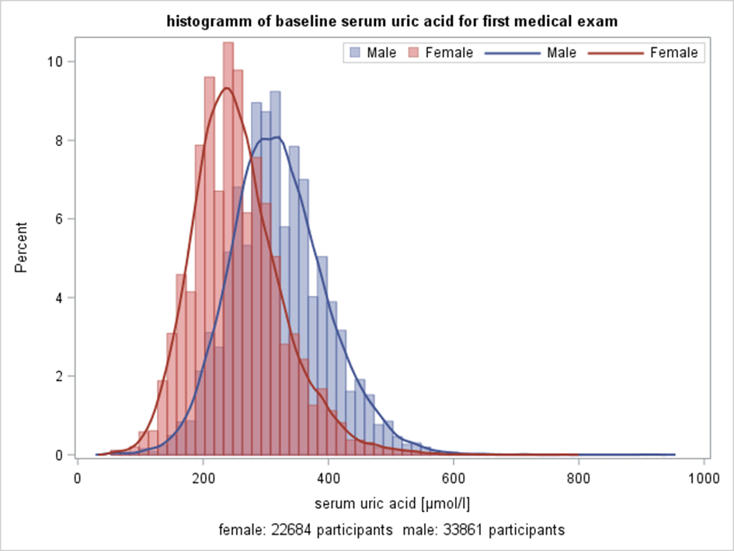

Supplementary Figure 2: Sex-specific mean serum uric acid concentration and 95% confidence interval according to time period, adjusted for age including repeated measurements in men (n= 306.983) and women (n= 223.738)

