Supporting Information for
Middle Miocene long-term continental temperature change in and out of pace with marine climate records

Methner, Katharina^{1,a}; Campani, Marion¹; Fiebig, Jens²; Löffler, Niklas^{1,2}; Kempf, Oliver³; Mulch, Andreas^{1,2}

¹Senckenberg Biodiversity and Climate Research Centre (BiK-F)
Senckenberganlage 25
60325 Frankfurt/Main, Germany

²Institut für Geowissenschaften
Goethe-Universität
Altenhöferallee 1
60438 Frankfurt/Main, Germany

³Bundesamt für Landestopografie swisstopo,
Geologische Landesaufnahme
Seftigenstr. 264
3084 Wabern, Switzerland

ªCorresponding Author:
Katharina Methner
Senckenberg Biodiversity and Climate Research Centre (BiK-F)
Senckenberganlage 25
60325 Frankfurt/Main
0049 69 7542 1815
katharina.methner@senckenberg.de

Contents of this file
  - Text SI1
  - Figure SI1
  - Tables SI1 to S5
The supplementary information comprises text document S1, which describes the analytical procedure of stable isotope (δ¹⁸O, δ¹³C) and clumped isotope (Δ₄₇) analyses and the calculation of oxygen isotopic compositions of water (δ¹⁸O_{water}). It further contains an additional figure (stable isotope data, published in Campani et al. 2012) and 5 data tables (separate file). These tables contain the sample and age information, the analytical results of stable isotope (Tab. SI1) and of clumped isotope analyses (Tab. SI2 – SI5)..
SI1. Analytical procedure
1.1. Stable isotope analyses
High-resolution oxygen and carbon isotope analyses of carbonates were performed at Leibniz Universität Hannover, Germany and data were presented in Campani et al. (2012). Carbonate sample powders were drilled using a low speed dental drill. 0.2 mg to 1.0 mg of carbonate powder were digested with phosphoric acid at 72 °C in a sealed reaction vessel and flushed with helium gas. The evolved CO₂ was sampled by a Thermo Scientific GasBench II and isotope ratios were measured on a Thermo Electron delta V advantage mass spectrometer. International and in-house standards were run in-line with the samples. NBS 19 yielded an average of δ¹⁸O = 28.60‰ (n = 34); the average uncertainty was ±0.2‰. All isotopic results are reported in standard delta notation and corrected to VSMOW (δ¹⁸O) or VPDB (δ¹³C) (Tab. SI1).
1.2. Clumped isotope analyses
Clumped isotope thermometry allows determination of carbonate formation temperatures. In equilibrium, the abundance of CO₂ isotopologues containing bonds between heavy isotopes of oxygen and carbon is purely temperature-dependent. C-O bond abundances are thereby expressed as the Δ₄₇ value, which mainly describes the difference of the abundance of the ¹³C¹⁸O¹⁶O-isotopologue of the sample gas (R⁴⁷, R⁴⁶, R⁴⁵) from the theoretical stochastic distribution of the gas (R^{47*}, R^{46*}, R^{45*}) with the same bulk isotopic composition (Eiler (2007, 2011) and ref. therein):
Δ₄₇ = ((R⁴⁷/ R^{47*} - 1) – (R⁴⁶/ R^{46*} - 1) - (R⁴⁵/ R^{45*} - 1)) * 1000 (‰) (ii)
with R^{i} = mass i / mass 44.
Carbonate powder (6-15 mg) was digested in >106% phosphoric acid at 90°C ± 0.1°C for 30 minutes. For carbonate digestion we used an automated acid bath as described in (Wacker et al., 2013) and (Fiebig et al., 2016). The CO₂ cleaning procedure and measurements follow (Bajnai et al., 2018; Wacker et al., 2013, 2014). Briefly, the produced CO₂ was purified by passing it through cryogenic traps (-80°C) before and after passage through a Porapak Q-packed gas chromatography column (-15°C) to remove traces of hydrocarbons. The cleaned CO₂ was measured on a Thermo ScientificMAT 253 gas source isotope ratio mass spectrometer dedicated to the measurements of masses 44 to 49 at the joint Goethe University – Senckenbrg BiK-F Stable Isotope Facility at the Institute of Geosciences, Goethe University Frankfurt. Each measurement included ten acquisitions (consisting of ten cycles each with an ion integration time of 20 s).
CO₂ equilibrated at 1000°C and 25°C were measured along with the samples to monitor the non-linearity of the mass spectrometer and the extent of scale compression (Tab. SI2). For samples analyzed prior to 2015, non-linearity was corrected using the heated gas approach of (Huntington et al., 2009). For samples analyzed in 2016/2017, measured m/z 47 intensities were directly corrected for the contribution of secondary electrons to m/z 47 after scaling the negative backgound on m/z 47 to the measured m/z 49 intensity (Fiebig et al., 2016). All data is reported in the CDES (Carbon Dioxide Equilibrium Scale) as proposed by Dennis et al. (2011). For this purpose, the theoretical 25°C-90°C acid fractionation factor of +0.069‰ (Guo et al., 2009) was applied. All data was processed using the Gonfiantini set of isotopic parameters (¹³R_{PDB} = 0.0112372, ¹⁸R_{VSMOW} = 0.0020052, ¹⁷R_{VSMOW} = 0.0003799 and λ = 0.5164).
Temperatures are calculated using the calibration of Wacker et al. (2014):
Δ₄₇ = 0.0327 (±0.0026) * 10⁶/T² + 0.3030 (±0.0308) (iii)
with Δ₄₇ in ‰ and T in K. Within the analytical error, this regression line (iii) is statistically indistinguishable from (a) the empirically determined calibration line of (Henkes et al., 2013) (after applying a consistent 25°C-90°C acid fractionation factor to both data sets) and (b) the theoretical calibration line (Guo et al., 2009) (after applying a 25°C acid fractionation factor of 0.268‰ (Passey and Henkes, 2012) to equation (18) provided by Guo et al. (2009). We refer to calibration (iii) because it has been determined at Goethe University Frankfurt under similar analytical conditions (digestion at 90°C; similar gas preparation; all measurements performed at the same mass spectrometer).
Each day 2-3 carbonate reference materials were measured (Tab. SI4). These were Carrara marble and Arctica islandica (also referred to as MuStd, a well-homogenized shell material of an aragonitic cold water bivalve), ETH 1 and ETH 3. For Arctica islandica we receive a mean Δ₄₇ value of 0.720‰ ± 0.006‰ (1 SE, n=24), indistinguishable from the 0.724‰ ±0.004‰ (1 SE, n=28) obtained by Wacker et al. (2014) during the time interval of their calibration. Carrara marble yields a mean Δ₄₇ value of 0.376‰ ±0.002‰ (1 SE, n=58). This reference material was not analyzed by Wacker et al. (2014). Its mean value, however, is indistinguishable from those reported by other labs (e.g., Bonifacie et al., 2017; Dennis et al., 2011) after applying a unique 25°C-90°C acid fractionation factor of 0.069‰ to all data.
External standard errors (SE) for 4-5 replicate measurements range from ±0.002‰ to ±0.011‰. A straightforward way to determine an error based on the mass spectrometric setup exclusively (and not on sample characteristics) is the consideration of its shot noise limit (Merritt and Hayes, 1994). SE values < ~0.0040‰ (n=4) and < ~0.0036‰ (n=5) are below the shot noise limit of our mass spectrometric setup (10 acquisitions, consisting of 10 cycles at 20 s integration time each, represent one replicate measurement) after (Merritt and Hayes, 1994). Therefore, whenever 1 SE is smaller than 0.0040‰, we provide the respective shot noise limit of the mass spectrometer which represents the minimum error of a homogeneous sample measurement based on the analytical setup.
1.3. Soil water oxygen isotopic composition
We calculated the oxygen isotopic composition of water (δ¹⁸O_{water}) from Δ₄₇ temperatures and GasBench-obtained δ¹⁸O_{carbonate} values using oxygen isotope fractionation coefficients calculated after Kim and O'Neil (1997) that was updated new acid fractionation factors of Kim et al. (2007):
1000 ln α = 18.03 (10³*T⁻¹) - 32.23 (iv)
where α is the oxygen isotope fractionation coefficient and T is the fractionation temperature in K. Note that the original intercept of -32.42 reported by Kim and O'Neil (1997) has been corrected by +0.19‰ which takes into account the difference in the 25°C acid fractionation factors of Kim et al. (2007) relative to Kim and O'Neil (1997). For clarity and to avoid temperature interpolations between sample localities, we only used calculated δ¹⁸O_{water} from those samples where we obtained clumped isotope analyses (Tab. SI5).
1.4. Extraction of climate model data from Zhou et al. (2018)
The approximate paleo-locality of the Fontannen section is at 7.5°E longitude and 44.5°N latitude at 15 Ma according to www.paleolatitute.org (lower bound 41.9° and upper bound 46.3°). We extracted climate model output from the closest grid cells of the paleogeographicla porsiotion of the Fontannen section (3x3 cells), namely, 5°, 7.5°, and 10°E and 46.4°, 44.5°, 42.6° N and for comparison 3x3 grid cells around the modern location of the section, namely, 5°, 7.5°, and 10°E and 48.3° 46.4°, 44.5°N. The extracted data include monthly 2m air temperature, ground temperatures, and the daily maximum of average 2m air temperatures as well as modelled relative humidity and soil water contents. We calculated the MAT, summer temperatures of JJA (likely closest to WMMT), winter temperatures of DJF (CMMT), the seasonal range of temperature (either warmest month vs. coldest month or JJA-DJF), and the differences between JJA temperature and MAT. This represents our suggested shift in temperature due to reorganization of rainfall patterns between the MCO and the MMCT. Results are described in the manuscript and are shown in Fig. SI3.
Figures
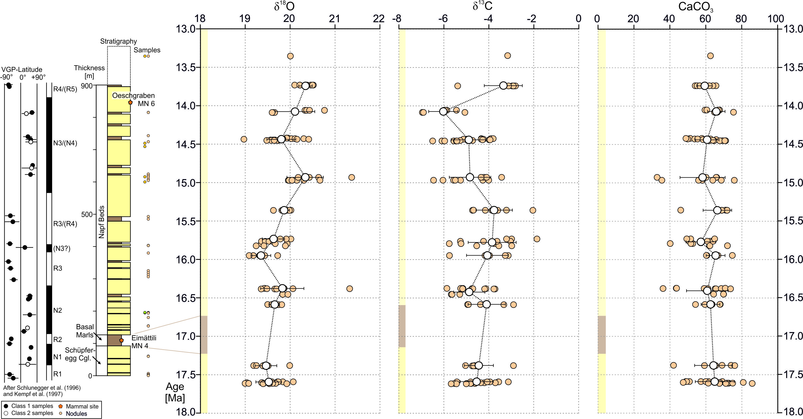
Figure SI1. Stratigraphic and paleomagnetic section (Schlunegger et al. (1996)). Age assignments are based on Kempf et al. (1997). All stable isotope data has been acquired by M. Campani (SBiK-F), δ¹⁸O data is published in Campani et al. (2012).

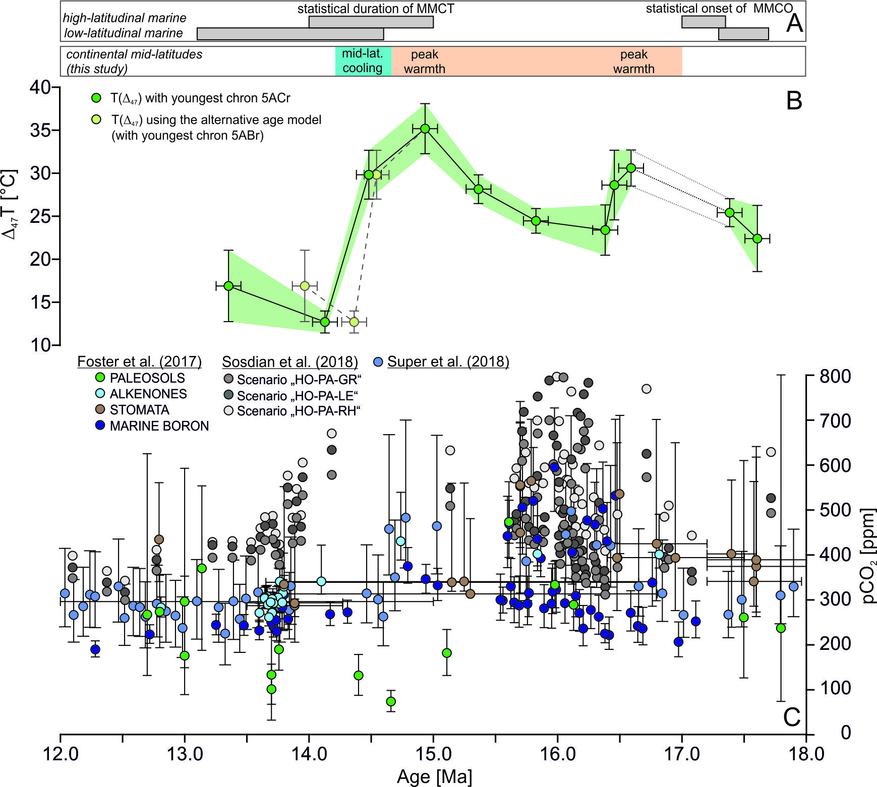
Figure SI2. (A) Age constraints of the statistical onset of the MCO start and the duration of the MMCT (Mudelsee et al. (2014)). (B+C) Comparison of terrestrial soil carbonate temperatures (T(Δ₄₇)) (B) with pCO₂ reconstructions (C), using the compilation of Foster et al. (2017) and new estimates of Super et al. (2018) and Sosdian et al. (2018). The alternative age model is indicated by the light green data in (B); ages are given in the manuscript Tab. 1.
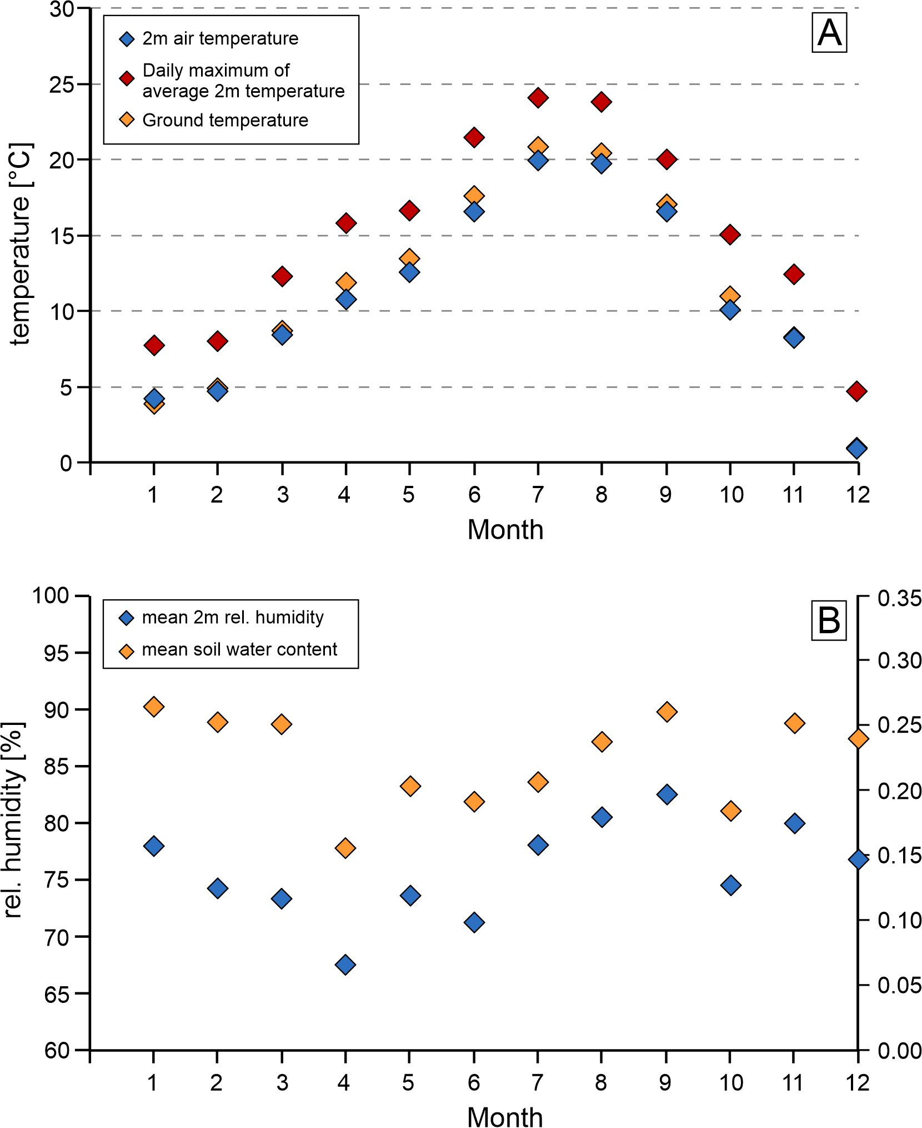
Fig. SI3. (A) Modeled temperature data including monthly 2m air temperature (blue diamonds), ground temperatures (green diamonds) and the daily maximum of average 2m air temperatures (red diamonds). (B) Modelled relative humidity (blue diamonds) and soil water (green diamonds) contents. Data from Zhou et al. (2018).

Tables (in separate file)
Table SI1. Pedogenic carbonate sample information (coordinates in Swiss coord. system, stratigraphic position, assigned ages) with GasBench oxygen (δ¹⁸O, VSMOW, ‰) and carbon (δ¹³C, VPDB, ‰) isotope ratios and calculated CaCO₃ content (%wt.). Different subsamples (e.g. MC954A to C) are nodules from the same bed. All data has been acquired by M. Campani, δ¹⁸O data is published in Campani et al. (2012).
Table SI2. Measured δ⁴⁷ and Δ₄₇ values (in ‰) of “heated gases” (equilibrated at 1000°C) and CO₂ gases equilibrated at 25 °C for the time intervals of sample measurements.
Table SI3. Empirical transfer function (ETF) applied during this study with x: background corrected Δ₄₇ value and y: Δ_{47 CDES} (CDES: Carbon dioxide equilibrium scale; Dennis et al., 2011)).
Table SI4. Measured isotopic compositions (δ⁴⁷, Δ₄₇, δ¹³C and δ¹⁸O values in ‰) of standard materials. Each day, 2-3 in-house standard materials were measured: Carrara marble, Arctica islandica ("MuStd", well-homogenized shell material of an aragonitic cold water bivalve), as well as ETH-1 and ETH-3.
Table SI5. Measured isotopic compositions (δ⁴⁷, Δ₄₇, δ¹³C and δ¹⁸O values in ‰) of pedogenic carbonate samples and calculated temperatures using the calibration of Wacker et al. (2014). Since 2014, δ⁴⁷ raw, Δ₄₇ raw values are corrected using the background correction of Fiebig et al. (2016).
References
Bajnai, D., Fiebig, J., Tomašových, A., Milner Garcia, S., Rollion-Bard, C., Raddatz, J., Löffler, N., Primo-Ramos, C. and Brand, U. (2018) Assessing kinetic fractionation in brachiopod calcite using clumped isotopes. Scientific Reports 8, 533.
Bonifacie, M., Calmels, D., Eiler, J.M., Horita, J., Chaduteau, C., Vasconcelos, C., Agrinier, P., Katz, A., Passey, B.H., Ferry, J.M. and Bourrand, J.-J. (2017) Calibration of the dolomite clumped isotope thermometer from 25 to 350 °C, and implications for a universal calibration for all (Ca, Mg, Fe)CO3 carbonates. Geochim Cosmochim Ac 200, 255-279.
Campani, M., Mulch, A., Kempf, O., Schlunegger, F. and Mancktelow, N. (2012) Miocene paleotopography of the Central Alps. Earth Planet Sc Lett 337–338, 174-185.
Dennis, K.J., Affek, H.P., Passey, B.H., Schrag, D.P. and Eiler, J.M. (2011) Defining an absolute reference frame for ‘clumped’ isotope studies of CO₂. Geochim Cosmochim Ac 75, 7117-7131.
Eiler, J.M. (2007) “Clumped-isotope” geochemistry—The study of naturally-occurring, multiply-substituted isotopologues. Earth Planet Sc Lett 262, 309-327.
Eiler, J.M. (2011) Paleoclimate reconstruction using carbonate clumped isotope thermometry. Quaternary Sci Rev 30, 3575-3588.
Fiebig, J., Hofmann, S., Löffler, N., Lüdecke, T., Methner, K. and Wacker, U. (2016) Slight pressure imbalances can affect accuracy and precision of dual inlet-based clumped isotope analysis. Isot Environ Healt S 52, 12-28.
Foster, G.L., Royer, D.L., Lunt, D.J., 2017. Future climate forcing potentially without precedent in the last 420 million years. Nature Communications 8, 14845, doi:10.1038/ncomms14845.
Guo, W., Mosenfelder, J.L., Goddard Iii, W.A. and Eiler, J.M. (2009) Isotopic fractionations associated with phosphoric acid digestion of carbonate minerals: Insights from first-principles theoretical modeling and clumped isotope measurements. Geochim Cosmochim Ac 73, 7203-7225.
Henkes, G.A., Passey, B.H., Wanamaker Jr, A.D., Grossman, E.L., Ambrose Jr, W.G. and Carroll, M.L. (2013) Carbonate clumped isotope compositions of modern marine mollusk and brachiopod shells. Geochim Cosmochim Ac 106, 307-325.
Huntington, K.W., Eiler, J.M., Affek, H.P., Guo, W., Bonifacie, M., Yeung, L.Y., Thiagarajan, N., Passey, B., Tripati, A., Daëron, M. and Came, R. (2009) Methods and limitations of ‘clumped’ CO₂ isotope (Δ₄₇) analysis by gas-source isotope ratio mass spectrometry. Journal of Mass Spectrometry 44, 1318-1329.
Kempf, O., Bolliger, T., Kälin, D., Engesser, B. and Matter, A. (1997) New magnetostratigraphic calibration of Early to Middle Miocene mammal biozones of the North Alpine foreland basin. Mémoires et travaux de l'Institut de Montpellier, 547-561.
Kim, S.-T., Mucci, A. and Taylor, B.E. (2007) Phosphoric acid fractionation factors for calcite and aragonite between 25 and 75 C: revisited. Chem Geol 246, 135-146.
Kim, S.-T. and O'Neil, J.R. (1997) Equilibrium and nonequilibrium oxygen isotope effects in synthetic carbonates. Geochim Cosmochim Ac 61, 3461-3475.
Merritt, D.A. and Hayes, J.M. (1994) Factors Controlling Precision and Accuracy in Isotope-Ratio-Monitoring Mass Spectrometry. Anal Chem 66, 2336-2347.
Mudelsee, M., Bickert, T., Lear, C.H., Lohmann, G., 2014. Cenozoic climate changes: A review based on time series analysis of marine benthic δ18O records. Rev Geophys 52(3), 333-374, doi:10.1002/2013RG000440.
Passey, B.H., Henkes, G.A., 2012. Carbonate clumped isotope bond reordering and geospeedometry. Earth Planet Sc Lett 351–352, 223-236, doi:10.1016/j.epsl.2012.07.021.
Schlunegger, F., Burbank, D., Matter, A., Engesser, B., Modden, C., 1996. Magnetostratigraphic calibration of the Oligocence to Middle Miocene (30-15 Ma) mammal biozones and depositional sequences of the Swiss Molasse basin. Eclogae Geologicae Helvetiae 89(2), 753-788, doi:10.5169/seals-167923.
Sosdian, S.M., Greenop, R., Hain, M.P., Foster, G.L., Pearson, P.N., Lear, C.H., 2018. Constraining the evolution of Neogene ocean carbonate chemistry using the boron isotope pH proxy. Earth Planet Sc Lett 498, 362-376, doi:10.1016/j.epsl.2018.06.017.
Super, J.R., Thomas, E., Pagani, M., Huber, M., O’Brien, C., Pincelli, M.H., 2018. North Atlantic temperature and pCO2 coupling in the early-middle Miocene. Geology 46(6), 519-522, doi:10.1130/G40228.1.
Wacker, U., Fiebig, J. and Schoene, B.R. (2013) Clumped isotope analysis of carbonates: comparison of two different acid digestion techniques. Rapid Communications in Mass Spectrometry 27, 1631-1642.
Wacker, U., Fiebig, J., Tödter, J., Schöne, B.R., Bahr, A., Friedrich, O., Tütken, T., Gischler, E. and Joachimski, M.M. (2014) Empirical calibration of the clumped isotope paleothermometer using calcites of various origins. Geochim Cosmochim Ac 141, 127-144.
Zhou, H., Helliker, B.R., Huber, M., Dicks, A., Akçay, E. (2018) C4 photosynthesis and climate through the lens of optimality. Proceedings of the National Academy of Sciences 115, 12057-12062, doi:10.1073/pnas.1718988115.

