Circulating and tumor-infiltrating arginase1-expressing cells in gastric adenocarcinoma patients were mainly immature and monocytic Myeloid-derived suppressor cells
WeiHong Ren¹*, XuRan Zhang¹, WenBo Li¹, Qian Feng¹, HuiJie Feng¹, Yan Tong¹, Hao Rong¹, Wei Wang¹, Dai Zhang¹, ZhenQiang Zhang² and ShiChun Tu³
Supplementary Figure 1. Isotype control chart for figure 2
Immune cells were labeled with isotype fluorescent antibodies (mouse IgG1-FITC/mouse IgG2b-PE/mouse IgG1-APC/rat IgG2b APC-CY7/mouse IgG2a-PerCP-Cy5.5/mouse IgM-PE-CY7) (BD Biosciences) respectively. The cells were gated based on isotype control, the count of positive cells < 0.2% by flow cytometry. As shown in supplementary figure 1, the panel of SSC-HLA-DR-isotype(a), HLA-DR-Arg1-isotype(b), CD11b-Arg1-isotype(c), CD14-Arg1-isotype(d), CD33-Arg1-isotype(e) and CD15-Arg1-isotype(f).
Supplementary Figure 2. Full length blots for figure 4
(a) The relative expression levels of ARG1 and NOS2 in the circulating HLA-DR^{-/low} mononuclear cells (n=20). (b) The relative expression levels of ARG1 and NOS2 in the tumor-infiltrating HLA-DR^{-/low} mononuclear cells (n=6). Abbreviations: GC-PB, gastric cancer-periferal blood; HD-PB, healthy donor-periferal blood. GC-T, gastric cancer-tissue; PC-T, para-carcinoma-tissues. Data in A and B are the representative of three independent experiments.
Supplementary Table 1. Backgrounds of gastric cancer patients and volunters
20 peripheral blood samples was collected from gastric adenocarcinoma patients prior to surgery, Simultaneously, 20 volunter’s samples was collected. backgrounds of Patients and volunteers were described in Supplemental Table1.

Supplementary Fig 1

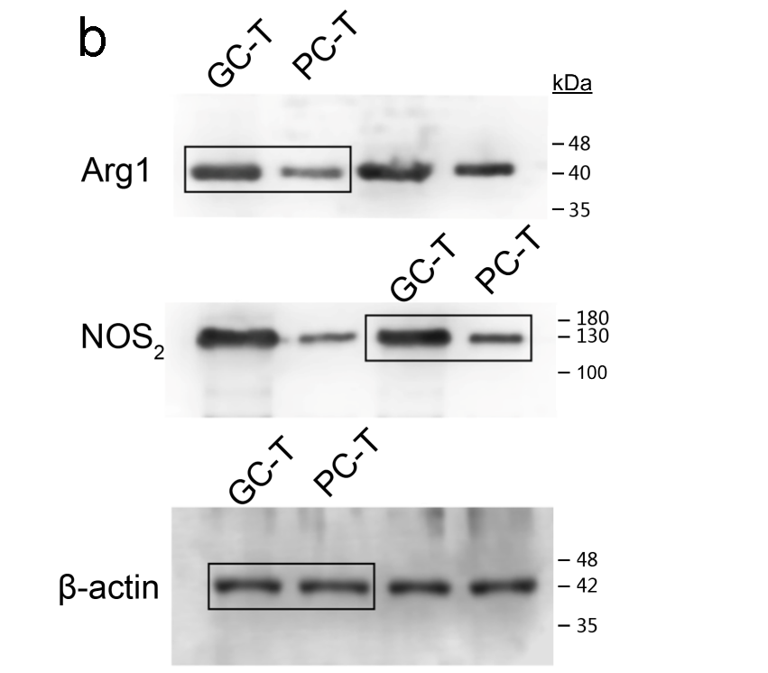
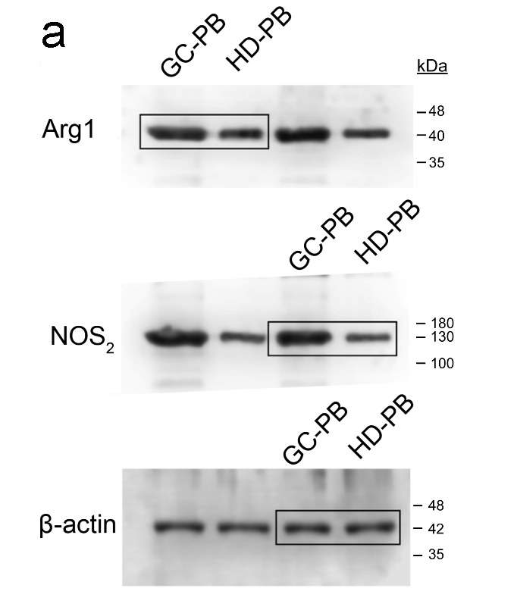
Supplementary Fig 2

Supplementary Table1
Backgrounds of gastric cancer patients and volunters
Clinical parameters patients set (n = 20) volunters set (n = 20)
Age (years)
<30 1 1
>30 and <60 8 8
>60 11 11
Male 14 14
Female 6 6

