Supplementary Information

Extracellular vesicles produced by human and animal Staphylococcus aureus strains share a highly conserved core proteome

Natayme Rocha Tartaglia^{1,2}, Aurélie Nicolas¹, Vinícius de Rezende Rodovalho^{1,2}, Brenda Silva Rosa da Luz^{1,2}, Valérie Briard-Bion¹, Zuzana Krupova³, Anne Thierry¹, François Coste⁴, Agnes Burel⁵, Patrice Martin⁶, Julien Jardin¹, Vasco Azevedo², Yves Le Loir¹, Eric Guedon^{1,*}

¹ INRAE, Agrocampus Ouest, STLO, F-35000, Rennes, France

² Federal University of Minas Gerais, Belo Horizonte, MG, Brazil

³ Excilone, F-78990, Elancourt, France
⁴ Univ Rennes, Inria, CNRS, IRISA, Rennes, France
⁵ Univ Rennes, CNRS, Inserm, BIOSIT - UMS 3480, US_S 018, F-35000 Rennes, France
⁶ INRAE, Université Paris-Saclay, AgroParisTech, UMR GABI, F-78350, Jouy-en-Josas, France
* Corresponding author’s e-mail: eric.guedon@inra.fr

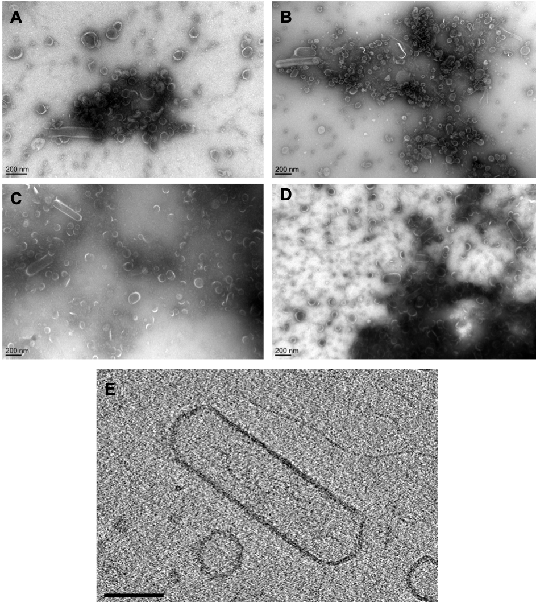

Figure S1. Nanotube-like structures co-purified with S. aureus EVs. (A-D) Representative electron microscopic images of negatively stained EVs purified from culture supernatant of S. aureus strains N305 (A), RF122 (B), O11 (C) and O46 (D).(E) Slice through a cryo-electron tomogram obtained from S. aureus N305 EVs with a nanotube-like structure. Scale bar = 100 nm.
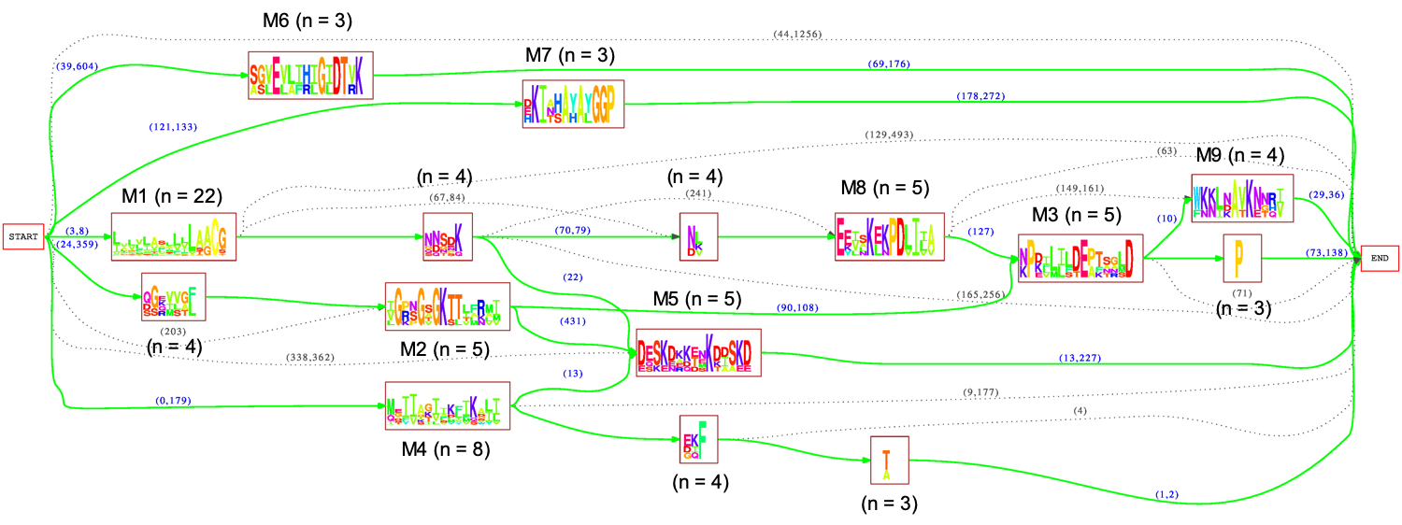

Figure S2. Protomaton built from non-redundant set of core EV protein sequences with 9 most significant motifs (length > 10) labeled from M1 to M9 and number n of sequences involved in each motif. Non-redundant set (built with MMseqs2¹, < 70% identity) contained all core EV protein sequences except A0A0H3K2S2. This set was given as input to Protomata v2.0 (1813) through http://tools.genouest.org/tools/protomata webserver with default PLMA parameters (minimum and maximum size of fragments of 1 and 15, weak consensus) except the similarity threshold lowered to 2 to enable observing weaker similarities. A quorum of 3 unweighted sequences by motif and no pseudocounts were used to build the protomaton.

1. Mirdita M, Steinegger M and Soeding J. MMseqs2 desktop and local web server app for fast, interactive sequence searches. Bioinformatics, doi: 10.1093/bioinformatics/bty1057 (2019).

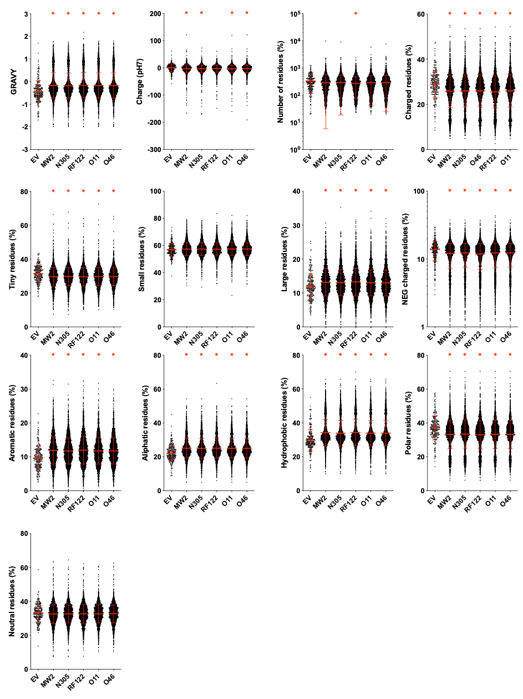

Figure S3. Comparison of the physicochemical properties of proteins found in EVs versus whole cell of Staphylococcus aureus strains MW2, N305, RF122, O11 and O46. The isoelectric point, the GRAVY value and the charge Physicochemical composition of proteins were computed with Sequence Manipulation Suite (https://www.bioinformatics.org/sms2/) and COPID (https://webs.iiitd.edu.in/raghava/COPid/index.html). Charged residues: DEKHR. Positively (POS) charged residues: KRH. Negatively (NEG) charged residues: DE. Aliphatic residues: ILV. Aromatic residues: FHWY. Polar residues: DERKQN. Neutral residues: AGHPSTY. Hydrophobic residues: CFILMVW. Tiny residues: ACDGST. Small residues: EHILKMNPQV. Large residues: FRWY. Asterisks indicate statistical significance when compared to the EV group (one-way ANOVA followed by Dunnett’s multiple comparisons test: *, P <0.001).

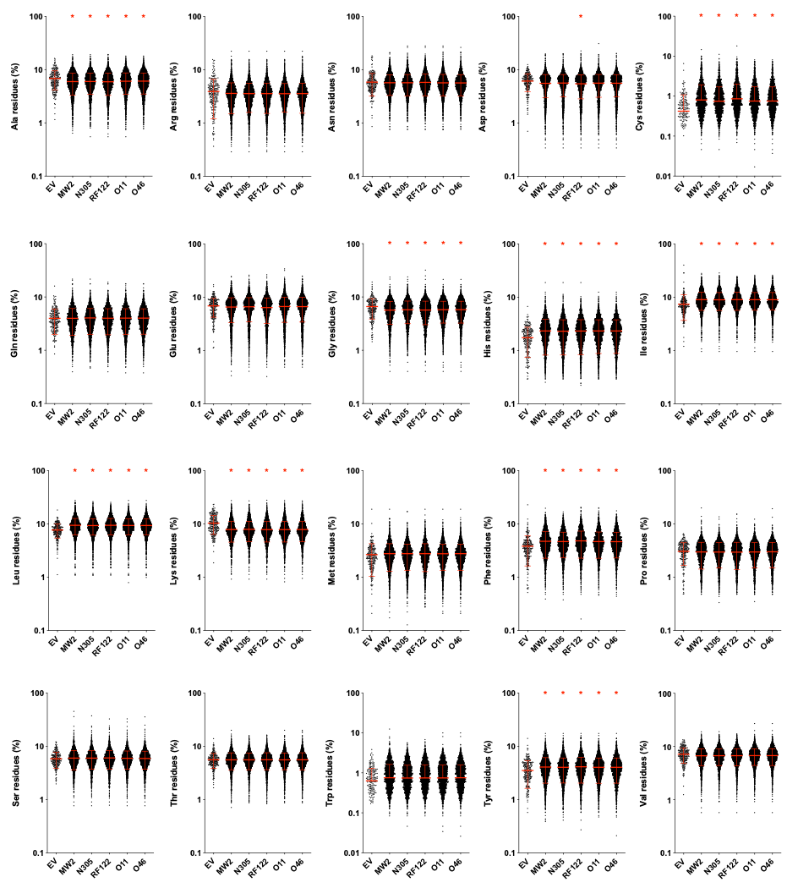

Figure S4. Comparison of amino acid composition of proteins found in EVs versus whole cell of S. aureus strains MW2, N305, RF122, O11 and O46. Amino acid of proteins were calculated from the COPID server (https://webs.iiitd.edu.in/raghava/COPid/index.html). Asterisks indicate statistical significance when compared to the EV group (one-way ANOVA followed by Dunnett’s multiple comparisons test: *, P <0.001).

