Genome sequence and comparative analysis of reindeer (Rangifer tarandus) in Northern Eurasia.
Melak Weldenegodguad^{1,2*}, Kisun Pokharel^{1*}, Yao Ming^{3*}, Mervi Honkatukia^{1,4}, Jaana Peippo¹, Tiina Reilas¹, Knut Røed⁵ & Juha Kantanen^{1**}

Contents
Supplementary Data
Supplementary Data 1. Reindeer-specific gene families. A total of 547 gene families were reindeer-specific compared to five ruminants. These reindeer-specific genes families comprised 1090 genes (sheet 1). Out of these 1090 genes, 802 had gene information (sheet 2).
Supplementary Data 2. Genes from reindeer-specific gene families that have known InterPro domains.
Supplementary Data 3. List of gene families expanded in reindeer. Altogether 2,683 genes were expanded in reindeer (sheet 1) of which 2,660 had gene information (sheet 2).
Supplementary Data 4. List of gene families contracted in reindeer.
Supplementary Data 5. Significantly enriched GO terms associated with expanded gene families.
Supplementary Data 6. Genes exhibiting signatures of positive selection.

Supplementary Figures
Figure S1. Estimation of genome size using 17-mer.
Figure S2. The GC content and sequencing depths of the reindeer genome.
Figure S3. GC content distribution for related species.
Figure S4. Comparison of the various gene parameters among sequenced mammalian genomes (R.tarandus, H. sapiens, M. musculus, B. taurus, C. familiaris and C. dromedaries ).

Supplementary Tables
Table S1. Statistics of raw and clean data.
Table S2. K- mer statistics.
Table S3. Statistics of the assembled sequence length.
Table S4. Assessment of the completeness of coding region using de novo transcriptome assembly of reindeer.
Table S5. Summary of BUSCO for genome assembly.
Table S6. Summary of BUSCO for gene set.
Table S7. General statistics of predicted protein-coding genes.
Table S8. Statistics of functional annotations. Four protein databases (InterPro, KEGG, Swissprot and TrEMBL) were used for predicting gene functions. The table shows numbers of genes match to each database. The TrEMBL results were based on five homologous species and exclude unknown or hypothetical genes.
Table S9. Summary of non-coding RNA genes in the genome.
Table S10.General statistics of repeats in genome.
Table S11. Contents of transposable elements (TEs) in reindeer genome.
Table S12. Summary of gene families of reindeer and nine other mammalian genomes.
Table S13. List of significantly enriched GO terms associated with reindeer-specific gene families. Two types of GO categories, molecular function (MF) and biological processes (BP) have been considered in this study. In the table “Query item” refers to number of reindeer-specific genes.
Table S14. Top 30 significantly enriched GO terms associated with expanded gene families. In the table “Query item” refers to number of expanded genes.

Table S15. List of significantly enriched GO terms associated with genes under positive selection in reindeer. In the table “Query item” refers to number of positively selected genes.

Table S16. Summary of clean reads generated from whole-genome resequencing of 23 reindeer samples.
Table S17. Summary statistics of the mapped reads for each resequencing sample.
Table S18. Summary statistics of the variants identified in each resequencing sample.
Table S19. Annotation of SNPs.
Table S20. Mitochondrial genome annotation.

Supplementary figures

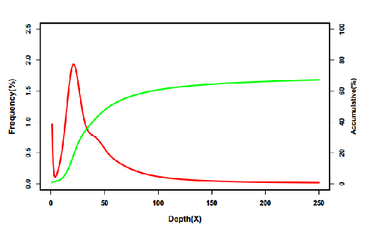

Figure S1. Estimation of genome size using 17-mer.

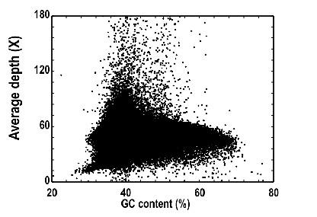

Figure S2. The GC content and sequencing depths of the reindeer genome.

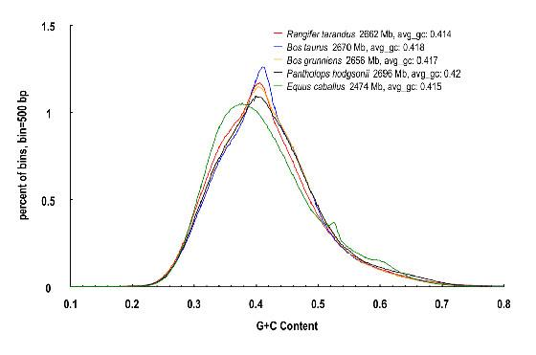

Figure S3. GC content distribution for related species.

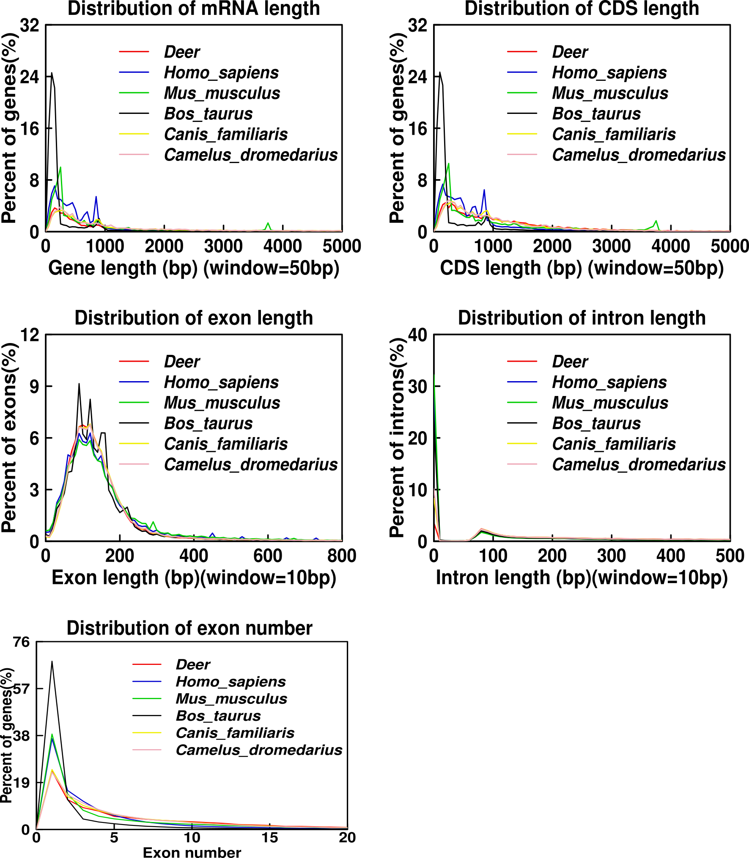

Figure S4 Comparison of the various gene parameters among sequenced mammalian genomes (R. tarandus, H. sapiens, M. musculus, B. taurus, C. familiaris and C. dromedaries).

Supplementary tables

Table S1: Statistics of raw and clean data.

 |  |  | Raw data |  |  | Clean data¹
 | Insert size | Read Length (bp) | Data (Mb) | Sequence depth (X) |  | Data (Mb) | Sequence depth (X)
 | 170 | 125 | 68,697 | 22.9 |  | 66,229 | 22
 | 500 | 125 | 66,443 | 22.1 |  | 64,721 | 21.6
 | 800 | 125 | 52,072 | 17.3 |  | 50,437 | 16.8
 | 2000 | 125 | 71,203 | 23.7 |  | 35,795 | 11.9
 | 5000 | 125 | 69,208 | 23.1 |  | 30,798 | 10.2
 | 10000 | 50 | 121,472 | 40.5 |  | 34,394 | 11.5
 | 20000 | 50 | 63,897 | 21.2 |  | 18,173 | 6
Total |  |  | 512,992 | 170 |  | 300,547 | 100
¹ Clean data were generated by filtering low-quality reads.

Table S2: K- mer statistics.

K | K-mer_num | Peak_depth | Genome Size | Used Bases | Used Reads | X
17 | 55,451,706,382 | 19 | 2,918,510,862 | 64,695,044,125 | 517,560,353 | 21.6

Table S3: Statistics of the assembled sequence length.

 | Contig |  | Scaffold
 | Length (bp) | Number | Length (bp) | Number
maximum length | 444,581 |  | 28,190,176
N10 | 127,487 | 1,583 | 13,328,327 | 17
N20 | 95,147 | 3,989 | 9,453,896 | 41
N30 | 75,378 | 7,096 | 7,772,072 | 72
N40 | 60,833 | 10,976 | 6,547,969 | 110
N50 | 48,758 | 15,793 | 5,023,617 | 157
N60 | 38,674 | 21,821 | 3,905,468 | 217
N70 | 29,450 | 29,560 | 2,815,736 | 297
N80 | 20,553 | 40,140 | 1,868,990 | 412
N90 | 10,934 | 57,163 | 839,408 | 624
Total length | 2,619,059,166 |  | 2,662,986,674
number >=100bp |  | 256,454 |  | 131,360
number >=2000bp |  | 89,211 |  | 4,970

Table S4: Assessment of the completeness of coding region using de novo transcriptome assembly of reindeer.

Length of transcript | Number | Total length (bp) | Covered by assembly | With > 90% sequence in one scaffold |  | With > 50% sequence in one scaffold
 |  |  |  | Number | Percent (%) | Number | Percent (%)
>0bp | 94,673 | 91,938,826 | 99.80 | 92.392 | 97.59 | 94,347 | 99.65
>200bp | 94,673 | 91,938,826 | 99.80 | 92.392 | 97.59 | 94,347 | 99.65
>500bp | 42,796 | 76,471,914 | 99.87 | 41,400 | 96.73 | 42,695 | 99.67
>1000bp | 26,599 | 65,090,161 | 99.92 | 25,587 | 96.19 | 26,531 | 99.74

Table S5: Summary of BUSCO for genome assembly.

 | Number | Percent (%)
Complete BUSCOs | 3895 | 94.9
Complete and single-copy BUSCOs | 3814 | 92.9
Complete and duplicated BUSCOs | 216 | 7.14
Fragmented BUSCOs | 81 | 2.0
Missing BUSCOs | 100 | 2.7
Total BUSCO groups searched | 4104

Table S6: Summary of BUSCO for gene set.

 | Number | Percent (%)
Complete BUSCOs | 3973 | 96.8
Complete and single-copy BUSCOs | 3861 | 94.1
Complete and duplicated BUSCOs | 112 | 2.7
Fragmented BUSCOs | 36 | 0.9
Missing BUSCOs | 95 | 2.3
Total BUSCO groups searched | 4104

Table S7: General statistics of predicted protein-coding genes.

Gene set |  | Number | Average transcript length (bp) | Average CDS length (bp) | Average exon per gene | Average exon length (bp) | Average intron length (bp)
Homolog | H.sapiens | 26,607 | 20,492 | 1,290 | 7.2 | 177 | 3,068
Homolog | M.musculus | 24,330 | 19,855 | 1,314 | 7.3 | 177 | 2,902
Homolog | B.taurus | 27,782 | 19,574 | 1,270 | 7.3 | 173 | 2,903
Homolog | C.dromedarius | 28,615 | 20,007 | 1,248 | 7.2 | 173 | 3,018
Homolog | C.familiaris | 26,234 | 18,653 | 1,219 | 6.9 | 175 | 2,920
RNA |  | 45,329 | 17,880 | 5,603 | 12 | 448 | 1,211
Final set |  | 27,332 | 28,808 | 1,305 | 7.4 | 175 | 3,804

Table S8: Statistics of functional annotations. Four protein databases (InterPro, KEGG, Swissprot and TrEMBL) were used for predicting gene functions. The table shows numbers of genes match to each database. The TrEMBL results were based on five homologous species and exclude unknown or hypothetical genes.

 | Number | Percent (%)
Total | 27,332
InterPro | 25,241 | 92.35
KEGG | 22,564 | 82.56
Swissprot | 25,928 | 94.86
TrEMBL | 26,707 | 97.71
Annotated | 26,838 | 98.19
Unannotated | 494 | 1.81

Table S9: Summary of non-coding RNA genes in the genome.

Type |  | Copy number | Average length(bp) | Total length (bp) | % of genome
miRNA |  | 551 | 89.81 | 49,487 | 0.001858
tRNA |  | 3,994 | 72.97 | 725,391 | 0.02724
rRNA | rRNA | 329 | 109.08 | 35,887 | 0.001348
 | 18S | 97 | 85.72 | 8,315 | 0.000312
 | 28S | 223 | 120.94 | 26,970 | 0.001013
 | 5.8S | 6 | 66.00 | 396 | 0.000015
 | 5S | 3 | 68.67 | 206 | 0.000008
snRNA | snRNA | 1,706 | 111.51 | 190,237 | 0.007144
 | CD-box | 359 | 93.57 | 33,592 | 0.001261
 | HACA-box | 310 | 134.61 | 41,729 | 0.001567
 | splicing | 1,009 | 110.58 | 111,573 | 0.00419

Table S10: General statistics of repeats in genome.

Type | Repeat length (bp) | % of genome length
Trf | 53,294,515 | 2.00
Repeatmasker | 857,864,301 | 32.21
Proteinmask | 290,364,346 | 10.90
De novo | 874,929,123 | 32.85
Total | 1,012,556,108 | 38.02

Table S11: Contents of transposable elements (TEs) in reindeer genome.

 | Repbase TEs |  | TE proteins |  | De novo |  | Combined TEs
Type | length (bp) | % genome | length (bp) | % genome | length (bp) | % genome | length (bp) | % genome
DNA | 31,664,761 | 1.18 | 4,619,577 | 0.17 | 34,692,623 | 1.30 | 40,055,380 | 1.84
LINE | 622,392,940 | 23.37 | 276,784,311 | 10.39 | 675,338,320 | 25.36 | 745,462,986 | 27.99
SINE | 132,576,480 | 4.97 | 0 | 0 | 43,027,594 | 1.61 | 149,586,647 | 5.61
LTR | 83,394,380 | 3.13 | 9,081,381 | 0.34 | 87,938,964 | 3.30 | 115,391,495 | 4.33
Other | 928 | 0.000035 | 0 | 0 | 0 | 0 | 928 | 0.000035
Unknown | 0 | 0 | 0 | 0 | 45,329,565 | 1.70 | 45,329,565 | 1.70
Total | 857,864,301 | 32.21 | 290,364,346 | 10.90 | 870,320,451 | 32.68 | 979,488,943 | 36.78
Note: Repbase TEs: the result of RepeatMasker based on Repbase; TE proteins: the result of RepeatProteinMask based on Repbase; De novo: Result of RepeatMasker by using library predicted through De novo; Combined: combine the results of Repbase TEs, TE proteins and De novo.

Table S12: Summary of gene families of reindeer and nine other mammalian genomes.

Species | Total genes | Unclustered genes | Families | Unique families | Ave. genes per family
R. tarandus | 27332 | 2224 | 17709 | 226 | 1.47
C. dromedaries | 19292 | 2084 | 15751 | 51 | 1.09
C. hircus | 22175 | 2378 | 16887 | 22 | 1.17
O. aries | 20889 | 548 | 17270 | 29 | 1.18
B. taurus | 19970 | 114 | 17040 | 1 | 1.17
B. grunniens | 22282 | 578 | 17522 | 25 | 1.24
E. caballus | 20419 | 278 | 16617 | 21 | 1.21
C. familiaris | 19839 | 785 | 16835 | 15 | 1.13
U. maritimus | 21142 | 758 | 16769 | 60 | 1.22
H. sapiens | 20071 | 627 | 18088 | 112 | 1.07

Table S13: List of significantly enriched GO terms associated with reindeer-specific gene families. Two types of GO categories, molecular function (MF) and biological processes (BP) have been considered in this study. In the table “Query item” refers to number of reindeer-specific genes.

GO ID | Term type | Term | Query item | P-value | FDR
GO:0050136 | MF | NADH dehydrogenase (quinone) activity | 7 | 9.2E-07 | 0.00011
GO:0008137 | MF | NADH dehydrogenase (ubiquinone) activity | 7 | 9.2E-07 | 0.00011
GO:0016655 | MF | oxidoreductase activity, acting on NAD(P)H, quinone or similar compound as acceptor | 7 | 9.2E-07 | 0.00011
GO:0099600 | MF | transmembrane receptor activity | 47 | 3.3E-06 | 0.00038
GO:0010556 | BP | regulation of macromolecule biosynthetic process | 52 | 3E-06 | 0.00049
GO:0003954 | MF | NADH dehydrogenase activity | 7 | 4.5E-06 | 0.00052
GO:0031326 | BP | regulation of cellular biosynthetic process | 52 | 3.5E-06 | 0.00058
GO:0009889 | BP | regulation of biosynthetic process | 52 | 3.6E-06 | 0.00059
GO:2000112 | BP | regulation of cellular macromolecule biosynthetic process | 51 | 5.2E-06 | 0.00085
GO:0097659 | BP | nucleic acid-templated transcription | 55 | 6E-06 | 0.00097
GO:0006351 | BP | transcription, DNA-templated | 55 | 6E-06 | 0.00097
GO:0010468 | BP | regulation of gene expression | 51 | 6.2E-06 | 0.001
GO:1903506 | BP | regulation of nucleic acid-templated transcription | 50 | 6.6E-06 | 0.0011
GO:0006355 | BP | regulation of transcription, DNA-templated | 50 | 6.6E-06 | 0.0011
GO:2001141 | BP | regulation of RNA biosynthetic process | 50 | 6.7E-06 | 0.0011
GO:0051252 | BP | regulation of RNA metabolic process | 50 | 7.1E-06 | 0.0012
GO:0032774 | BP | RNA biosynthetic process | 55 | 7.1E-06 | 0.0012
GO:0051171 | BP | regulation of nitrogen compound metabolic process | 51 | 7.3E-06 | 0.0012
GO:0019219 | BP | regulation of nucleobase-containing compound metabolic process | 50 | 0.00001 | 0.0017
GO:0004888 | MF | transmembrane signaling receptor activity | 43 | 1.8E-05 | 0.0021
GO:0080090 | BP | regulation of primary metabolic process | 52 | 1.4E-05 | 0.0022
GO:0060255 | BP | regulation of macromolecule metabolic process | 52 | 1.5E-05 | 0.0024
GO:0031323 | BP | regulation of cellular metabolic process | 52 | 1.6E-05 | 0.0026
GO:0017137 | MF | Rab GTPase binding | 5 | 2.7E-05 | 0.0031
GO:0019222 | BP | regulation of metabolic process | 52 | 2.2E-05 | 0.0035
GO:0004871 | MF | signal transducer activity | 47 | 0.00004 | 0.0046
GO:0004984 | MF | olfactory receptor activity | 16 | 5.9E-05 | 0.0068
GO:0034654 | BP | nucleobase-containing compound biosynthetic process | 57 | 4.4E-05 | 0.0072
GO:0060089 | MF | molecular transducer activity | 47 | 6.3E-05 | 0.0073
GO:0004872 | MF | receptor activity | 47 | 6.3E-05 | 0.0073
GO:0038023 | MF | signaling receptor activity | 43 | 6.5E-05 | 0.0075
GO:0019438 | BP | aromatic compound biosynthetic process | 57 | 6.8E-05 | 0.011
GO:0018130 | BP | heterocycle biosynthetic process | 57 | 7.4E-05 | 0.012
GO:1901362 | BP | organic cyclic compound biosynthetic process | 57 | 8.7E-05 | 0.014
GO:0004867 | MF | serine-type endopeptidase inhibitor activity | 8 | 0.00012 | 0.014
GO:0004950 | MF | chemokine receptor activity | 5 | 0.00029 | 0.034
GO:0001637 | MF | G-protein coupled chemoattractant receptor activity | 5 | 0.00029 | 0.034
GO:0007186 | BP | G-protein coupled receptor signaling pathway | 35 | 0.00028 | 0.046
GO:0046872 | MF | metal ion binding | 89 | 0.0004 | 0.047
MF: molecular function; BP: biological process

Table S14: Top 30 significantly enriched GO terms associated with expanded gene families. In the table “Query item” refers to number of expanded genes.
GO ID | Term type | Term | Query item | P-value | FDR
GO:0003735 | MF | structural constituent of ribosome | 651 | 0 | 0
GO:0006412 | BP | translation | 683 | 1.5e-308 | 6.8E-306
GO:0043043 | BP | peptide biosynthetic process | 683 | 2.4E-306 | 1.1E-303
GO:0043604 | BP | amide biosynthetic process | 683 | 1.9E-305 | 8.7E-303
GO:0006518 | BP | peptide metabolic process | 683 | 1.1E-297 | 4.9E-295
GO:0043603 | BP | cellular amide metabolic process | 683 | 1E-292 | 4.9E-290
GO:1901566 | BP | organonitrogen compound biosynthetic process | 726 | 8.8E-268 | 4.1E-265
GO:0005198 | MF | structural molecule activity | 654 | 2.6E-258 | 5.3E-256
GO:1901564 | BP | organonitrogen compound metabolic process | 751 | 2.5E-225 | 1.2E-222
GO:0044271 | BP | cellular nitrogen compound biosynthetic process | 908 | 4.6E-139 | 2.2E-136
GO:0034645 | BP | cellular macromolecule biosynthetic process | 869 | 2.8E-126 | 1.3E-123
GO:0009059 | BP | macromolecule biosynthetic process | 869 | 2.3E-124 | 1.1E-121
GO:0010467 | BP | gene expression | 892 | 2.4E-124 | 1.1E-121
GO:0044249 | BP | cellular biosynthetic process | 920 | 1.2E-114 | 5.5E-112
GO:1901576 | BP | organic substance biosynthetic process | 915 | 4.5E-111 | 2.1E-108
GO:0044267 | BP | cellular protein metabolic process | 809 | 5.9E-108 | 2.8E-105
GO:0009058 | BP | biosynthetic process | 920 | 7E-107 | 3.3E-104
GO:0034641 | BP | cellular nitrogen compound metabolic process | 967 | 7.6E-98 | 3.6E-95
GO:0006807 | BP | nitrogen compound metabolic process | 967 | 4.8E-87 | 2.2E-84
GO:0019538 | BP | protein metabolic process | 822 | 1.9E-73 | 9.1E-71
GO:0008199 | MF | ferric iron binding | 84 | 2E-59 | 4.2E-57
GO:0006826 | BP | iron ion transport | 84 | 7E-56 | 3.3E-53
GO:0006879 | BP | cellular iron ion homeostasis | 84 | 1.5E-53 | 6.9E-51
GO:0046916 | BP | cellular transition metal ion homeostasis | 84 | 1.5E-53 | 6.9E-51
GO:0055072 | BP | iron ion homeostasis | 84 | 1.5E-53 | 6.9E-51
GO:0044260 | BP | cellular macromolecule metabolic process | 1024 | 3.4E-53 | 1.6E-50
GO:0055076 | BP | transition metal ion homeostasis | 84 | 7.9E-53 | 3.7E-50
GO:0000041 | BP | transition metal ion transport | 84 | 1.9E-51 | 9E-49
GO:0006875 | BP | cellular metal ion homeostasis | 84 | 1.4E-46 | 6.4E-44
GO:0006873 | BP | cellular ion homeostasis | 84 | 4.8E-46 | 2.2E-43
MF: molecular function; BP: biological process

Table S15: List of significantly enriched GO terms associated with genes under positive selection in reindeer. In the table “Query item” refers to number of positively selected genes.

GO ID | Term type | Term | Query item | P-value | FDR
GO:0005272 | MF | sodium channel activity | 5 | 0.00013 | 0.013
GO:0022803 | MF | passive transmembrane transporter activity | 20 | 0.00015 | 0.016
GO:0015267 | MF | channel activity | 20 | 0.00015 | 0.016
GO:0022835 | MF | transmitter-gated channel activity | 5 | 0.0002 | 0.021
GO:0022824 | MF | transmitter-gated ion channel activity | 5 | 0.0002 | 0.021
GO:0005216 | MF | ion channel activity | 19 | 0.0004 | 0.041
GO:0022838 | MF | substrate-specific channel activity | 19 | 0.0004 | 0.041
GO:0030594 | MF | neurotransmitter receptor activity | 5 | 0.0011 | 0.11
GO:0005085 | MF | guanyl-nucleotide exchange factor activity | 10 | 0.0017 | 0.17
GO:0006820 | BP | anion transport | 9 | 0.0017 | 0.24
GO:0006814 | BP | sodium ion transport | 6 | 0.0017 | 0.25
GO:0035556 | BP | intracellular signal transduction | 29 | 0.0019 | 0.28
GO:0005230 | MF | extracellular ligand-gated ion channel activity | 7 | 0.0029 | 0.3
GO:0022836 | MF | gated channel activity | 14 | 0.0032 | 0.33
GO:0008509 | MF | anion transmembrane transporter activity | 7 | 0.0035 | 0.37
GO:0035091 | MF | phosphatidylinositol binding | 6 | 0.0038 | 0.39
GO:0008270 | MF | zinc ion binding | 38 | 0.0041 | 0.42
GO:0005543 | MF | phospholipid binding | 7 | 0.0055 | 0.57
GO:0008236 | MF | serine-type peptidase activity | 10 | 0.0057 | 0.59
GO:0017171 | MF | serine hydrolase activity | 10 | 0.0057 | 0.59
GO:0004252 | MF | serine-type endopeptidase activity | 9 | 0.0069 | 0.72
GO:0007166 | BP | cell surface receptor signaling pathway | 15 | 0.0099 | 1
GO:0015103 | MF | inorganic anion transmembrane transporter activity | 5 | 0.01 | 1
GO:0022892 | MF | substrate-specific transporter activity | 30 | 0.011 | 1
GO:0005215 | MF | transporter activity | 37 | 0.011 | 1
GO:0007265 | BP | Ras protein signal transduction | 7 | 0.011 | 1
GO:0051716 | BP | cellular response to stimulus | 70 | 0.012 | 1
GO:0015698 | BP | inorganic anion transport | 5 | 0.012 | 1
GO:0007264 | BP | small GTPase mediated signal transduction | 18 | 0.012 | 1
GO:0015276 | MF | ligand-gated ion channel activity | 7 | 0.013 | 1
GO:0005515 | MF | protein binding | 146 | 0.013 | 1
GO:0022834 | MF | ligand-gated channel activity | 7 | 0.013 | 1
GO:0007154 | BP | cell communication | 67 | 0.013 | 1
GO:0044700 | BP | single organism signaling | 66 | 0.014 | 1
GO:0007267 | BP | cell-cell signaling | 8 | 0.014 | 1
GO:0023052 | BP | signaling | 66 | 0.015 | 1
GO:0007165 | BP | signal transduction | 64 | 0.017 | 1
GO:0015075 | MF | ion transmembrane transporter activity | 25 | 0.023 | 1
GO:0022891 | MF | substrate-specific transmembrane transporter activity | 27 | 0.023 | 1
GO:0016773 | MF | phosphotransferase activity, alcohol group as acceptor | 27 | 0.024 | 1
GO:1902589 | BP | single-organism organelle organization | 13 | 0.025 | 1
GO:0016301 | MF | kinase activity | 27 | 0.031 | 1
GO:0070011 | MF | peptidase activity, acting on L-amino acid peptides | 21 | 0.031 | 1
GO:0043167 | MF | ion binding | 80 | 0.035 | 1
GO:0006811 | BP | ion transport | 26 | 0.036 | 1
GO:0005261 | MF | cation channel activity | 10 | 0.037 | 1
GO:0051056 | BP | regulation of small GTPase mediated signal transduction | 6 | 0.038 | 1
GO:0008233 | MF | peptidase activity | 21 | 0.04 | 1
GO:0006810 | BP | transport | 58 | 0.04 | 1
GO:0015081 | MF | sodium ion transmembrane transporter activity | 5 | 0.041 | 1
GO:0051234 | BP | establishment of localization | 58 | 0.041 | 1
GO:0008610 | BP | lipid biosynthetic process | 5 | 0.041 | 1
GO:0004518 | MF | nuclease activity | 5 | 0.044 | 1
GO:0046872 | MF | metal ion binding | 77 | 0.045 | 1
GO:0050896 | BP | response to stimulus | 76 | 0.045 | 1
GO:0043169 | MF | cation binding | 77 | 0.049 | 1
MF: molecular function; BP: biological process

Table S16: Summary of clean reads generated from whole-genome resequencing of 23 reindeer samples.

Sample name | Type | Country | Code | Read length (bp) | Clean reads | Clean bases | Q20(%) | GC(%)
NMBU-23 | Russian domestic forest reindeer | Russia | Ru-D-F | 150 | 197129978 | 29569496700 | 97.01;92.13 | 41,93
NMBU-24 | Russian domestic forest reindeer | Russia | Ru-D-F | 150 | 197224378 | 29583656700 | 97.01;92.23 | 42,44
NMBU-25 | Fennoscandian domestic tundra reindeer | Norway | Fe-D-T | 150 | 196946404 | 29541960600 | 96.73;92.18 | 43,25
NMBU-26 | Fennoscandian domestic tundra reindeer | Norway | Fe-D-T | 150 | 197200970 | 29580145500 | 96.83;92.14 | 43,03
NMBU-27 | Russian wild arctic reindeer (i.e. Novaya Zemlya) | Russia | Ru-W-A | 150 | 197170264 | 29575539600 | 97.20;91.94 | 43,83
NMBU-28 | Russian wild arctic reindeer (i.e. Novaya Zemlya) | Russia | Ru-W-A | 150 | 197641802 | 29646270300 | 97.71;90.76 | 43,4
NMBU-29 | Russian wild tundra reindeer | Russia | Ru-W-T | 150 | 197511096 | 29626664400 | 97.72;91.91 | 43,95
NMBU-30 | Russian wild tundra reindeer | Russia | Ru-W-T | 150 | 197275212 | 29591281800 | 97.78;92.42 | 43,6
NMBU-31 | Russian wild tundra reindeer | Russia | Ru-W-T | 150 | 197478826 | 29621823900 | 97.79;91.98 | 43,66
NMBU-32 | Russian wild tundra reindeer | Russia | Ru-W-T | 150 | 197208290 | 29581243500 | 92.34;94.31 | 43,88
NMBU-33 | Fennoscandian domestic tundra reindeer | Norway | Fe-D-T | 150 | 195739934 | 29360990100 | 91.59;93.76 | 44,52
NMBU-34 | Fennoscandian domestic tundra reindeer | Norway | Fe-D-T | 150 | 196758758 | 29513813700 | 92.18;94.15 | 44,57
NMBU-35 | Svalbard wild arctic reindeer | Svalbard (Norway) | Sv-W-A | 150 | 195509386 | 29326407900 | 91.82;93.89 | 44,42
NMBU-36 | Svalbard wild arctic reindeer | Svalbard (Norway) | Sv-W-A | 150 | 196518502 | 29477775300 | 97.74;92.78 | 43,86
NMBU-37 | Svalbard wild arctic reindeer | Svalbard (Norway) | Sv-W-A | 150 | 196560146 | 29484021900 | 97.67;92.57 | 43,9
NMBU-38 | Fennoscandian wild tundra reindeer | Norway | Fe-W-T | 150 | 196509916 | 29476487400 | 97.62;92.73 | 44,42
NMBU-39 | Fennoscandian wild tundra reindeer | Norway | Fe-W-T | 150 | 196012330 | 29401849500 | 97.66;92.76 | 44,07
NMBU-40 | Fennoscandian wild tundra reindeer | Norway | Fe-W-T | 150 | 196752758 | 29512913700 | 96.96;93.57 | 44,23
NMBU-41 | Fennoscandian wild tundra reindeer | Norway | Fe-W-T | 150 | 198418656 | 29762798400 | 96.98;93.59 | 43,87
NMBU-42 | Fennoscandian wild tundra reindeer | Norway | Fe-W-T | 150 | 198495940 | 29774391000 | 96.88;92.90 | 43,8
NMBU-43 | Alaska domestic tundra  reindeer | USA (Alaska) | Al-D-T | 150 | 196678634 | 29501795100 | 96.95;93.81 | 45,26
NMBU-44 | Alaska domestic tundra  reindeer | USA (Alaska) | Al-D-T | 150 | 196889532 | 29533429800 | 97.18;91.70 | 45,2
NMBU-45 | Alaska wild caribou | USA (Alaska) | Al-W-C | 150 | 196444314 | 29466647100 | 97.15;91.83 | 44,47

Table S17: Summary statistics of the mapped reads for each resequencing sample.

Sample name | Type | Country | Code | Mapped (%)
NMBU-23 | Russian domestic forest reindeer | Russia | Ru-D-F | 98,79
NMBU-24 | Russian domestic forest reindeer | Russia | Ru-D-F | 98,56
NMBU-25 | Fennoscandian domestic tundra reindeer | Norway | Fe-D-T | 99,18
NMBU-26 | Fennoscandian domestic tundra reindeer | Norway | Fe-D-T | 99,09
NMBU-27 | Russian wild arctic reindeer (i.e. Novaya Zemlya) | Russia | Ru-W-A | 99,28
NMBU-28 | Russian wild arctic reindeer (i.e. Novaya Zemlya) | Russia | Ru-W-A | 98,21
NMBU-29 | Russian wild tundra reindeer | Russia | Ru-W-T | 98,42
NMBU-30 | Russian wild tundra reindeer | Russia | Ru-W-T | 99,08
NMBU-31 | Russian wild tundra reindeer | Russia | Ru-W-T | 99
NMBU-32 | Russian wild tundra reindeer | Russia | Ru-W-T | 98,54
NMBU-33 | Fennoscandian domestic tundra reindeer | Norway | Fe-D-T | 99,09
NMBU-34 | Fennoscandian domestic tundra reindeer | Norway | Fe-D-T | 99,09
NMBU-35 | Svalbard wild arctic reindeer | Svalbard (Norway) | Sv-W-A | 98,87
NMBU-36 | Svalbard wild arctic reindeer | Svalbard (Norway) | Sv-W-A | 98,84
NMBU-37 | Svalbard wild arctic reindeer | Svalbard (Norway) | Sv-W-A | 98,83
NMBU-38 | Fennoscandian wild tundra reindeer | Norway | Fe-W-T | 98,1
NMBU-39 | Fennoscandian wild tundra reindeer | Norway | Fe-W-T | 99,12
NMBU-40 | Fennoscandian wild tundra reindeer | Norway | Fe-W-T | 98,98
NMBU-41 | Fennoscandian wild tundra reindeer | Norway | Fe-W-T | 98,56
NMBU-42 | Fennoscandian wild tundra reindeer | Norway | Fe-W-T | 98,86
NMBU-43 | Alaska domestic tundra reindeer | USA (Alaska) | Al-D-T | 98,58
NMBU-44 | Alaska domestic tundra reindeer | USA (Alaska) | Al-D-T | 97,97
NMBU-45 | Alaska wild caribou | USA (Alaska) | Al-W-C | 98,99

Table S18: Summary statistics of the variants identified in each resequencing sample.

Sample name | Code | Number of SNPs | Number of heterozygous SNPs | Number of homozygous SNPs | Number of indels
NMBU-23 | Ru-D-F | 8029264 | 4676488 | 3352776 | 1014986
NMBU-24 | Ru-D-F | 7977352 | 4455208 | 3522144 | 997145
NMBU-25 | Fe-D-T | 6902853 | 3811778 | 3091075 | 843556
NMBU-26 | Fe-D-T | 7017232 | 3864203 | 3153029 | 868310
NMBU-27 | Ru-W-A | 7408460 | 3459260 | 3949200 | 923800
NMBU-28 | Ru-W-A | 7499726 | 3629870 | 3869856 | 927347
NMBU-29 | Ru-W-T | 7854635 | 4434727 | 3419908 | 955428
NMBU-30 | Ru-W-T | 7679475 | 4114040 | 3565435 | 938555
NMBU-31 | Ru-W-T | 7741624 | 4222697 | 3518927 | 945422
NMBU-32 | Ru-W-T | 7434899 | 3786060 | 3648839 | 933342
NMBU-33 | Fe-D-T | 6656663 | 3552086 | 3104577 | 826515
NMBU-34 | Fe-D-T | 6580652 | 3504009 | 3076643 | 821481
NMBU-35 | Sv-W-A | 6641877 | 1372091 | 5269786 | 866670
NMBU-36 | Sv-W-A | 6736833 | 1327658 | 5409175 | 842797
NMBU-37 | Sv-W-A | 6786081 | 1417957 | 5368124 | 848290
NMBU-38 | Fe-W-T | 6943964 | 3777025 | 3166939 | 827401
NMBU-39 | Fe-W-T | 7063533 | 3985083 | 3078450 | 841937
NMBU-40 | Fe-W-T | 7103364 | 3547431 | 3555933 | 876525
NMBU-41 | Fe-W-T | 7080248 | 2960661 | 4119587 | 892057
NMBU-42 | Fe-W-T | 7252612 | 3408553 | 3844059 | 915918
NMBU-43 | Al-D-T | 7210585 | 3494806 | 3715779 | 877790
NMBU-44 | Al-D-T | 7274248 | 3509957 | 3764291 | 889104
NMBU-45 | Al-W-C | 7549416 | 4066355 | 3483061 | 919495

Table S19: Annotation of SNPs.

A B

Type |  |  |  | Region
Type (alphabetical order) | Count | Percent |  | Type (alphabetical order) | Count | Percent
Downstream_gene_variant | 2466729 | 6,23% |  | Downstream | 2466729 | 6,24%
Initiator_codon_variant | 19 | 0,00% |  | Exon | 223900 | 0,57%
Intergenic_region | 23053964 | 58,24% |  | Intergenic | 23053964 | 58,27%
Intron_variant | 5550415 | 14,02% |  | Intron | 5535539 | 13,99%
Missense_variant | 99624 | 0,25% |  | Splice_site_acceptor | 348 | 0,00%
Non_canonical_start_codon | 4 | 0,00% |  | Splice_site_donor | 337 | 0,00%
Non_coding_transcript_variant | 5778833 | 14,60% |  | Splice_site_region | 16860 | 0,04%
Splice_acceptor_variant | 348 | 0,00% |  | Transcript | 5778833 | 14,61%
Splice_donor_variant | 467 | 0,00% |  | Upstream | 2486049 | 6,28%
Splice_region_variant | 19128 | 0,05%
Start_lost | 71 | 0,00%
Stop_gained | 1651 | 0,00%
Stop_lost | 1 | 0,00%
Synonymous_variant | 125203 | 0,32%
Upstream_gene_variant | 2486049 | 6,28%

Table S20: Mitochondrial genome annotation.

Name | Start | Stop | Strand
nad6 | 804 | 1331 | -
trnE(ttc) | 1332 | 1400 | -
cob | 1405 | 2547 | +
trnT(tgt) | 2548 | 2617 | +
trnP(tgg) | 2617 | 2682 | -
OH | 2852 | 3393 | +
trnF(gaa) | 3609 | 3677 | +
rrnS | 3678 | 4633 | +
trnV(tac) | 4633 | 4699 | +
rrnL | 4700 | 6268 | +
trnL2(taa) | 6270 | 6344 | +
nad1 | 6347 | 7303 | +
trnI(gat) | 7303 | 7371 | +
trnQ(ttg) | 7369 | 7440 | -
trnM(cat) | 7443 | 7511 | +
nad2 | 7512 | 8555 | +
trnW(tca) | 8554 | 8621 | +
trnA(tgc) | 8623 | 8691 | -
trnN(gtt) | 8693 | 8765 | -
OL | 8768 | 8798 | +
trnC(gca) | 8798 | 8864 | -
trnY(gta) | 8865 | 8933 | -
cox1 | 8935 | 10479 | +
trnS2(tga) | 10477 | 10545 | -
trnD(gtc) | 10553 | 10620 | +
cox2 | 10622 | 11305 | +
trnK(ttt) | 11309 | 11376 | +
atp8 | 11378 | 11578 | +
atp6 | 11539 | 12219 | +
cox3 | 12219 | 13003 | +
trnG(tcc) | 13003 | 13071 | +
nad3 | 13081 | 13428 | +
trnR(tcg) | 13419 | 13488 | +
nad4l | 13489 | 13785 | +
nad4 | 13812 | 15192 | +
trnH(gtg) | 15157 | 15225 | +
trnS1(gct) | 15226 | 15285 | +
trnL1(tag) | 15287 | 15356 | +
nad5 | 15348 | 820 | +

