Human BDNF/TrkB variants impair hippocampal synaptogenesis and associate with neurobehavioral abnormalities

Takuhiro Sonoyama^{1,7}, Lukas K.J. Stadler^{1,7}, Mingyan Zhu², Julia M. Keogh¹, Elana Henning¹, Fuki Hisama³, Peter Kirwan¹, Magdalena Jura¹, Beata K. Blaszczyk⁴, David C. DeWitt², Bas Brouwers¹, Marko Hyvönen⁴, Inês Barroso^{5,6}, Florian T. Merkle¹, Suzanne M. Appleyard², Gary A. Wayman^{2,8,}*, I. Sadaf Farooqi^{1,8,*}.

¹University of Cambridge Metabolic Research Laboratories and NIHR Cambridge Biomedical Research Centre, Wellcome Trust-MRC Institute of Metabolic Science, Addenbrooke's Hospital, Cambridge, UK; ²Integrative Physiology and Neuroscience, College of Veterinary Medicine, Washington State University, Pullman, Washington, USA; ³Department of Medicine (Medical Genetics), University of Washington School of Medicine, Seattle, Washington, USA; ⁴Department of Biochemistry, 80 Tennis Court Road, CB2 1QW, University of Cambridge, UK; ⁵MRC Epidemiology Unit, Addenbrooke's Hospital, Cambridge, UK; ⁶Wellcome Sanger Institute, Cambridge, UK.

⁷these authors contributed equally; ⁸these authors contributed equally; *corresponding authors: isf20@cam.ac.uk and waymang@wsu.edu

Supplementary Information – Full Western Blot Images

Supplementary Information – Full Western Blot Images

Figure 1

C.

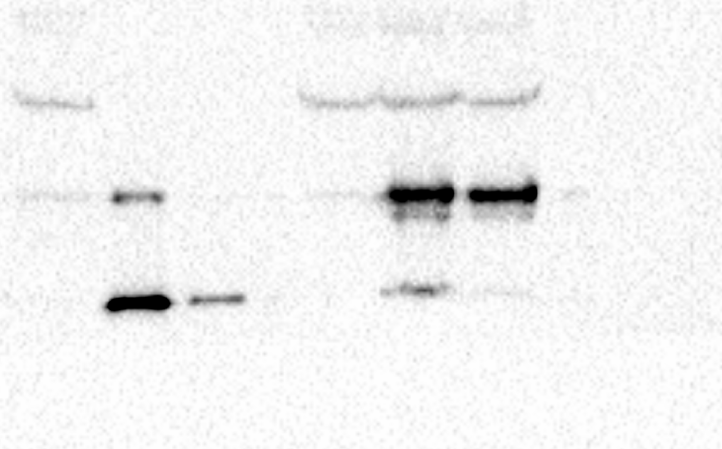

ii. i.

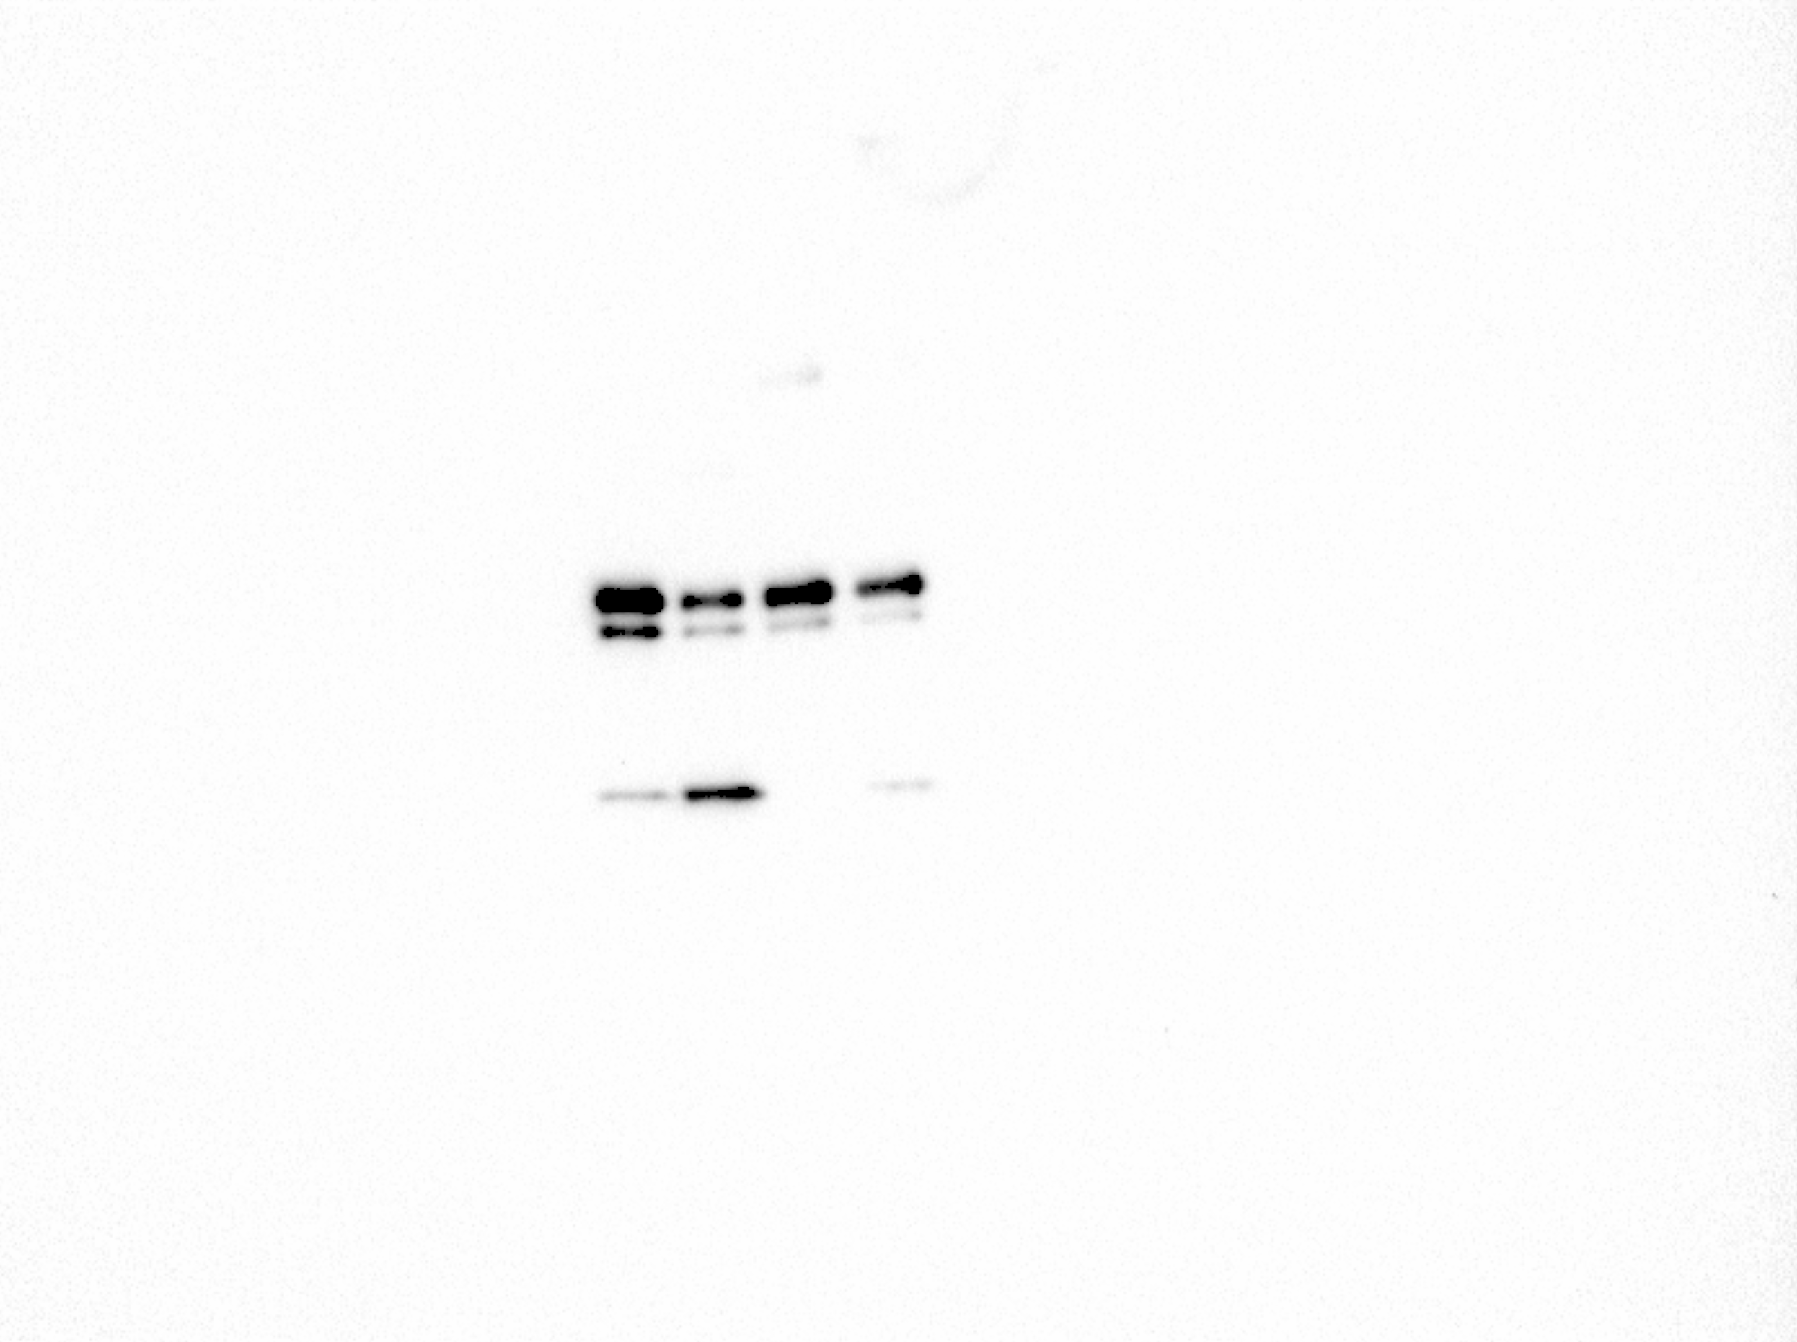
E.

F.
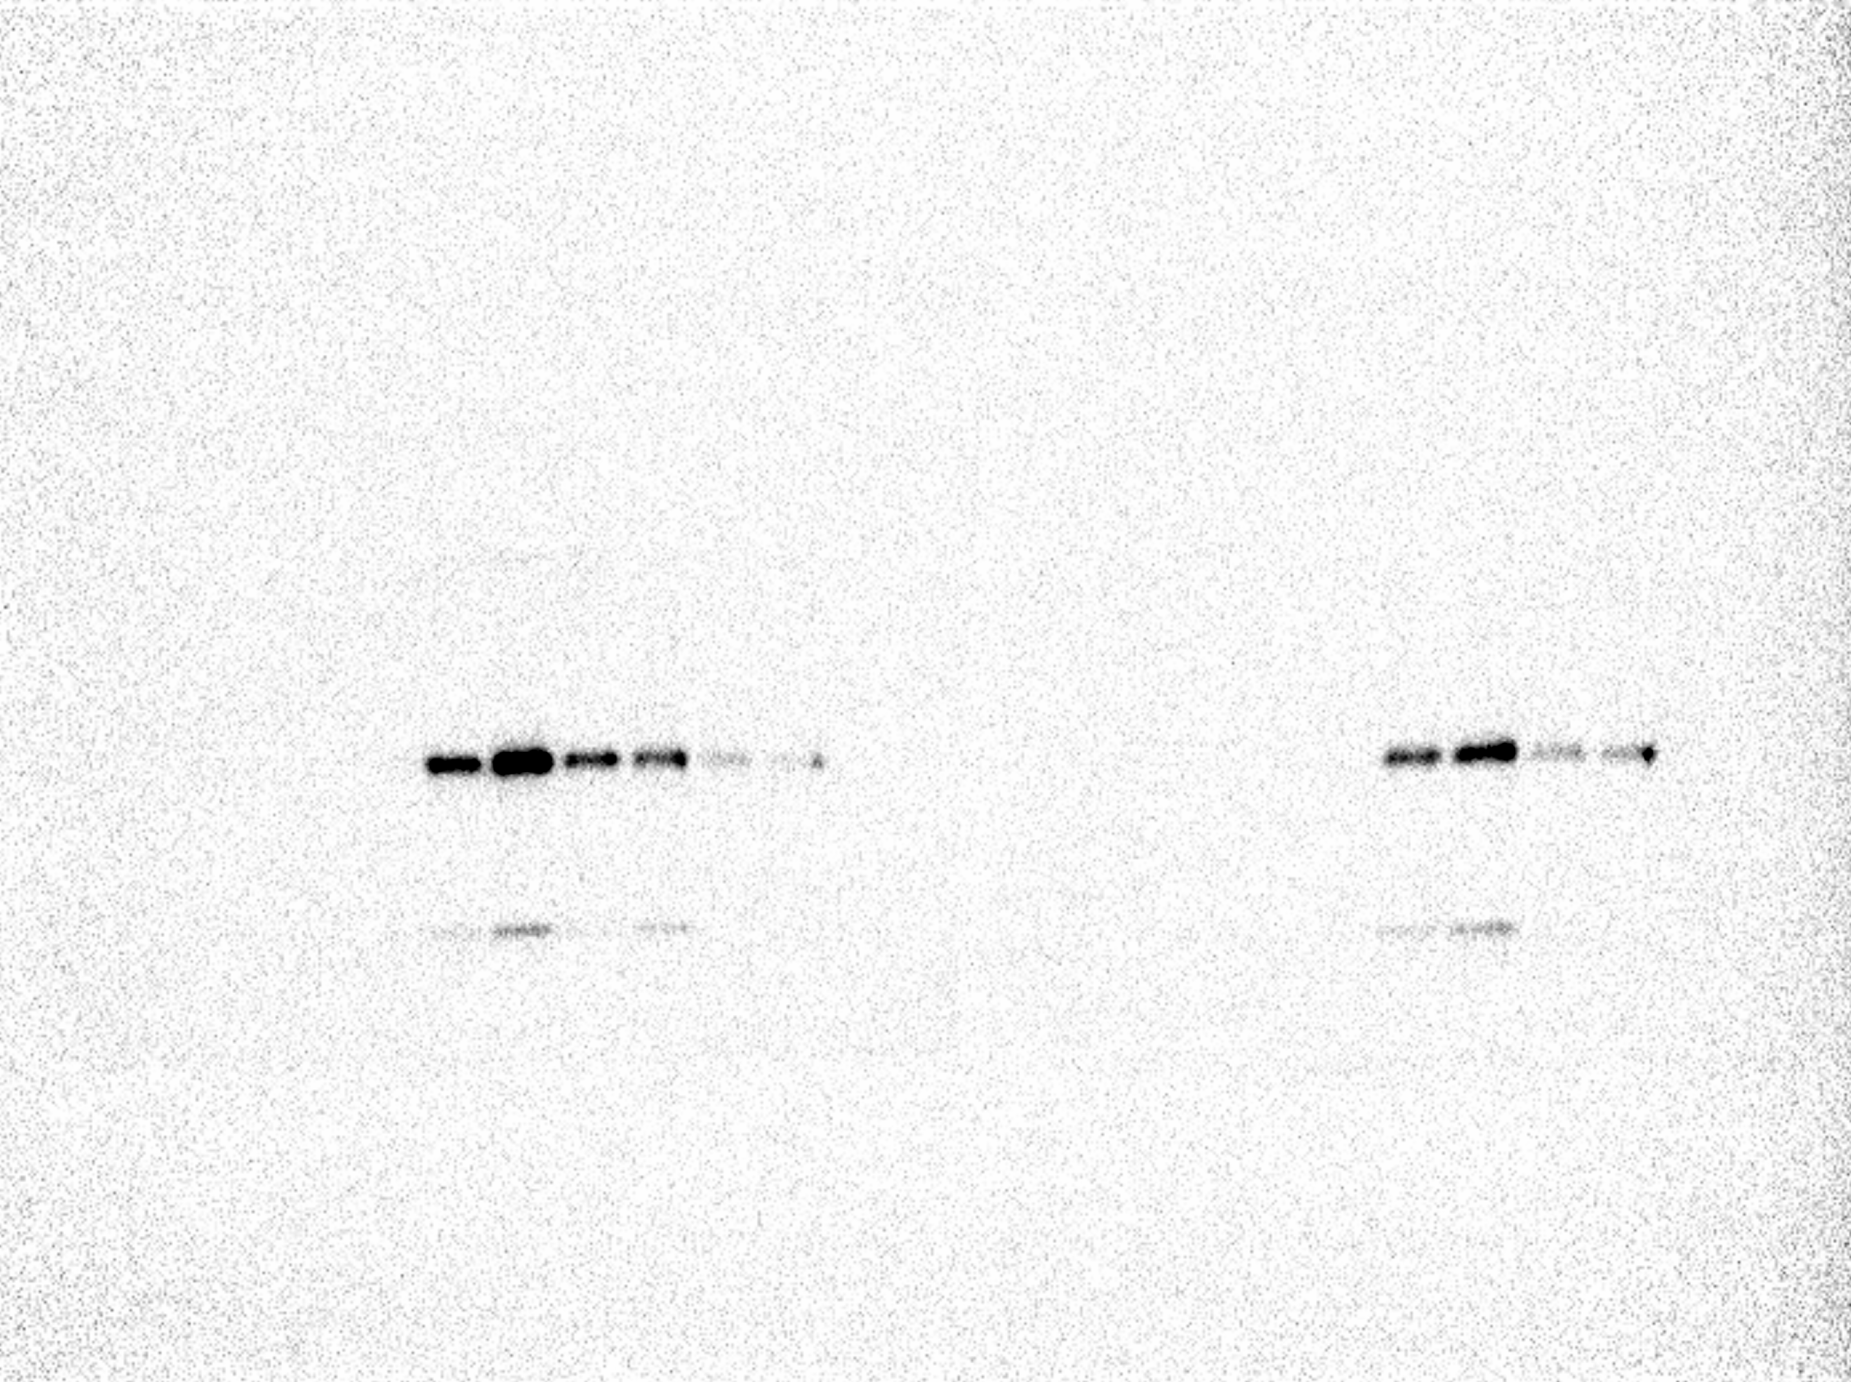

Figure 2
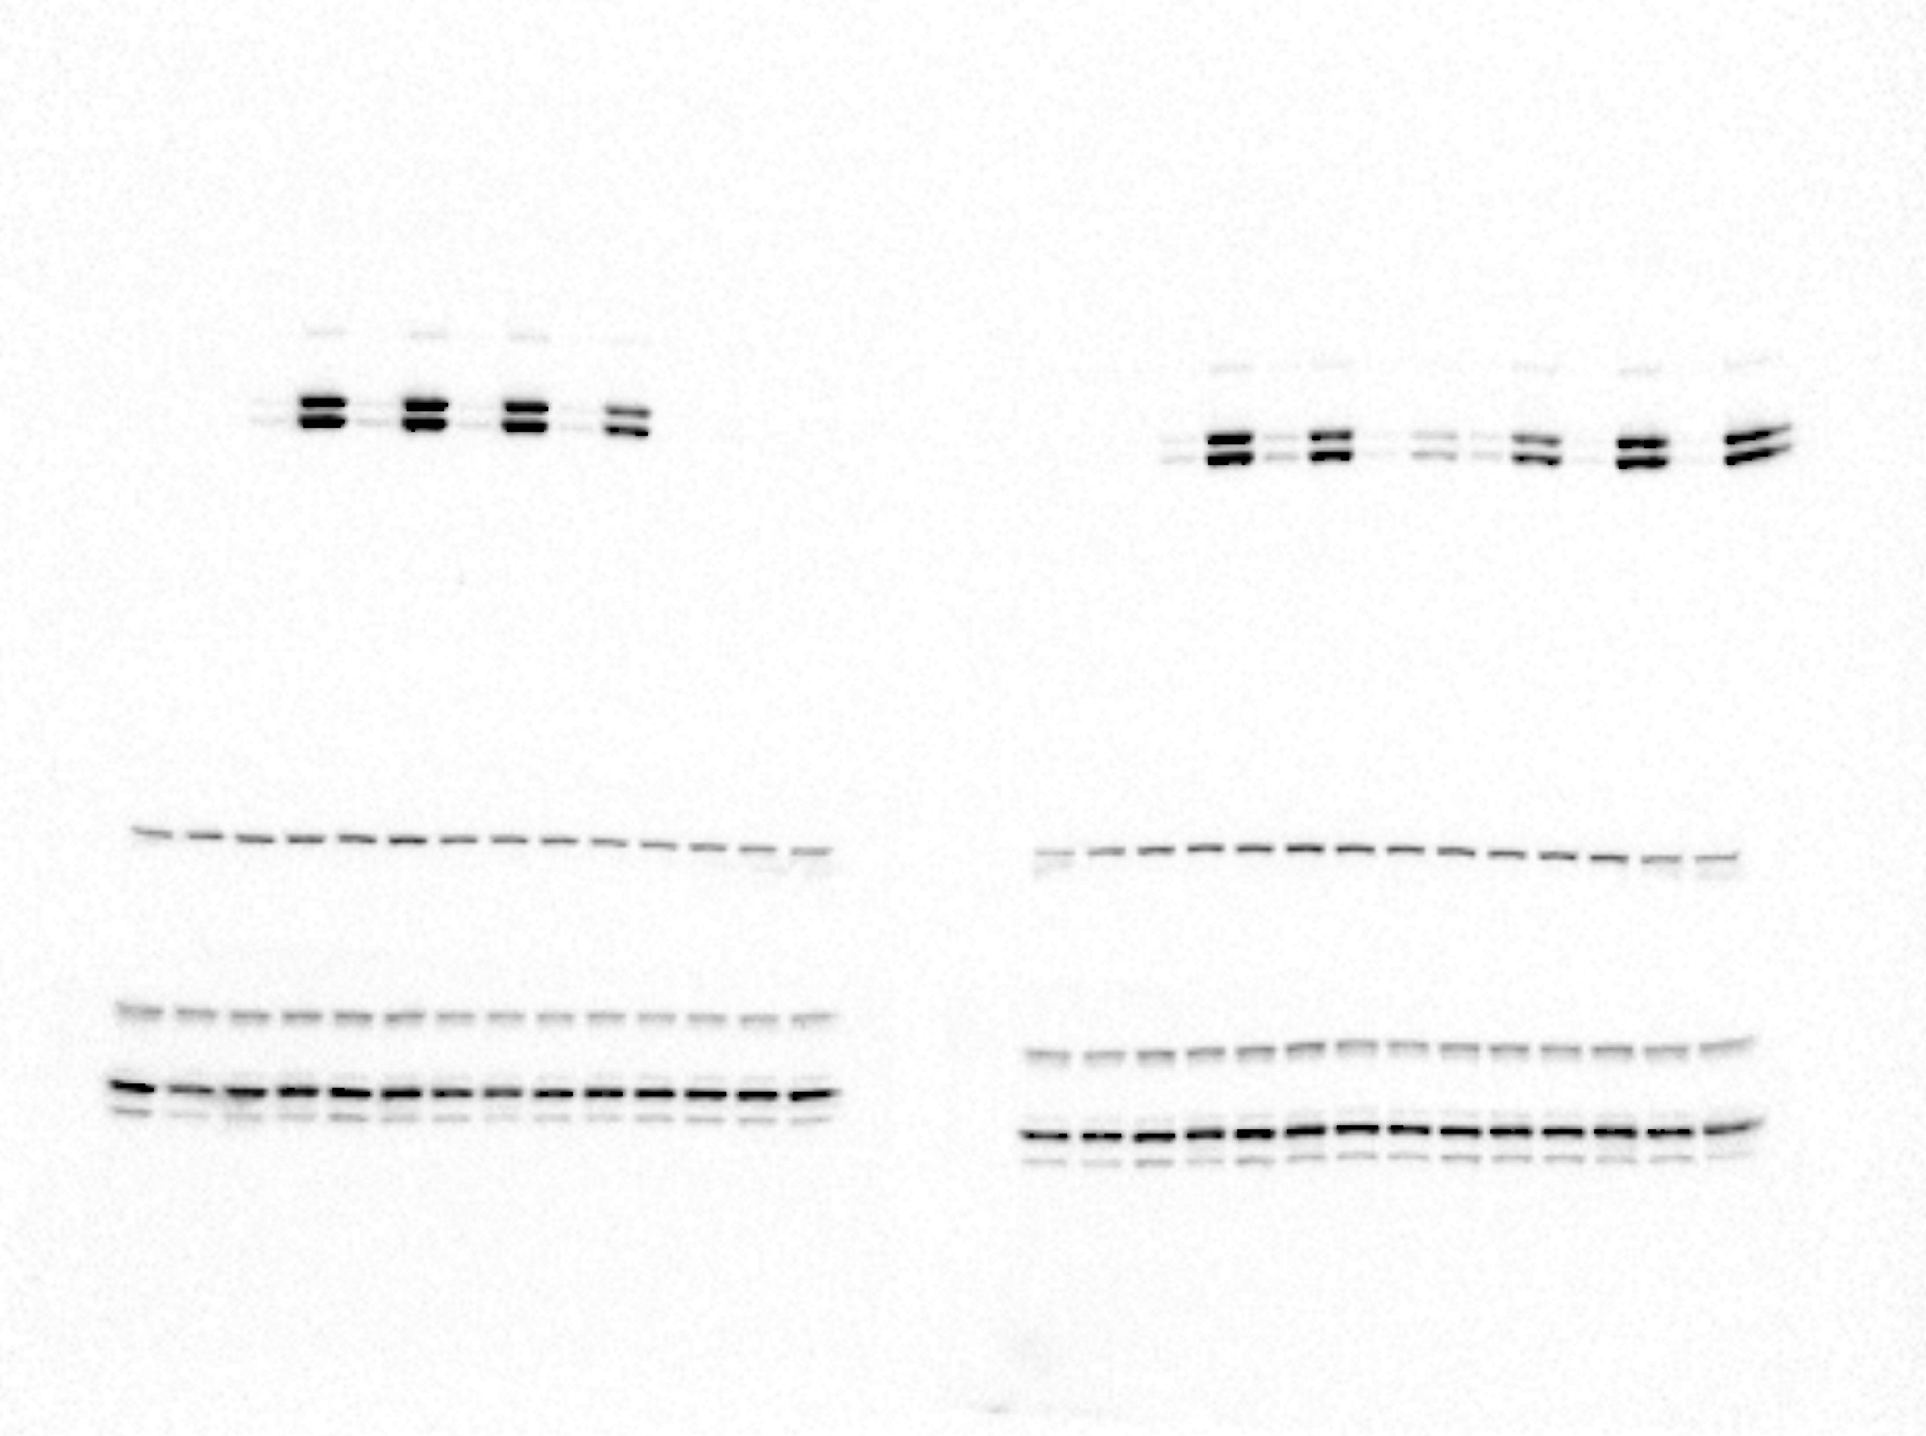

pERK

PLCy

AKT
ERK

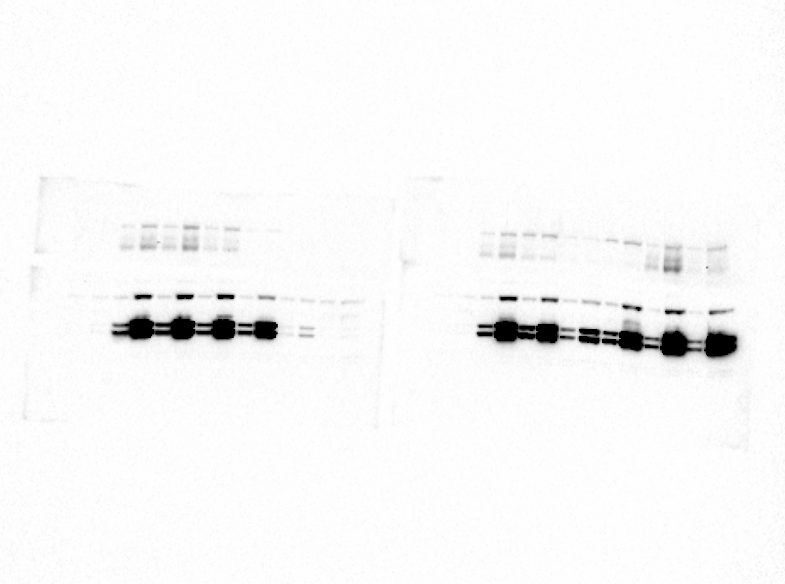

pPLCy

pAKT

