Supplementary Data

Excessive Homeostatic Gain in Spinal Motoneurons in a Mouse Model of Amyotrophic Lateral Sclerosis

Su-Wei Kuoª, Marc D. Binder^{b} and C.J. Heckman^{a,c,d}*

a Department of Physiology, Northwestern University, Chicago, IL 60611, USA
b Department of Physiology & Biophysics, University of Washington School of Medicine, Seattle, WA 98195, USA
c Department of Physical Medicine and Rehabilitation, Northwestern University, Chicago, IL 60611, USA
d Department of Physical Therapy and Human Movement Sciences, Northwestern University, Chicago, IL 60611, USA
*Correspondence to CJ Heckman, 303 E. Chicago Ave, Ward 5-334, Northwestern University, IL 60611, USA.
Email: c-heckman@northwestern.edu
Tel: 312-503-2164

S1. Optimization of PF-4708671 dosage
PF-4708671 dosage was optimized by a toxicology test conducted on P2-P8 mice with daily IP injections of PF-4708671 in 10 mg/kg (N=13), 30 mg/kg (N=16) and 60 mg/kg (N=14) over a period of 6 days. Littermate controls received equivalent vehicle injections. The 60 mg/kg per day group showed a significantly increased mortality rate starting from P4 and a much lower overall survival rate at P8 (P=0.001). In contrast, the 10 mg/kg and 30 mg/kg per day groups and the vehicle control group showed no change in mortality rate. These results led us to test the efficacy of the 30 mg/kg per day dose of PF-4708671 on regulating cell size.

(S2A) (S2B)
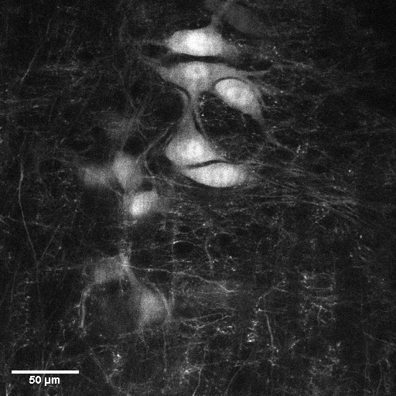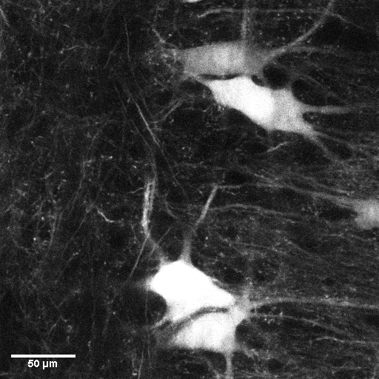
(S2C) (S2D)
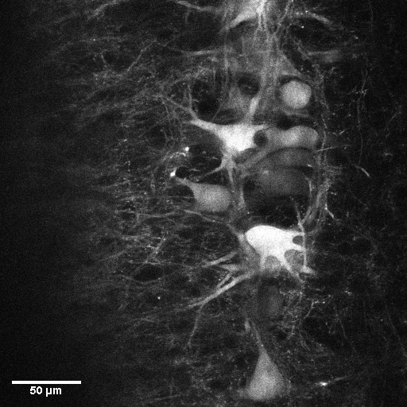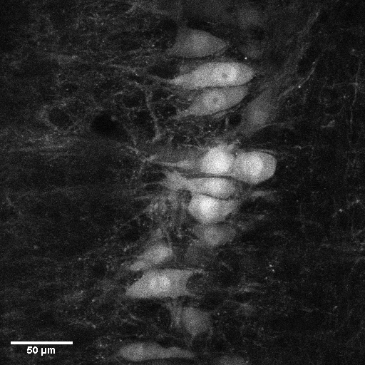
S2. Representative image from two-photon microscopy
A, Wild-type motoneurons subjected to two-photon scanning (40x) from ventrolateral spinal cord tissue. B, Certain hG93A-SOD1 motoneurons showed increased cell size, which shifted the overall distribution curve as shown in Figure 2B. C and D, Wild-type and hG93A-SOD1 motoneurons received PF-4708671 have cell size distributed in similar range.

