LUNG FUNCTION AND GENE EXPRESSION OF PATHOGEN RECOGNITION PATHWAY RECEPTORS: THE CARDIA LUNG STUDY
Ramya Ramasubramanian¹, Ravi Kalhan^{2,3}, David R. Jacobs Jr.¹, George R. Washko^{4,5}, Lifang Hou², Myron D. Gross⁶, Weihua Guan⁷, Bharat Thyagarajan^{6,8}.
- Division of Epidemiology and Community Health, University of Minnesota School of Public Health, Minneapolis, MN, USA
- Department of Preventive Medicine, Northwestern University Feinberg School of Medicine, Chicago, IL, USA
- Division of Pulmonary and Critical Care Medicine, Northwestern University Feinberg School of Medicine, Chicago, IL, USA
- Division of Pulmonary and Critical Care Medicine, Brigham and Women’s Hospital, Boston, MA, USA
- Applied Chest Imaging Laboratory, Brigham and Women’s Hospital, Boston, MA, USA
- Department of Pathology and Laboratory Medicine, University of Minnesota School of Medicine, Minneapolis, MN, USA
- Department of Biostatistics, University of Minnesota School of Public Health, Minneapolis, MN, USA

Supplementary table 1a: Participant characteristics at year 25 with respect to MAPK14 gene expression levels
Characteristics | MAPK14 gene expression levels |  |  |  |  | p-value
Characteristics | 0-25 percentile  (n=568) | >25-50 percentile  (n=568) | >50-75 percentile  (n=568) | >75-95 percentile  (n=454) | >95-100 percentile  (n=113) | p-value
Age (years) | 50.09  (3.68) | 49.95  (3.64) | 50.27  (3.59) | 50.26  (3.35) | 50.39  (3.43) | 0.47
Race
%Blacks | 60.92 | 44.01 | 35.92 | 29.30 | 36.28 | <0.0001
Sex
% Female | 57.57 | 56.87 | 56.69 | 62.11 | 64.60 | 0.22
Smoking
Never | 67.96 | 66.37 | 64.08 | 62.33 | 54.87 | 0.13
Former | 20.42 | 22.01 | 23.77 | 22.03 | 27.43 | 0.13
Current | 11.62 | 11.62 | 12.15 | 15.64 | 17.70 | 0.13
BMI | 29.85 (6.53) | 29.56  (6.88) | 29.67  (6.79) | 30.19  (7.49) | 32.22  (9.08) | 0.005
Alcohol consumption (mL/day) | 10.29  (22.83) | 11.41  (17.99) | 11.39  (19.40) | 10.76  (19.54) | 9.65  (19.94) | 0.79
C-reactive protein (uG/ML) | 2.45  (3.70) | 2.48  (4.41) | 2.77  (4.16) | 3.58  (5.43) | 6.42  (8.07) | <0.0001

Supplementary table 1b: Participant characteristics at year 25 with respect to CCR1 gene expression levels

Characteristics | CCR1 gene expression levels |  |  |  |  | p-value
Characteristics | 0-25 percentile  (n=568) | >25-50 percentile  (n=568) | >50-75 percentile  (n=568) | >75-95 percentile  (n=454) | >95-100 percentile  (n=113) | p-value
Age (years) | 50.31  (3.47) | 50.29  (3.60) | 50.07  (3.58) | 49.97  (3.59) | 49.67  (3.83) | 0.24
Race
%Blacks | 27.64 | 38.20 | 43.84 | 57.93 | 77.88 | <0.0001
Sex
% Female | 46.65 | 54.40 | 62.15 | 70.26 | 71.68 | <0.0001
Smoking
Never | 64.44 | 67.08 | 67.61 | 60.35 | 59.29 | 0.005
Former | 25.70 | 21.48 | 18.84 | 23.79 | 21.24 | 0.005
Current | 9.86 | 11.44 | 13.56 | 15.86 | 19.47 | 0.005
BMI | 28.93  (6.21) | 29.41  (6.51) | 30.22  (7.54) | 31.19  (7.76) | 30.74  (7.13) | <0.0001
Alcohol consumption (mL/day) | 11.65  (16.34) | 12.15  (26.12) | 10.32  (18.23) | 9.46  (18.88) | 9.63  (13.39) | 0.18
C-reactive protein (uG/ML) | 2.07  (3.35) | 2.42  (3.56) | 3.14  (5.00) | 4.03  (6.18) | 4.99  (6.36) | <0.0001

Supplementary table 1c: Participant characteristics at year 25 with respect to TLR1 gene expression levels
Characteristics | TLR1 gene expression levels |  |  |  |  | p-value
Characteristics | 0-25 percentile  (n=568) | >25-50 percentile  (n=568) | >50-75 percentile  (n=568) | >75-95 percentile  (n=454) | >95-100 percentile  (n=113) | p-value
Age (years) | 50.51  (3.56) | 50.49  (3.57) | 49.93  (3.48) | 49.75  (3.67) | 49.23  (3.36) | <0.0001
Race
%Blacks | 41.37 | 38.73 | 43.84 | 45.37 | 56.64 | 0.006
Sex
% Female | 51.23 | 57.57 | 59.86 | 62.78 | 74.34 | <0.0001
Smoking
Never | 66.73 | 65.67 | 64.79 | 63.22 | 57.52 | 0.11
Former | 22.71 | 23.06 | 22.36 | 20.26 | 24.78 | 0.11
Current | 10.56 | 11.27 | 12.85 | 16.52 | 17.70 | 0.11
BMI | 28.58  (6.00) | 29.12  (6.42) | 30.58  (7.39) | 31.17  (7.59) | 32.26  (8.91) | <0.0001
Alcohol consumption (mL/day) | 12.11  (23.76) | 11.25  (19.37) | 10.01  (16.19) | 10.01  (20.09) | 11.21  (19.91) | 0.37
C-reactive protein (uG/ML) | 1.91  (3.93) | 2.53  (3.95) | 3.25  (4.81) | 3.87  (5.49) | 5.36  (6.70) | <0.0001

Supplementary table 1d: Participant characteristics at year 25 with respect to TLR6 gene expression levels
Characteristics | TLR6 gene expression levels |  |  |  |  | p-value
Characteristics | 0-25 percentile  (n=570) | >25-50 percentile  (n=566) | >50-75 percentile  (n=568) | >75-95 percentile  (n=454) | >95-100 percentile  (n=113) | p-value
Age (years) | 50.17  (3.59) | 50.41  (3.58) | 50.13  (3.56) | 49.92  (3.55) | 49.68  (3.48) | 0.15
Race
%Blacks | 46.67 | 34.45 | 40.85 | 44.93 | 68.14 | <0.0001
Sex
% Female | 54.04 | 56.54 | 56.69 | 64.10 | 76.11 | <0.0001
Smoking
Never | 66.32 | 69.08 | 63.03 | 60.35 | 62.83 | 0.01
Former | 23.16 | 20.85 | 23.24 | 21.81 | 23.01 | 0.01
Current | 10.53 | 10.07 | 13.73 | 17.84 | 14.16 | 0.01
BMI | 29.51  (6.60) | 28.69  (5.95) | 29.87  (6.89) | 31.12  (7.77) | 33.45  (9.67) | <0.0001
Alcohol consumption (mL/day) | 10.30  (23.43) | 11.87  (17.47) | 11.09  (19.33) | 10.52  (19.12) | 9.76  (20.57) | 0.66
C-reactive protein (uG/ML) | 2.11  (3.23) | 2.38  (3.99) | 3.05  (4.66) | 4.05  (6.19) | 5.36  (6.49) | <0.0001

Supplementary table 1e: Participant characteristics at year 25 with respect to ICAM1 gene expression levels
Characteristics | ICAM1 gene expression levels |  |  |  |  | p-value
Characteristics | 0-25 percentile  (n=569) | >25-50 percentile  (n=567) | >50-75 percentile  (n=568) | >75-95 percentile  (n=454) | >95-100 percentile  (n=113) | p-value
Age (years) | 50.29  (3.54) | 50.21  (3.44) | 49.98  (3.65) | 50.09  (3.69) | 50.17  (3.55) | 0.64
Race
%Blacks | 43.06 | 42.50 | 43.49 | 43.83 | 37.17 | 0.77
Sex
% Female | 54.83 | 55.20 | 61.09 | 63.22 | 60.18 | 0.02
Smoking
Never | 65.38 | 64.20 | 65.32 | 64.54 | 63.72 | 0.99
Former | 21.97 | 22.22 | 22.36 | 22.47 | 23.89 | 0.99
Current | 12.65 | 13.58 | 12.32 | 13.00 | 12.39 | 0.99
BMI | 29.94  (6.84) | 30.32  (7.38) | 29.52  (6.68) | 29.92  (7.19) | 29.64  (7.48) | 0.43
Alcohol consumption (mL/day) | 12.48  (26.25) | 10.52  (17.54) | 10.82  (19.12) | 9.63  (15.24) | 10.45  (16.35) | 0.23
C-reactive protein (uG/ML) | 2.82  (5.24) | 2.89  (4.10) | 2.59  (4.21) | 3.49  (5.19) | 3.75  (5.60) | 0.01

Supplementary table 2: Association between year 30 lung function and year 25 gene
expression levels
Year 30 % predicted FEV1
Markers | 0 to 25 percentile | 25 to 50 percentile | 50 to 75 percentile | 75 to 95 percentile | 95 to 100 percentile | Difference between lowest quartile and highest levels | p-value for trend
TLR1 | 92.82 ± 0.63 | 93.10 ± 0.63 | 91.50 ± 0.62 | 92.53 ± 0.70 | 91.54 ± 1.40 | 1.28 (-1.75, 4.30) | 0.47
TLR6 | 92.16 ± 0.63 | 92.66 ± 0.63 | 92.69 ± 0.62 | 92.24 ± 0.70 | 92.18 ± 1.41 | -0.02 (-3.06, 3.01) | 0.97
ICAM1 | 91.88 ± 0.62 | 91.95 ± 0.62 | 92.19 ± 0.62 | 93.98 ± 0.70 | 92.69 ± 1.40 | -0.81 (-3.82, 2.20) | 0.14
Year 30 % predicted FVC
TLR1 | 94.62 ± 0.57 | 94.39 ± 0.57 | 93.69 ± 0.57 | 94.07 ± 0.63 | 94.00 ± 1.27 | 0.61 (-2.12, 3.35) | 0.53
TLR6 | 94.02 ± 0.57 | 94.25 ± 0.57 | 94.57 ± 0.56 | 93.75 ± 0.63 | 94.56 ± 1.27 | -0.54 (-3.28, 2.20) | 0.93
ICAM1 | 93.93 ± 0.56 | 93.87 ± 0.56 | 93.87 ± 0.56 | 95.55 ± 0.63 | 93.24 ± 1.27 | 0.69 (-2.03,3.41) | 0.42
Year 30 % predicted FEV1/ % predicted FVC
TLR1 | 98.13 ± 0.34 | 98.69 ± 0.34 | 97.69 ± 0.34 | 98.44 ± 0.38 | 97.32 ± 0.75 | 0.82 (0.81, 2.44) | 0.83
TLR6 | 98.04 ± 0.34 | 98.33 ± 0.34 | 98.06 ± 0.34 | 98.49 ± 0.38 | 97.51 ± 0.76 | 0.53 (-1.10, 2.16) | 0.96
ICAM1 | 97.88 ± 0.34 | 97.91 ± 0.34 | 98.24 ± 0.34 | 98.49 ± 0.38 | 99.51 ± 0.75 | -1.63 (-3.25, -0.02) | 0.14

Note: All percentages are represented as percentage ± SD. The differences are represented with the 95% CI.

Supplementary table 3: Association between 10-year change in lung function from year 20 to year 30 and year 25 gene expression profiles
% predicted FEV1 – 10-year decline
Markers | 0 to 25 percentile | 25 to 50 percentile | 50 to 75 percentile | 75 to 95 percentile | 95 to 100 percentile | Difference between first and final levels | p-value for trend
TLR1 | 2.51±  0.39 | 2.50±  0.39 | 2.48±  0.39 | 2.69±  0.44 | 2.70±  0.88 | -0.19  (-2.09,  1.69) | 0.72
TLR6 | 3.27±  0.39 | 2.16±  0.39 | 2.43±  0.39 | 2.40±  0.44 | 1.94±  0.88 | 1.33  (-0.556,  3.22) | 0.15
ICAM1 | 2.72±  0.39 | 2.52±  0.39 | 2.76±  0.39 | 2.25±  0.44 | 1.89±  0.89 | 0.83  (-1.07,  2.74) | 0.59
% predicted FVC – 10-year decline
TLR1 | 3.14±  0.39 | 2.88±  0.39 | 2.61±  0.39 | 2.99±  0.44 | 3.08±  0.87 | 0.07  (-1.81,  1.94) | 0.45
TLR6 | 3.88±  0.39 | 2.60±  0.39 | 2.69±  0.39 | 2.53±  0.43 | 2.17±  0.87 | 1.71  (-0.16,  3.58) | 0.06
ICAM1 | 3.06±  0.39 | 2.86±  0.39 | 3.17±  0.39 | 2.78±  0.43 | 1.57±  0.88 | 1.49  (-0.39,  3.38) | 0.49
% predicted FEV1/ % predicted FVC – 10-year decline
TLR1 | -1.03±  0.23 | -1.04±  0.22 | -0.72±  0.22 | -0.96±  0.25 | -1.23±  0.50 | 0.19  (-0.89,  1.29) | 0.65
TLR6 | -1.03±  0.22 | -1.06±  0.23 | -0.77±  0.22 | -0.91±  0.25 | -1.03±  0.51 | 0.001  (-1.09,  1.08) | 0.74
ICAM1 | -0.79±  0.22 | -0.86±  0.22 | -1.08±  0.22 | -1.23±  0.25 | -0.35±  0.50 | -0.45  (-1.53,  0.63) | 0.99
Note: All percentages are represented as percentage ± SD. The differences are represented with the 95% CI.

Figure 1: Correlation between gene expression profiles of six genes in the Toll Like Receptor pathway.
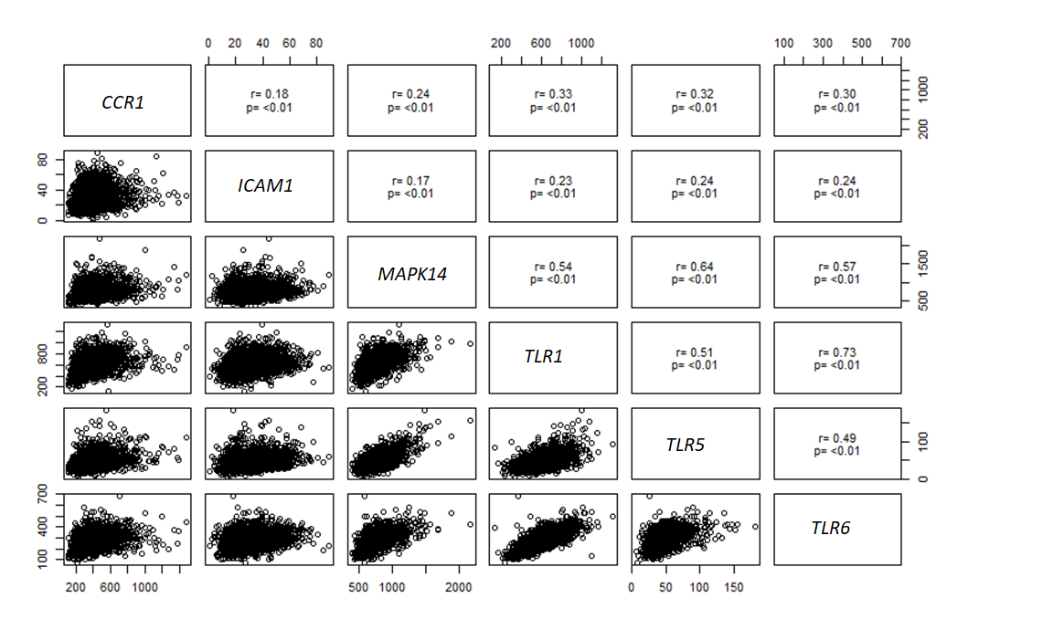
Note: r is the pearson correlation coefficient between the genes.

