Investigation on the Electrochemical Performances of Mn₂O₃ as a Potential Anode for Na-Ion Batteries
Nor Fazila Mahamad Yusoffª, Nurul Hayati Idris^{a,}* , Mohd Faiz Md Din^{b}, Siti Rohana Majid^{c}, Noor Aniza Harun^{d} and Md Mokhlesur Rahman^{e,}*
ª Energy Storage Research Group, Faculty of Ocean Engineering Technology and Informatics, Universiti Malaysia Terengganu 21300 Kuala Nerus, Terengganu, Malaysia
^{b} Department of Electrical and Electronic Engineering, Faculty of Engineering, National Defence University of Malaysia , Kem Sungai Besi, 57000 Kuala Lumpur, Malaysia
^{c} Center for Ionics University of Malaya, Department of Physics, Faculty of Science, University of Malaya 50603 Kuala Lumpur, Malaysia
^{d} Advance Nano Materials (ANOMA) Research Group, Faculty of Science and Marine Environment, Universiti Malaysia Terengganu 21300 Kuala Nerus, Terengganu, Malaysia
^{e} Institute for Frontier Materials, Deakin University, Waurn Ponds, Victoria 3216, Australia

*Corresponding authors
Tel.: +60 96683185; fax: +6096683391.
E-mail address: nurulhayati@umt.edu.my (N. H. Idris)
m.rahman@deakin.edu.au (M. M. Rahman)
Supporting information
Table S1. Rietveld refinement results of the MnCO₃ and Mn₂O₃. The standard errors derived from the refinements are also listed in lattice columns.
Sample | a (Å) | c (Å) | Bragg R_{factor} (%) | R_{f factor}  (%) | χ²
MnCO₃ (C) | 4.8045 (3) | 15.6891(8) | 9.45 | 5.65 | 0.846
MnCO₃ (S) | 4.8019 (2) | 15.6798(1) | 6.70 | 4.81 | 0.736
Mn₂O₃(C600) | 9.3996 (0) | - | 3.93 | 3.91 | 2.760
Mn₂O₃ (S500) | 9.3990 (0) | - | 6.39 | 6.33 | 7.740
Mn₂O₃ (S600) | 9.4043 (3) | - | 7.34 | 5.88 | 0.892
Mn₂O₃ (S700) | 9.4057 (3) | - | 7.63 | 7.86 | 0.600

Table S2. The specific surface area of Mn₂O₃ samples.
Sample | BET surface area (m²/g)
Mn₂O₃ (C600) | 13.3268
Mn₂O₃ (S500) | 27.5512
Mn₂O₃ (S600) | 20.2528
Mn₂O₃ (S700) | 10.1416

Fig. S1.

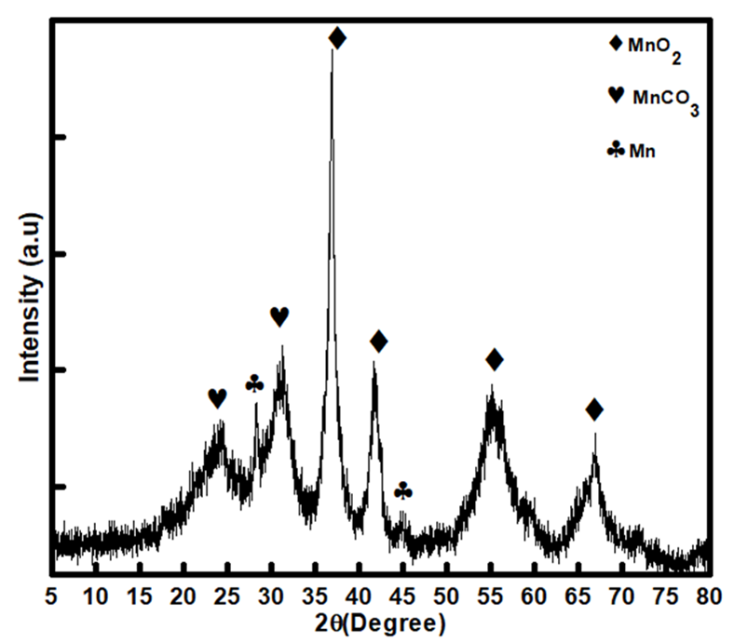
Fig. S1. XRD pattern of the MnCO₃ (C) sample calcined at 300°C.

Fig. S2.

Fig. S2. SEM images of (a) MnCO₃ (C) and (b) MnCO₃(S).

Fig. S3.

Fig. S3. TEM image of Mn₂O₃ (S600).

Fig. S4.

Fig. S4. HRTEM image for sample of Mn₂O₃ (S600).
Fig. S5.
Fig. S5. N₂ adsorption-desorption isotherms and BJH pore-size distribution curves (inset) of (a) Mn₂O₃ (C600), (b) Mn₂O₃ (S500), (c) Mn₂O₃ (S600), and Mn₂O₃ (S700).

Fig. S6.
Fig. S6. CV curves of (a) Mn₂O₃ (C600), (b) Mn₂O₃ (S500), (c) Mn₂O₃ (S600), and (d) Mn₂O₃ (S700) at a scan rate of 0.3 mV s⁻¹ (versus Na/Na⁺).

Fig. S7.
Fig. S7. Ex-situ XRD patterns of Mn₂O₃ electrode obtained at different charge-discharge state.

