the impact of stress caused by LiGHT PENETRATION AND AGROTECHNOLOGICAL TOOLS on photosynthetic behavior of apple trees
Kristina LAUŽIKĖ^{*1}, Vaida SIRGEDAITĖ-ŠĖŽIENĖ², Nobertas USELIS¹, Giedrė SAMUOLIENĖ¹

¹Institute of Horticulture, Lithuanian Research Centre for Agriculture and Forestry, Kauno 30, Babtai, Kaunas distr., Lithuania
²Institute of Forestry, Lithuanian Research Centre for Agriculture and Forestry, Liepų str. 1, LT-53101 Girionys, Kaunas District, Lithuania
*Corresponding author: K.Lauzike@lsdi.lt ORCID ID 0000-0002-8821-1245

Supplementary data.

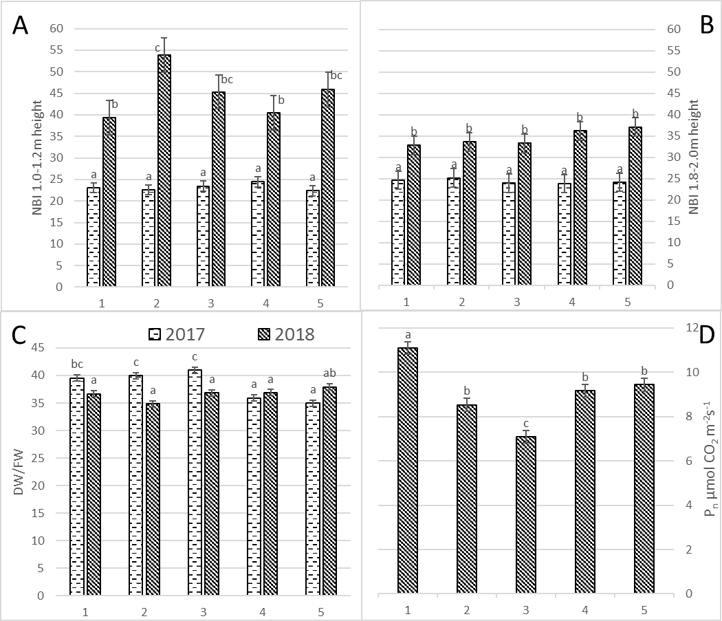
Fig. S1
Nitrogen balance index (NBI) (A – 1,8-2,0 m height, B – 1,0-1,2 m height), dry to fresh weight ratio (DW/FW) (C) and photosynthetic rate (P_{N}) (D) in apple trees on harvest time during two years. 1. Each year hand pruning forming slender spindle (control); 2. Mechanical pruning (each year) with hand pruning every second year; 3. Mechanical pruning (each year); 4. Trunk incision using chain saw + mechanical pruning (each year); 5. Mechanical pruning (each year) + spraying with calcium-prohexadione. Averages followed by different letter within the same figure indicate significant differences according to the Duncan’s least significant difference test (P < 0.05).

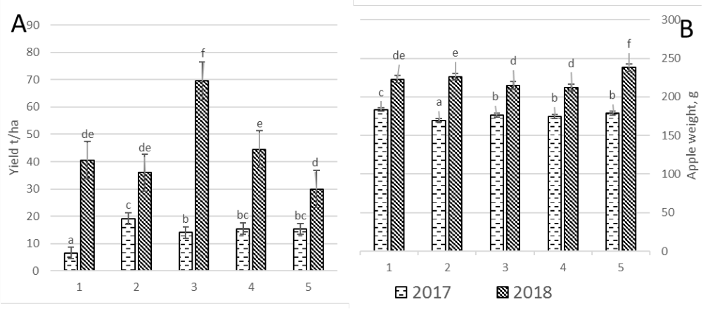
Fig. S2
Variation of total yield t/ha (A) and apple weight g (B) during treatment years. 1. Each year hand pruning forming slender spindle (control); 2. Mechanical pruning (each year) with hand pruning every second year; 3. Mechanical pruning (each year); 4. Trunk incision using chain saw + mechanical pruning (each year); 5. Mechanical pruning (each year) + spraying with calcium-prohexadione Averages followed by different letter within the same figure indicate significant differences according to the Duncan’s least significant difference test (P < 0.05).

