SUPPLEMENTARY MATERIAL FOR Untargeted lipidomics using liquid chromatography – ion mobility– mass spectrometry reveals novel triacylglycerides in human milk
AUTHORS Alexandra D. George, Melvin C.L. Gay, Mary E. Wlodek, Robert D. Trengove, Kevin Murray, Donna T. Geddes
Page 1: Online repository details for untargeted human milk triacylglyceride analysis
Repository can be found here https://github.com/ADGEORGElipidomics/TAG-search and contains:
In-house R script
HM TAG list
HM TAG example raw data set
Page 2: Supplementary Figure 1A
Page 3: Supplementary Figure 1B

Supplementary tables are in excel file
Table 1: Analytical characteristics of the 205 triacylglycerides identified in human milk and example reference if previously published
Table 2: Human milk triacylglycerides with significant concentration changes throughout the morning feed
Table 3: Human milk triacylglycerides with significant concentration changes throughout the evening feed
Table 4: Average concentrations of all 205 triacylglycerides identified in each sample type
Table 5: Average infant daily dose for the 205 triacylglycerides identified

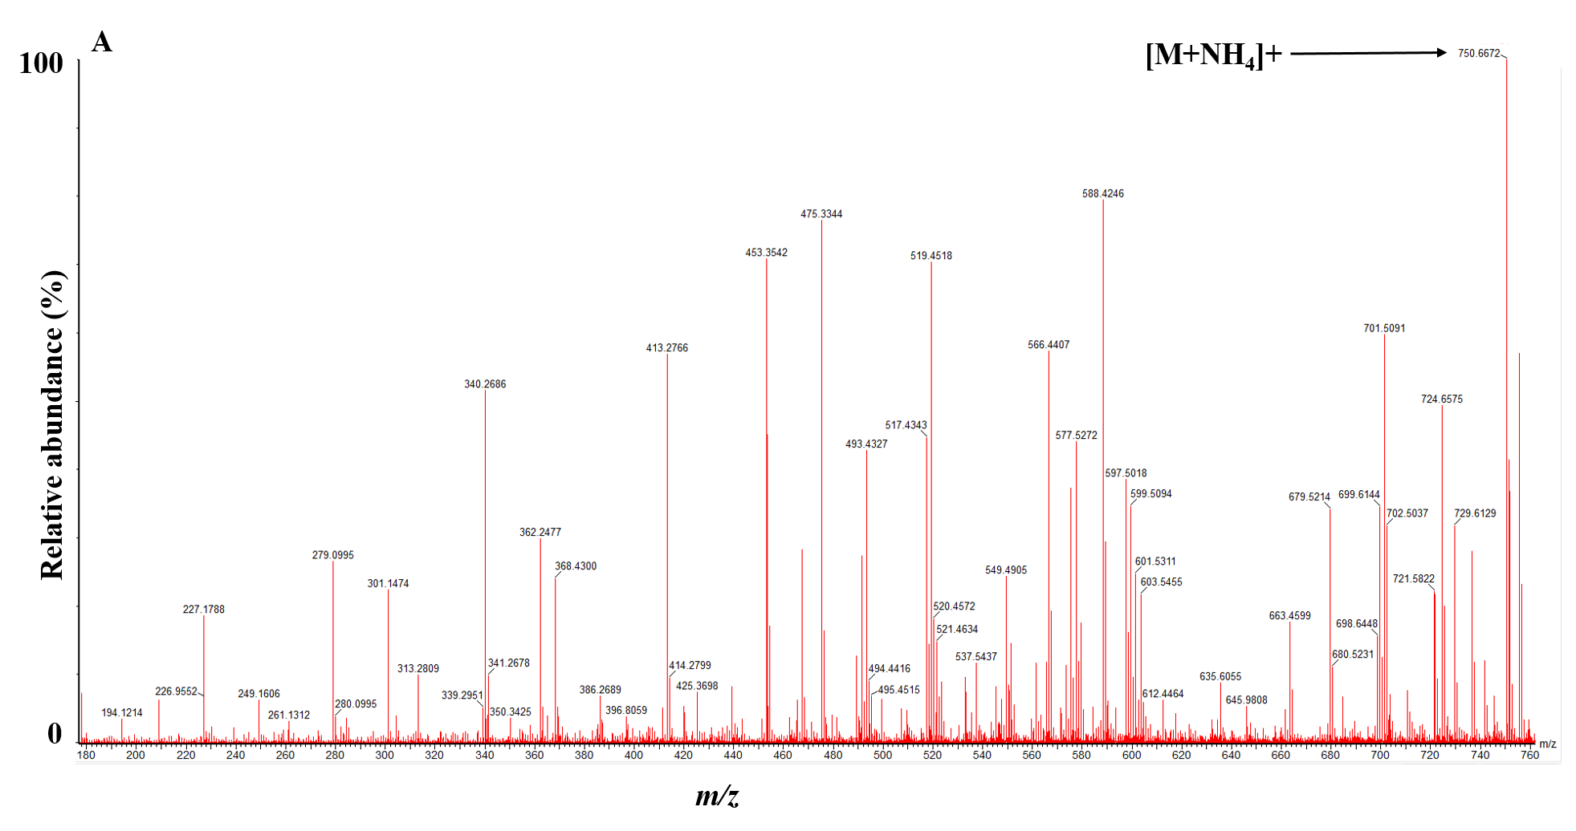Supplementary Figure 1. A) Mass spectra for TAG(12:0_/17:1/_14:1) (TAG192) from m/z 180 to 760 at 15.3 minutes, with low collision energy (20eV). Maximum (100%) abundance is 2.34e4. Ammonium adduct precursor ion is present, m/z 750.6672. Spectra contains many overlapping ions.

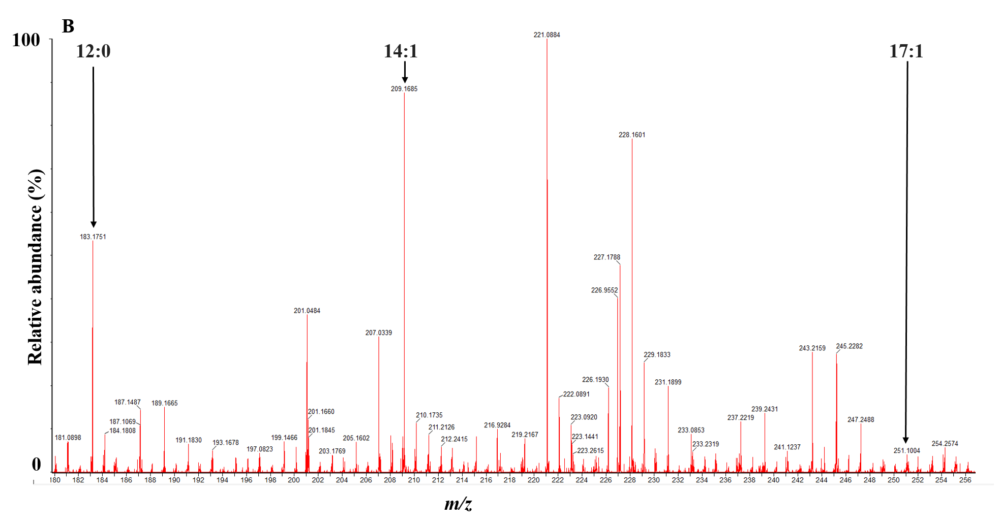
Supplementary Figure 1. B) Corresponding mass spectra for TAG(12:0_/17:1/_14:1) (TAG192) with high collision energy (55eV), from m/z 180 to 256. Maximum (100%) abundance is 4.17e3. When fragment ions for this TAG are searched, the most abundant is m/z 209.1685 [CH₃(CH₂)₄CH=CH(CH₂)₆C=O]⁺ for FA 14:1; the second most abundant is m/z 183.1751 [CH₃(CH₂)₁₀C=O]⁺ for FA 12:0; the least abundant is m/z 251.1004 [CH₃(CH₂)₆CH=CH(CH₂)₇C=O]⁺ for FA 17:1. This tentatively identifies 17:1 as the FA in the Sn-2 position.

