Sex- and age-specific effect of energy intake
and physical activity on sarcopenia

Yu Jin Choª, Youn-Hee Lim^{b}, Jae Moon Yoonª, Hyung-Jin Yoon^{c,d}, Minseon Parkª*
a. Department of Family Medicine, Seoul National University, College of Medicine, Seoul, Korea
b. Institute of Environmental Medicine, Seoul National University Medical Research Center, Seoul, Korea
c. Department of Biomedical Engineering, Seoul National University College of Medicine, Seoul, Korea
d. Bio-MAX Institute, Seoul National University, Seoul, Korea

* Corresponding author: Minseon Park, Department of Family Medicine, Seoul National University, Hospital, Seoul National University College of Medicine, 101, Daehak-ro Jongno-gu, Seoul 03080, Korea
Tel: +82-2-2072-3497, Fax: +82-2-766-3276, E-mail: msp20476@hanmail.net
Table S1. Average proportion of energy intake, exercise and physical activity according to age and sex
 | Age < 50 (N=8,092) |  |  | Age ≥ 50 (N=8,221)
Characteristics | Male (N=3,127) | Female (N=4,965) | P-value | Male (N=3,449) | Female (N=4,772) | P-value
Intake:BMR ratio | 1.51±0.53 | 1.42±0.54 | <0.0001 | 1.50±0.51 | 15.50±0.53 | 0.890
Strength exercise
Yes | 1,299 (41.67) | 922 (18.62) |  | 1,124 (32.75) | 622 (13.12)
No | 1,818 (58.33) | 4,030 (81.38) | <0.0001 | 2,308 (67.25) | 4,118 (86.88) | <0.0001
Flexibility exercise
Yes | 1,787 (57.33) | 2,741 (55.35) | 0.081 | 1,661 (48.40) | 1,987 (41.92) | <0.0001
No | 1,330 (42.67) | 2,211 (44.65) |  | 1,771 (81.60) | 2,753 (58.08)
MET-h/week | 58.06±86.84 | 42.16±68.27 | <0.0001 | 91.63±86.44 | 49.44±83.31 | <0.0001

Figure S1. Predicted physical activity levels according to energy intake
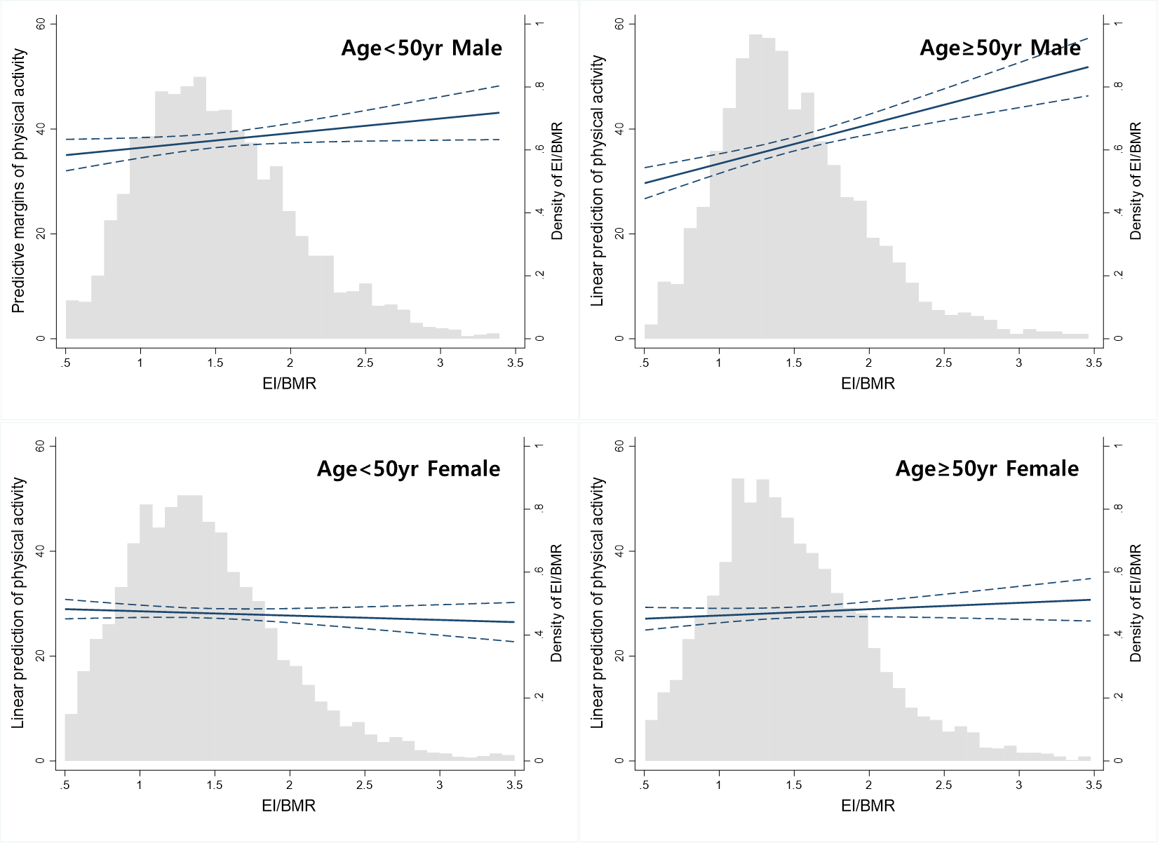

Figure S2. Predicted physical activity levels according to energy intake 