Rapeseed-based diet modulates the imputed functions of gut microbiome in growing-finishing pigs

Özgün Candan Onarman Umu^{1*}: ozgun.umu@nmbu.no
Liv Torunn Mydland²: liv.mydland@nmbu.no
Margareth Øverland²: margareth.overland@nmbu.no
Charles McLean Press³: charles.press@nmbu.no
Henning Sørum¹: henning.sorum@nmbu.no

¹Department of Paraclinical Sciences, Faculty of Veterinary Medicine, Norwegian University of Life Sciences, Oslo, Norway.
²Department of Animal and Aquacultural Sciences, Faculty of Biosciences, Norwegian University of Life Sciences, Ås, Norway
³Department of Preclinical Sciences and Pathology, Faculty of Veterinary Medicine, Norwegian University of Life Sciences, Oslo, Norway
*Corresponding author

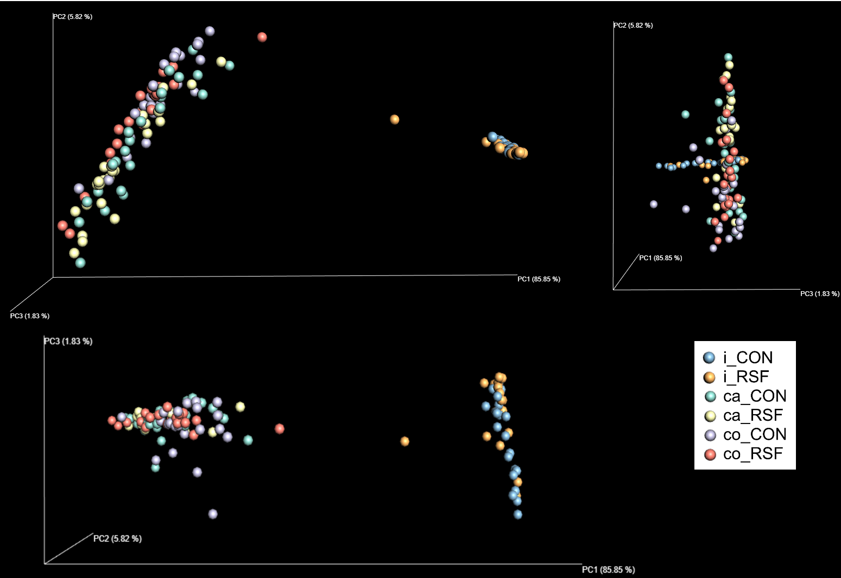

Figure S1. Bacterial compositions in ileum, caecum and colon of CON- and RSF-fed pigs based on the calculated distances in the weighted UniFrac matrix. Samples were grouped by color based on the gut location and feed type. i, ileum; ca, caecum; co, colon.

