Supplementary Materials

Lifestyle risk score and mortality in Korean adults: a population-based cohort study

Dong Hoon Lee^{1*}, Jin Young Nam^{2*}, Sohyeon Kwon², NaNa Keum^{1,3}, Jong-Tae Lee^{2,4}, Min-Jeong Shin^{2,5}, Hannah Oh^{2,4}

¹ Department of Nutrition, Harvard T.H. Chan School of Public Health, Boston, MA, USA
² Department of Public Health Sciences, BK21PLUSProgram in Embodiment: Health-Society Interaction, Graduate School, Korea University, Seoul, Republic of Korea
³ Department of Food Science and Biotechnology, Dongguk University, Goyang, South Korea
⁴ Division of Health Policy and Management, College of Health Sciences, Korea University, Seoul, Republic of Korea
⁵ Division of Biosystems and Biomedical Sciences, College of Health Sciences, Korea University, Seoul, Republic of Korea

Supplementary Table 1. General participant characteristics according to lifestyle score with missing vs non-missing value from 2007 to 2014
 |  | Missing |  | Non-missing
 |  | N | % | N | %
Lifestyle score | 0 | 437 | 9.73 | 6912 | 18.5
 | 1 | 1066 | 23.75 | 14086 | 35.6
 | 2 | 1894 | 42.19 | 10951 | 29.2
 | 3 | 991 | 22.08 | 4429 | 11.8
 | 4-5 | 101 | 2.25 | 1094 | 2.9
Sex | Men | 1956 | 43.6 | 15827 | 42.2
 | Women | 2533 | 56.4 | 21645 | 57.8
Age group | 19-44 | 1753 | 39.1 | 16620 | 44.4
 | 45-64 | 1495 | 33.3 | 13299 | 35.5
 | 65+ | 1241 | 27.7 | 7553 | 20.2
Education | < High school | 1181 | 26.3 | 12825 | 34.2
 | High school | 932 | 20.8 | 13185 | 35.2
 | College or higher | 689 | 15.4 | 11407 | 30.4
 | Missing | 1687 | 37.6 | 55 | 0.2
Income | Q1 | 1018 | 22.7 | 6778 | 18.1
 | Q2-Q3 | 2179 | 48.5 | 19749 | 52.7
 | Q4 | 1037 | 23.1 | 10505 | 28.0
 | Missing | 255 | 5.7 | 440 | 1.2
Occupation | White collar | 498 | 11.1 | 7971 | 21.3
 | Blue collar | 988 | 22.0 | 14707 | 39.3
 | Unemployed | 1268 | 28.3 | 14645 | 39.1
 | Missing | 1735 | 38.7 | 149 | 0.4
Residential area | Metropolitan area | 2669 | 59.5 | 23808 | 63.5
 | Small cities | 692 | 15.4 | 6368 | 17.0
 | Rural areas | 1128 | 25.1 | 7296 | 19.5
Marital status | Married | 3105 | 69.2 | 26950 | 71.9
 | Single, divorced, separated, widowed | 1237 | 27.6 | 10446 | 27.9
 | Missing | 147 | 3.3 | 76 | 0.2

Supplementary Table 2. The Pearson correlation coefficient among lifestyle risk behavior factors.
 |  | Smoking | Alcohol intake | Unhealthy Weight | Inadequate physical activity | Insufficient/prolonged sleep
Total | Smoking | 1
Total | Alcohol consumption | 0.276*** | 1
Total | Unhealthy Weight | 0.023*** | 0.05*** | 1
Total | Inadequate physical activity | -0.018*** | -0.03*** | 0.002 | 1
Total | Insufficient/ prolonged sleep | -0.003 | 0.004 | 0.027*** | 0.015** | 1
Men | Smoking | 1
Men | Alcohol consumption | 0.175*** | 1
Men | Unhealthy Weight | -0.001 | 0.067*** | 1
Men | Inadequate physical activity | 0.042*** | -0.013 | -0.003 | 1
Men | Insufficient/ prolonged sleep | -0.012 | 0.008 | 0.016* | 0.009 | 1
Women | Smoking | 1
Women | Alcohol consumption | 0.219*** | 1
Women | Unhealthy Weight | -0.001 | -0.002 | 1
Women | Inadequate physical activity | 0.006 | -0.002 | 0.013 | 1
Women | Insufficient/ prolonged sleep | 0.028*** | 0.010 | 0.036*** | 0.018** | 1
*P<0.05, **P<0.01, ***P<0.001

Supplementary Table 3. Hazard ratios (HRs) and 95% confidence intervals (CIs) for the associations between lifestyle risk score and all-cause mortality, after adding sodium and total dietary fat intake into lifestyle risk score calculation
 |  | Score with sodium intake ª |  |  |  |  | Score with total dietary fat intake ^{b}
 |  | PY | N | HR | 95% CI |  | PY | N | HR | 95% CI
Lifestyle risk score | 0 | 5115 | 20 | 1.00 |  |  | 30578 | 97 | 1.00
 | 1 | 42757 | 185 | 1.16 | 0.70 | 1.92 | 67293 | 367 | 1.38 | 1.10 | 1.72
 | 2 | 69968 | 345 | 1.17 | 0.72 | 1.89 | 58100 | 302 | 1.24 | 0.99 | 1.56
 | 3 | 49341 | 279 | 1.23 | 0.75 | 2.02 | 25205 | 156 | 1.70 | 1.32 | 2.21
 | 4 | 17964 | 113 | 1.55 | 0.93 | 2.58 | 6902 | 41 | 1.88 | 1.30 | 2.72
 | 5-6 | 4139 | 28 | 2.01 | 1.10 | 3.66 | 1207 | 7 | 3.32 | 1.64 | 6.70
Adjusted for sex, age, educational level, income, occupation, regional area, and marital status.
ª Lifestyle risk score calculated based on current smoking, high-risk alcohol drinking, obesity, physical activity, sleep duration, and sodium intake
^{b} Lifestyle risk score calculated based on current smoking, high-risk alcohol drinking, obesity, physical activity, sleep duration, and total dietary fat intake

Supplementary Table 4. Hazard ratios (HRs) and 95% confidence intervals (CIs) for the associations between lifestyle risk score and all-cause mortality, using different definition of sleep as a risk factor
 |  | Sleeping for <7 or 9≥h |  |  | Sleeping for <7h |  |  | Sleeping for 9≥h
 |  | HR | 95% CI |  | HR | 95% CI |  | HR | 95% CI
Lifestyle scores | 0 | 1.00 |  |  | 1.00 |  |  | 1.00
Lifestyle scores | 1 | 1.31 | 1.07 | 1.60 | 1.19 | 1.00 | 1.42 | 1.15 | 0.98 | 1.34
Lifestyle scores | 2 | 1.21 | 0.98 | 1.48 | 1.08 | 0.89 | 1.31 | 1.43 | 1.20 | 1.70
Lifestyle scores | 3 | 1.72 | 1.36 | 2.18 | 1.60 | 1.27 | 2.02 | 1.51 | 1.16 | 1.97
Lifestyle scores | 4-5 | 2.01 | 1.43 | 2.82 | 1.50 | 1.01 | 2.24 | 3.20 | 2.04 | 5.02

Supplementary Table 5. Combination of lifestyle risk behavior factors on mortality from 2007 to 2014
No. | Lifestyle risk behavior |  |  |  |  | Total |  | All-cause mortality
No. | SM | A | W | P | SP | Cohort N | % | Person-year | death N | HR* | 95% CI
5 | 1 | 1 | 1 | 1 | 1 | 91 | 0.2 | 457.1 | 4 | 4.74 | 1.66 | 13.52
4 | 1 | 1 | 1 | 1 | 0 | 123 | 0.3 | 653.7 | 1 | 1.59 | 0.22 | 11.51
4 | 1 | 1 | 1 | 0 | 1 | 369 | 1.0 | 2230.0 | 7 | 1.55 | 0.69 | 3.45
4 | 1 | 1 | 0 | 1 | 1 | 123 | 0.3 | 680.4 | 8 | 3.28 | 1.20 | 8.94
4 | 1 | 0 | 1 | 1 | 1 | 280 | 0.8 | 1459.7 | 21 | 1.99 | 1.29 | 3.08
4 | 0 | 1 | 1 | 1 | 1 | 108 | 0.3 | 547.5 | 2 | 1.44 | 0.39 | 5.31
3 | 1 | 1 | 1 | 0 | 0 | 350 | 0.9 | 2171.4 | 6 | 1.73 | 0.75 | 3.99
3 | 1 | 1 | 0 | 1 | 0 | 150 | 0.4 | 804.6 | 4 | 2.39 | 0.92 | 6.22
3 | 1 | 1 | 0 | 0 | 1 | 535 | 1.4 | 3199.1 | 20 | 2.49 | 1.45 | 4.26
3 | 1 | 0 | 1 | 1 | 0 | 250 | 0.7 | 1346.4 | 4 | 0.91 | 0.36 | 2.29
3 | 1 | 0 | 1 | 0 | 1 | 781 | 2.1 | 4648.2 | 24 | 1.67 | 1.07 | 2.62
3 | 1 | 0 | 0 | 1 | 1 | 452 | 1.2 | 2359.7 | 32 | 2.22 | 1.45 | 3.40
3 | 0 | 1 | 1 | 1 | 0 | 92 | 0.3 | 446.8 | 1 | 1.53 | 0.27 | 8.70
3 | 0 | 1 | 1 | 0 | 1 | 360 | 1.0 | 2089.1 | 7 | 1.32 | 0.61 | 2.85
3 | 0 | 1 | 0 | 1 | 1 | 119 | 0.3 | 626.2 | 6 | 2.49 | 1.07 | 5.77
3 | 0 | 0 | 1 | 1 | 1 | 1340 | 3.6 | 6863.4 | 61 | 1.53 | 1.12 | 2.11
2 | 1 | 1 | 0 | 0 | 0 | 527 | 1.4 | 3220.6 | 14 | 2.15 | 1.23 | 3.77
2 | 1 | 0 | 1 | 0 | 0 | 803 | 2.1 | 4846.1 | 22 | 1.76 | 1.13 | 2.74
2 | 1 | 0 | 0 | 1 | 0 | 430 | 1.2 | 2260.6 | 18 | 1.74 | 1.07 | 2.84
2 | 1 | 0 | 0 | 0 | 1 | 1277 | 3.4 | 7682.3 | 52 | 1.48 | 1.06 | 2.05
2 | 0 | 1 | 1 | 0 | 0 | 346 | 0.9 | 2134.8 | 3 | 0.53 | 0.17 | 1.71
2 | 0 | 1 | 0 | 1 | 0 | 126 | 0.3 | 653.0 | 1 | 0.42 | 0.05 | 3.53
2 | 0 | 1 | 0 | 0 | 1 | 442 | 1.2 | 2662.2 | 10 | 1.15 | 0.59 | 2.23
2 | 0 | 0 | 1 | 1 | 0 | 1148 | 3.1 | 6077.4 | 30 | 1.19 | 0.78 | 1.80
2 | 0 | 0 | 1 | 0 | 1 | 3573 | 9.5 | 21178.0 | 81 | 0.89 | 0.68 | 1.18
2 | 0 | 0 | 0 | 1 | 1 | 2279 | 6.1 | 11847.5 | 96 | 1.30 | 0.99 | 1.70
1 | 1 | 0 | 0 | 0 | 0 | 1438 | 3.8 | 8574.0 | 61 | 1.89 | 1.40 | 2.56
1 | 0 | 1 | 0 | 0 | 0 | 444 | 1.2 | 2734.1 | 11 | 1.48 | 0.79 | 2.80
1 | 0 | 0 | 1 | 0 | 0 | 3513 | 9.4 | 20687.9 | 71 | 1.08 | 0.81 | 1.45
1 | 0 | 0 | 0 | 1 | 0 | 2361 | 6.3 | 12656.2 | 61 | 1.56 | 1.14 | 2.13
1 | 0 | 0 | 0 | 0 | 1 | 6330 | 16.9 | 36596.3 | 202 | 1.21 | 0.97 | 1.52
0 | 0 | 0 | 0 | 0 | 0 | 6912 | 18.5 | 40752.2 | 116 | 1.00
SM, smoking; A, high-risk alcohol drinking; W, unhealthy weigh; P, inadequate physical activity; SP, insufficient/prolonged sleep.

Supplementary Table 6. Hazard ratios (HRs) and 95% confidence intervals (CIs) for associations between the all-cause, cancer, and cardiovascular disease mortality and lifestyle risk behaviors excluding deaths within first 3 years.
 |  | All-cause mortality |  |  |  |  | Cardiovascular disease mortality |  |  |  |  | Cancer mortality
 |  | PY | N | HR | 95% CI |  | PY | N | HR | 95% CI |  | PY | N | HR | 95% CI
Lifestyle scores | 0 | 40709 | 94 | 1.00 |  |  | 40709 | 19 | 1.00 |  |  | 40709 | 40 | 1.00
 | 1 | 80968 | 272 | 1.10 | 0.88 | 1.37 | 80968 | 49 | 0.94 | 0.55 | 1.59 | 80968 | 99 | 0.95 | 0.67 | 1.36
 | 2 | 62334 | 221 | 1.02 | 0.81 | 1.29 | 62334 | 45 | 1.00 | 0.58 | 1.72 | 62334 | 74 | 0.84 | 0.57 | 1.23
 | 3 | 24428 | 104 | 1.43 | 1.08 | 1.90 | 24428 | 25 | 1.74 | 0.97 | 3.11 | 24428 | 29 | 0.94 | 0.58 | 1.51
 | 4-5 | 6001 | 29 | 1.80 | 1.20 | 2.69 | 6001 | 7 | 2.32 | 0.95 | 5.66 | 6001 | 3 | 0.48 | 0.15 | 1.56
P for trend ª |  | 0.01 |  |  |  |  | 0.03 |  |  |  |  | 0.27
Adjusted for sex, age, educational level, income, occupation, regional area, and marital status.
ª P for interaction adjusting covariates

Supplementary Figure 1. Cumulative all-cause, cardiovascular disease (CVD), and cancer mortality according to combined lifestyle risk score
- All-cause mortality
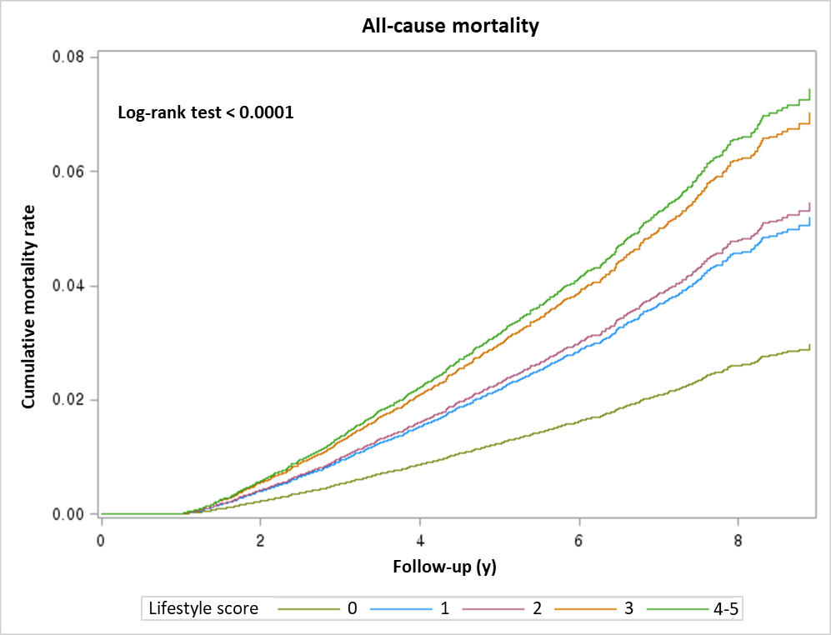

- CVD mortality
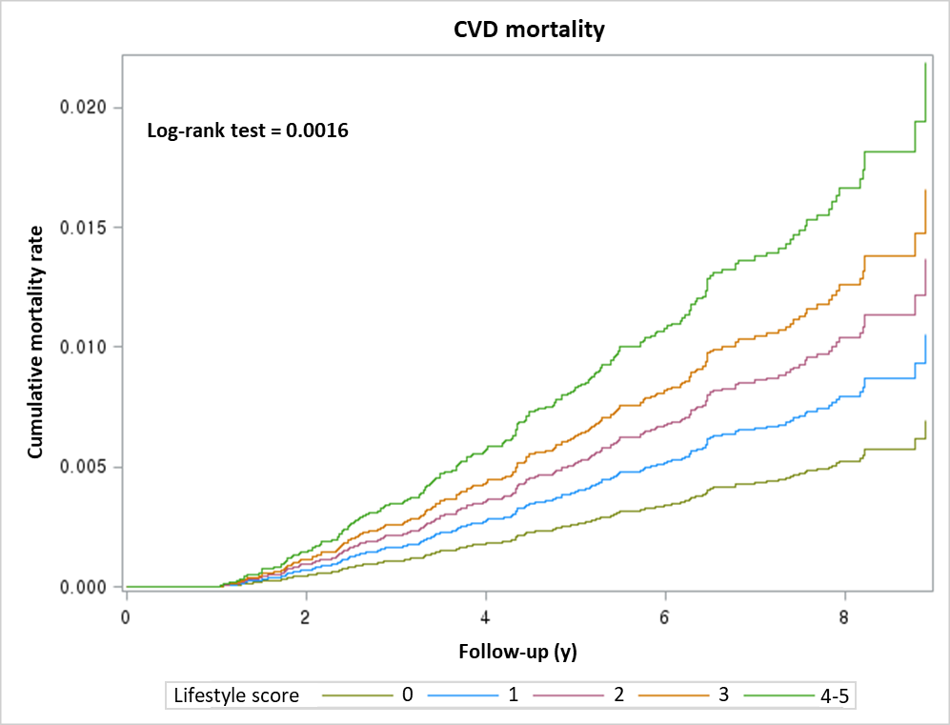

- Cancer mortality
