MANUSCRIPT TITLE:
Distinct abdominal and gluteal adipose tissue transcriptome signatures are altered by exercise training in African women with obesity

AUTHORS:
Pamela A. Nono Nankam^{1,2*}, Matthias Blüher^{2,3}, Stephanie Kehr⁴, Nora Klöting^{2,3}, Knut Krohn⁵, Kevin Adams¹, Peter F. Stadler⁴, Amy E. Mendham^{1,6}, Julia H. Goedecke^{1,6}
AFFILIATIONS:
¹Division of Exercise Science and Sports Medicine, Department of Human Biology, University of Cape Town, Cape Town, South Africa
²Department of Endocrinology, Faculty of Medicine, University of Leipzig, Leipzig, Germany
³Helmholtz Institute for Metabolic, Obesity and Vascular Research (HI-MAG) of the Helmholtz Zentrum München at the University of Leipzig and University Hospital Leipzig
⁴Bioinformatics Group, Department of Computer Science, and Interdisciplinary Center for Bioinformatics, University of Leipzig, Germany
⁵Core Unit DNA-Technologies, Medical Faculty, University Leipzig, Leipzig, Germany
⁶Non-communicable Diseases Research Unit, South African Medical Research Council
Tygerberg, Cape Town, South Africa.

*Correspondence to: pamela.nononankam@medizin.uni-leipzig.de
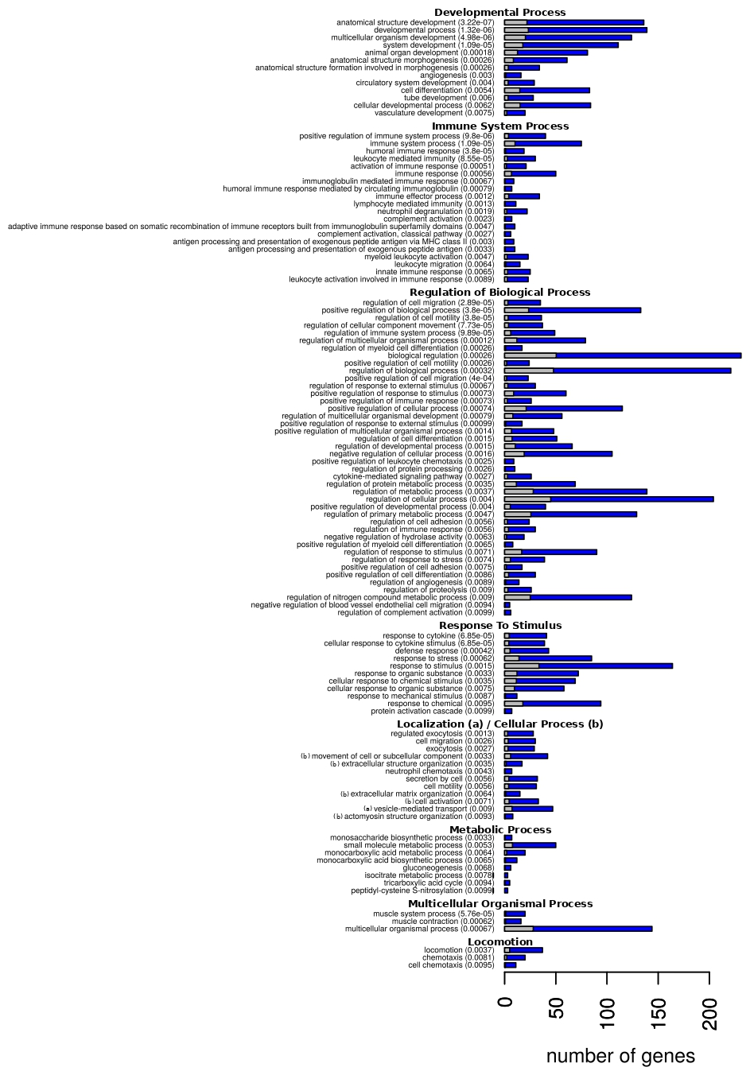 Supplementary figure 1: GO term enrichment of differentially expressed genes between gluteal and abdominal SAT after (B) exercise training.

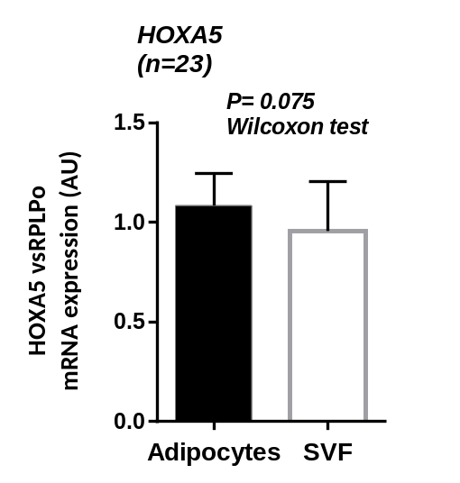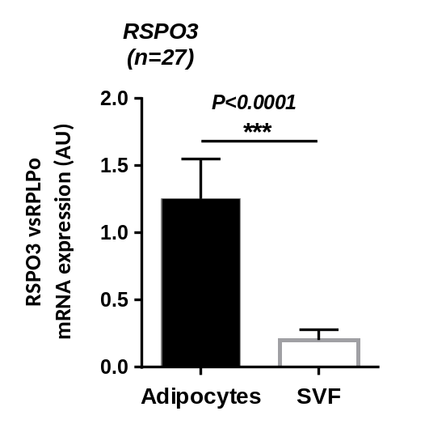
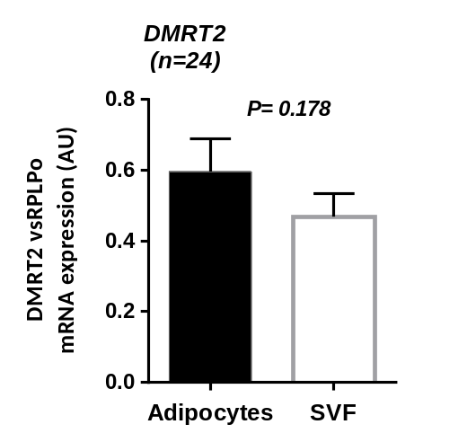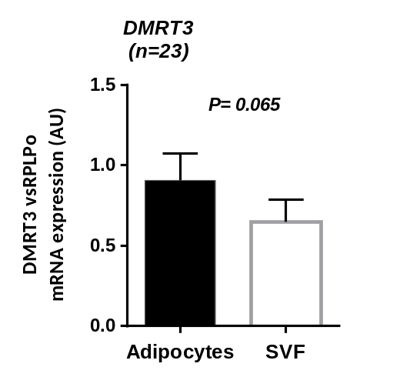
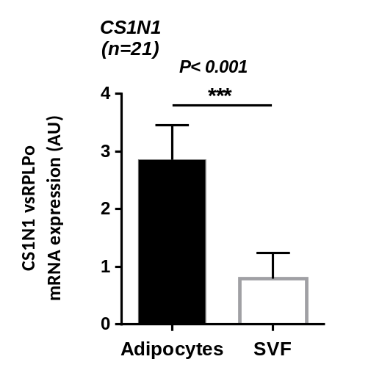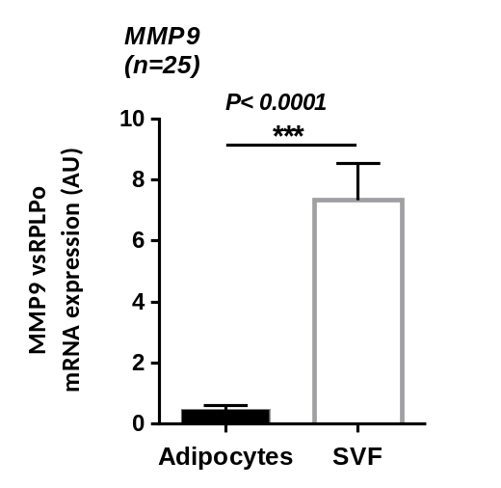
Supplementary Figure 2: mRNA expression in isolated adipocytes and cells of the stromal vascular fraction (SVF) normalized to RPLPo. Data are presented as mean ± SEM; significant differences are marked with *(P < 0.05), **(P < 0.01) or ***(P < 0.0001). AU: arbitrary units; n: number of pairs of adipocytes vs SVF.
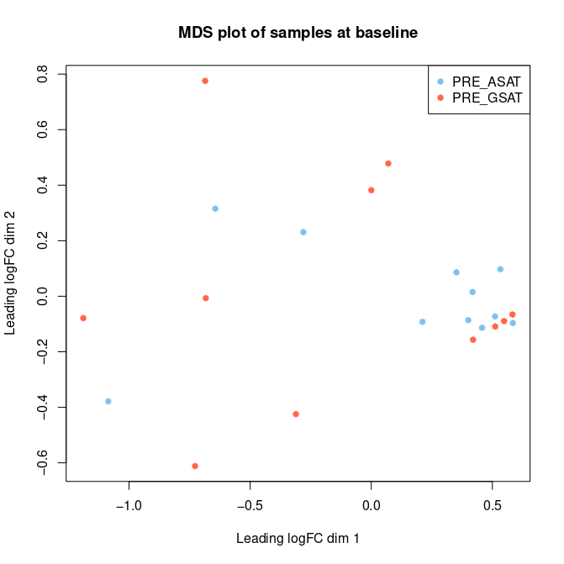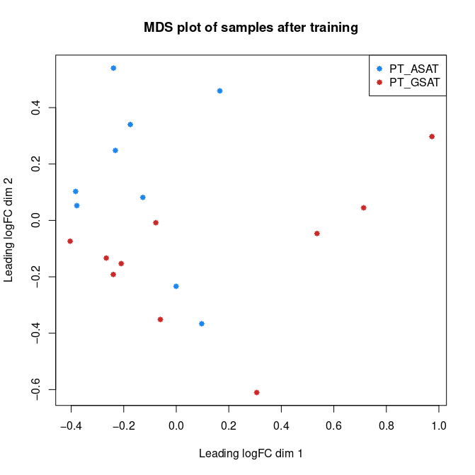
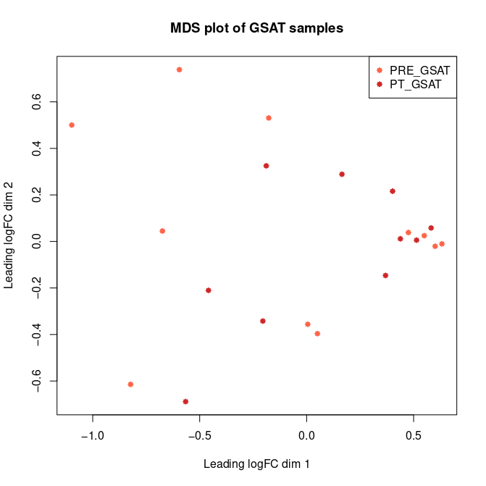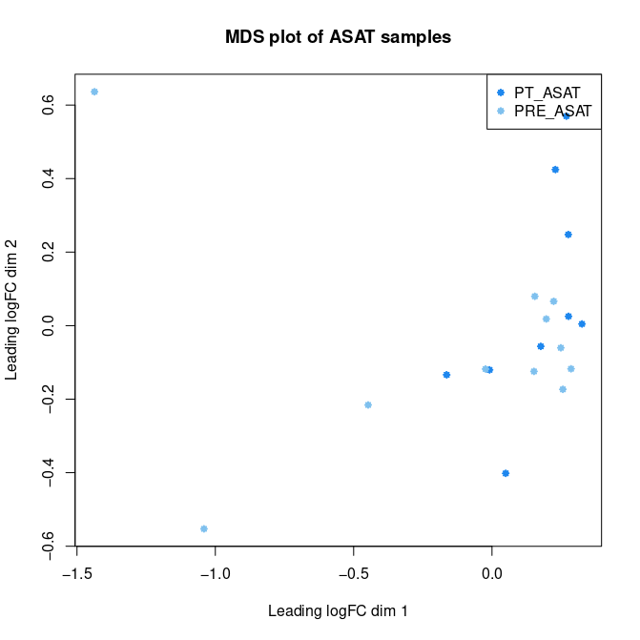
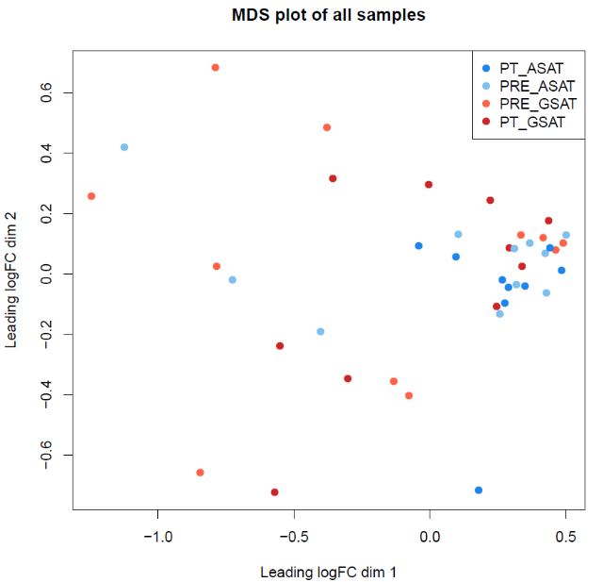
Supplementary Figure 3: Multidimensional scaling (MDS) plots of all samples, at both time points and in each adipose depot. FC: fold change; GSAT: gluteal subcutaneous adipose tissue; ASAT: abdominal subcutaneous adipose tissue; PRE: before exercise training; PT: post-exercise training.

