SupplementaRY materials

Induced tolerance to abiotic and biotic stresses of broccoli and Arabidopsis after treatment with elicitor molecules

Jhon J. Venegas-Molina, Silvia Proietti, Jacob Pollier, Wilson Orozco-Freire, Darío Ramírez-Villacis, and Antonio Leon-Reyes

The following supplementary materials are available for this article:
SUPPLEMENTARY FIGURES:
Figure S1. Representation of the scale of damage of broccoli plants infested with A. monuste caterpillars for 25 days.
Figure S2. Time course experiment of mock and SA-treated broccoli plants under drought stress after 9 days.
SUPPLEMENTARY TABLES:
Table S1. Caterpillar weight five days after elicitor treatment.
Table S2. Caterpillar weight ten days after elicitor treatment.
Table S3. Caterpillar weight fifteen days after elicitor treatment.
Table S4. Caterpillar weight twenty days after elicitor treatment.
Table S5. Pupal weight.
Table S6. Pupal transformation time.

SUPPLEMENTARY FIGURES
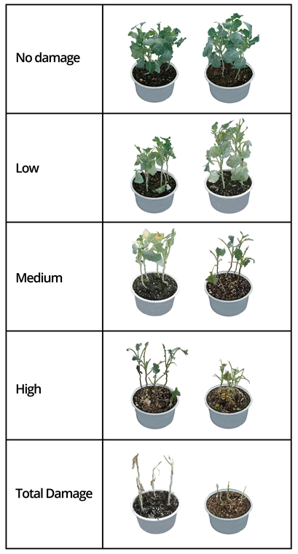
Figure S1. Representation of the scale of damage of broccoli plants infested with A. monuste caterpillars for 25 days. No damage (91 to 100% of leaves), low damage (71 to 90 % of leaves); medium damage (41 to 70% of leaves); high damage (11 to 40% of leaves) and total damage (0 to 10% of leaves) ranges are presented.
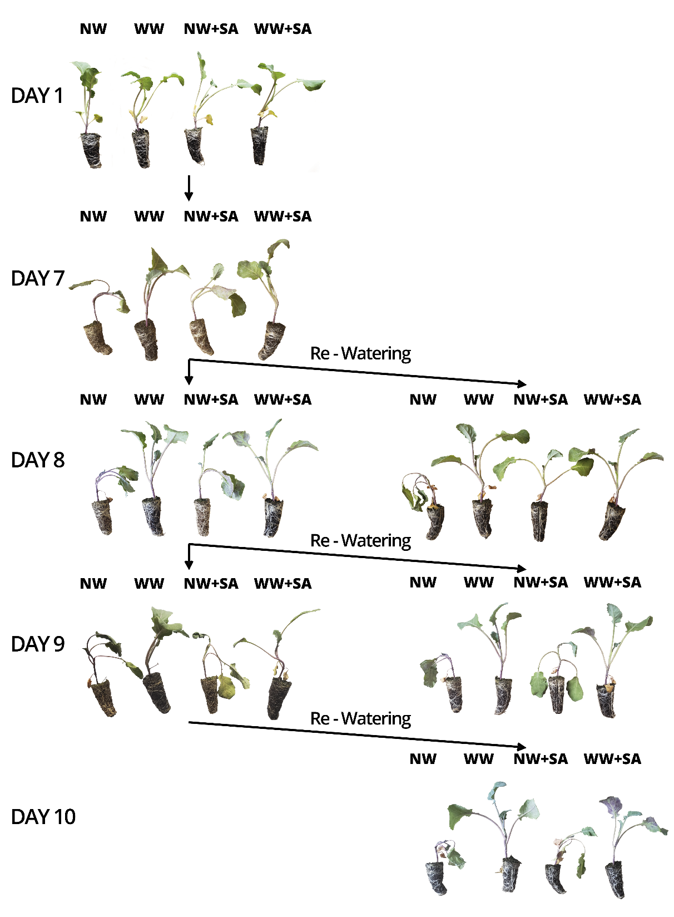
Figure S2. Time course experiment of mock and SA-treated broccoli plants under drought stress after 9 days. A set of plants were re-watered at the end of days 7, 8, and 9 for the evaluation of plant recovery.

SUPPLEMENTARY TABLES
Table S1. Caterpillar weight five days after elicitor treatment.
Treatment | Caterpillar weight (mg) | Standard deviation
Sacch | 5.23 | 0.27
Hx | 5.18 | 0.40
CHT | 5.16 | 0.27
Rib | 5.15 | 0.24
SA | 5.15 | 0.41
BABA | 5.10 | 0.26
Thiam | 5.06 | 0.31
CaP | 5.06 | 0.17
AzA | 5.01 | 0.32
CTR | 5.01 | 0.33
ASM | 5.00 | 0.26
MeJA | 4.95 | 0.43
KP | 4.90 | 0.22
Si | 4.81 | 0.43
MSB | 4.78 | 0.27

Table S2. Caterpillar weight ten days after elicitor treatment.
Treatment | Caterpillar weight (mg) | Standard deviation
BABA | 56.03 | 19.16
SA | 42.33 | 16.68
Rib | 41.17 | 17.81
CaP | 41.12 | 20.98
ASM | 40.93 | 18.02
Thiam | 35.10 | 16.29
Sacch | 32.72 | 10.93
AzA | 32.47 | 15.32
Hx | 32.47 | 13.53
Si | 31.87 | 16.29
KP | 31.03 | 18.76
CHT | 28.27 | 13.94
CTR | 24.60 | 3.90
MSB | 22.95 | 8.08
MeJA | 18.12 | 4.75

Table S3. Caterpillar weight fifteen days after elicitor treatment.
Treatment | Caterpillar weight (mg) | Standard deviation
SA | 105.80 | 12.58
Rib | 95.37 | 31.72
Si | 91.68 | 21.37
Thiam | 91.63 | 20.38
CaP | 90.00 | 19.91
AzA | 84.10 | 17.71
BABA | 82.45 | 23.17
Hx | 79.67 | 16.86
Sacch | 71.75 | 8.88
CHT | 71.72 | 16.99
BTH | 71.42 | 20.93
KP | 70.98 | 17.99
MSB | 68.70 | 15.42
CTR | 65.18 | 8.84
MeJA | 50.83 | 8.79

Table S4. Caterpillar weight twenty days after elicitor treatment.
Treatment | Caterpillar weight (mg) | Standard deviation
Control | 264.92 | 50.41
MeJA | 181.83 | 38.25
Sacch | 269.97 | 28.55
MBS | 270.07 | 35.50
Hx | 273.42 | 60.11
BTH | 282.28 | 33.49
Kphi | 290.87 | 37.55
CHT | 292.70 | 30.28
AzA | 316.95 | 30.50
Rib | 330.60 | 31.47
Si | 344.30 | 35.70
BABA | 339.58 | 42.27
CaPhi | 371.78 | 27.48
Thiam | 375.15 | 41.14
SA | 376.17 | 37.51

Table S5. Pupal weight.
Treatment | Pupal weight (mg) | Standard deviation
Thiam | 323.24 | 24.93
Sa | 308.67 | 18.74
CaPhi | 293.92 | 24.27
AzA | 285.98 | 23.23
BABA | 285.94 | 26.34
Sacch | 282.44 | 20.78
MBS | 280.74 | 19.12
KPhi | 276.78 | 24.26
BTH | 271.03 | 23.15
Ctrl. | 263.25 | 24.65
Rib | 261.45 | 21.03
CHT | 259.53 | 12.71
Hx | 255.48 | 25.84
Si | 254.51 | 24.27
MeJA | 226.37 | 27.26

Table S6. Average time to reach to pupal stage (in days; n = 6).
Treatment | Days to pupa | Standard deviation
MeJA | 28.33 | 1.97
BTH | 27.50 | 2.14
Sacch | 26.83 | 2.11
CHT | 26.50 | 1.50
Si | 26.50 | 1.50
Hx | 26.50 | 1.89
Ctrl | 26.33 | 1.89
KPhi | 25.50 | 1.61
CaPhi | 25.50 | 1.89
MBS | 25.50 | 1.89
Rib | 25.33 | 1.80
BABA | 24.83 | 1.95
Thiam | 24.33 | 1.70
AzA | 23.83 | 2.03
SA | 23.83 | 2.03

Table S7. Statistical analysis of the physiological responses to drought stress of broccoli plants treated with salicylic acid (AS) shown in Figure 8. Data obtained from day one to day ten are presented. The different letters indicate the statistical significance determined by ANOVA (P < 0.001) with a post-hoc Tukey test (P < 0.05).
