Supplemental information for:

AAV8 Ins1-Cre can produce efficient β-cell recombination but requires consideration of off-target effects

Adam Ramzy¹, Eva Tudurí^{1,2,3}, Maria M. Glavas¹, Robert K. Baker¹, Majid Mojibian¹, Jessica K Fox¹, Shannon M O'Dwyer¹, Derek Dai⁴, Xiaoke Hu¹, Heather C. Denroche¹, Nazde Edeer¹, Sarah L Gray⁵, Cameron B Verchere^{4,6}, James D. Johnson^{1,4}, Timothy J. Kieffer^{1,4}

¹ Department of Cellular and Physiological Sciences, Life Sciences Institute, University of British Columbia, Vancouver, British Columbia, Canada.
² Centro de Investigación Biomédica en Red de Diabetes y Enfermedades Metabólicas Asociadas (CIBERDEM), Spain.
³ Instituto de Investigación, Desarrollo e innovación en Biotecnología Sanitaria de Elche (IDiBE), Elche, Spain.
⁴ Department of Surgery, University of British Columbia, Vancouver, British Columbia, Canada.
⁵ Northern Medical Program, University of Northern British Columbia, Prince George, British Columbia, Canada.
⁶ Department of Pathology and Laboratory Medicine, BC Children’s Hospital Research Institute, Vancouver, British Columbia, Canada.

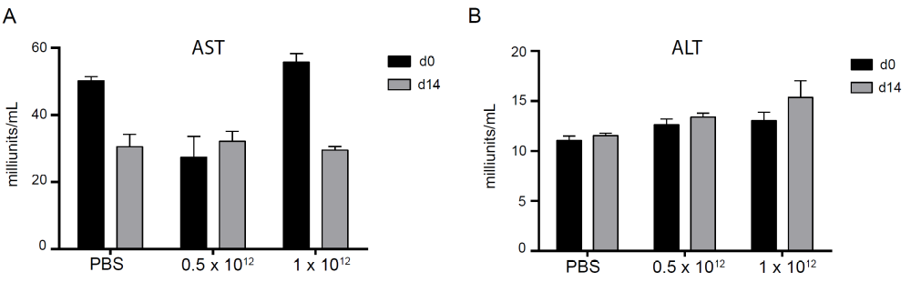
Supplemental Figure 1. AAV Ins1-Cre does not elevate liver enzymes. AST and ALT levels were measured in serum from PBS and AAV Ins1-Cre injected animals before (day 0) and on day 14 relative to virus delivery.

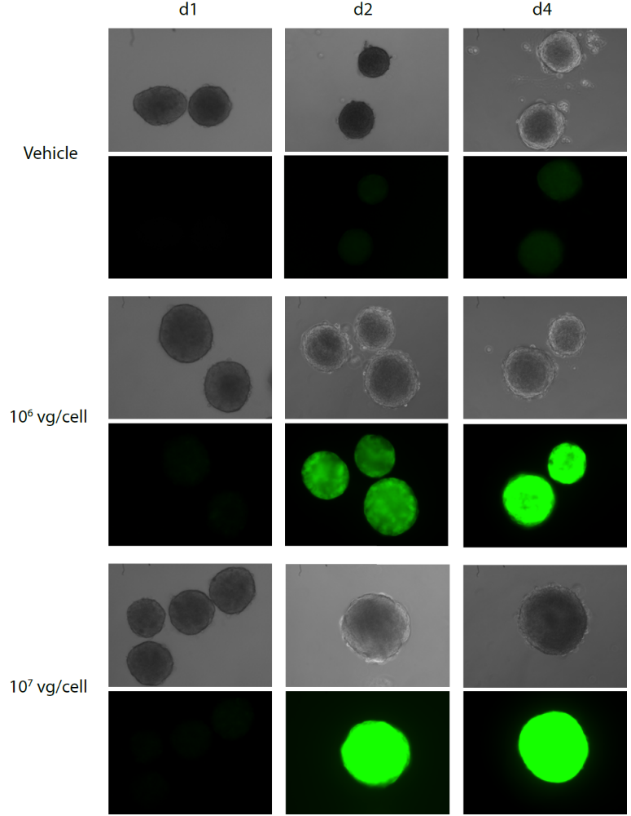
Supplemental Figure 2. AAV Ins1-Cre can infect islets in vitro. Islets from adult reporter mTmG mice were isolated and exposed to 10⁶ VGP and 10⁷ VGP of AAV Ins1-Cre per cell, or PBS, overnight. Endogenous EGFP fluorescence was tracked for the following four days.

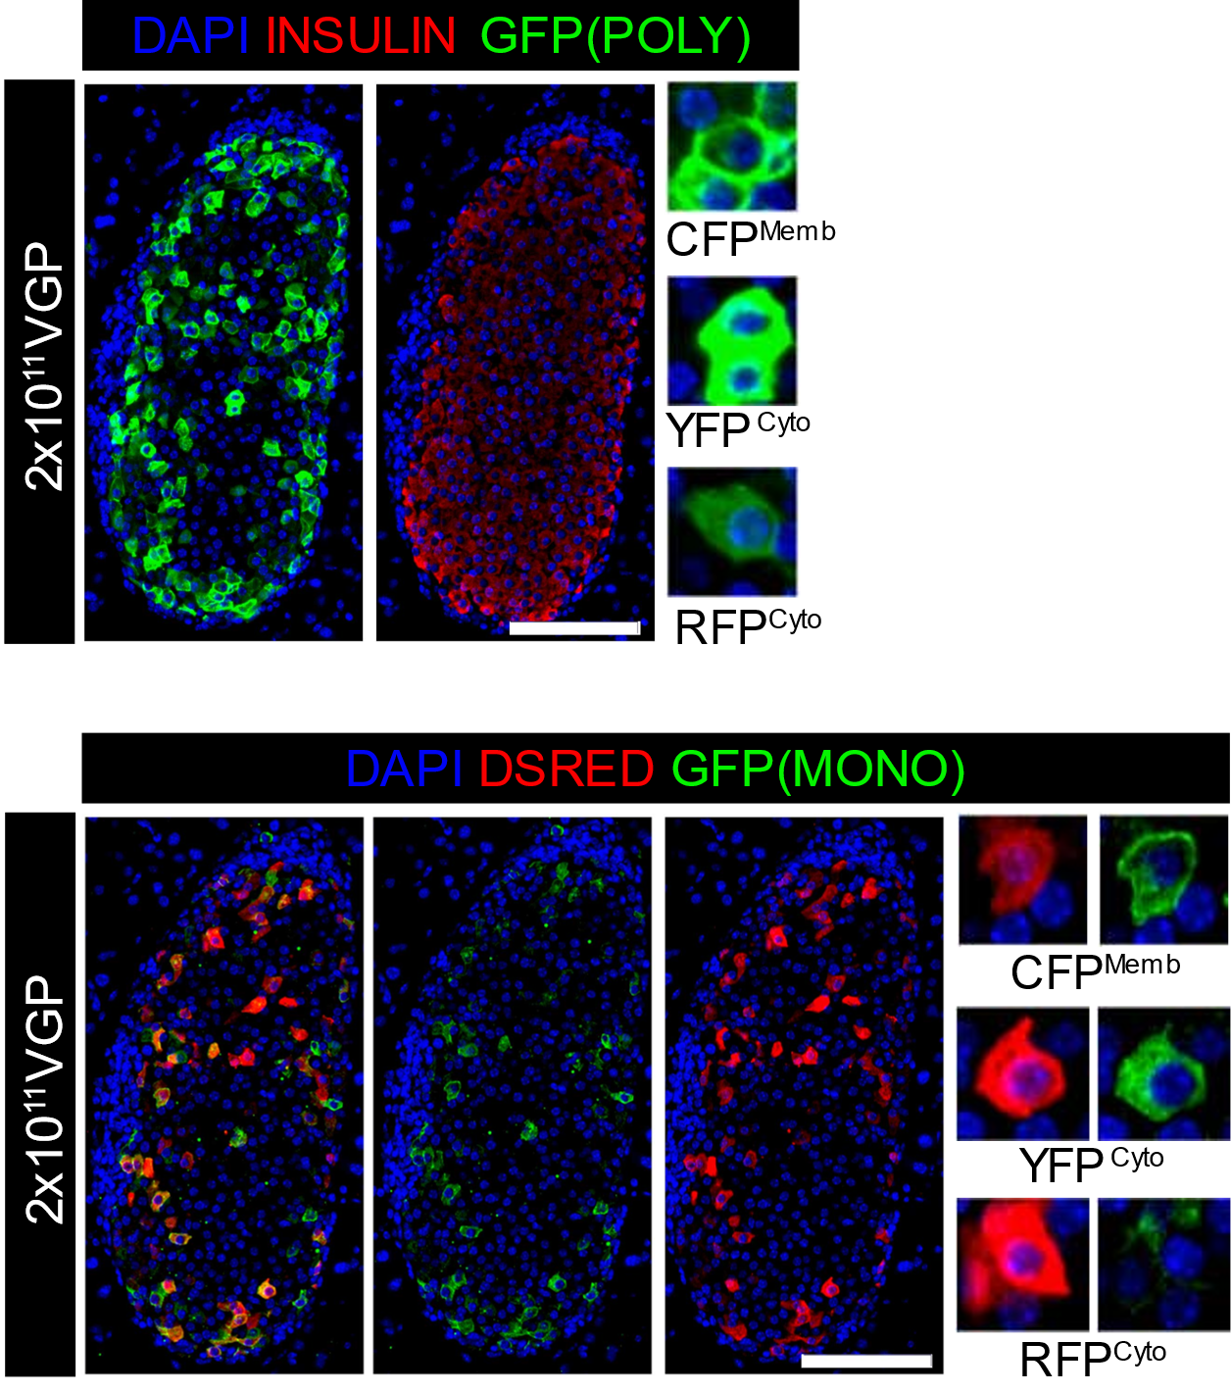
Supplemental Figure 3. High sequence similarity allows detection of different confetti recombination events using a polyclonal α GFP antibody. Pancreas collected from adult confetti mice treated with ID AAV Ins1-Cre was immunostained for fluorescent proteins to identify recombination events yielding nuclear GFP (not clearly observed), cytoplasmic RFP, cytoplasmic YFP, and membranous CFP. Representative images of n=3. Scale bar is 100 μm and insets are enlarged 4x.

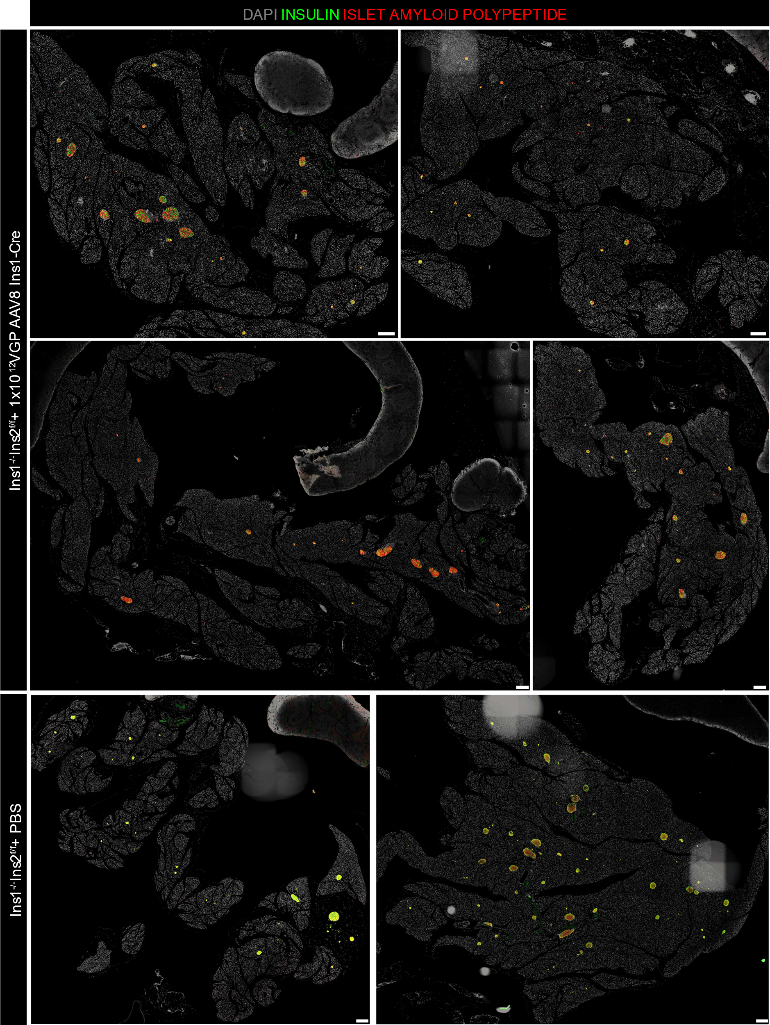
Supplemental Figure 4. AAV8 Ins1-Cre treated Ins1^{-/-};Ins2^{f/f} mice have a normal IAPP+ area but develop heterogenous insulitis. Pancreas collected from Ins1^{-/-};Ins2^{f/f} mice treated with either PBS or 10¹² VGP AAV8 Ins1-Cre was immunostained for insulin and IAPP. Scale bars are 250 μm.
Supplemental Table 1. List of primary antibodies used for Immunohistofluorescence.
Peptide/protein target | Antigen Sequence | Name of Antibody | Manufacturer, catalog #, and/or name of individual providing the antibody |  | Species raised in; monoclonal or polyclonal |  | Dilution used | RRID
CD3 | C-terminus of human CD3 | Rabbit anti-CD3 | Anaspec | 29588 | Rabbit | Polyclonal | 1 to 50 | AB_2275572
CD45 | Unknown | Rat anti-CD45 | BD Biosciences | 550539 | Rat | Monoclonal | 1 to 25 | AB_2174426
dsRED | Unknown | Rabbit anti-dsRED | Clontech | 632496 | Rabbit | Polyclonal | 1 to 100 | AB_10013483
Glucagon | unknown | Mouse anti-GCG | Sigma | G 2654 | Mouse | Monoclonal | 1 to 1000 | AB_259852
Glucose transporter 2 | First extracellular loop of Glut2 | Rabbit anti-GLUT2 | Millipore | 07-1402 | Rabbity | Polyclonal | 1 to 500 | AB_1587076
Green fluorescent protein | Full length Aequorea GFP | Mouse anti- GFP (mono) | Clontech | 632375 | Mouse | Monoclonal | 1 to 200 | AB_2756343
Green fluorescent protein | GFP | GFP (poly) | Life Technologies | A11122 | Rabbit | Polyclonal | 1 to 500 | AB_221569
Islet amyloid polypeptide | unknown | Rabbit anti-IAPP | AbCam | ab15125 | Rabbit | Polyclonal | 1 to 50 | AB_2295631
Insulin | unknown | Rabbit anti-INS | Cell Signaling | C27C9 | Rabbit | Monoclonal | 1 to 200 | AB_2126503
Insulin | Residues surrounding Val36 of human insulin | Mouse anti-INS | Cell Signaling | L6B10 | Mouse | Monoclonal | 1 to 250 | AB_10949314
V-maf muscoloapo-neurotic fibrosarcoma oncogene homolog A | unknown | Rabbit anti-MAFA | Betalogics (Johnson & Johnson) | LP9872 | Rabbit | Polyclonal | 1 to 1000 | AB_2665528
homeodomain transcription factor 6.1 | Human Nkx6.1 | Goat anti-NKX6.1 | R and D Systems | AF5857 | Goat | Polyclonal | 1 to 20 | AB_1857045
Somatostatin | Human somatostatin | Mouse anti-SST | Β Cell Biology Consortium | AB1985 | Mouse | Polyclonal | 1 to 500 | AB_10014609

