Supplementary information

Functional analysis of BPSS2242 reveals its detoxification role in Burkholderia pseudomallei under salt stress

Kamonwan Chamchoy¹, Pornpan Pumirat², Onrapak Reamtong¹,
Danaya Pakotiprapha³, Ubolsree Leartsakulpanich⁴, and Usa Boonyuen^{1,}*

¹ Department of Molecular Tropical Medicine and Genetics, Faculty of Tropical Medicine, Mahidol University, Bangkok, 10400, Thailand
² Department of Microbiology and Immunology, Faculty of Tropical Medicine, Mahidol University, Bangkok, 10400, Thailand
³ Department of Biochemistry, Faculty of Science, Mahidol University, Bangkok, 10400, Thailand; Center for Excellence in Protein and Enzyme Technology, Faculty of Science, Mahidol University, Bangkok, 10400, Thailand
⁴ National Center for Genetic Engineering and Biotechnology, National Science and Technology Development Agency, Pathumthani, 12120, Thailand
* email: usa.boo@mahidol.ac.th

Experimental
Cloning of bpss2242, bpss2241 and bpss2242+41 and site-directed mutagenesis
The full-length bpss2242 was amplified from genomic DNA of B. pseudomallei K96243. Two restriction sites, BamHI and HindIII, were introduced in the forward and reverse primers, respectively. The amplified products were gel purified and digested. Subsequently, the digested amplicon was cloned into pET23a expression vector. A recombinant pET28a plasmid containing bpss2241, a locus downstream of bpss2242, was also constructed. Additionally, a recombinant pET28a containing both bpss2242 and bpss2241 as a single gene (bpss2242+41) was synthesized by Gen script (Piscataway, NJ, USA).
The predicted catalytic residues of BPSS2242–Ser149, Tyr162, and Lys166–were identified and mutated to Ala by site-directed mutagenesis using pET23a-bpss2242 WT as a template. The polymerase chain reaction (PCR) mixture (50 µL) comprised 1x HF Phusion buffer, 200 μM of each dNTP, 1 U of Phusion HF DNA polymerase, 100 ng of template plasmid, and 0.5 μM of primers. The cycling parameters for site-directed mutagenesis are as follows: 1 cycle of 98 ºC for 30 sec, 25 cycles of 98 ºC for 10 sec, 60 ºC for 30 sec, and 72 ºC for 2 min and 30 sec. PCR products were digested with DpnI at 37 ºC for 2 hours to specifically digest the DNA templates, followed by transformation into E. coli DH5α competent cells. All constructs were verified by restriction digestion and DNA sequencing. The primers used for gene cloning and site-directed mutagenesis are in Supplementary Table S1.

Table S1. List of primers used in gene cloning and site-directed mutagenesis.
Primer | Sequence
BPSS2242_F | 5’ CCGGGATCCATGAAATGCACGCTGAAG 3’
BPSS2242_R | 5’GTGAAGCTTCCCGCGCGAGAACAGCGACGTGGCGAGCCG 3’
BPSS2241_F | 5’ CTAGGATCCATGCGCCCCGCGCGGCCGCGCGACGAC 3’
BPSS2241_R | 5’ GTGAAGCTTCTACGAAGCGACGCCGCGCCGAGC 3’
Ser149Ala_F | 5’ ATCAACATGGGCGCCGAGGCGTCC 3’
Ser149Ala_R | 5’ GGACGCCTCGGCGCCCATGTTGAT 3’
Tyr162Ala_F | 5’ CTGCAAAGCGCGGCTGCGGCATCC 3’
Tyr162Ala_R | 5’ GGATGCCGCAGCCGCGCTTTGCAG 3’
Lys166Ala_F | 5’AGCGCGTATGCGGCATCCGCGCACGCG 3’
Lys166Ala_R | 5’ CGCGTGCGCGGATGCCGCATACGCGCT 3’

Protein overexpression and purification
A single colony of BL21 (DE3) harboring the desired plasmid was inoculated in LB media containing 100 µg/mL ampicillin for pET23a-bpss2242 or 50 µg/mL kanamycin for pET28a-bpss2241 and pET28a-bpss2242+41 and incubated at 37 ºC with 250 rpm shaking overnight. Fresh overnight cultures were inoculated in LB media at a dilution of 1:100 and grown at 37 ºC with 250 rpm shaking until OD₆₀₀ reached 0.8-1. Then, the protein expressions were induced with IPTG at a final concentration of 1 mM, followed by additional cultured for 20 hours before harvesting by centrifugation at 3,000xg for 15 minutes. Expression of BPSS2242 and BPSS2242+41 was induced at 20 ºC while that of BPSS2241 was done at 37 ºC in the presence of 10% glycerol.
For protein purification of BPSS2242, cell pellets were resuspended in lysis buffer (20 mM sodium phosphate pH 7.4, 500 mM NaCl and 10 mM imidazole), disrupted by sonication and subjected to centrifugation at 20,000xg for 1 hour. The supernatant was collected and incubated with TALON metal affinity resin at 4 ºC for 1 hour. The unbound proteins were removed using wash buffer (20 mM sodium phosphate pH 7.4, 500 mM NaCl and 20 mM imidazole). The protein was eluted with increasing imidazole concentrations from 40 to 400 mM in lysis buffer. Each eluted fraction was subjected to SDS-PAGE to determine the protein purity. Then, the fractions containing BPSS2242 were pooled and overnight dialyzed against 20 mM Tris-HCl pH 8.0 in the presence of 500 mM NaCl and 10% glycerol. Finally, the protein concentration was determined by the Bradford assay.
BPSS2241 and BPSS2242+41 proteins were purified using protocol mentioned above with some modifications. All buffers used for these protein purifications did not contain salt and purified proteins were dialyzed against 20 mM Tris-HCl pH 8.0 containing 10% glycerol. The expression of recombinant proteins was verified by Western blotting using anti-His antibody.

Results
Sequence analysis reveals a unique character of BPSS2242
Alignment of bpss2242 and sdr from other Burkholderia spp. revealed high sequence identity among the pathogenic Burkholderia. Surprisingly, sequences that show high identity with bpss2242 contain additional sequence at the 3’-end, which is not found in bpss2242 isolate K96243 used in this study (Supplementary Fig. S1). This additional sequence was identified as bpss2241 (NCBI Reference Sequence: YP_112244.1) which is the locus downstream of bpss2242.
Cloning of bpss2242, bpss2241 and bpss2242+41
The bpss2242 gene from B. pseudomallei K96243 is 816 bp in length. The downstream gene, bpss2241, is 210 bp in size and coded for a 69-amino acid protein. Amplification of bpss2242+41 was also attempted (Supplementary Fig. S2). DNA sequencing of bpss2242+41 PCR products revealed a stop codon between bpss2242 and bpss2241, indicating the separation of bpss2242 and bpss2241 into two loci in B. pseudomallei K96243. This is a unique characteristic that differentiates K96243 from other B. pseudomallei pathogenic isolates.
Purification of the recombinant BpSDRs
During purification, the recombinant BPSS2242 was unstable i.e. easily precipitated. SDS-PAGE analysis of purified protein showed two bands near the expected size of 30 kDa (Supplementary Fig. S3A). The presence of 500 mM NaCl improved protein stability and the protease cleavage was prevented by addition of phenanthroline, an inhibitor of metalloproteases. In contrast to BPSS2242, BPSS2242+41 and BPSS2241 did not degrade during purification. However, they were precipitated in the presence of NaCl. Therefore, the purification of these two proteins was carried out in the absence of NaCl. SDS-PAGE and Western blotting of purified recombinant BPSS2242, BPSS2242+41, and BPSS2241 are shown in Supplementary Fig. S3B and S3C, respectively.
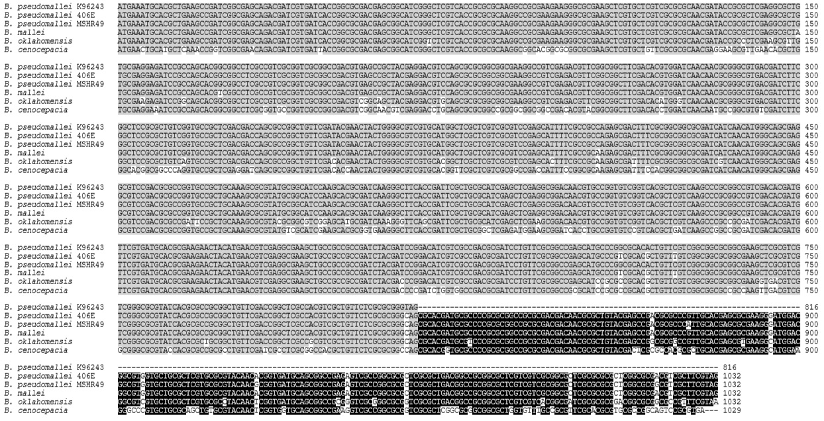
Figure S1. Multiple sequence alignment of bpss2242 from B. pseudomallei K96243 and sdr from pathogenic Burkholderia. Among other Burkholderia isolates, there are additional nucleotides added to 3’-end that is absent in bpss2422. Homologs of bpss2242 are shaded in gray. Additional sequence was identified as bpss2241 (black).
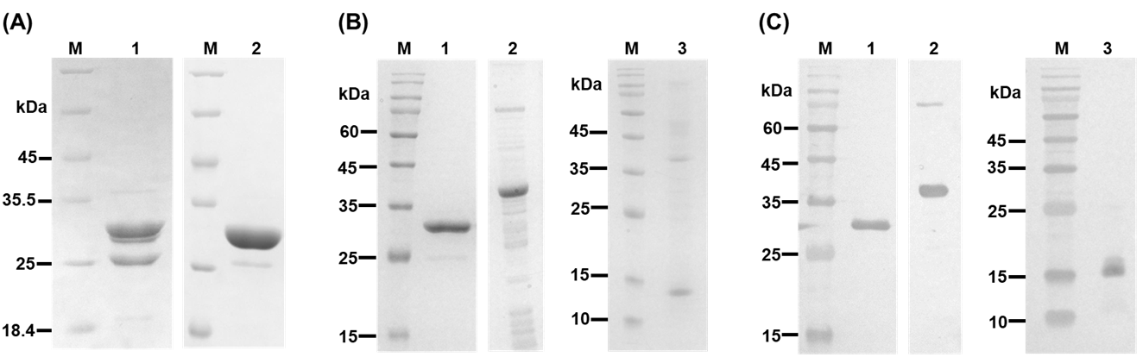
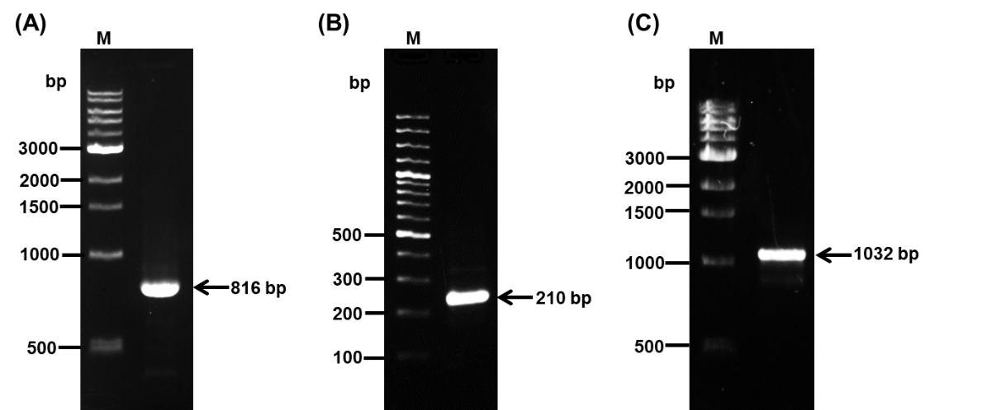
Figure S2. Agarose gel electrophoresis. Full-length PCR products of (A) bpss2242, (B) bpss2241, and (C) bpss2242+41. Lane M, DNA ladder.

Figure S3. Analyses of purified recombinant proteins. (A) BPSS2242 was purified in the absence (lane 1) or presence (lane 2) of phenanthroline. (B) SDS-PAGE analysis and (C) Western blot analysis of purified BpSDRs. Lane M, molecular weight protein markers. Lane 1, BPSS2242; lane 2, BPSS2242+41 and lane 3, BPSS2241.

Comparison of the gene structure between B. pseudomallei K96243 and other B. pseudomallei isolates was performed and the result is shown in Supplementary Fig. S4.
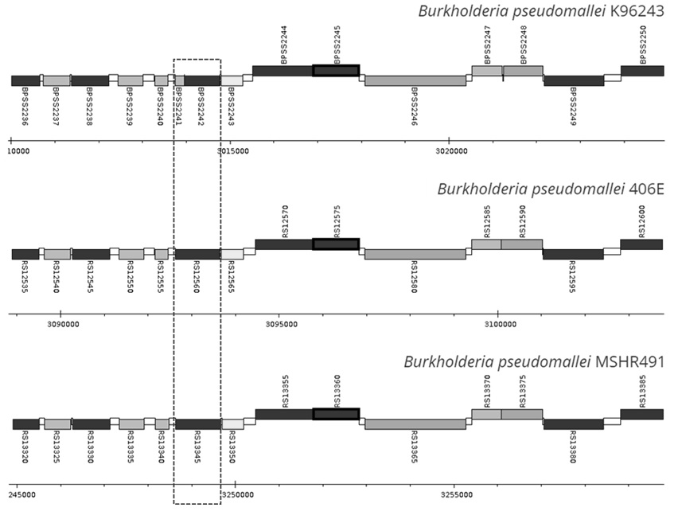
Figure S4. Comparison of sdr gene structure between B. pseudomallei isolate K96243 and other isolates. The sdr from other B. pseudomallei isolates composes of both bpss2242 and bpss2241 counterparts.

The raw image files of cropped gels and blots are shown below.

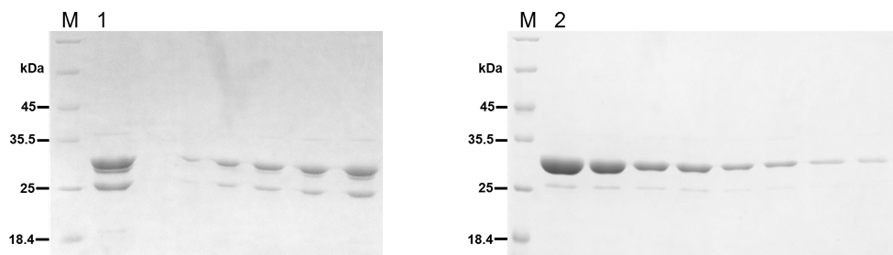
Figure S5. Raw image file of Figure S3A. SDS-PAGE analysis of BPSS2242 purified in the absence (lane 1) or presence (lane 2) of phenanthroline.

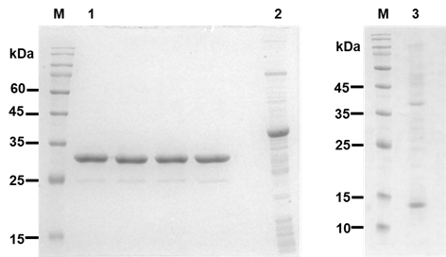
Figure S6. Raw image file of Figure S3B. SDS-PAGE analysis of purified BpSDRs. Lane M, molecular weight protein markers. Lane 1, BPSS2242; lane 2, BPSS2242+41 and lane 3, BPSS2241.

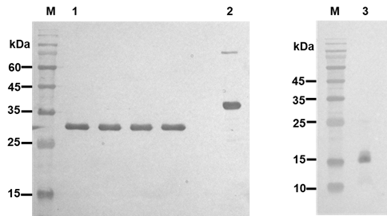
Figure S7. Raw image file of Figure S3C. Western blot analysis of purified BpSDRs. Lane M, molecular weight protein markers. Lane 1, BPSS2242; lane 2, BPSS2242+41 and lane 3, BPSS2241.

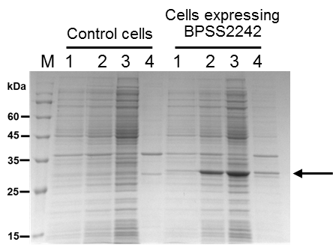
Figure S8. Raw image file of Figure 7A. Recombinant protein expression in BL21 (DE3). Lane M, molecular weight protein markers; lane 1, un-induced cells; lane 2, induced cells after 4 hours induction with 1 mM IPTG; lane 3, soluble fraction; lane 4, insoluble fraction. Control cells are E. coli BL21 (DE3) carrying empty pET23a plasmid. Control cells are E. coli BL21 (DE3) carrying empty pET23a plasmid.

