Effects of combining constraint-induced movement therapy and action-observation training on upper limb kinematics in children with unilateral cerebral palsy: A randomized controlled trial.

Cristina Simon-Martinez^{1,2}*, cristina.simon@kuleuven.be
Lisa Mailleux¹, lisa.mailleux@kuleuven.be
Ellen Jaspers³, ellen.jaspers@hocoma.com
Els Ortibus⁴, els.ortibus@uzleuven.be
Kaat Desloovere^{1,5}, kaat.desloovere@uzleuven.be
Katrijn Klingels^{1,6}, katrijn.klingels@kuleuven.be
Hilde Feys¹, hilde.feys@kuleuven.be

¹ KU Leuven, Department of Rehabilitation Sciences, Leuven, Belgium.
² Information Systems Institute, University of Applied Sciences Western Switzerland Valais (HES-SO Valais) Sierre, Switzerland.
³ Neural Control of Movement Lab, ETH Zurich, Zurich, Switzerland.
⁴ KU Leuven, Department of Development and Regeneration, Leuven, Belgium.
⁵ University Hospitals Leuven, Clinical Motion Analysis Laboratory, Leuven, Belgium
⁶ Rehabilitation Research Centre, Faculty of Rehabilitation Sciences, Hasselt University, Diepenbeek, Belgium.

*Correspondence:
Cristina Simon-Martinez, cristina.simon@kuleuven.be
Herestraat 49, box 1510
3000 Leuven

Supplementary Materials
Table S1. Descriptive characteristics of the participants per group and statistical comparison.
 |  | mCIMT+AOT (n=20)° | mCIMT+placebo (n=16)* | p-value
Age | Mean (line) (SD) | 9y4m (1y11m) | 9y6m (1y10m) | 0.76ª
Sex | n (%) |  |  | 0.11^{b}
Boys |  | 14 (70) | 7 (44)
Girls |  | 6 (30) | 9 (56)
Affected side | n (%)
Left |  | 7 (35) | 11 (69)
Right |  | 13 (65) | 5 (31)
MACS | n (%) |  |  | 0.90^{b}
I |  | 5 (25) | 3 (19)
II |  | 7 (35) | 6 (37)
III |  | 8 (40) | 7 (44)
HFC system | n (%) |  |  | 0.65^{b}
Levels 4-5 |  | 15 (65) | 13 (81)
Level 6-8 |  | 5 (35) | 3 (19)
MACS, Manual Ability Classification System; HFC, House Functional Classification. ªMann-Whitney U Test; ^{b}Chi-square test. °Missing participant data after the intervention (n=2); *Missing participant data after intervention (n=4) and at follow up (n=2).
Table S2. Correlation analysis results (Spearman’s rho and p-value) between improvements in spatiotemporal parameters and clinical measures immediately after the camp (T1-T2).
 |  |  | Muscle tone | Muscle weakness | Grip strength
Reaching upward (RU)
 | Duration | Spearman’s rho (p) | -0.13 (0.46) | 0.10 (0.54) | 0.14 (0.42)
 | Peak velocity | Spearman’s rho (p) | 0.04 (0.82) | 0.14 (0.40) | -0.10 (0.58)
 | Time to peak velocity | Spearman’s rho (p) | -0.18 (0.29) | -0.13 (0.44) | 0.15 (0.38)
 | Trajectory straightness | Spearman’s rho (p) | -0.45 (0.007) | 0.26 (0.13) | 0.11 (0.53)
Reach-to-grasp a vertically oriented cylinder (RGV)
 | Duration | Spearman’s rho (p) | 0.00 (0.99) | 0.01 (0.95) | -0.06 (0.71)
 | Peak velocity | Spearman’s rho (p) | -0.11 (0.53) | -0.03 (0.87) | 0.09 (0.59)
 | Time to peak velocity | Spearman’s rho (p) | -0.34 (0.05) | -0.13 (0.46) | 0.10 (0.55)
 | Trajectory straightness | Spearman’s rho (p) | 0.19 (0.27) | -0.35 (0.04) | -0.10 (0.56)
Hand to shoulder (HTS)
 | Duration | Spearman’s rho (p) | -0.18 (0.29) | -0.13 (0.44) | 0.15 (0.38)
 | Peak velocity | Spearman’s rho (p) | 0.25 (0.16) | 0.16 (0.36) | -0.14 (0.40)
 | Time to peak velocity | Spearman’s rho (p) | 0.27 (0.11) | -0.19 (0.27) | -0.19 (0.26)
 | Trajectory straightness | Spearman’s rho (p) | -0.13 (0.47) | -0.04 (0.83) | 0.21 (0.22)
The correlations that reached p<0.01 significance are highlighted in bold.
Table S3. Correlation analysis results (Spearman’s rho and p-value) between improvements in spatiotemporal parameters and clinical measures immediately after the camp (T1-T3).
 |  |  | Muscle tone | Muscle weakness | Grip strength
Reaching upward (RU)
 | Duration | Spearman’s rho (p) | -0.06 (0.75) | 0.00 (0.99) | -0.03 (0.88)
 | Peak velocity | Spearman’s rho (p) | 0.33 (0.05) | 0.15 (0.37) | 0.06 (0.72)
 | Time to peak velocity | Spearman’s rho (p) | -0.23 (0.19) | -0.08 (0.64) | -0.14 (0.43)
 | Trajectory straightness | Spearman’s rho (p) | 0.09 (0.61) | 0.33 (0.05) | 0.13 (0.45)
Reach-to-grasp a vertically oriented cylinder (RGV)
 | Duration | Spearman’s rho (p) | -0.30 (0.08) | -0.14 (0.43) | -0.10 (0.56)
 | Peak velocity | Spearman’s rho (p) | 0.27 (0.11) | 0.11 (0.53) | 0.07 (0.69)
 | Time to peak velocity | Spearman’s rho (p) | -0.06 (0.75) | 0.06 (0.72) | 0.01 (0.95)
 | Trajectory straightness | Spearman’s rho (p) | 0.00 (0.98) | -0.28 (0.10) | 0.00 (0.98)
Hand to shoulder (HTS)
 | Duration | Spearman’s rho (p) | -0.41 (0.01) | -0.06 (0.73) | 0.22 (0.19)
 | Peak velocity | Spearman’s rho (p) | 0.25 (0.14) | 0.08 (0.63) | 0.04 (0.80)
 | Time to peak velocity | Spearman’s rho (p) | -0.06 (0.73) | -0.25 (0.14) | -0.47 (0.004)
 | Trajectory straightness | Spearman’s rho (p) | -0.39 (0.02) | -0.05 (0.76) | -0.08 (0.66)
The correlations that reached p<0.01 significance are highlighted in bold.

Figure S1. Marker locations at the start (left panels) and end (right panels) position of each task: (a) reaching forward, (b) reach-to-grasp a vertically oriented cylinder and (c) hand to shoulder. This figure was created using Vicon Nexus software (version 1.8.5, Oxford Metrics, Oxford, UK, https://www.vicon.com/software/nexus/?section=downloads).
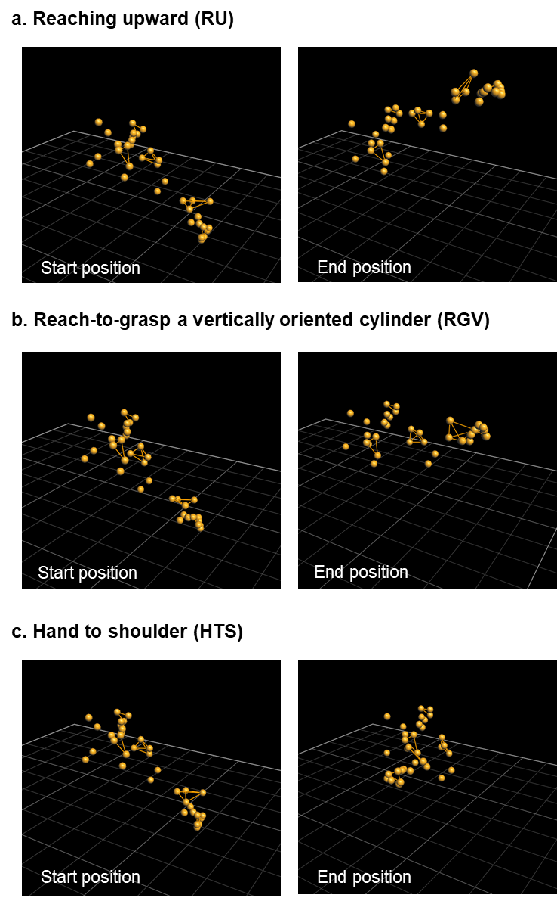
Figure S2. Mean (line) and standard deviation (translucent area) of each joint angle at each time point for the mCIMT+AOT group (left), the mCIMT+placebo group (middle), and the total group (right). Each panel represents one task. The grey line depicts the mean (line) and standard deviation (translucent area) of a group of 60 typically developing children aged 5-15y, which is plotted for visualization of a normal movement pattern. (a) trunk flexion-extension, (b) trunk lateral flexion, (c) trunk axial rotation, (d) scapula tilting, (e) scapula pro-retraction, (f) scapula rotation, (g) shoulder elevation, (h) shoulder rotation, (i) shoulder elevation plane, (j) elbow flexion-extension, (k) elbow pro-supination, and (l) wrist flexion-extension.
Figure S3. Correlation analyses between the change in kinematic and clinical measures at T1-T2 (left) and T1-T3 (right).
