Rescue of Mutant Gonadotropin-Releasing Hormone Receptor Function Independent of Cognate Receptor Activity

Emery Smith^{1a†}, Jo Ann Janovick^{2†}, Thomas D. Bannister^{1b}, Justin Shumate^{1a}, Vadivel Ganapathy², Louis Scampavia^{1a} and Timothy P. Spicer^{1a}*
Affiliations:
¹The Scripps Research Molecular Screening Center, Department of Molecular Medicine^{1a} and Department of Chemistry^{1b}, Scripps Research Florida, 130 Scripps Way, Jupiter, Florida, USA
²Texas Tech University Health Sciences Center, 3601 4th Street, Lubbock, Texas, USA
Short title: Gonadotropin-Releasing Hormone Receptor Pharmacoperones
Key words: calcium signaling, pharmacoperone, GPCR, protein folding, protein trafficking
†Equal Contribution
*Correspondence: spicert@scripps.edu

Timothy P. Spicer
Scripps Research
130 Scripps Way #1A1
Jupiter, FL 33458
U.S.A.
561-228-2150

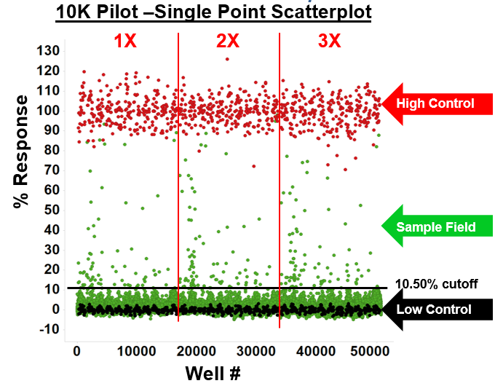
Supplemental Figure 1. GnRHR 10K pilot. 10K pilot screen run in triplicate at a single concentration. The scatterplot of the 12,801 compounds run in triplicate at 6 µM screening concentration. Z’ for the pilot was 0.76±0.05, S:B was 2.65±0.08, N=33 plates. 89 active compounds with an average activity greater than 10.5% (average+3SD of the low control).

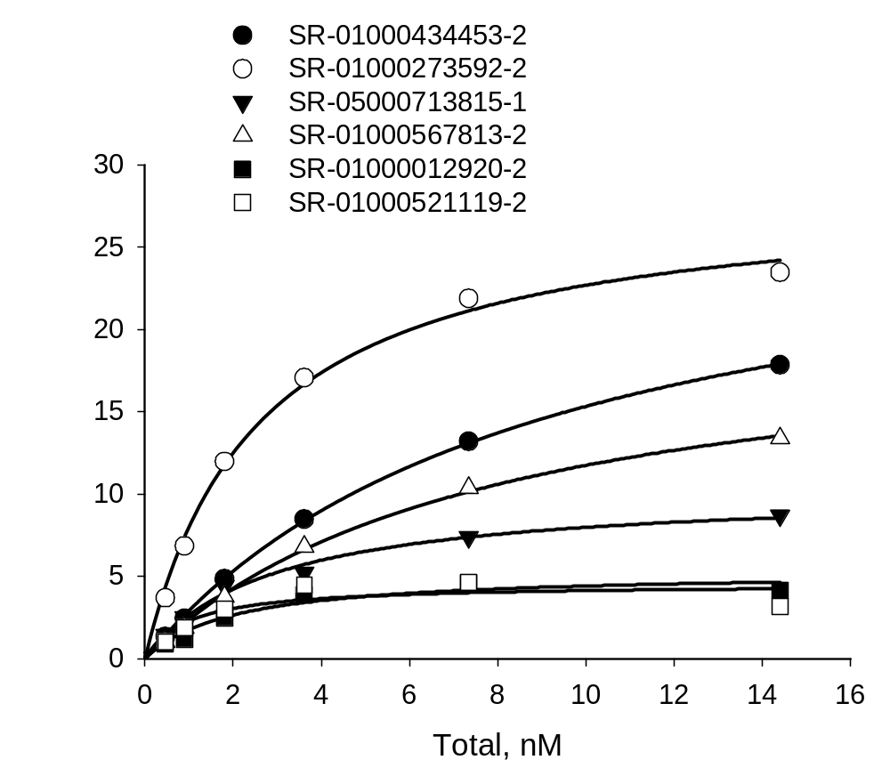
Supplemental Figure 2A.

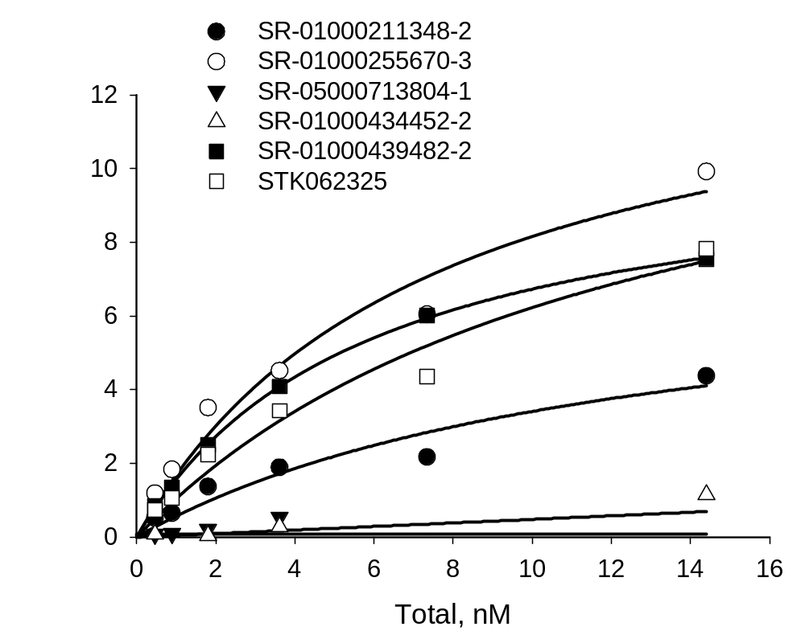

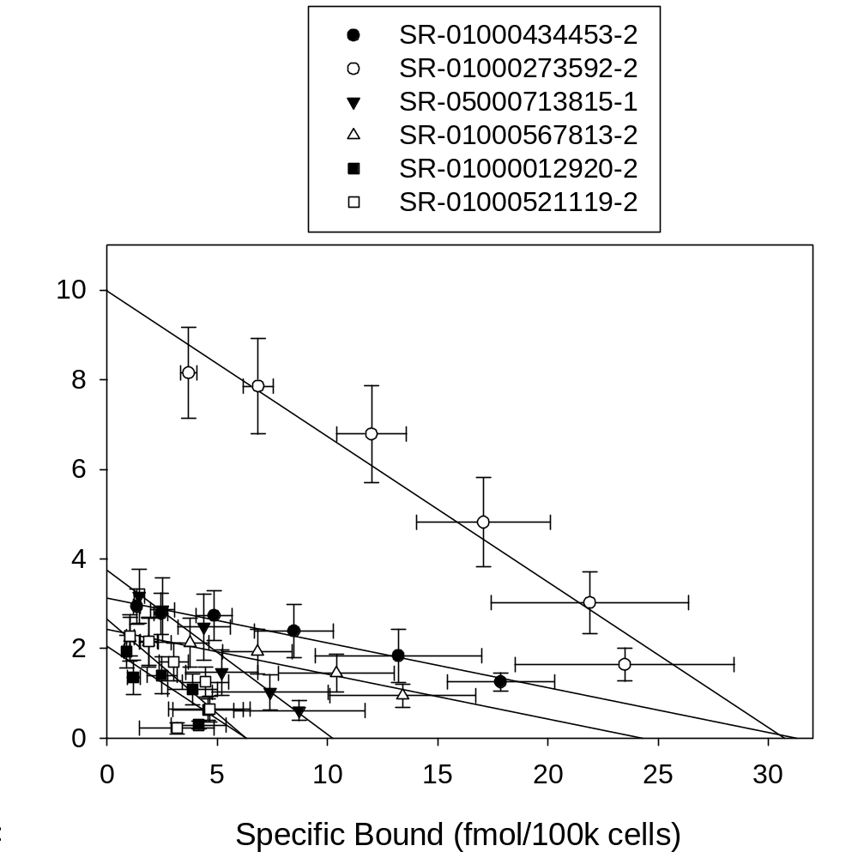
Supplemental Figure 2B.

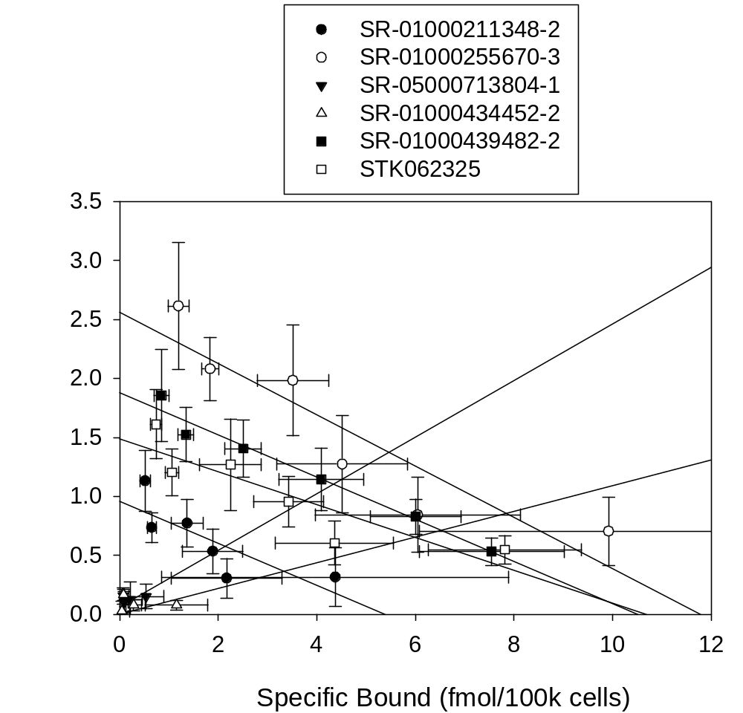

Supplemental Figure 2. Saturation binding and Scatchard plots of the 11 compounds. E90K GnRHR mutant binding after rescue with each of the 11 compounds. All experiments were done at least 3 times and averaged; N of 3 + SEMs. A. Saturation Binding Plots. B. Scatchard Plots.

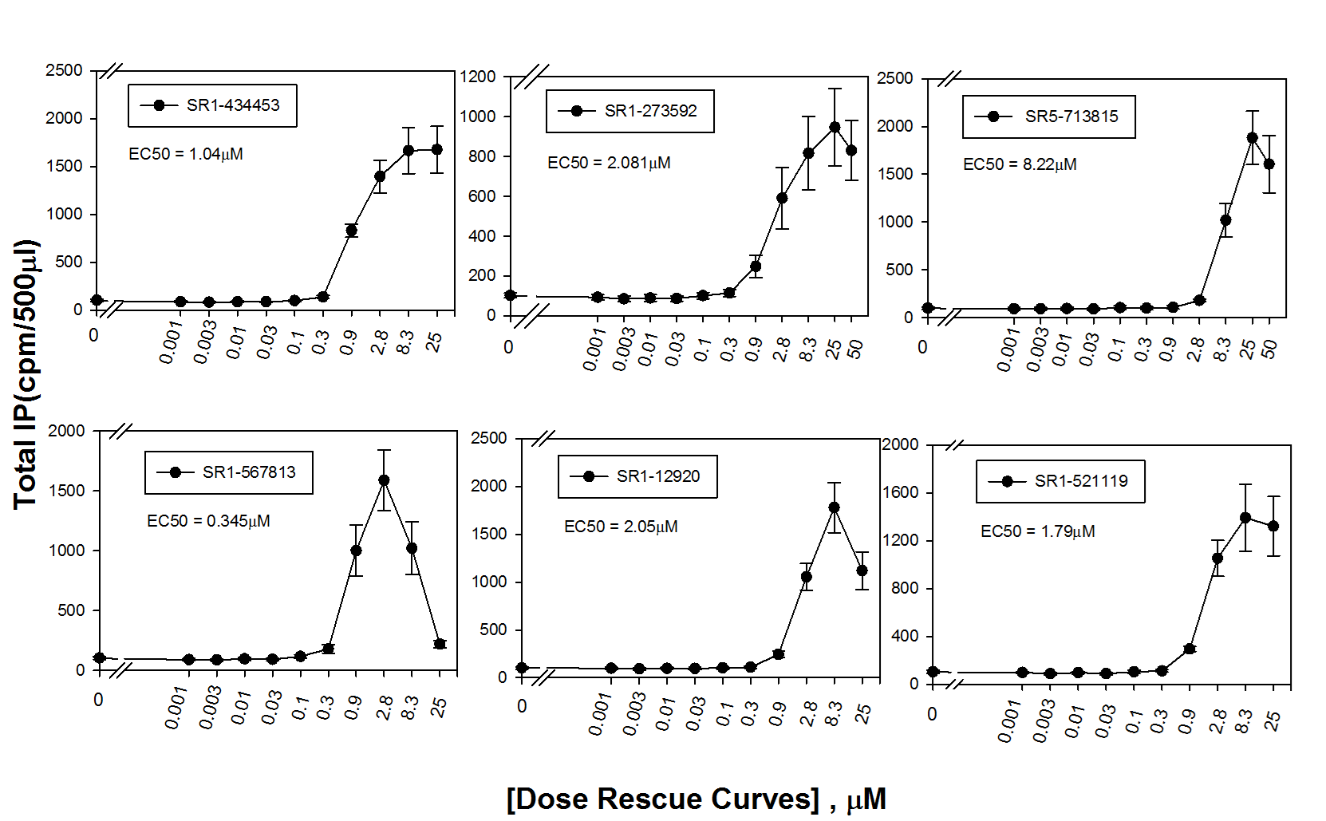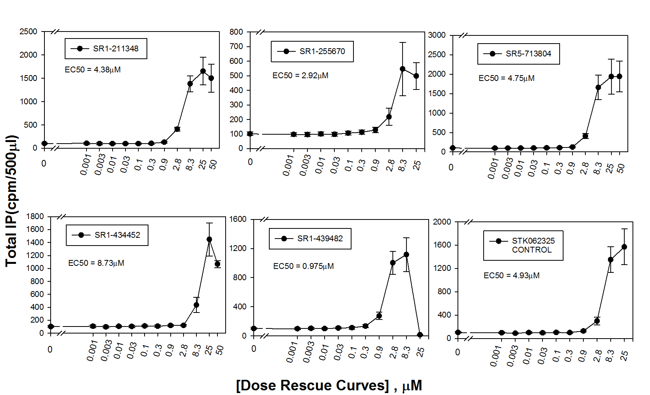
Supplemental Figure 3: GnRHR IP assay mutant rescue. IP assay activity of 12 compounds showing rescue of the E90K GnRHR mutant. All experiments were done at least 3 times and averaged; N of 3 + SEMs.

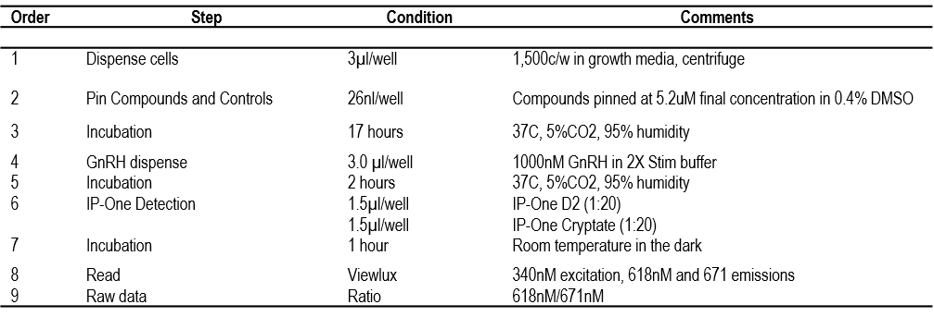
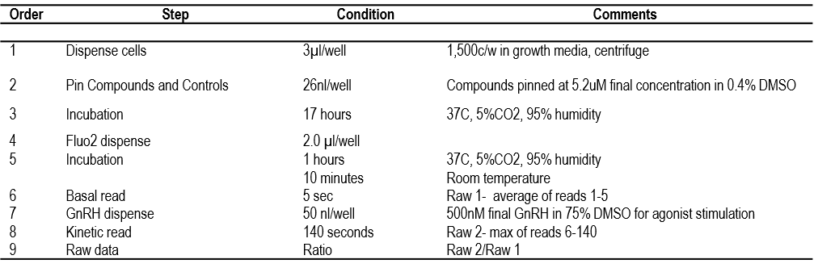
Supplemental Table 2. GnRHR IP-One TR-FRET assay protocol in 1,536-well plate format.

Supplemental Table 1. GnRHR FLUO2 assay protocol in 1,536-well plate format.

