miRNA-mRNA network regulation in the skeletal muscle fiber phenotype of chickens revealed by integrated analysis of miRNAome and transcriptome
Yifan Liu^{1§}, Ming Zhang^{1§}, Yanju Shan¹, Gaige Ji¹, Xiaojun Ju¹, Yunjie Tu¹, Zhongwei Sheng¹, Jingfang Xie², Jianmin Zou¹, and Jingting Shu¹*

¹Key Laboratory for Poultry Genetics and Breeding of Jiangsu Province, Poultry Institute, Chinese Academy of Agricultural Sciences, Yangzhou 225125, Jiangsu, China.
²Jiangxi Academy of Agricultural Science, Nanchang 330200, Jiangxi, China

§These authors contributed equally to this work

Correspondence and requests for materials should be addressed to J.S. (email: shujingting@163.com)

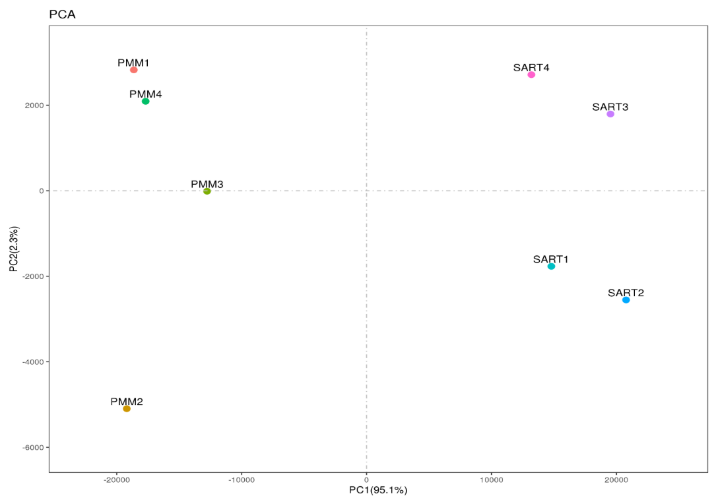 Figure S1: Principal components plot of eight samples used in RNA sequencing.

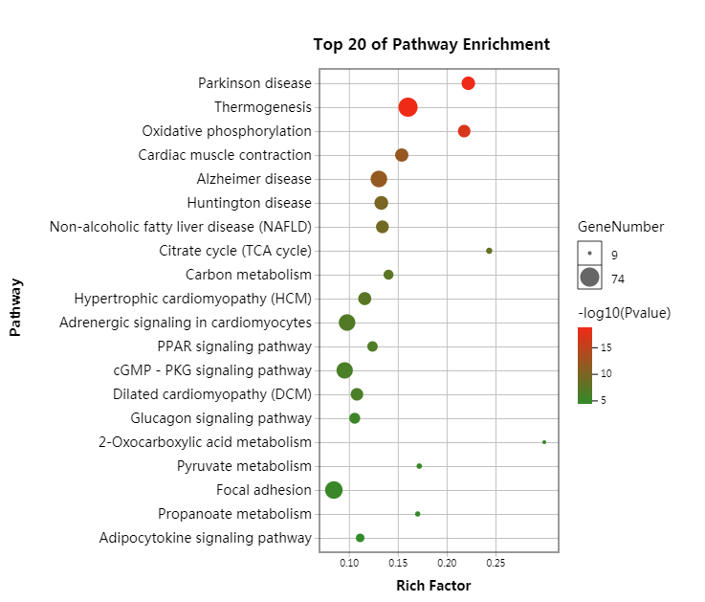
A

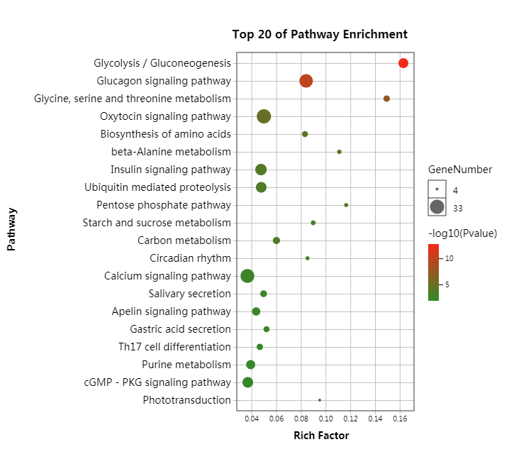

B

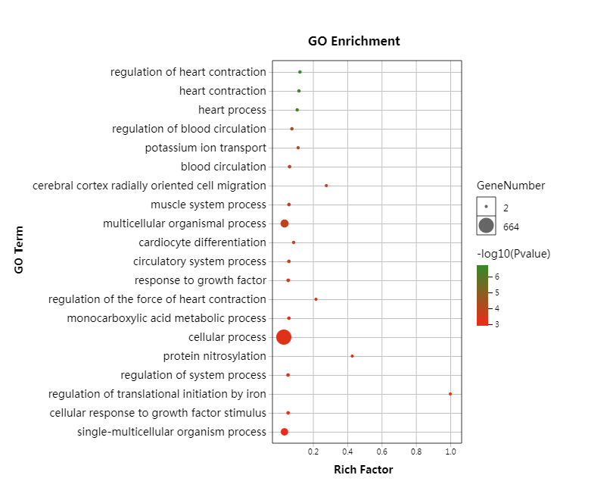
Figure S2: Top 20 significantly enriched KEEG pathways of up-regulated (A) and down-regulated (B) mRNAs in SART.
A

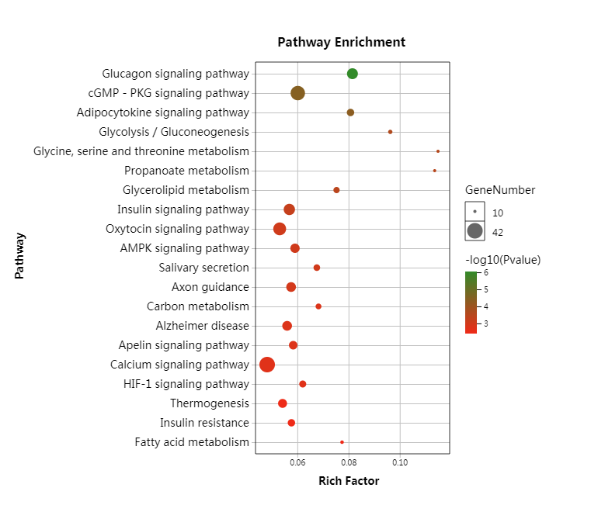

B

Figure S3: Top 20 significantly enriched GO terms (A) and KEEG pathways (B) of target genes differentially expressed miRNAs.

