New Methodology to Process Shifted Excitation Raman Difference Spectroscopy Data: A Case Study of Pollen Classification
F. Korinth¹, A.S. Mondol¹, C. Stiebing¹, I.W. Schie^{1, 2}, C. Krafft^{1*}, J. Popp^{1, 3}
¹ Leibniz Institute of Photonic Technology, Jena, Albert-Einstein-Straße 9, 07745 Jena, Germany
² Department of Medical Engineering and Biotechnology, University of Applied Sciences, Jena,
Carl-Zeiss-Promenade 2, 07745 Jena, Germany
³ Institute of Physical Chemistry and Abbe Center of Photonics, Friedrich Schiller University Jena,
Jena, Helmholtzweg 4, 07743 Jena, Germany
* christoph.krafft@leibniz-ipht.de
Supplementary Information: Tables
Supplementary Tables S1. Average sensitivity, specificity, accuracy and precision in % using difference, reconstructed, 784 nm and 786 nm excited Raman spectra as input.
A: tree versus non-tree classification
Classifiers | Difference | Reconstructed | 784 nm | 786 nm
Sensitivity | 95.8 | 92.8 | 95.7 | 95.2
Specificity | 95.8 | 92.8 | 95.7 | 95.2
Accuracy | 95.9 | 92.7 | 95.7 | 95.1
Precision | 95.9 | 92.7 | 95.6 | 95.1
B: tree types
Classifiers | Difference | Reconstructed | 784 nm | 786 nm
Sensitivity | 91.3 | 89.9 | 93.8 | 95.6
Specificity | 95.9 | 95.2 | 96.8 | 98.2
Accuracy | 94.6 | 93.7 | 95.9 | 97.5
Precision | 90.0 | 88.3 | 91.5 | 93.6
C: non-tree types
Classifiers | Difference | Reconstructed | 784 nm | 786 nm
Sensitivity | 86.1 | 89.8 | 91.5 | 90.3
Specificity | 96.3 | 97.3 | 97.7 | 97.3
Accuracy | 94.2 | 95.8 | 96.4 | 95.7
Precision | 85.1 | 89.3 | 90.6 | 88.8

Supplementary Tables S2A: tree versus non-tree classification
Reconstructed |  | REAL CLASSES
 |  | Non-tree | Tree
PREDICTED  CLASSES | Non-tree | 2579 | 179
PREDICTED  CLASSES | Tree | 207 | 2325
Sensitivity |  | 92.6 | 92.9
Specificity |  | 92.9 | 92.6
Accuracy |  | 92.7 | 92.7
Precision |  | 93.5 | 91.8

784 nm |  | REAL CLASSES
 |  | Non-tree | Tree
PREDICTED  CLASSES | Non-tree | 2649 | 93
PREDICTED  CLASSES | Tree | 137 | 2411
Sensitivity |  | 95.1 | 96.3
Specificity |  | 96.3 | 95.1
Accuracy |  | 95.7 | 95.7
Precision |  | 96.6 | 94.6

786 nm |  | REAL CLASSES
 |  | Non-tree | Tree
PREDICTED  CLASSES | Non-tree | 2607 | 79
PREDICTED  CLASSES | Tree | 179 | 2425
Sensitivity |  | 93.6 | 96.8
Specificity |  | 96.8 | 93.6
Accuracy |  | 95.1 | 95.1
Precision |  | 97.1 | 93.1

Supplementary Tables S2B: classification of tree types
Reconstructed |  | REAL CLASSES
 |  | Alder | Hazel | Larch | Birch
PREDICTED CLASSES | Alder | 903 | 93 | 0 | 38
PREDICTED CLASSES | Hazel | 83 | 703 | 2 | 8
PREDICTED CLASSES | Larch | 0 | 4 | 59 | 1
PREDICTED CLASSES | Birch | 70 | 19 | 0 | 521
Sensitivity |  | 85.5 | 85.8 | 96.7 | 91.7
Specificity |  | 91.0 | 94.5 | 99.8 | 95.4
Accuracy |  | 88.7 | 91.7 | 99.7 | 94.6
Precision |  | 87.3 | 88.3 | 92.2 | 85.4

784 nm |  | REAL CLASSES
 |  | Alder | Hazel | Larch | Birch
PREDICTED CLASSES | Alder | 954 | 54 | 0 | 47
PREDICTED CLASSES | Hazel | 57 | 764 | 0 | 0
PREDICTED CLASSES | Larch | 5 | 2 | 61 | 1
PREDICTED CLASSES | Birch | 40 | 0 | 0 | 520
Sensitivity |  | 90.3 | 93.3 | 100.0 | 91.5
Specificity |  | 93.0 | 96.6 | 99.7 | 97.9
Accuracy |  | 91.9 | 95.5 | 99.7 | 96.5
Precision |  | 90.4 | 93.1 | 89.7 | 92.9

786 nm |  | REAL CLASSES
 |  | Alder | Hazel | Larch | Birch
PREDICTED CLASSES | Alder | 987 | 29 | 0 | 17
PREDICTED CLASSES | Hazel | 29 | 788 | 2 | 5
PREDICTED CLASSES | Larch | 5 | 2 | 59 | 0
PREDICTED CLASSES | Birch | 35 | 0 | 0 | 546
Sensitivity |  | 93.5 | 96.2 | 96.7 | 96.1
Specificity |  | 96.8 | 97.9 | 99.7 | 98.2
Accuracy |  | 95.4 | 97.3 | 99.6 | 97.7
Precision |  | 95.5 | 95.6 | 89.4 | 94.0

Supplementary Tables S2C: classification of non-tree types
Reconstructed |  | REAL CLASSES
 |  | Cyclamen | Rumex | Mugwort | Moor grass
PREDICTED CLASSES | Cyclamen | 896 | 0 | 24 | 0
PREDICTED CLASSES | Rumex | 1 | 289 | 10 | 93
PREDICTED CLASSES | Mugwort | 15 | 0 | 671 | 0
PREDICTED CLASSES | Moor grass | 1 | 74 | 15 | 697
Sensitivity |  | 98.1 | 79.6 | 93.2 | 88.2
Specificity |  | 98.7 | 95.7 | 99.3 | 95.5
Accuracy |  | 98.5 | 93.6 | 97.7 | 93.4
Precision |  | 97.4 | 73.5 | 97.8 | 88.6

784 nm |  | REAL CLASSES
 |  | Cyclamen | Rumex | Mugwort | Moor grass
PREDICTED CLASSES | Cyclamen | 899 | 0 | 18 | 1
PREDICTED CLASSES | Rumex | 2 | 309 | 6 | 93
PREDICTED CLASSES | Mugwort | 10 | 0 | 679 | 0
PREDICTED CLASSES | Moor grass | 2 | 54 | 17 | 696
Sensitivity |  | 98.5 | 85.1 | 94.3 | 88.1
Specificity |  | 99.0 | 95.8 | 99.5 | 96.3
Accuracy |  | 98.8 | 94.4 | 98.2 | 94.0
Precision |  | 97.9 | 75.4 | 98.5 | 90.5

786 nm |  | REAL CLASSES
 |  | Cyclamen | Rumex | Mugwort | Moor grass
PREDICTED CLASSES | Cyclamen | 901 | 0 | 7 | 0
PREDICTED CLASSES | Rumex | 3 | 307 | 12 | 135
PREDICTED CLASSES | Mugwort | 9 | 0 | 684 | 0
PREDICTED CLASSES | Moor grass | 0 | 56 | 17 | 655
Sensitivity |  | 98.7 | 84.6 | 95.0 | 82.9
Specificity |  | 99.6 | 93.8 | 99.6 | 96.3
Accuracy |  | 99.3 | 92.6 | 98.4 | 92.5
Precision |  | 99.2 | 67.2 | 98.7 | 90.0

Supplementary Table S3. Data Set Overview: Name, growth habit, family, genus and number of spectra for the training and test data set of the analyzed pollen samples.
Name | Growth habit | Family | Genus | Training set  Number of spectra | Test set  Number of spectra
Alder | Tree | Betulaceae | Alnus | 90 | 1056
Birch | Tree | Betulaceae | Betula | 90 | 586
Hazel | Tree | Betulaceae | Corylus | 90 | 819
Larch | Tree | Pinaceae | Larix | 90 | 61
Cyclamen | Non-tree (herb) | Primulaceae | Cyclamen | 90 | 913
Rumex | Non-tree (herb) | Polygonaceae | Rumex | 90 | 363
Mugwort | Non-tree (shrub) | Asteraceae | Artemisia | 90 | 720
Moor grass | Non-tree (grass) | Poaceae | Molinia | 90 | 790
Supplementary Information: Figures
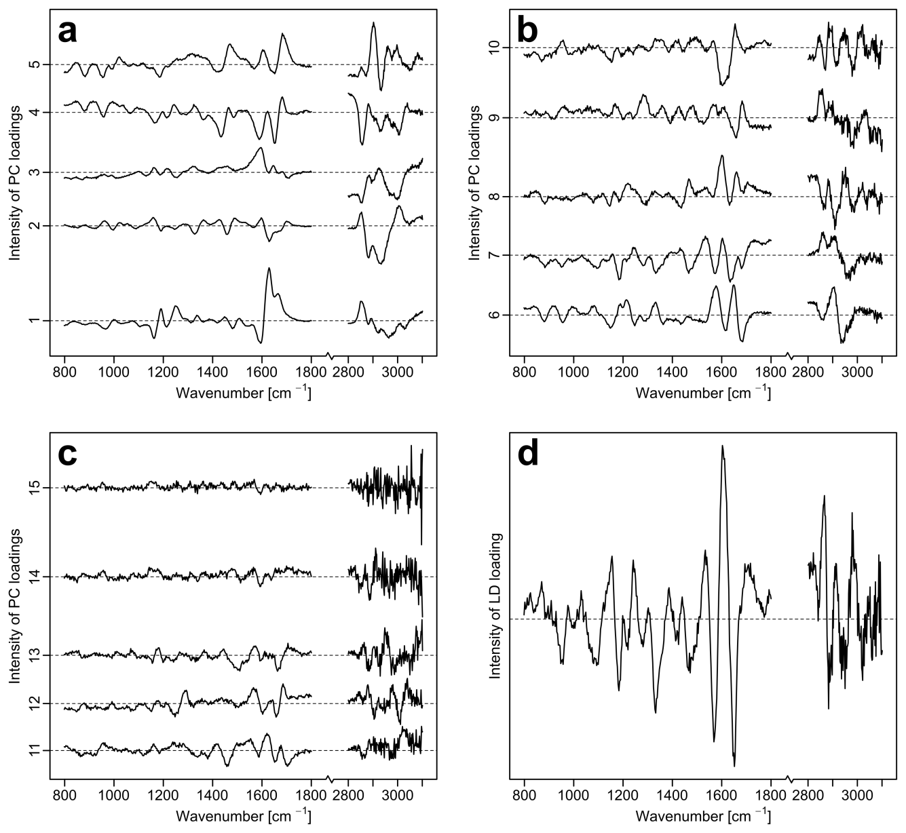
Supplementary Figure S1. Loadings of the PCA and the LDA of the whole training data set (8 pollen types) – classification of tree vs. non-tree: loadings 1 – 5 (a), loadings 6 – 10 (b), loadings 11 – 15 (c) of the PCA, d, loading of the LDA (d).
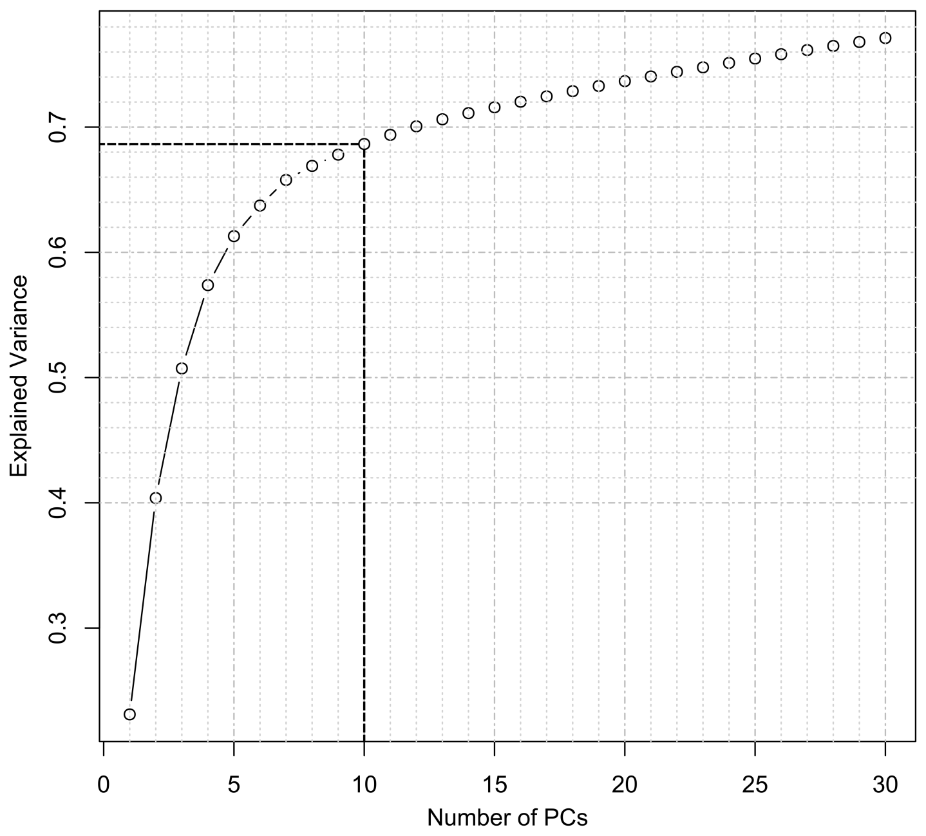
Supplementary Figure S2. Explained variance curve of the PCA of the whole training data set (8 different pollen types) – classification of tree vs. non-tree, and optimal number of PCs according to the 10-fold cross validation results (dashed line).

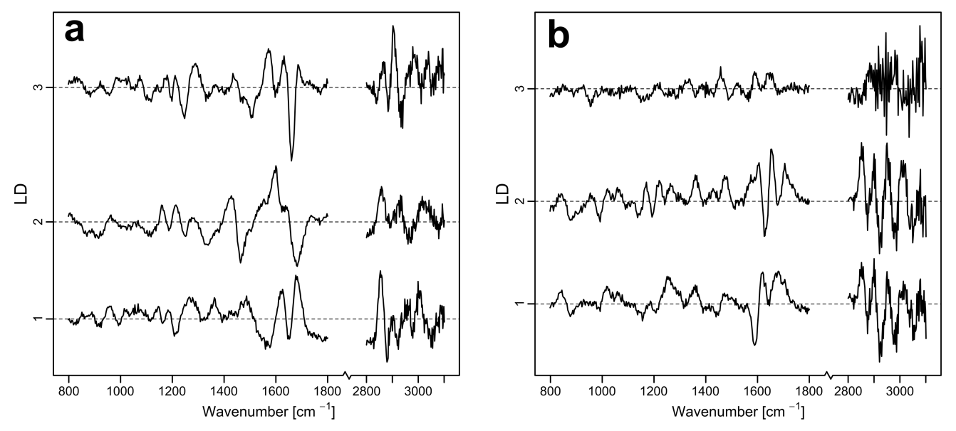
Supplementary Figure S3. LD loadings for classification and separation of pollen genera:
tree pollen types (A) and non-tree pollen types (B).
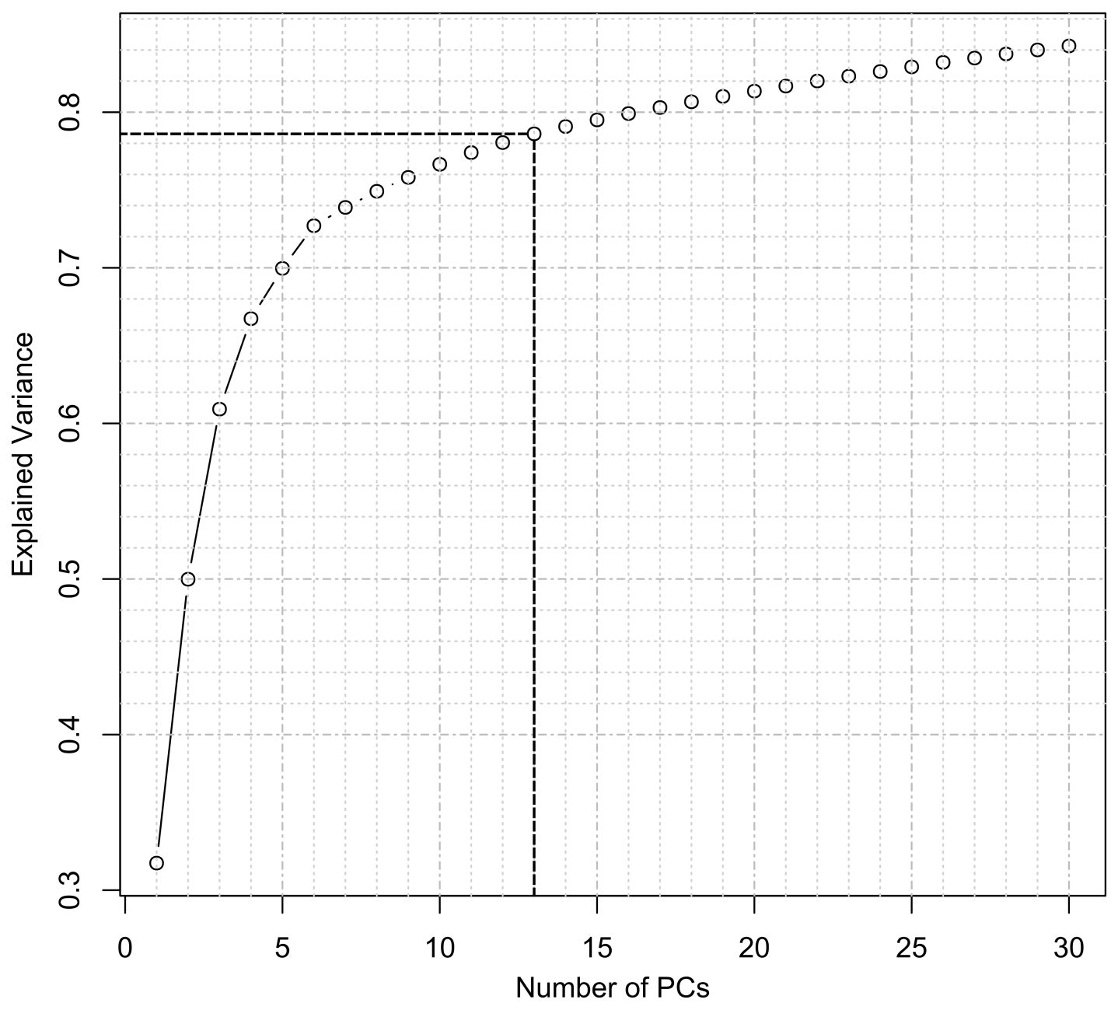
Supplementary Figure S4. Explained variance curve of the PCA for the separation of tree genera:
optimal number of PCs according to the 10-fold cross validation results was 13 (dashed line).
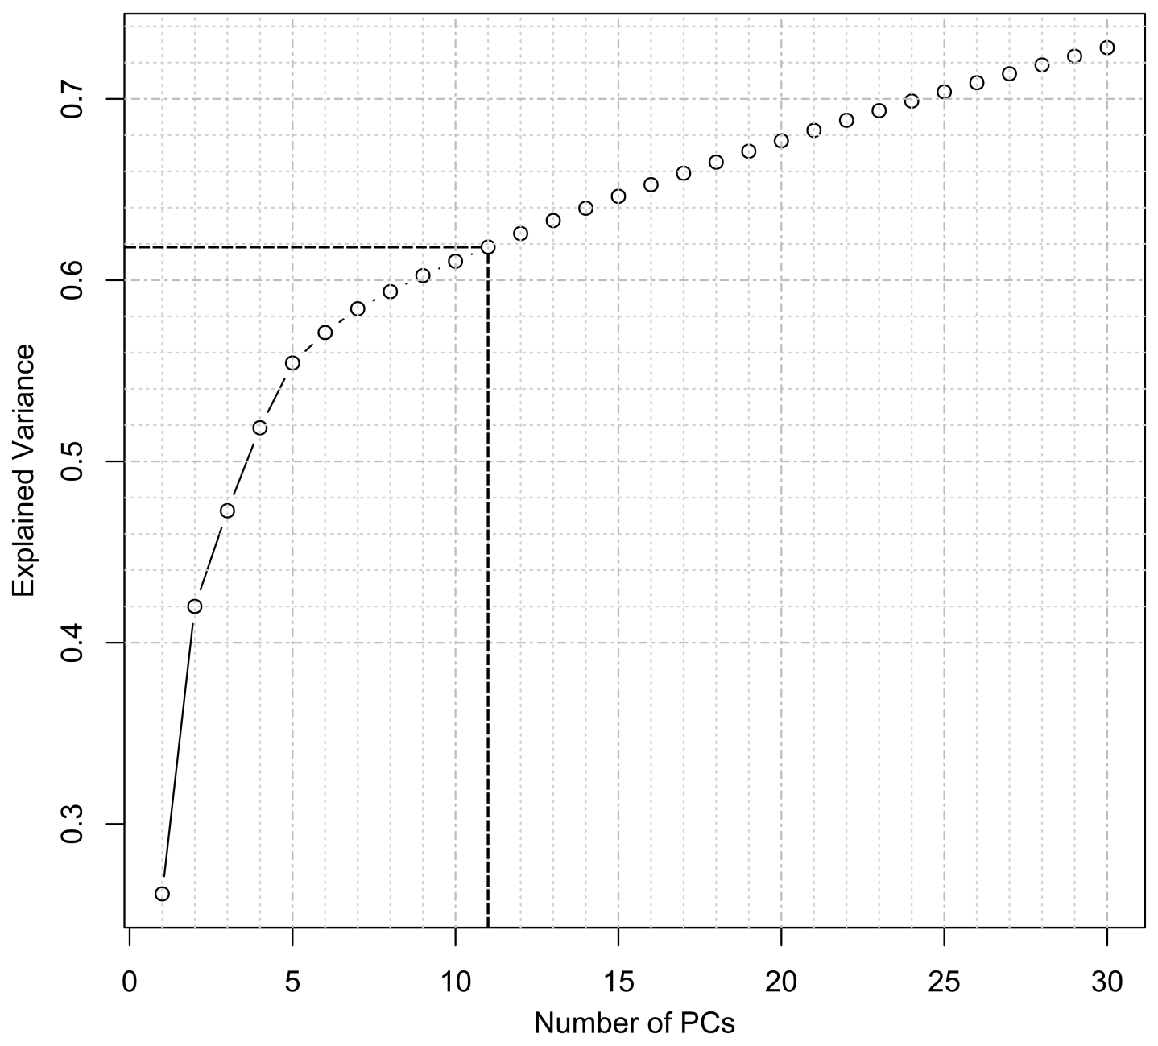
Supplementary Figure S5. Explained variance curve of the PCA for the separation of non-tree genera:
optimal number of PCs according to the 10-fold cross validation results was 11 (dashed line).

