Molecular markers from the chloroplast genome of rose provide new complementary tool for variety discrimination and profile

Li Changhong, Zheng Yongqi*, Huang Ping*

State Key Laboratory of Tree Genetics and Breeding; Key Laboratory of Forest Silviculture and Tree Cultivation, State Forestry Administration; Research Institute of Forestry, Chinese Academy of Forestry, Beijing 100091, China.

*Correspondence: zhengyq@caf.ac.cn;Tel: +86-10-62888565; huangping@caf.ac.cn; Tel.: +86-10-62889592

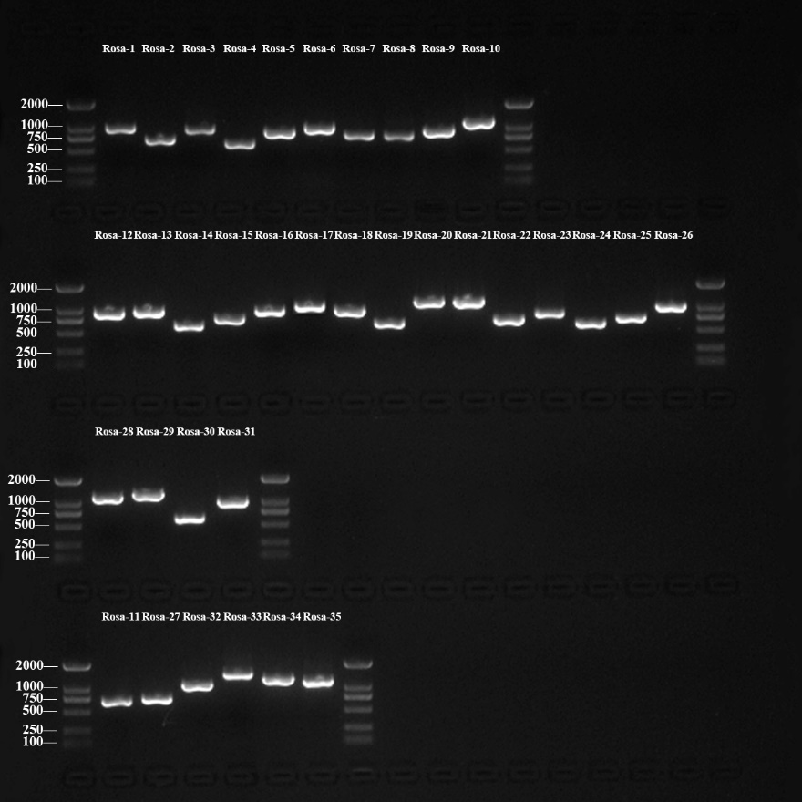

Figure S1 The gel photo of PCR products for validating and correcting chloroplast genome sequences base on NGS assembly. The PCR products were separated on 1.5% agarose gels, and the D2000 DNA ladder were loaded as markers. All the PCR products have been sequenced by Sanger’s method, and these regions in cp genome also have been aligned and corrected base on sanger’s sequence results, five sequences of them are across four conjunction regions e.g., Rosa32 (LSC-IRb), Rosa33 (IRb-SSC), Rosa34 (SSC-IRa) and Rosa35 (LSC-IRa).

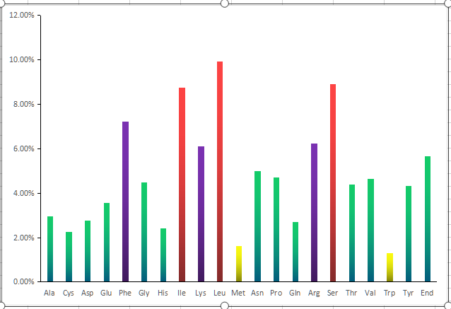
Figure S2. Frequency of amino acids in the cp genome of Rosa ‘Margo Koster’
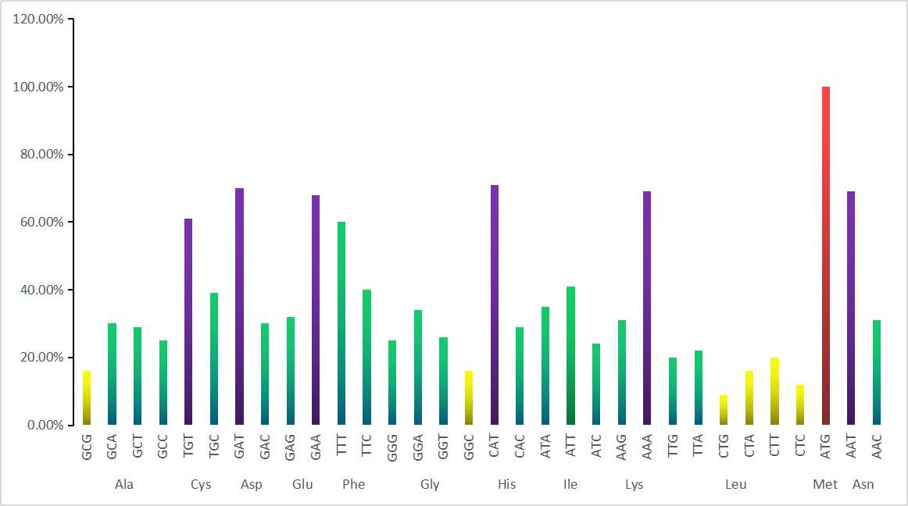
Figure S3-1. Codon usage in the cp genome of Rosa ‘Margo Koster’
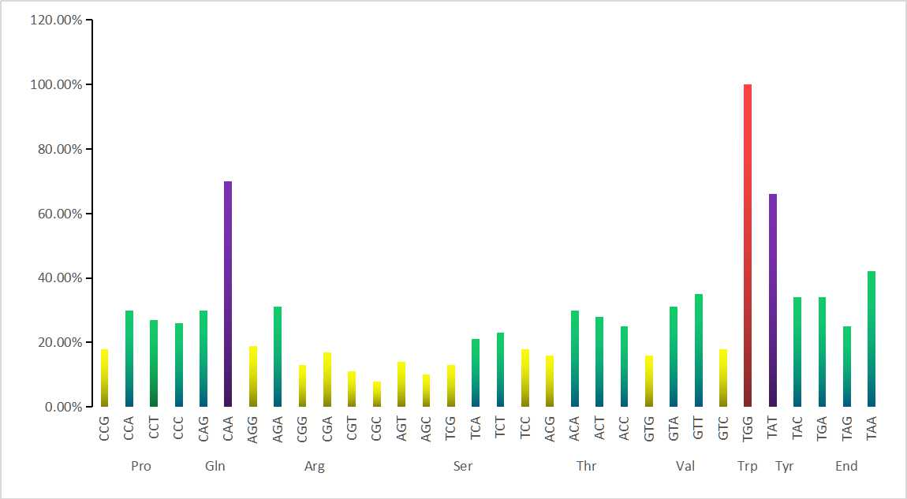
Figure S3-2. Codon usage in the cp genome of Rosa ‘Margo Koster’

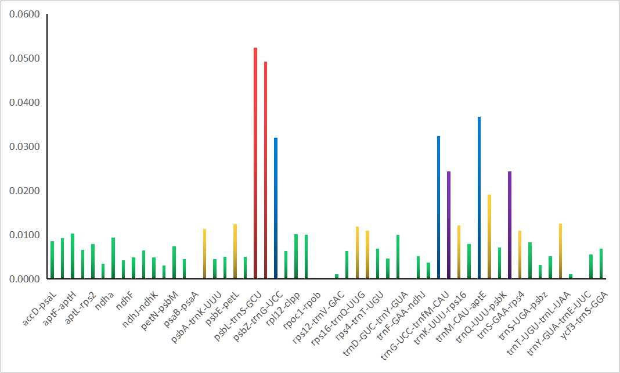
Figure S4. Nucleotide diversity (π) of sequence regions in the cp genome among five Rosa species

Table S1 Results of PCR-based verification of the cp genome and primer information

Name | Forward primer | Reverse primer | Purification | Tm  （℃） | Size of validated sequence*（bp） | Validated region
Rosa-1 | GGTAAAGGAGCAACACCAAAC | CTGGTGCCATTATCCCTACTT | PAGE | 56 | 847 | LSC (353-1199)
Rosa-2 | CGTATATAGCTAGAACGACCCTCAC | TGGAAGAGATGATGGAAGCAG | PAGE | 58 | 593 | LSC (15616-16208)
Rosa-3 | GGTTGAAGTAGTTGAATAGGAGG | ACTCCAAGAGCACTCATCCATA | PAGE | 57 | 847 | LSC (33671-34517)
Rosa-4 | CCACTGATAAACACCAGAATAAGC | AATGTTTCTATTCAGCGGACG | PAGE | 57 | 508 | LSC (40296-40903)
Rosa-5 | GACATCACATTGATAGCCTCGAC | CGTACTATCAAGAGGATTAGCTGC | PAGE | 59 | 813 | LSC (54407-55219)
Rosa-6 | GTGTTGGATTCAAAGCTGGTG | GGATATGATCTCCACCAGACATAC | PAGE | 60 | 891 | LSC (57120-58010)
Rosa-7 | TCTATCTATAGTCATTGGGGCCTC | CTATTAGTACTGGGCGACTAACCA | PAGE | 59 | 695 | LSC (66102-66796）
Rosa-8 | GTTCCTTTCTTCTTCCTCGTTTC | TTCTAAGACCAGTAGTTCTAGCGGT | PAGE | 58 | 680 | LSC (69388-70067)
Rosa-9 | GTCGCACTATACGTCAATCCAC | GATCCCAATACACCCAATGC | PAGE | 57 | 846 | LSC (73814-74659)
Rosa-10 | CAGGGTTCATAACTACTCCTCTTAC | ATACGACCCTAATCGAAATGC | PAGE | 57 | 974 | LSC (86994-87592)
Rosa-11 | CCACACCAATTCGTTATGTATGG | GATACAGGAGCGAAACAATCAAC | PAGE | 57 | 598 | IRb (88380-88977)
Rosa-12 | CATACCAAATCCCATCAATCG | GAACATCTTTCACAATCCCTGG | PAGE | 57 | 857 | IRb (92972-93828)
Rosa-13 | ACGAATCGGAGTTTGAAGAAG | GTGAGTAATAGCTCTGGTTGTTCG | PAGE | 56 | 857 | IRb (94743-95599)
Rosa-14 | GAGAAGATCACCAAGATTTCGTG | AGAATTAGTAGATCTGTTCCGCC | PAGE | 56 | 528 | IRb (96344-96871)
Rosa-15 | CGGATAGAGGAATACATAGAGTTG | AAGTTCCGAATTAGTGGATGC | PAGE | 57 | 677 | IRb (98868-99544)
Rosa-16 | GATAGGAAAGATCTCCCTCCAAG | GTGACTGAATTGGTCCTGGTTAC | PAGE | 56 | 855 | IRb (10031-100885)
Rosa-17 | CGAATGAGAATGGATAAGAGGC | GCATGATGACTTGACGTCATC | PAGE | 59 | 955 | IRb (102702-103655）
Rosa-18 | GTCTGGAGAAAGCTGCAATCA | AGGGAGATAGTGCATCAAGCTG | PAGE | 56 | 867 | IRb (105112-105978)
Rosa-19 | CGATTACGGGTTGGATGTCTA | GCTGAGTTGGAATCCCATTCT | PAGE | 57 | 570 | IRb (105811-106380)
Rosa-20 | TTGTCTATCGTCGGCCTCTATG | CAGAGTTTGCCTCGATTTGGT | PAGE | 56 | 1074 | IRb (106567-107640)
Rosa-21 | CAAGGAAGTTGGTGACCTGATG | ATGGCGAGTGCCTGATCAAT | PAGE | 58 | 1077 | IRb (108681-109757)
Rosa-22 | AGGGAATCTAGTATCCTTATGCATG | CTTAGTAACAATGGGTGACGGTA | PAGE | 58 | 645 | IRb (111440-112084)
Rosa-23 | CTATGAAAAGAGGAAGAAGCCG | TCATACCGTTCATTCCACTTCC | PAGE | 57 | 799 | SSC (113944-114713)
Rosa-24 | CGTAAGTATGATGGTATTGGGCT | GGTTCTTGATGGTTTACATGAGG | PAGE | 57 | 548 | SSC (117448-117995)
Rosa-25 | GACCCATACTTCGAGTTGTTTCA | ACGAGCCGAAATATGGTTAGAG | PAGE | 57 | 632 | SSC (119896-120527)
Rosa-26 | ACATCGGTAAACGACCCAAAG | GCGTCAGCCTATAGGGTTTATC | PAGE | 57 | 828 | SSC (121911-122738)
Rosa-27 | GTTTCTTAGTAACAATGGGTGACG | GGGAATCTAGTATCCTTATGCATG | PAGE | 58 | 635 | SSC-IRa (131713-132347)
Rosa-28 | CAATGAAAATAGATGGCGAGTG | CGTAACTATAACGGTCCTAAGGTA | PAGE | 57 | 1037 | IRa (133955-134991)
Rosa-29 | TTAAGGTAACGACTTCGGGC | TAATACCCCGTAGGCTGAGGA | PAGE | 57 | 1149 | IRa (139532-140680)
Rosa-30 | CAGAGACAAAATGTAGGACTGGTG | GACCCATTTTCTCATTAAGCG | PAGE | 57 | 520 | IRa (142096-142615)
Rosa-31 | ACTCCGGATATAGCAGTAAAAGC | CCTCCTAGAGTAGCTGTTAATACGA | PAGE | 58 | 877 | IRa (144038-144914)
Rosa-32 | GGAATCAAAATCTGCCGAA | AGCTATGAATAGTCATCGACTCC | PAGE | 58 | 963 | LSC-IRb (82064-88026)
Rosa-33 | GGAAAGTGAGGAAGAAACAGATG | CTCTTGCTTGTTTTTGGTCCA | PAGE | 58 | 1281 | IRb-SSC (113444-112164)
Rosa-34 | TAGAGGGGACTTTTTCCTTTGG | TGGATTTCTGACCACATTCTCC | PAGE | 58 | 1101 | SSC-IRa (131155-1332255)
Rosa-35 | AGGAACGGGAAGACCTAGGAT | CTCTAGACCTAGCTGCTGTTGAAG | PAGE | 58 | 1038 | LSC-IRa (156656-398)
* the size of validated sequence is the number of base pair which can be mapped to reference cp genome

Table S2. Codon-anticodon recognition patterns and codon usage of Rosa ‘Margo Koster’ cp genome
AmAcid | Codon | Number | CBI | AmAcid | Codon | Number | CBI | AmAcid | Codon | Number | CBI
Ala | GCT | 456 | 1.17 | Lys | AAG | 996 | 0.62 | Ser | TCT | 1082 | 1.39
Ala | GCC | 385 | 0.99 | Leu | TTA | 1160 | 1.33 | Ser | TCC | 849 | 1.09
Ala | GCA | 461 | 1.19 | Leu | TTG | 1067 | 1.23 | Ser | TCA | 1001 | 1.28
Ala | GCG | 254 | 0.65 | Leu | CTT | 1026 | 1.18 | Ser | TCG | 598 | 0.77
Cys | TGT | 732 | 1.23 | Leu | CTC | 649 | 0.75 | Ser | AGT | 663 | 0.85
Cys | TGC | 461 | 0.77 | Leu | CTA | 834 | 0.96 | Ser | AGC | 486 | 0.62
Asp | GAT | 1024 | 1.41 | Leu | CTG | 479 | 0.55 | Thr | ACT | 653 | 1.14
Asp | GAC | 429 | 0.59 | Met | ATG | 845 | 1 | Thr | ACC | 582 | 1.01
Glu | GAA | 1284 | 1.37 | Asn | AAT | 1821 | 1.39 | Thr | ACA | 692 | 1.2
Glu | GAG | 591 | 0.63 | Asn | AAC | 807 | 0.61 | Thr | ACG | 372 | 0.65
Phe | TTT | 2283 | 1.2 | Pro | CCT | 666 | 1.08 | Val | GTT | 851 | 1.39
Phe | TTC | 1512 | 0.8 | Pro | CCC | 640 | 1.04 | Val | GTC | 443 | 0.72
Gly | GGT | 598 | 1.02 | Pro | CCA | 731 | 1.18 | Val | GTA | 753 | 1.23
Gly | GGC | 366 | 0.62 | Pro | CCG | 434 | 0.7 | Val | GTG | 399 | 0.65
Gly | GGA | 801 | 1.37 | Gln | CAA | 995 | 1.4 | Trp | TGG | 677 | 1
Gly | GGG | 578 | 0.99 | Gln | CAG | 426 | 0.6 | Tyr | TAT | 1503 | 1.33
His | CAT | 900 | 1.42 | Arg | CGT | 371 | 0.68 | Tyr | TAC | 761 | 0.67
His | CAC | 368 | 0.58 | Arg | CGC | 265 | 0.49 | TER | TAA | 1232 | 1.25
Ile | ATT | 1875 | 1.23 | Arg | CGA | 569 | 1.04 | TER | TAG | 730 | 0.74
Ile | ATC | 1121 | 0.73 | Arg | CGG | 411 | 0.75 | TER | TGA | 1002 | 1.01
Ile | ATA | 1595 | 1.04 | Arg | AGA | 1018 | 1.87
Lys | AAA | 2217 | 1.38 | Arg | AGG | 635 | 1.17
CBI: Codon Bias index
Table S3. Summary of complete cp genome features of 19 species within the Rosaceae family and 2 species of basal angiosperms
No. | Species | GenBank  numbers | Genus | No. rRNA | No.  tRNA | Protein -coding genes | No.  genes | Genome Size（bp） | LSC length（bp） | IR length（bp） | SSC length（bp）
1 | Rosa ‘Margo Koster’ | MN435990 | Rosa | 8 | 37 | 88 | 133 | 157395 | 87710 | 25418 | 18849
2 | Rosa praelucens | MG450565.1 | Rosa | 8 | 37 | 84 | 129 | 157186 | 86313 | 26054 | 18765
3 | Rosa chinensis var. spontanea | NC_038102.1 | Rosa | 8 | 37 | 84 | 129 | 156590 | 85910 | 25959 | 18762
4 | Rosa roxburghii | NC_032038.1 | Rosa | 8 | 39 | 88 | 135 | 156749 | 85852 | 26053 | 18791
5 | Rosa odorata var. gigantea | KF753637.1 | Rosa | 8 | 40 | 88 | 136 | 156634 | 85767 | 26053 | 18761
6 | Prunus padus | KP760072.1 | Padus | 8 | 37 | 84 | 129 | 158955 | 87666 | 26209 | 18871
7 | Chaenomeles sinensis | KT932967.1 | Chaenomeles | 8 | 36 | 83 | 127 | 159351 | 87463 | 26357 | 19174
8 | Hagenia abyssinica | KX008604.2 | Hagenia | 8 | 37 | 85 | 130 | 154961 | 84318 | 25973 | 18697
9 | Cydonia oblonga | KX499857.1 | Cydonia | 8 | 37 | 82 | 127 | 159609 | 87823 | 26253 | 19280
10 | Malus baccata | KX499859.1 | Malus | 8 | 35 | 82 | 125 | 160163 | 88267 | 26354 | 19188
11 | Docynia delavayi | KX499860.1 | Docynia | 8 | 35 | 83 | 126 | 159428 | 87471 | 26357 | 19243
12 | Pyrus pyrifolia | NC_015996.1 | Pyrus | 8 | 36 | 83 | 127 | 159922 | 87901 | 26392 | 19237
13 | Prunus cerasoides | NC_035891.1 | Cerasus | 8 | 37 | 84 | 129 | 157685 | 85792 | 26416 | 19061
14 | Prunus persica | NC_014697.1 | Prunus | 8 | 37 | 85 | 130 | 157790 | 85968 | 26381 | 19060
15 | Fragaria vesca subsp. vescat | NC_015206.1 | Fragaria | 8 | 37 | 85 | 130 | 155691 | 85606 | 25956 | 18173
16 | Pentactina rupicola | NC_016921.1 | Spiraea | 8 | 37 | 84 | 129 | 156612 | 84970 | 26351 | 18940
17 | Sorbus torminalis | NC_033975.1 | Sorbus | 8 | 36 | 83 | 127 | 160390 | 88250 | 26,416 | 19208
18 | Chaenomeles japonica | NC_035566.1 | Chaenomeles | 8 | 35 | 83 | 126 | 160088 | 88052 | 26316 | 19404
19 | Eriobotrya japonicat | NC_034639.1 | Eriobotrya | 8 | 37 | 84 | 129 | 159137 | 87202 | 26326 | 19283
20 | Nymphaea alba | NC_006050.1 | Nymphaea | 8 | 37 | 85 | 130 | 159930 | 90014 | 25177 | 19562
21 | Amborella trichopoda | NC_005086.1 | Amborella | 8 | 36 | 84 | 128 | 162686 | 90970 | 26651 | 18414

Table S4-1. Repeat sequences in the cp genome of Rosa ‘Margo Koster’
ID | Repeat Start 1 | Type | Size(bp) | Repeat Start 2 | Mismatch (bp) | E-Value | Region
1 | 4988 | F | 181 | 5176 | 0 | 7.42E-100 | LSC
2 | 8471 | F | 32 | 36347 | -3 | 5.06E-05 | LSC
3 | 9908 | F | 30 | 37491 | -3 | 6.62E-04 | LSC
4 | 12290 | F | 30 | 72354 | -3 | 6.62E-04 | LSC
5 | 16389 | F | 31 | 16417 | 0 | 1.51E-09 | LSC
6 | 27756 | F | 31 | 27780 | -3 | 1.83E-04 | LSC
7 | 33285 | F | 55 | 33421 | 0 | 5.37E-24 | LSC
8 | 36971 | F | 34 | 37014 | 0 | 2.36E-11 | LSC
9 | 37338 | F | 50 | 37379 | 0 | 5.50E-21 | LSC
10 | 39745 | F | 30 | 41969 | -3 | 6.62E-04 | LSC
11 | 44414 | F | 33 | 44459 | -1 | 9.35E-09 | LSC
12 | 44805 | F | 39 | 100797 | 0 | 2.31E-14 | LSC
13 | 44805 | F | 38 | 122917 | 0 | 9.22E-14 | LSC
14 | 54277 | F | 38 | 54315 | 0 | 9.22E-14 | LSC
15 | 59071 | F | 34 | 59102 | 0 | 2.36E-11 | LSC
16 | 86971 | F | 33 | 87022 | 0 | 9.44E-11 | LSC
17 | 91145 | F | 32 | 91166 | -3 | 5.06E-05 | IRb
18 | 98165 | F | 31 | 145495 | -3 | 1.83E-04 | IRb
19 | 100795 | F | 40 | 122915 | 0 | 5.76E-15 | IRb
20 | 109823 | F | 30 | 109855 | -2 | 2.37E-05 | IRb
21 | 123062 | F | 70 | 123127 | -1 | 1.05E-30 | SSC
22 | 133835 | F | 30 | 133867 | -2 | 2.37E-05 | IRa
23 | 152493 | F | 32 | 152514 | -3 | 5.06E-05 | IRa
24 | 156800 | F | 32 | 156933 | -3 | 5.06E-05 | IRa
25 | 156844 | F | 36 | 156923 | -2 | 8.37E-09 | IRa
26 | 156853 | F | 30 | 156932 | -3 | 6.62E-04 | IRa
27 | 37409 | R | 35 | 37409 | -2 | 3.16E-08 | LSC
28 | 37417 | R | 31 | 37417 | -2 | 6.32E-06 | LSC
29 | 69635 | R | 33 | 69635 | -2 | 4.49E-07 | LSC
30 | 79787 | R | 31 | 79787 | -2 | 6.32E-06 | LSC
31 | 0 | P | 54 | 86265 | 0 | 2.15E-23 | LSC
32 | 8473 | P | 30 | 46567 | 0 | 6.04E-09 | LSC
33 | 10275 | P | 54 | 10275 | 0 | 2.15E-23 | LSC
34 | 36349 | P | 30 | 46567 | -3 | 6.62E-04 | LSC
35 | 37418 | P | 30 | 37418 | -2 | 2.37E-05 | LSC
36 | 44805 | P | 39 | 142855 | 0 | 2.31E-14 | LSC
37 | 54269 | P | 46 | 54320 | -1 | 1.94E-16 | LSC
38 | 54282 | P | 33 | 54282 | -1 | 9.35E-09 | LSC
39 | 54299 | P | 37 | 54299 | -3 | 7.74E-08 | LSC
40 | 54315 | P | 43 | 54315 | -1 | 1.16E-14 | LSC
41 | 76170 | P | 38 | 76170 | -2 | 5.83E-10 | LSC
42 | 86318 | P | 83 | 157312 | 0 | 7.45E-41 | LSC
43 | 86415 | P | 407 | 156894 | 0 | 6.38E-236 | LSC
44 | 86751 | P | 32 | 156800 | -3 | 5.06E-05 | LSC
45 | 86757 | P | 36 | 156844 | -2 | 8.37E-09 | LSC
46 | 86971 | P | 33 | 156636 | 0 | 9.44E-11 | LSC
47 | 87003 | P | 14991 | 141697 | 0 | 0 0.00e+00 | LSC
48 | 91145 | P | 32 | 152493 | -3 | 5.06E-05 | IRb
49 | 91166 | P | 32 | 152514 | -3 | 5.06E-05 | IRb
50 | 98165 | P | 31 | 98165 | -3 | 1.83E-04 | IRb
51 | 101992 | P | 4426 | 137271 | 0 | 0 0.00e+00 | IRb
52 | 106439 | P | 6009 | 131272 | 0 | 0 0.00e+00 | IRb
53 | 109823 | P | 30 | 133835 | -2 | 2.37E-05 | IRb
54 | 109855 | P | 30 | 133867 | -2 | 2.37E-05 | IRb
55 | 122915 | P | 40 | 142856 | 0 | 5.76E-15 | SSC
56 | 145495 | P | 31 | 145495 | -3 | 1.83E-04 | IRa
57 | 6569 | C | 31 | 61070 | -3 | 1.83E-04 | LSC
F: forward repeat, C: complement repeat, R: reverse repeat, P: palindromic repeat.
Table S4-2. Repeat sequences in the cp genome of Rosa ‘Margo Koster’
 | Indices | Type | Period Size | Period Size | Period Size | Period Size | Period Size | Score | A | C | G | T | Entropy (0-2) | Region
58 | 4982--5357 | T | 188 | 2 | 187 | 99 | 0 | 743 | 23 | 17 | 13 | 46 | 1.83 | LSC
59 | 10591--10631 | T | 19 | 2.2 | 19 | 100 | 0 | 82 | 29 | 0 | 4 | 65 | 1.13 | LSC
60 | 16390--16448 | T | 28 | 2.1 | 28 | 100 | 0 | 118 | 22 | 23 | 6 | 47 | 1.75 | LSC
61 | 27764--27811 | T | 24 | 2 | 24 | 100 | 0 | 96 | 41 | 12 | 8 | 37 | 1.73 | LSC
62 | 28679--28718 | T | 20 | 2 | 20 | 100 | 0 | 80 | 30 | 10 | 5 | 55 | 1.54 | LSC
63 | 33286--33554 | T | 136 | 1.9 | 135 | 89 | 4 | 403 | 33 | 13 | 20 | 31 | 1.92 | LSC
64 | 36966--37054 | T | 43 | 2.1 | 43 | 95 | 4 | 162 | 13 | 20 | 19 | 47 | 1.82 | LSC
65 | 37342--37408 | T | 20 | 3.3 | 20 | 76 | 12 | 82 | 58 | 2 | 2 | 35 | 1.29 | LSC
66 | 37355--37448 | T | 12 | 7.3 | 12 | 81 | 13 | 98 | 58 | 1 | 1 | 39 | 1.12 | LSC
67 | 37332--37429 | T | 41 | 2.4 | 41 | 98 | 1 | 189 | 58 | 2 | 2 | 37 | 1.21 | LSC
68 | 44405--44526 | T | 45 | 2.6 | 46 | 90 | 5 | 183 | 17 | 15 | 5 | 61 | 1.52 | LSC
69 | 54278--54353 | T | 38 | 2 | 38 | 100 | 0 | 152 | 39 | 13 | 15 | 31 | 1.86 | LSC
70 | 59072--59136 | T | 31 | 2.1 | 31 | 100 | 0 | 130 | 30 | 12 | 9 | 47 | 1.72 | LSC
71 | 60692--60786 | T | 42 | 2.2 | 44 | 85 | 11 | 124 | 55 | 2 | 8 | 33 | 1.42 | LSC
72 | 67379--67426 | T | 19 | 2.6 | 19 | 96 | 3 | 89 | 25 | 20 | 10 | 43 | 1.83 | LSC
73 | 68490--68529 | T | 19 | 2.1 | 19 | 100 | 0 | 80 | 27 | 10 | 0 | 62 | 1.27 | LSC
74 | 86947--87000 | T | 25 | 2.1 | 27 | 93 | 6 | 94 | 37 | 22 | 11 | 29 | 1.89 | LSC
75 | 91146--91213 | T | 21 | 3.2 | 21 | 82 | 0 | 82 | 11 | 22 | 7 | 58 | 1.57 | IRb
76 | 101551--101609 | T | 11 | 5.5 | 11 | 90 | 6 | 95 | 33 | 1 | 16 | 47 | 1.57 | IRb
77 | 101548--101609 | T | 21 | 3 | 21 | 92 | 4 | 99 | 32 | 3 | 16 | 48 | 1.62 | IRb
78 | 106391--106449 | T | 27 | 2 | 29 | 87 | 12 | 86 | 23 | 5 | 23 | 47 | 1.71 | IRb
79 | 109824--109885 | T | 32 | 1.9 | 32 | 93 | 0 | 106 | 38 | 22 | 11 | 27 | 1.88 | IRb
80 | 123063--123197 | T | 65 | 2.1 | 65 | 98 | 0 | 261 | 40 | 3 | 7 | 48 | 1.49 | SSC
81 | 133836--133897 | T | 32 | 1.9 | 32 | 93 | 0 | 106 | 27 | 11 | 22 | 38 | 1.88 | IRa
82 | 142083--142141 | T | 11 | 5.5 | 11 | 90 | 6 | 95 | 47 | 16 | 1 | 33 | 1.57 | IRa
83 | 142083--142144 | T | 21 | 3 | 21 | 92 | 4 | 99 | 48 | 16 | 3 | 32 | 1.62 | IRa
84 | 152480--152568 | T | 21 | 4.1 | 21 | 81 | 5 | 81 | 56 | 7 | 23 | 12 | 1.62 | IRa
T: tandem repeats

Table S5. Rose varieties used to evaluate the polymorphism and discriminating power
No. | Name | No. | Name | No. | Name
A01 | Grand Gala | A56 | Queen Elizabeth | A216 | Rigoletto
A02 | First Red | A58 | Hojun | A219 | Revival
A03 | Charlotte | A60 | Mu Guafen | A221 | Guy de Maupassants
A04 | Sangria' 90 | A72 | Blue Ribbon | A224 | Scepter’d Isle
A08 | Red France | A81 | Frisco | A226 | St. Ethelburga
A09 | Black Magic | A82 | Sky line | A228 | Madamu Figaro
A10 | Carola | A83 | Golden Emblem | A232 | Margret Merril
A12 | Mirandy | A85 | Shinsei | A249 | Yntevose
A16 | Samantha | A86 | Marlorie Atherton | A252 | Jing Yu
A18 | Unknown1 | A88 | Princess Michael of Kent | A254 | Bolero
A21 | Shu-oh | A91 | Cocktail 80 | A255 | Dukat
A22 | Red cap | A92 | Golden Starlite | A256 | Athena
A23 | Red One | A93 | Goldmarie | A257 | Flair
A24 | Royal Class | A95 | Papillon | A258 | Vanilla Sky
A25 | Black Lady | A96 | Sonrisa | A260 | Moonlight Lover
A26 | Charles Mallerin | A97 | Flair | A261 | Lover Island
A27 | Cardinal Hume | A98 | Xiangzilan | A271 | Amsterdam
A28 | Precious Platinum | A101 | Sun Flare | A274 | Abaisite
A29 | Black Baccara | A102 | Golden Gate | A275 | Huang Ying
A41 | Diana | A104 | Violina | A276 | Green Tea
A42 | Naomi | A108 | Leandra | A278 | Sun City
A43 | Rhapsody | A109 | Azfran | A281 | Molineux
A44 | Vanity | A110 | Annemarie | A294 | Spanish Dancer
A45 | Yuzen | A111 | Iceberg | A307 | Nongkeyuan1
A46 | Parade | A112 | Viviane | B125 | Amorosa
A47 | Fenshan | A115 | Avalanche | B302 | BJFU-27
A51 | Universe | A116 | Ankila（White Universe） | B314 | Crimson Glory
A52 | Anna | A117 | Tineke | OK | Margo Koster
A53 | Lisa | A183 | Norita | PK | Pink Margo Koster
A54 | Belami | A186 | American Pride | RK | Red Margo Koster
A55 | Rosita Vendela | A187 | Barkarole | WK | White Margo Koster

