A bioinformatics investigation into molecular mechanism of Yinzhihuang Granules in the treatment of Hepatitis B by network pharmacology and molecular docking approaches
Jingyuan Zhang1,+, Xinkui Liu1,+, Wei Zhou1, Guoliang Cheng2, Jiarui Wu1,*, Siyu Guo1, Shanshan Jia1, Yingying Liu1, Bingbing Li1, Xiaomeng Zhang1 and Miaomiao Wang1
1Beijing University of Chinese Medicine, Beijing, 100102, China
2 State Key Laboratory of Generic Manufacture Technology of Chinese Traditional Medicine, Linyi, 276000, China
* Corresponding email: exogamy@163.com
+these authors contributed equally to this work

Supplementary Table
Compound | Structure | Herb | Source | Article
shanzhiside | 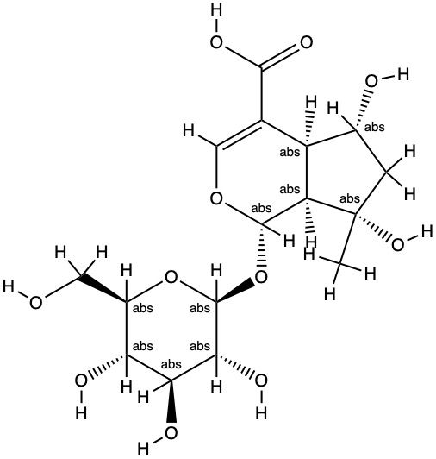 | Zhizi | CNKI | Study on HPLC fingerprints of Yinzhihuang granules and attributive analysis of their common peaks
decetylasperulosidic acid methyl ester | 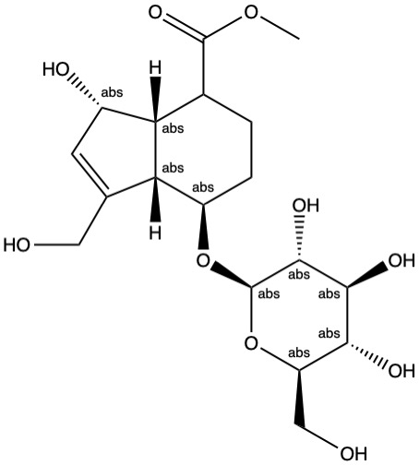 | Zhizi | CNKI | Study on HPLC fingerprints of Yinzhihuang granules and attributive analysis of their common peaks
neochlorogenic acid（5-caffeoylquinic acid） | 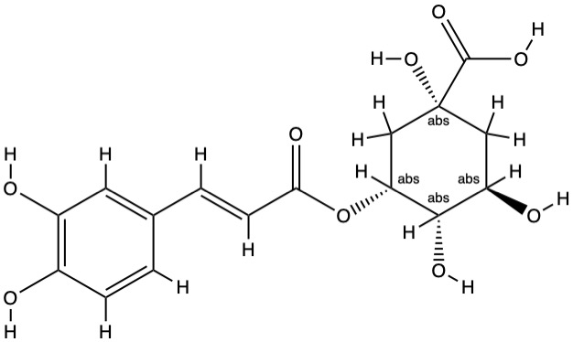 | Yinchen/Jinyinhua | CNKI | Study on HPLC fingerprints of Yinzhihuang granules and attributive analysis of their common peaks
chlorogenic acid | 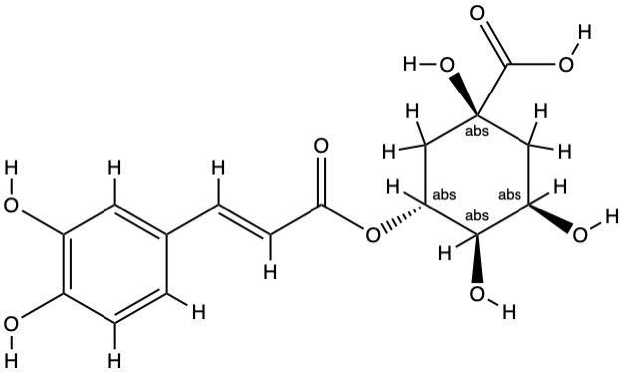 | Yinchen/Jinyinhua | CNKI | Study on HPLC fingerprints of Yinzhihuang granules and attributive analysis of their common peaks
cryptochlorogenic acid（4-Dicaffeoylquinic Acid） | 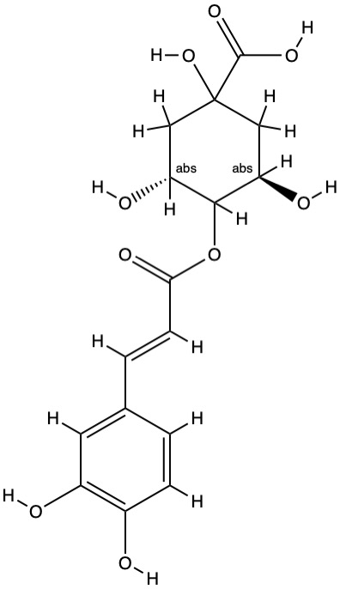 | Yinchen/Jinyinhua | CNKI | Study on HPLC fingerprints of Yinzhihuang granules and attributive analysis of their common peaks
genipin-1-β-D-gentiobioside | 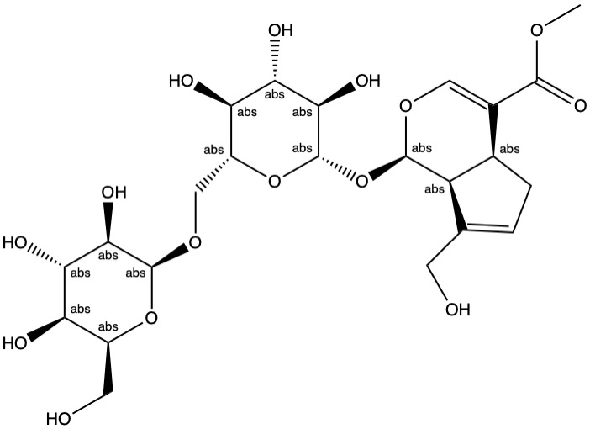 | Zhizi | CNKI | Study on HPLC fingerprints of Yinzhihuang granules and attributive analysis of their common peaks
geniposide | 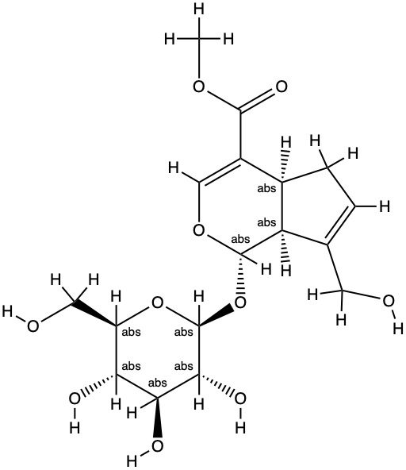 | Zhizi | CNKI | Study on HPLC fingerprints of Yinzhihuang granules and attributive analysis of their common peaks
p-Hydroxyacetophenone | 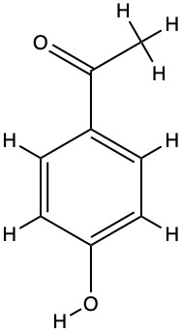 | Yinchen | CNKI | Study on HPLC fingerprints of Yinzhihuang granules and attributive analysis of their common peaks
scutellarin | 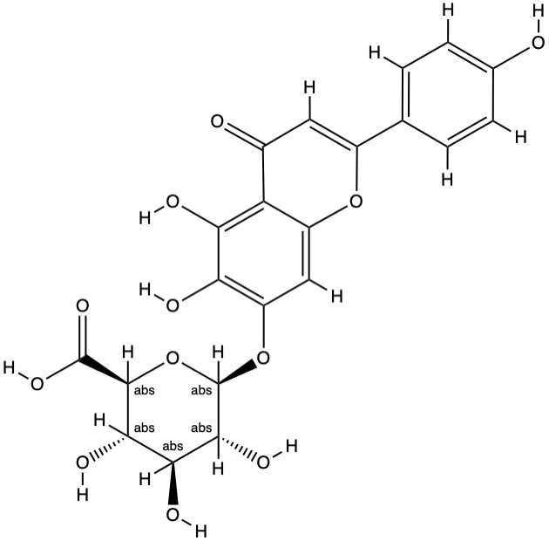 | Huangqin | CNKI | Study on HPLC fingerprints of Yinzhihuang granules and attributive analysis of their common peaks
Isochlorogenic acid B | 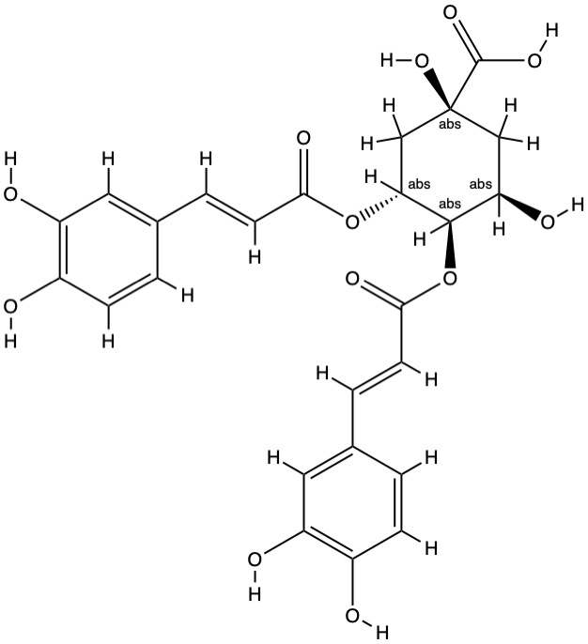 | Yinchen/Jinyinhua | CNKI | Study on HPLC fingerprints of Yinzhihuang granules and attributive analysis of their common peaks
Isochlorogenic acid A | 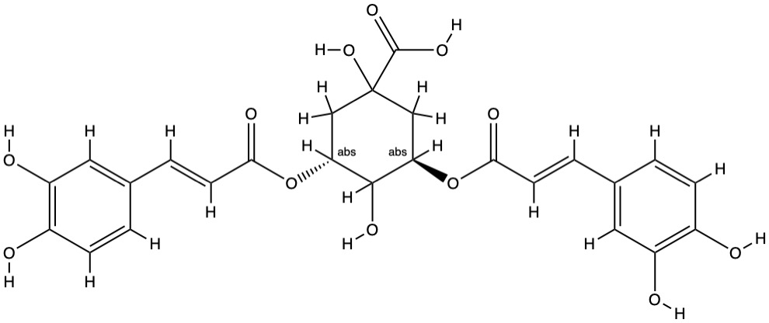 | Yinchen/Jinyinhua | CNKI | Study on HPLC fingerprints of Yinzhihuang granules and attributive analysis of their common peaks
Isochlorogenic acid C | 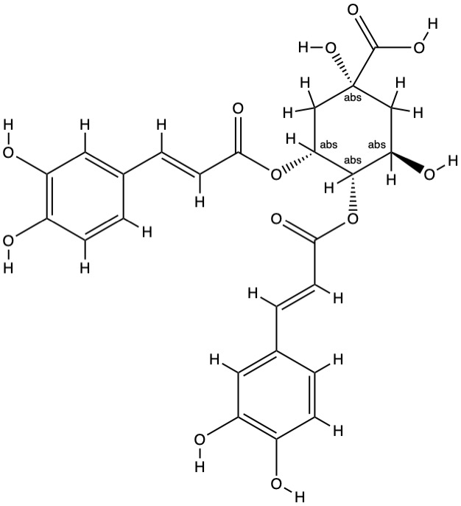 | Yinchen/Jinyinhua | CNKI | Study on HPLC fingerprints of Yinzhihuang granules and attributive analysis of their common peaks
Baicalin | 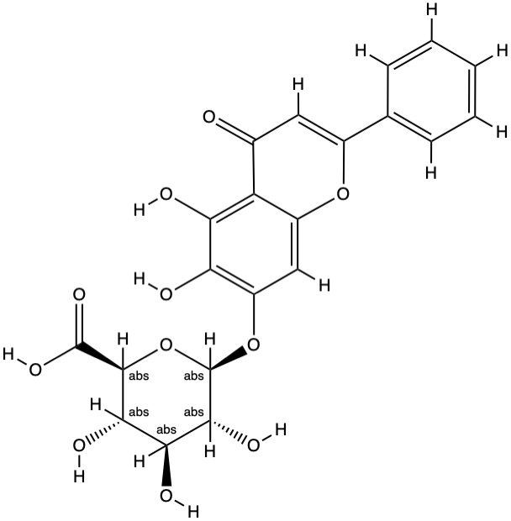 | Huangqin | CNKI | Study on HPLC fingerprints of Yinzhihuang granules and attributive analysis of their common peaks
Oroxylin A-7-O-β-D-glucuronide | 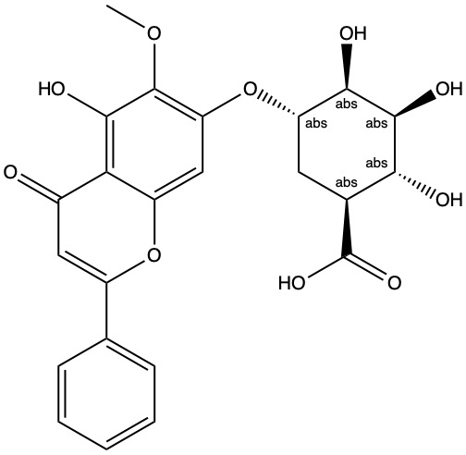 | Huangqin | CNKI | Study on HPLC fingerprints of Yinzhihuang granules and attributive analysis of their common peaks
Wogonoside | 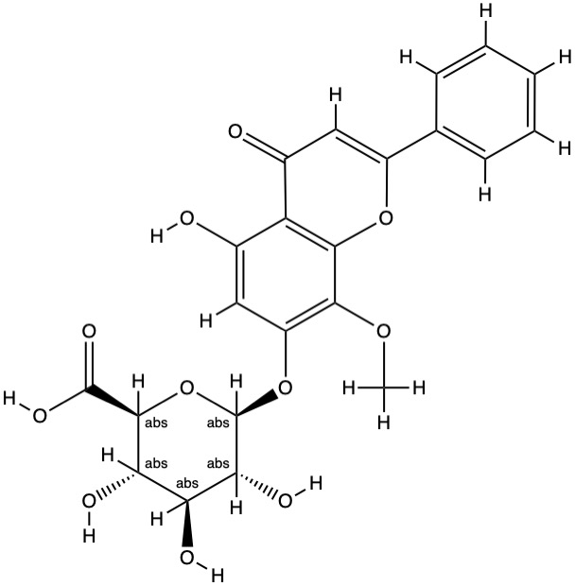 | Huangqin | CNKI | Study on HPLC fingerprints of Yinzhihuang granules and attributive analysis of their common peaks
Baicalein | 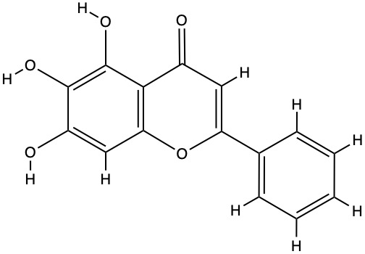 | Huangqin | CNKI | Study on HPLC fingerprints of Yinzhihuang granules and attributive analysis of their common peaks
1,3-dicaffeoylquinic acid | 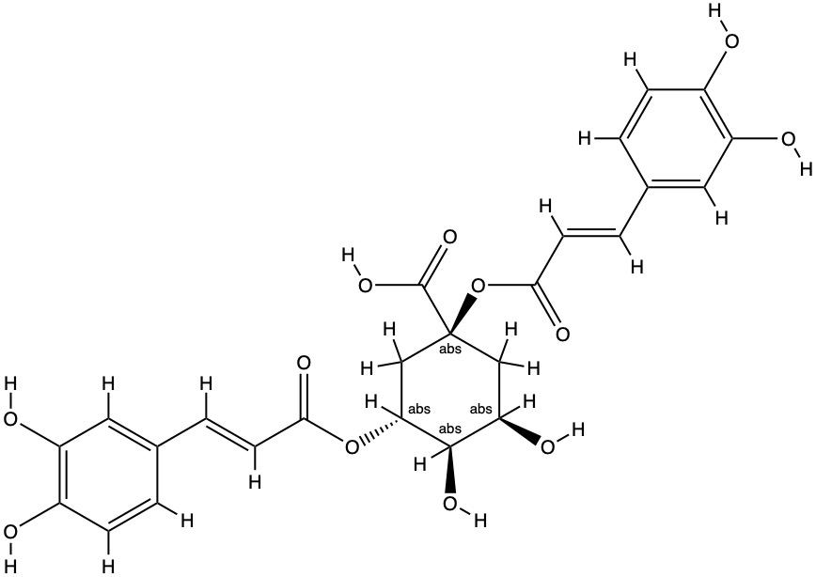 | Yinchen/Jinyinhua | CNKI | Simultaneous determination of fourteen constituents in Yinzhihuang granules by HPLC
scoparone | 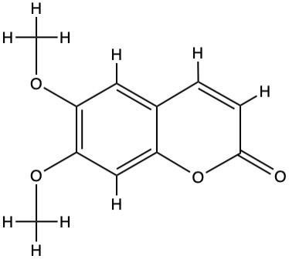 | Yinchen | CNKI | Simultaneous determination of fourteen constituents in Yinzhihuang granules by HPLC
wogonin | 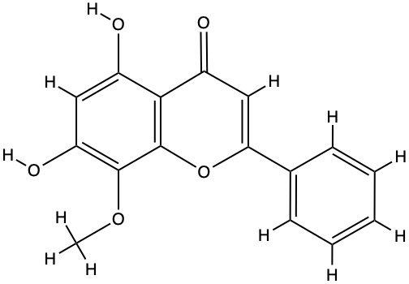 | Huangqin | CNKI | Simultaneous determination of fourteen constituents in Yinzhihuang granules by HPLC
oroxylin A | 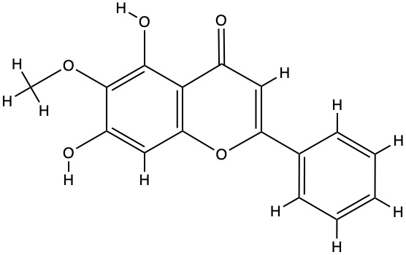 | Huangqin | CNKI | Simultaneous determination of fourteen constituents in Yinzhihuang granules by HPLC
Hyperoside | 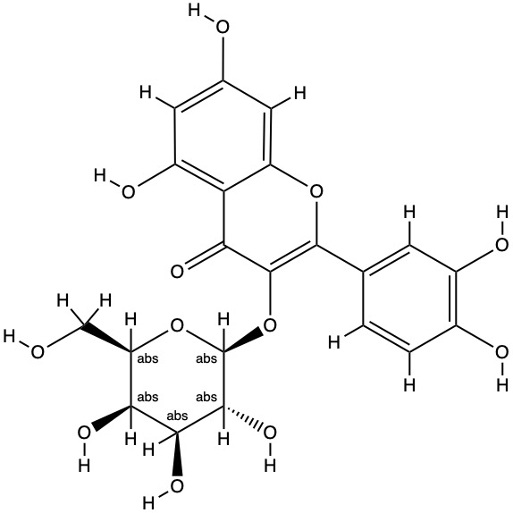 | Jinyinhua | CNKI | Simultaneous Determination of Four Components in Yinzhihuang Granules by High Performance Liquid Chromatography
Caffeic acid | 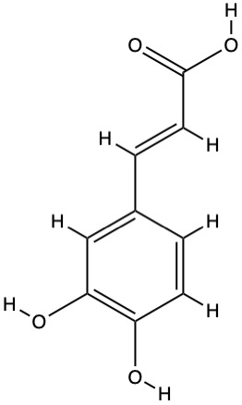 | Jinyinhua | PUBMED | Simultaneous Determination of 11 Components in Yinzhihuang Preparations and Their Constituent Herbs by High-Performance Liquid Chromatography with Diode Array Detector
geniposidic acid | 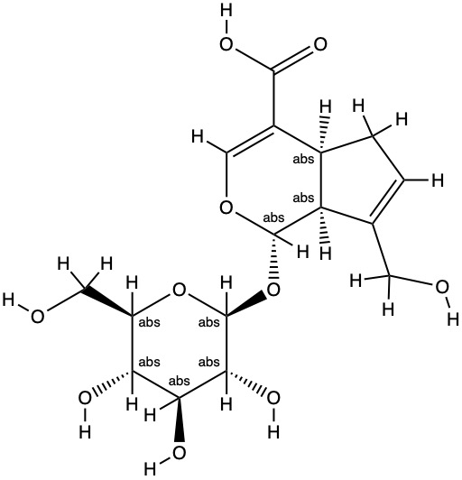 | Zhizi | PUBMED | Simultaneous Determination of 12 Components in Yinzhihuang Preparations and Their Constituent Herbs by High-Performance Liquid Chromatography with Diode Array Detector
luteoloside | 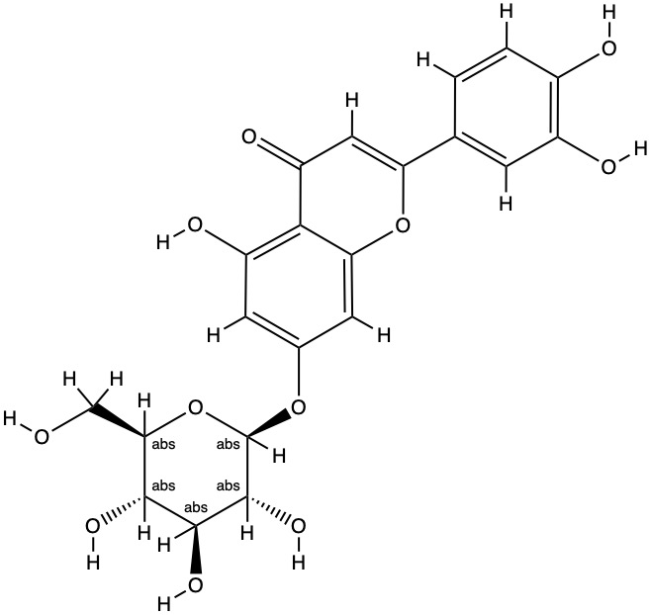 | Jinyinhua | PUBMED | Simultaneous Determination of 13 Components in Yinzhihuang Preparations and Their Constituent Herbs by High-Performance Liquid Chromatography with Diode Array Detector
luteolin | 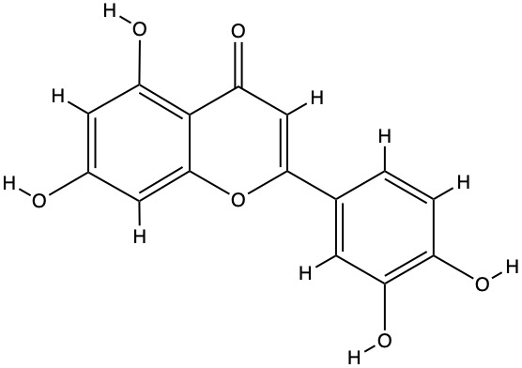 | Jinyinhua | PUBMED | Simultaneous Determination of 14 Components in Yinzhihuang Preparations and Their Constituent Herbs by High-Performance Liquid Chromatography with Diode Array Detector
Supplementary Table S1: The information for the 25 compounds in YZHG.
Target | Source
HMGCR | TTD
TLR7 | TTD
IFNA8 | TTD
IFNAR1 | TTD
TLR9 | TTD
DDX58 | TTD
NOD2 | TTD
HLA-DPA1 | pharmgkb
IFNA1 | disgenet
IFNG | disgenet
IFNA2 | disgenet
SLC10A1 | disgenet
IFNB1 | disgenet
HP | disgenet
IFNAR2 | disgenet
IL10RB | disgenet
IFNGR1 | disgenet
LOX | disgenet
LOXL2 | disgenet
HLA-DPB1 | disgenet
ALDH2 | disgenet
HLA-DQB2 | disgenet
PNPLA3 | disgenet
UBE2L3 | disgenet
GPT | disgenet
TP53 | disgenet
TNF | disgenet
IFNA13 | disgenet
PAEP | disgenet
AFP | disgenet
IFNL3 | disgenet
IL10 | disgenet
ALB | disgenet
IL6 | disgenet
CDKN2A | disgenet
HNF4A | disgenet
HLA-A | disgenet
GP1BA | disgenet
GGT1 | disgenet
TCF19 | disgenet
ITPR3 | disgenet
EHMT2 | disgenet
Supplementary Table S2: The information for the 42 Hepatitis B targets.
Category | Term | Count | PValue | Genes | FDR
GOTERM_MF_DIRECT | GO:0044212~transcription regulatory region DNA binding | 6 | 2.25E-07 | TNF, JUN, CREB1, TP53, BRCA1, STAT3 | 0.000243064
GOTERM_BP_DIRECT | GO:0045893~positive regulation of transcription, DNA-templated | 7 | 6.38E-07 | TNF, JUN, CREB1, TP53, BRCA1, STAT3, CDK2 | 0.000916109
GOTERM_BP_DIRECT | GO:0010628~positive regulation of gene expression | 6 | 6.45E-07 | TNF, TP53, CDK6, BRCA1, STAT3, TLR9 | 0.000925117
GOTERM_BP_DIRECT | GO:0045944~positive regulation of transcription from RNA polymerase II promoter | 8 | 1.39E-06 | NOD2, TNF, JUN, CREB1, TP53, BRCA1, STAT3, TLR9 | 0.001994508
Supplementary Table S3: GO enrichment of potential target of YZHG for Hepatitis B (FDR < 0.01).
Category | Term | Count | PValue | Genes | FDR
KEGG  PATHWAY | hsa05161:  Hepatitis B | 7 | 6.59E-08 | TNF, JUN, CREB1, TP53, CDK6, STAT3, CDK2 | 0.000075600
KEGG  PATHWAY | hsa05203:Viral carcinogenesis | 6 | 1.50E-05 | JUN, CREB1, TP53, CDK6, STAT3, CDK2 | 0.017161555
Supplementary Table S4: KEGG enrichment of potential target of YZHG for Hepatitis B (FDR < 0.05).

