Optimized Ex Vivo Stimulation Identifies Multi-functional HBV-specific T cells in a Majority of Chronic Hepatitis B Patients

Conan G. Chua^{1,2}, Aman Mehrotra¹, Tony Mazzulli^{3,4}, David K.H. Wong¹, Jordan J. Feld¹, Harry L.A. Janssen¹, Adam J. Gehring^{1,2}

¹Toronto Centre for Liver Disease, Toronto General Research Institute, University Health Network, Toronto, Canada
²Institute of Medical Sciences, University of Toronto, Toronto, Canada
³Department of Laboratory Medicine and Pathobiology, University of Toronto, Toronto, Canada
⁴Department of Microbiology, Mount Sinai Hospital, University Health Network, Toronto, Canada

Corresponding author:
Adam J. Gehring, Ph.D.
Toronto General Hospital Research Institute
Princess Margaret Cancer Research Tower
Room 10-356
101 College St,
Toronto, ON M5G 1L7
Canada
Tel: +1 (416) 634-7095
Email: adam.gehring@uhnresearch.ca

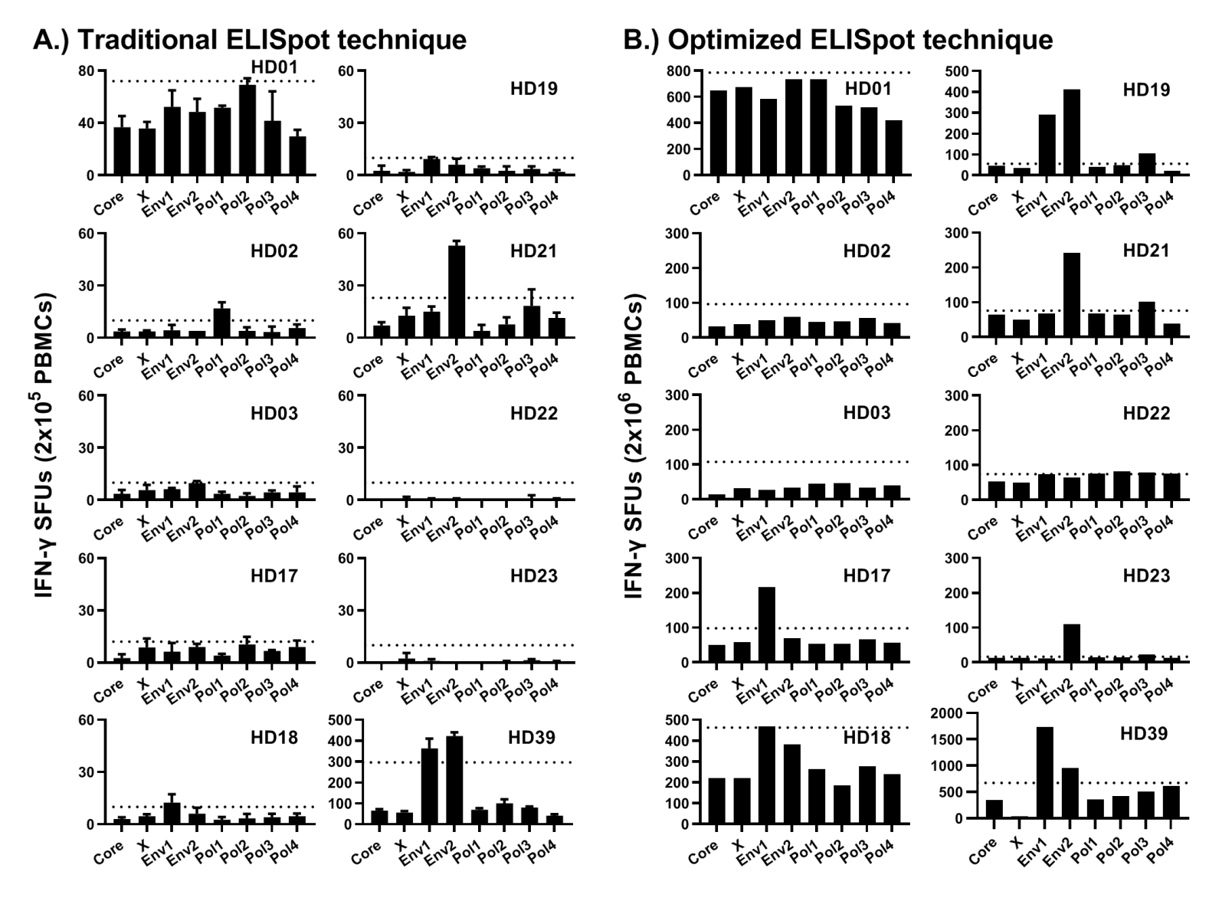
Supplementary Figure S1:

Supplementary Figure S1. Comparison of traditional and optimized ex vivo ELISpot protocols. Vaccinated donor PBMCs were thawed and rested overnight at 37ºC. (A) 2x10⁵ PBMCs were plated in triplicate and stimulated overnight with 5µg/mL/OLP of each pool. Results per pool were averaged over triplicates with error bars; dotted lines indicate 2x DMSO SFUs or a cut-off of 10 SFUs. (B) 4.5x10⁵ PBMCs (20%) were pulsed with 5µg/mL/OLP of each pool for 1 hour at 37ºC. Cells were washed then pooled with 1.8x10⁶ PBMCs (80%). Results per pool were summed; dotted lines indicate 2x DMSO SFUs or a cut-off of 25 SFUs.

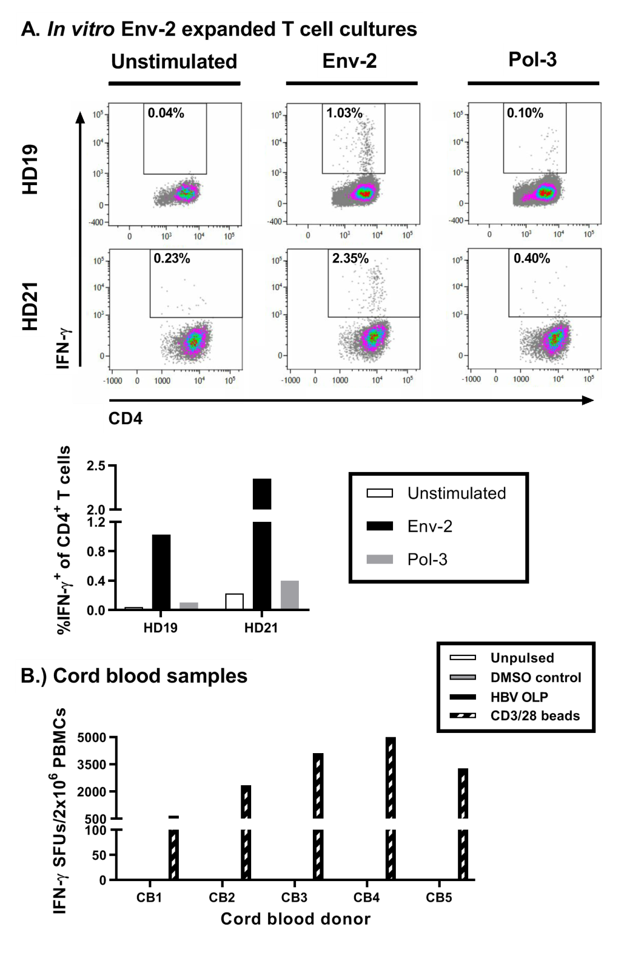
Supplementary Figure S2. Ex vivo peptide stimulation does not induce non-specific T cell responses. (A) Env-2 pool stimulated PBMCs were expanded in vitro with 10µg/mL IL-2 for 7 days. Expanded PBMCs were re-stimulated with either Env-2 or Pol-3 pools (or unstimulated) and 10µg/mL BFA. Cells were stained and prepared for FACS analysis. (B) Human cord blood mononuclear cells (CBMCs) from 5 donors were stimulated as previously described. No IFN-γ SFUs were detected from HBV OLP or DMSO stimulation. SFUs from CD3/28 bead stimulation demonstrated T cell responsiveness of each sample. Results were extrapolated from 50k CBMCs.
Supplementary Figure S2:

Supplementary Table S3:
Patient ID | Sex | Age | HBeAg Status | HBVsAg (IU/ml) | ALT (IU/L) | HBV DNA (IU/mL) | Clinical phase | Treatment | ELISpot response
CHB007 | F | 47 | (-) | 4825.72 | 13 | 0.00 | On treatment | Treated | (-)
CHB008 | F | 42 | (-) | 64.48 | 21 | 207.00 | Inactive | Untreated | (+)
CHB011 | F | 55 | (-) | 1037.04 | 16 | 10400.00 | On treatment | Treated | (+)
CHB016 | F | 32 | (+) | 13447.10 | 127 | 127000000.00 | On treatment | Treated | (+)
CHB017 | F | 29 | (-) | 5983.23 | 17 | 4620.00 | Indeterminate | Untreated | (-)
CHB020 | F | 57 | (-) | 30.38 | 17 | 112.00 | Inactive | Treated | (-)
CHB021 | F | 41 | (-) | 1626.84 | 12 | 0.00 | Inactive | Treated | (-)
CHB025 | F | 35 | (-) | 659.18 | 17 | 3010.00 | Inactive | Treated | (-)
CHB026 | M | 65 | (-) | 16.51 | 26 | 0.00 | On treatment | Treated | (+)
CHB027 | M | 51 | (-) | 2000.95 | 92 | 87000.00 | Immune-active | Untreated | (+)
CHB028 | M | 41 | (-) | 4019.70 | 53 | 182000.00 | Immune-active | Untreated | (+)
CHB030 | M | 56 | (-) | 111.77 | 19 | 76.60 | Inactive | Untreated | (+)
CHB031 | M | 56 | (-) | 60.23 | 29 | 0.00 | On treatment | Treated | (-)
CHB033 | M | 54 | (-) | 0.76 | 33 | 106.00 | Inactive | Untreated | (+)
CHB034 | F | 40 | (-) | 2396.02 | 39 | 61000.00 | Immune-active | Untreated | (+)
CHB035 | F | 27 | (+) | 51229 | 139 | 98000000.00 | On treatment | Treated | (+)
CHB036 | F | 49 | (+) | 1011.22 | 18 | 238000.00 | Immune-tolerant | Untreated | (+)
CHB037 | M | 57 | (-) | 31.27 | 32 | 0.00 | On treatment | Treated | (+)
Patient ID | Sex | Age | HBeAg | HBVsAg (IU/ml) | ALT (IU/L) | HBV DNA (IU/mL) | Clinical phase | Treatment | ELISpot response
CHB038 | M | 67 | (-) | 212.73 | 32 | 11600.0 | Indeterminate | Untreated | (-)
CHB040 | M | 84 | (-) | 616.37 | 43 | 0.0 | On treatment | Treated | (+)
CHB041 | M | 55 | (-) | 1.66 | 32 | 0.0 | On treatment | Treated | (+)
CHB042 | M | 55 | (-) | 28.36 | 40 | 1720.0 | Inactive | Untreated | (+)
CHB043 | M | 45 | (-) | 1357 | 79 | 20.4 | On treatment | Treated | (+)
CHB044 | M | 45 | (-) | 95.38 | 49 | 76.3 | On treatment | Treated | (+)
CHB046 | F | 28 | (+) | 2395.55 | 20 | 10700.0 | Immune-tolerant | Untreated | (+)
CHB047 | M | 37 | (+) | >124925.00 | 72 | 170000000.0 | Immune-active | Untreated | (-)
CHB048 | M | 37 | (-) | 37606 | 29 | 878.0 | Indeterminate | Untreated | (+)
CHB049 | M | 31 | (-) | 0.00 | 33 | 0.0 | Inactive | Untreated | (-)
CHB060 | M | 34 | (-) | 2227.8 | 50 | 185000.0 | Immune-active | Untreated | (-)
CHB061 | M | 46 | (-) | 11190.77 | 26 | 0.0 | On treatment | Treated | (+)
Supplementary Table S3. Patient characteristics for ex vivo ELISpots (Fig. 2). Patient clinical phases are determined according to 2018 AASLD guidelines or are classified as ‘indeterminate’ otherwise.

Supplementary Table S4:
Patient ID | Sex | Age | HBeAg | HBVsAg (IU/mL) | ALT (IU/L) | HBV DNA (IU/mL) | Clincal phase | Treatment | IFN-γ | TNF-α | IL-2
CHB002 | M | 49 | (-) | 1518.00 | 25 | 4250.0 | Indeterminate | Untreated | (+) | (-) | (-)
CHB005 | M | 29 | (+) | 108981.00 | 47 | 170000000.0 | Immune tolerant | Untreated | (+) | (+) | (+)
CHB007 | F | 45 | (-) | 4825.72 | 13 | 0.0 | On treatment | Treated | (+) | (+) | (-)
CHB008 | F | 41 | (-) | 64.48 | 21 | 207.0 | Inactive | Untreated | (+) | (-) | (+)
CHB009 | M | 49 | (+) | 21215.70 | 275 | 185000.0 | On treatment | Treated | (+) | (+) | (+)
CHB010 | F | 42 | (+) | 7147.00 | 52 | 170000000.0 | On treatment | Treated | (+) | (-) | (+)
CHB056 | M | 49 | (-) | 26.72 | 54 | 0.0 | Inactive | Untreated | (+) | (-) | (+)
CHB065 | F | 54 | (-) | 5.60 | 25 | 199.0 | Inactive | Untreated | (+) | (-) | (+)
CHB066 | M | 53 | (-) | 1005.03 | 25 | 0.0 | On treatment | Treated | (+) | (+) | (-)
CHB067 | M | 69 | (-) | 95.10 | 20 | 0.0 | On treatment | Treated | (+) | (-) | (+)
CHB069 | F | 33 | (-) | 4657.55 | 19 | 0.0 | On treatment | Treated | (+) | (+) | (+)
CHB070 | F | 43 | (-) | 26.94 | 17 | 666.0 | Inactive | Untreated | (+) | (+) | (+)
CHB073 | M | 43 | (-) | 1116.35 | 31 | 0.0 | On treatment | Treated | (+) | (+) | (+)
Supplementary Table S4. Patient characteristics for ex vivo FluoroSpots (Figs. 5 and 6). Patient clinical phases are determined according to 2018 AASLD guidelines or are classified as ‘indeterminate’ otherwise.

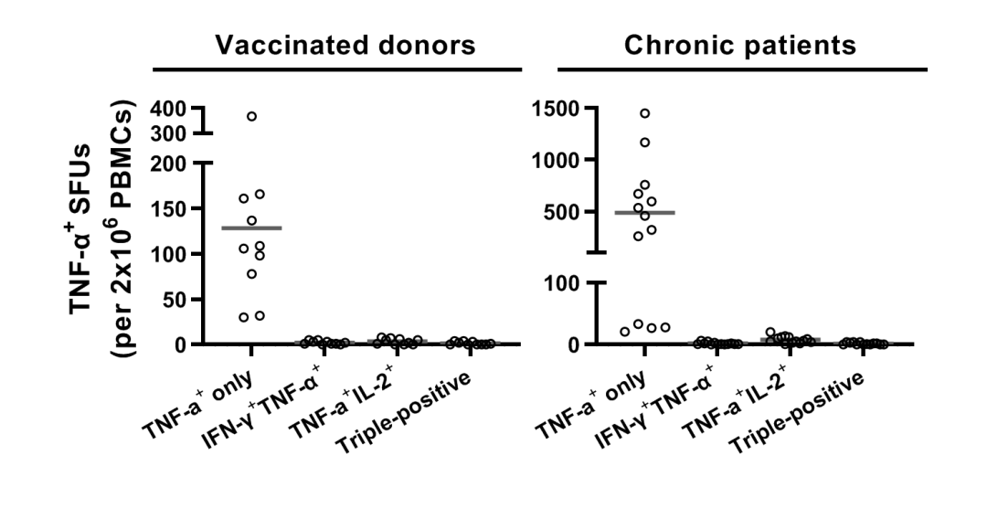
Supplementary Figure S5:
Supplementary Figure S5. Majority of TNF-α SFUs comprise of single-positive cells. TNF-α responses from DMSO-stimulated PBMCs in figure 5 were analyzed for functionality. Majority (>90%) are found to be single-positive for TNF-α⁺ secretion only.

Supplementary Figure S6:

Supplementary Figure S6. Functionality of CEF-stimulated PBMCs. (A) IFN-γ (green), (B) IL-2 (red) and (C) TNF-α (orange) FluoroSpot responses against CEF peptides. (D) Polyfunctionality between CHB patient and vaccinated donors were calculated as total of double-/triple-positive SFUs out of unique SFU counts. (E) Double-positive subsets were further delineated and compared between the two cohorts. Levels of significance are included alongside each panel where necessary.

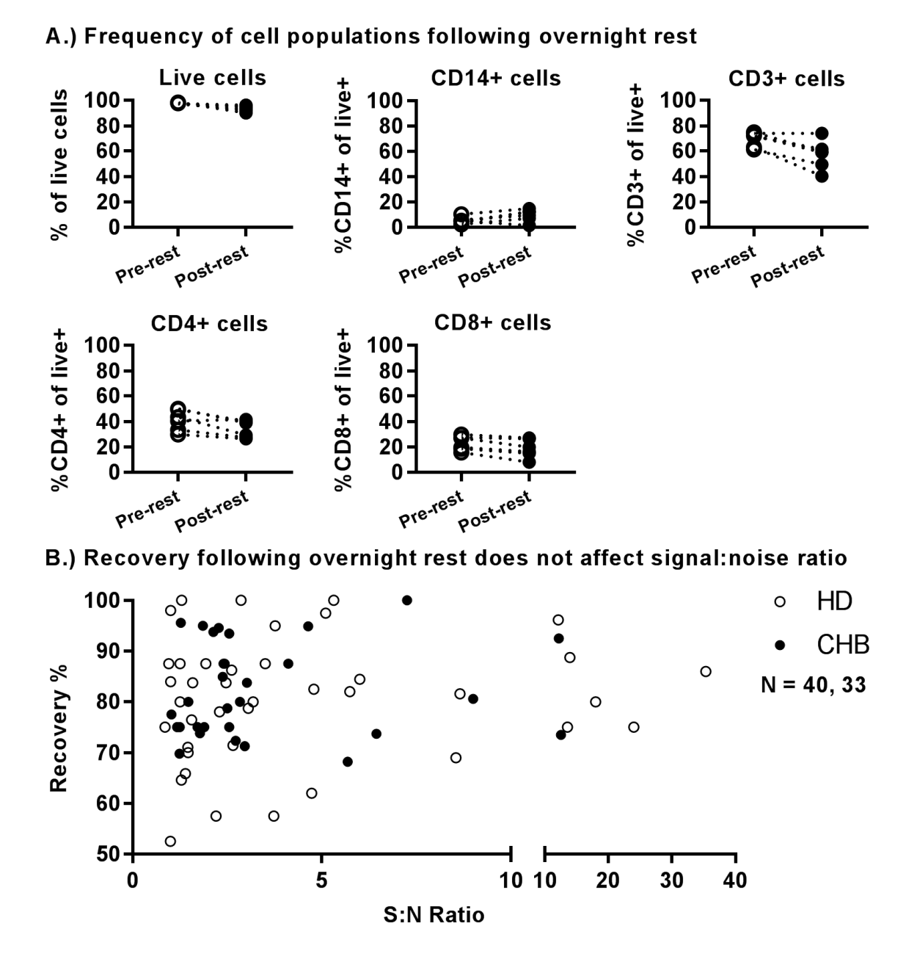
Supplementary Figure S7. Overnight resting does not significantly affect immune cell populations or ex vivo assay readout. (A) Frequencies of live cells, monocytes (CD14⁺), and T cells (CD3⁺CD4⁺ or CD3⁺CD8⁺) before and after overnight rest. (B) Recovery following overnight rest graphed against ex vivo ELISpot signal:noise ratio for HDs and CHBs.
Supplementary Figure S7:

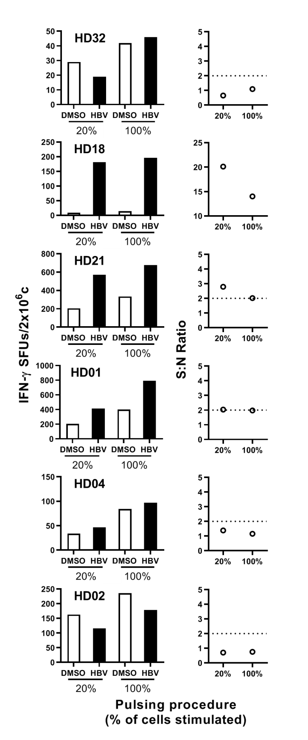
Supplementary Figure S8:
Supplementary Figure S8. 20:80 pulsing strategy results in less DMSO background. 20% and 100% of vaccinated donor PBMCs (N=6) were exposed to OLP/DMSO for 1 hour at 37ºC. 20% pulsed cells were pooled with remaining unpulsed 80% of cells following incubation. Cells were plated on IFN-γ ELISpot plates and S:N ratios were calculated.

