Nitrogen-rich graphitic-carbon@graphene as a metal-free electrocatalyst for oxygen reduction reaction
Halima Begum, Mohammad Shamsuddin Ahmed, Young-Bae Kim*
Department of Mechanical Engineering, Chonnam National University, Gwangju, Republic of Korea. *E-mail address: ybkim@chonnam.ac.kr

Electrochemical characterization.
An ink of RGO and/or Ng-C@G (2 mg mL⁻¹ in ethanol) was prepared with ultrasonic agitation for 30 min in order to better dispersion. The prepolished glassy carbon electrode (GCE) of rotating ring disk electrode (RRDE) was then drop coated by a 10 μL portion of RGO and/or Ng-C@G ink separately. For the preparation of 20% Pt/C (E-TEK), the suspension of 1 mg mL⁻¹ with 5 μL of Nafion (5%) in ethanol was dropped onto GCE. All electrochemical techniques were recorded using a CHI 700C electrochemical workstation (U.S.A.) three-electrode potentiostat and an EG&G Model 636 RDE system along with the CHI 700C used for RRDE measurements in high purity argon (Ar)- or O₂-purged (for at least 30 min) alkaline solution at room temperature (RT). A carbon-rod and Ag/AgCl electrode were used as counter and reference electrode, respectively. The electrode potential was determined with respect to reversible hydrogen electrode (RHE) scale according to the Nernst equation: (E_{RHE}=E_{Ag/AgCl}+0.059 pH + E°_{0.197} V, at 25 °C).

Instrumental Characterization
The transmission electron microscopy (TEM) and energy dispersive X-ray spectroscopy (EDS) were carried out using a Tecnai 20 microscope at 200 kV. The surface morphology was also characterized by a JSM-7500F JEOL for field emission scanning electron microscope (FESEM). Crystal structure was examined by X-ray diffraction (XRD), which was carried out on a Rigaku D/max-2500, using filtered Cu Kα radiation. Detailed chemical compositions of the samples were analyzed by X-ray photoelectron spectroscopy (XPS) using a VG multilab 2000 spectrometer (Thermo VG Scientific, Southend-on-Sea, Essex, UK) in an ultrahigh vacuum using an unmonochromatized Mg Kα (1253.6 eV) radiation source and a spherical section analyzer. BET surface area and pore size distribution were obtained through the Barrett-Joyner-Halenda method by nitrogen isotherm adsorption and desorption (BelsorpII mini, BEL Japan Inc.). Raman spectra were collected with a LabRam HR800 UV Raman microscope (Horiba Jobin-Yvon, France), at an excitation wavelength of 514 nm using an argon ion (Ar⁺) laser.

Koutecky–Levich equation
$\frac{1}{j}=\frac{1}{j_{k}}+\frac{1}{j_{L}}$ (1)
j_{L} = B$ω^{1/2}$ =0.62nFA$D_{O_{2}}^{2/3}C_{O_{2}}v^{-1/6}ω^{1/2}$ (2)
j_{k} = nFk$C_{O_{2}}$ (3)
where j for measured current densities (mA cm⁻²); A for surface area of working electrode (0.196 cm²); F for Faraday constant (96485.3 C mol⁻¹), $D_{O_{2}}$ for O₂ diffusion coefficient (1.9 × 10⁻⁵ cm² s⁻¹); $C_{O_{2}}$ for O₂ bulk concentration (1.2 mM L⁻¹); v for kinetic viscosity of 0.1 M KOH (1 × 10⁻² cm² s⁻¹); ω for revolution speed of electrode (ω = 2π*rpm); k for electron-transfer rate constant and B is a factor which yield from slope of j_{k}^{–1} vs. ω^{–1/2} straight line plot.

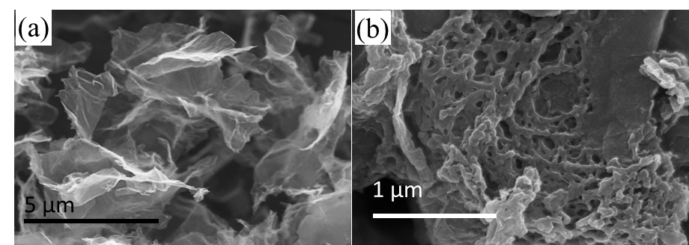
Figure S1: The SEM images of RGO (a) and Ng-C@G (with 25 µL aniline addition) (b).

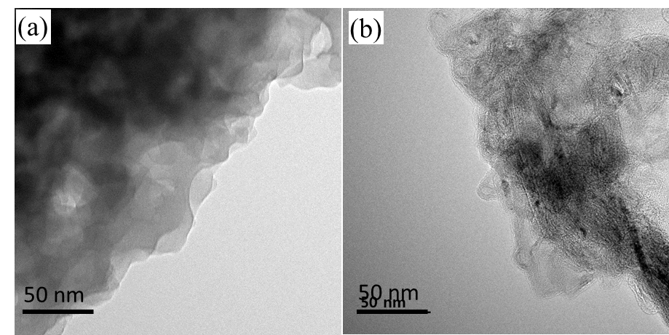
Figure S2: TEM images of GOPANI (a) and Ng-C@G at 800 ℃ (b).
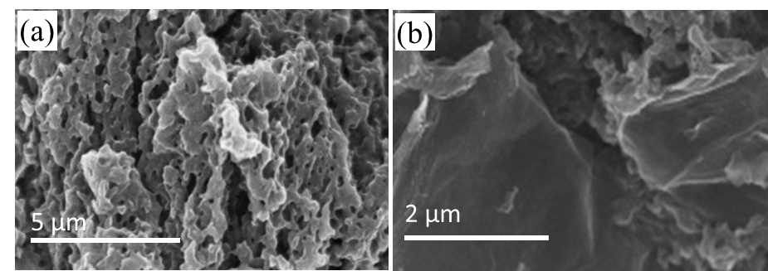
Figure S3: The SEM image of pure PANI derived carbon (a) and enlarged SEM image (Figure 2c) of the Ng-C@G at 800 ℃ (b).

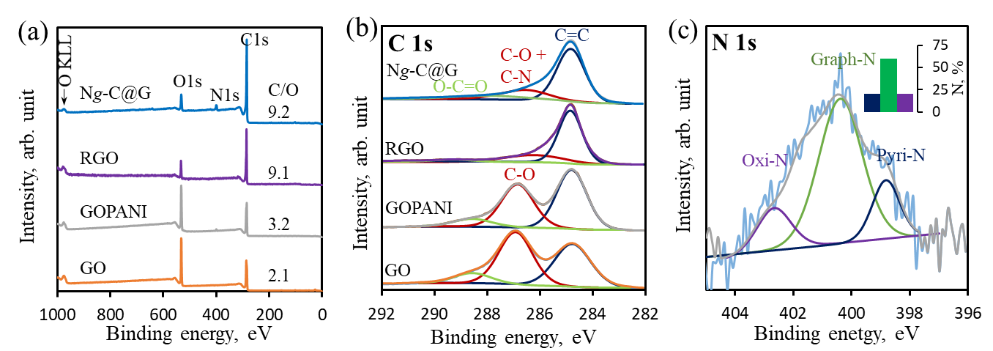
Figure S4: The XPS survey spectra (a) and the C 1s XPS spectra (b) of GO, GOPANI, RGO at 800 ℃, Ng-C@G at 800 ℃, and the N 1s XPS spectrum of Ng-C@G at 900 ℃ (c).

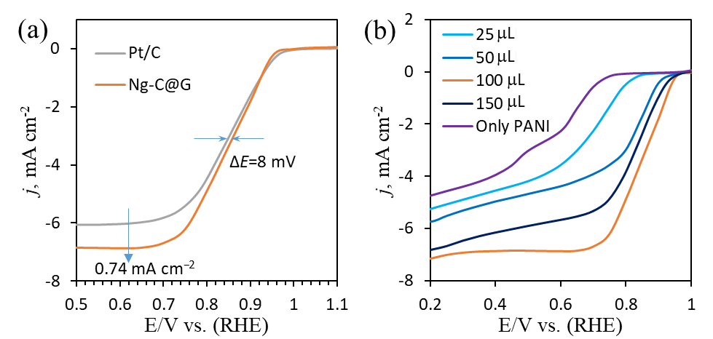
Figure S5: The enlarged LSVs of ORR on Ng-C@G and Pt/C catalysts (a) and LSVs of ORR on Ng-C@G which prepared with various addition of aniline (b) in O₂-saturated 0.1 M KOH solution at a scan rate of 5 mV s⁻¹ and at 1600 rpm rotation speed.
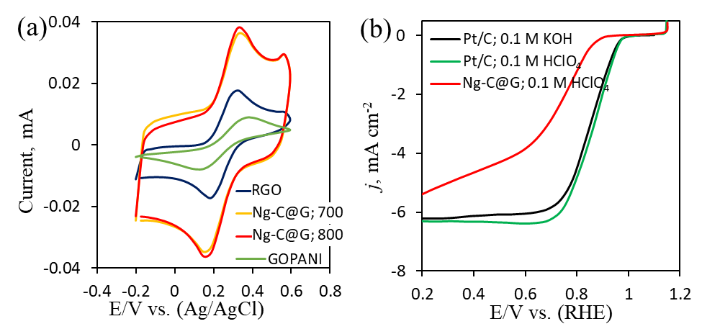
Figure S6: Cyclic voltammetry of different modified electrodes in a 0.1 M KCl containing with 5.0 mM [Fe(CN)₆]^{3−/4−} redox probe solution at a scan rate of 50 mV s⁻¹ (a), and the enlarged LSVs of ORR on Ng-C@G (red) and Pt/C (green) catalysts in O₂-saturated 0.1 M HClO₄ solution with comparison of Pt/C in 0.1 M KOH solution (black) at a scan rate of 5 mV s⁻¹ and at 1600 rpm rotation speed (b).

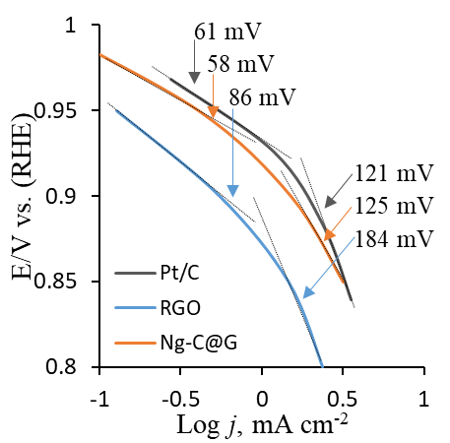
Figure S7: The Tafel plots of Ng-C@G, RGO and Pt/C catalysts during ORR in O₂-saturated 0.1 M KOH solution.

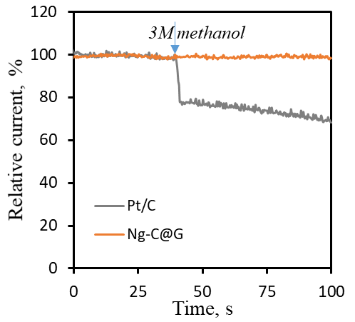
Figure S8: Current vs. time curves of Ng-C@G and Pt/C at −0.3 V in 0.1 M KOH with the addition of 3 M methanol.
Table S1: The comparison of ORR properties on tested catalysts with other metal-free ORR catalysts.
Catalysts | E_{onset} (V_{RHE}) | E_{1/2} (V_{RHE}) | n value @ 0.6 V_{RHE} | References
Ng-C@G | 0.96 | 0.806 | 3.96 | This work
N-HC@G-900 | 1.0 | 0.85 | 3.9 | [1]²⁰¹⁸
BN-CNOs | ~0.78 | ~68 | 3.94 | [2]²⁰¹⁸
30%MIL/PPy-800 | 0.997 | 0.864 | ~3.79 | [3]²⁰¹⁸
SN-C@ 800 | 0.962 | 0.865 | 4 | [4]²⁰¹⁸
N-pGF | ~0.86 | ~0.76 | 3.9 | [5]²⁰¹⁸
N,S₁,S₂-CM1000-b | 0.98 | ~0.86 | ~3.85 | [6]²⁰¹⁸
NCF | 0.93 | ~0.83 | 3.8 | [7]²⁰¹⁸
N-GA-150 | ~0.95 | ~0.78 | 3.7 | [8]²⁰¹⁸
N′N-GDY | 0.98 | 0.83 | ~3.9 | [9]²⁰¹⁷
N,F-Carbon-1000 | 0.97 | 0.84 | 3.92 | [10]²⁰¹⁷
BCN | 0.94 | 0.82 | 3.93 | [11]²⁰¹⁷
NL-C | 0.95 | 0.86 | ~4 | [12]²⁰¹⁶
NGM | 0.89 | 0.77 | 3.8 | [13]²⁰¹⁶
N-CNS-120 | 0.9 | 0.77 | 3.9 | [14]²⁰¹⁶
NPGC-950 | 0.91 | 0.78 | 3.79 | [15]²⁰¹⁶
NCNP−CNF | 0.84 | ~0.77 | 3.5 | [16]²⁰¹⁶
N-CNF aerogel | ~0.94 | 0.8 | 3.96 | [17]²⁰¹⁵
NGA900 | 0.914 | 0.828 | 3.9 | [18]²⁰¹⁵
N-C@CNT-900 | 0.94 | 0.81 | 3.9 | [19]²⁰¹⁵
BN-GQD/G-10 | 0.98 | ~0.82 | 3.93 | [20]²⁰¹⁴
~eye estimated

References
- J. Sun, S. E. Lowe, L. Zhang, Y. Wang, K. Pang, Y. Wang, Y. Zhong, P. Liu, K. Zhao, Z. Tang, H. Zhao, Angew. Chem. Int. Ed. 2018, 57, 16511–16515.
- A. Camisasca, A. Sacco, R. Brescia, S. Giordani, ACS Appl. Nano Mater. 2018, 1, 5763−5773.
- J. Tong, W. Li, L. Bo, J. Ma, T. Li, Y. Li, Q. Zhang, H. Fan, ACS Sustainable Chem. Eng. 2018, 6, 8383−8391.
- J. Tong, W. Li, J. Ma, W. Wang, L. Bo, Z. Lei, A. Mahboob, ACS Appl. Energy Mater. 2018, 1, 5746−5754.
- G. S. Bang, G. W. Shim, G. H. Shin, D. Y. Jung, H. Park, W. G. Hong, J. Choi, J. Lee, S.-Y. Choi, ACS Omega 2018, 3, 5522−5530.
- C. Yang, H. Jin, C. Cui, J. Li, J. Wang, K. Amine, J. Lu, S. Wang, Nano Energy 54 (2018) 192–199.
- H. Zhang, K. Lv, B. Fang, M. C. Forster, R. Dervisoglu, L. B. Andreas, K. Zhang, S. Chen, Electrochim. Acta 292 (2018) 942–950.
- Q. Xue, Y. Ding, Y. Xue, F. Li, P. Chen, Y. Chen, Carbon 139 (2018) 137–144.
- Q. Lv, W. Si, Z. Yang, N. Wang, Z. Tu, Y. Yi, C. Huang, L. Jiang, M. Zhang, J. He, Y. Long, ACS Appl. Mater. Interfaces 2017, 9, 29744−29752.
- Y. Lv, L. Yang, D. Cao, ACS Appl. Mater. Interfaces 2017, 9, 32859−32867.
- J. Wang, J. Hao, D. Liu, S. Qin, D. Portehault, Y. Li, Y. Chen, W. Lei, ACS Energy Lett. 2017, 2, 306−312.
- M. Graglia, J. Pampel, T. Hantke, T.-P. Fellinger, D. Esposito, ACS Nano 2016, 10 (4), 4364
- C. Tang, H.F. Wang, X. Chen, B.Q. Li, T.Z. Hou, B. Zhang, Q. Zhang, M.M. Titirici, F. Wei, Adv. Mater. 2016, 28 (32), 6845–6851.
- H. Yu, L. Shang, T. Bian, R. Shi, G. I. N. Waterhouse, Y. Zhao, C. Zhou, L.-Z. Wu, C.-H. Tung, T. Zhang, Adv. Mater. 2016, 28, 5080–5086.
- B. Men, Y. Sun, M. Li, C. Hu, M. Zhang, L. Wang, Y. Tang, Y. Chen, P. Wan, J. Pan, ACS Appl. Mater. Interfaces 2016, 8, 1415−1423.
- G. Panomsuwan, N. Saito, T, Ishizaki, ACS Appl. Mater. Interfaces 2016, 8, 6962−6971.
- H.-W. Liang, Z.-Y. Wu, L.-F. Chen, C. Li, S.-H. Yu, Nano Energy 2015, 11, 366–376.
- J. Li, Y. Zhang, X. Zhang, J. Han, Y. Wang, L. Gu, Z. Zhang, X. Wang, J. Jian, P. Xu, B. Song, ACS Appl. Mater. Interfaces 2015, 7, 19626−19634.
- C. Guo, W. Liao, Z. Li, L. Sun, C. Chen, Nanoscale, 2015, 7, 15990–15998.
- H. Fei, R. Ye, G. Ye, Y. Gong, Z. Peng, X. Fan, E. L. G. Samuel, P. M. Ajayan, J. M. Tour, ACS Nano, 8, 10837–10843, 2014.

