Localization of Quantitative Trait Loci for Cucumber Fruit Shape by A Population of Chromosome Segment Substitution Lines

Xiangfei Wang†, Hao Li†, Zhihui Gao, Lina Wang*, Zhonghai Ren*

State Key Laboratory of Crop Biology; Shandong Collaborative Innovation Center of Fruit & Vegetable Quality and Efficient Production; Key Laboratory of Biology and Genetic Improvement of Horticultural Crops in Huang-Huai Region, Ministry of Agriculture; College of Horticulture Science and Engineering, Shandong Agricultural University, Tai’an, Shandong 271018, People’s Republic of China

†These authors contribute equally to this work.

*Correspondence should be addressed to Z. R. (zhren@sdau.edu.cn) or L.W. (lnwang@sdau.edu.cn ).

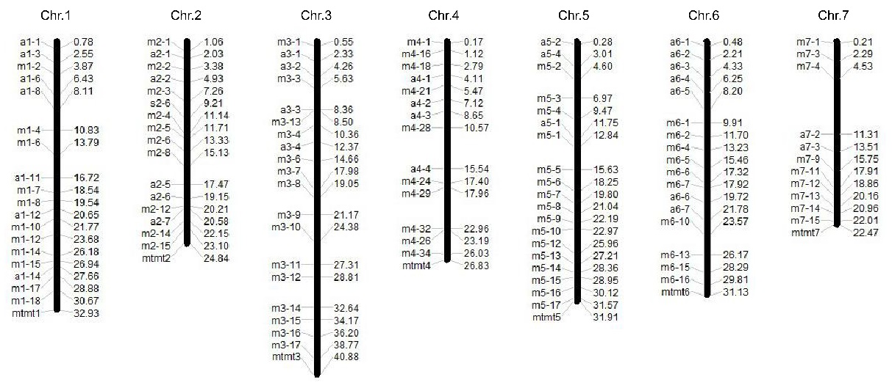
Figure S1. Chromosomal distribution of 114 InDel markers used in this study. Markers are shown on the left side of each chromosome and their physical locations (Mb) are indicated on the right side based on cucumber 9930 V3.0 draft genome.

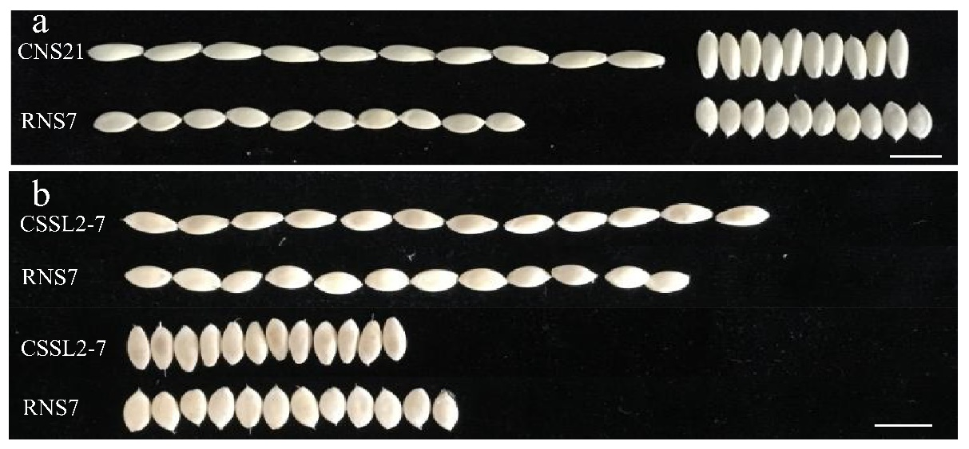

Figure S2. Seed phenotypes of CNS21, RNS7 and CSSL2-7 carrying QTLs for seed shape. (a) Seed shape of CNS21 and RNS7. (b) Phenotypic comparisons of cucumber seeds between CSSL2-7, a substitution line carrying QTLs for seed shape, and the recurrent parent RNS7. Scale bar = 1 cm.

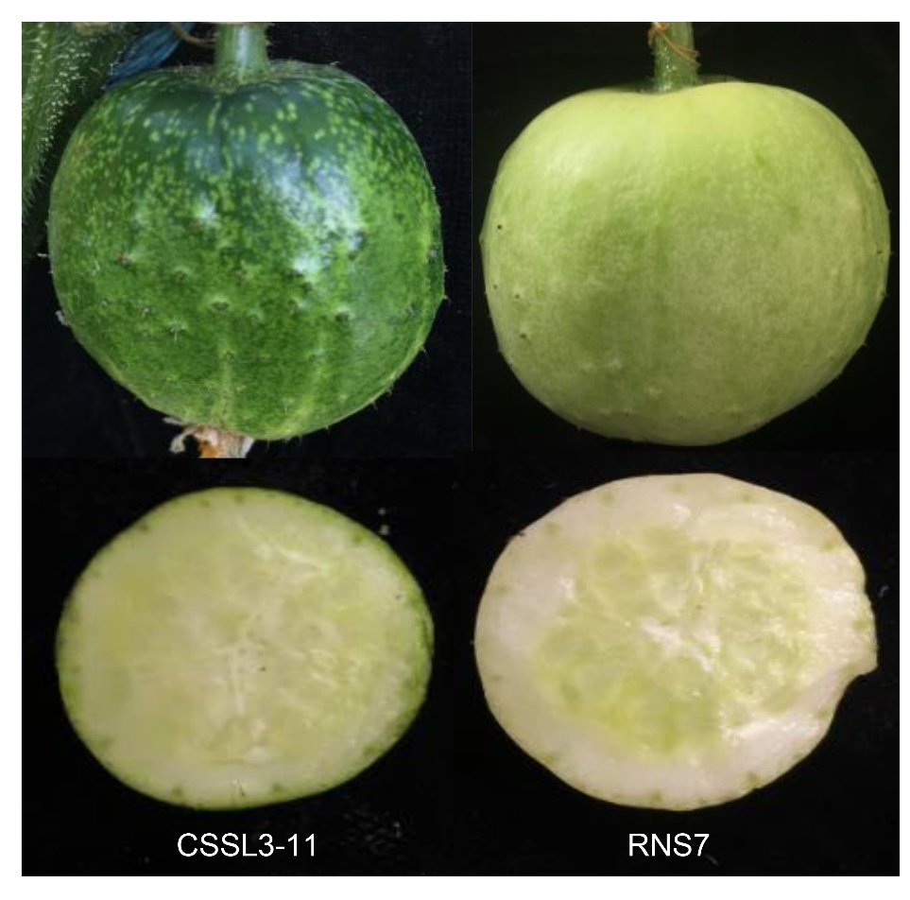

Figure S3. Comparison of fruit ground and flesh color between CSSL3-11 and the recurrent parent RNS7. CSSL3-11 is a substitution line that carries QTLs responsible for fruit color.

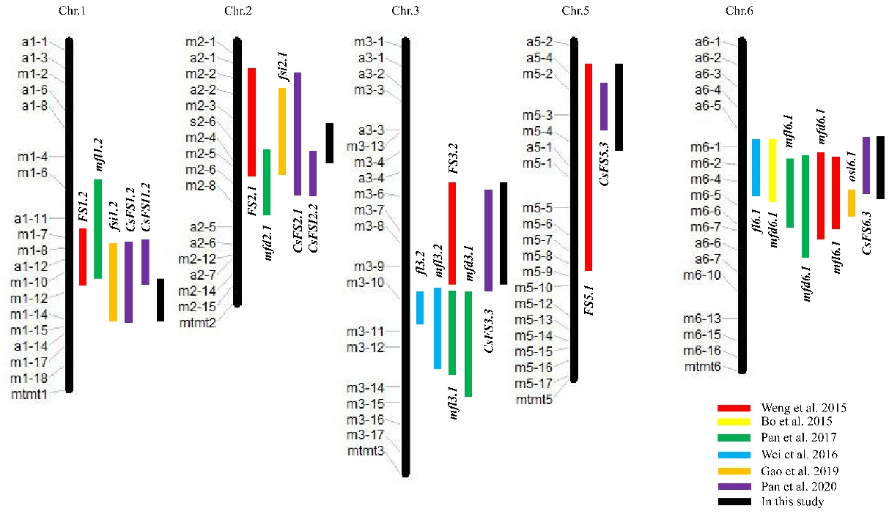

Figure S4. Chromosomal distribution of cucumber fruit shape related QTLs in previous and the present studies based on cucumber 9930 V3.0 draft genome.

Table S1. Distribution of the substituted segments from 71 CSSLs on 7 chromosomes.
Chr. | Length of Chr. (Mb) | Number of CSSL | Number of substituted segments | Length of substituted segments (Mb) |  |  | Times of genome coverage
 |  |  |  | Rang | Average | Total | Times of genome coverage
1  2  3  4  5  6  7  Average  Total | 32.93  24.84  40.88  26.83  31.91  31.13  22.47  -  210.43 | 17  12  11  6  9  7  9  -  71 | 20  12  12  6  10  7  9  10.86  76 | 2.48-19.31  3.29-9.94  4.51-15.85  1.96-18.92  2.36-16.94  3.46-16.39  1.73-14.66  -  - | 7.04  13.52  7.18  7.94  7.98  7.60  7.07  7.19  - | 140.81  75.72  86.10  47.66  79.83  53.17  63.67  78.14  546.96 | 4.28  3.05  2.11  1.78  2.50  1.71  2.83  2.61  -
Note: Data were analyzed based on cucumber 9930 V3.0 draft genome.

Table S2. Phenotypic comparisons and additive effects of CSSLs carrying QTLs for cucumber seed shape and fruit color.
Line | Chr. | Position (Mb)ª | Substituted region | Trait | Add
FGC
CSSL3-11 | 3 | 33.31 ~ 40.88 | m3 - 15 ~ m3 - 17 | Deep green | —
RNS7 |  |  |  | Light green
FLC
CSSL3-11 | 3 | 33.31 ~ 40.88 | m3 - 15 ~ m3 - 17 | Light green | —
RNS7 |  |  |  | White
SDL(mm)
CSSL2-7 | 2 | 5.10 ~ 14.23 | m2 - 3 ~ m2 - 5 | 9.10±0.10 *** | 0.70
RNS7 |  |  |  | 7.70±0.10
SW(mm)
CSSL2-7 | 2 | 5.10 ~ 14.23 | m2 - 3 ~ m2 - 5 | 3.70±0.06 *** | -0.40
RNS7 |  |  |  | 4.50±0.04
Note: ª Based on cucumber 9930 V3.0 draft genome. *** indicate significant differences at the statistical level of 0.001. Traits of interest were described as the means ± standard deviations (n ≥20). Add: additive effect; FGC: fruit ground color (commercial stage); FLC: flesh color (commercial stage); SDL: seed length; SW: seed width.

Table S3. Phenotypic comparisons of 71 CSSLs at anthesis, commercial and mature fruit stages (attached as an .xlsx file).

Table S4. The list of InDel markers used in this study.
Chr. | Primer Name | Position (9930 V3.0) | Position (Gy14 V2.0) | Forward Primer | Reverse Primer
1  1  1  1  1  1 | a1-1  a1-3  m1-2  a1-6  a1-8  m1-4 | 787,992  2,552,949  3,866,546  6,428,077  8,112,320  10,832,509 | 760,273  2,525,812  not available  6,397,845  8,111,410  10,809,897 | CGTAGTCTATCACACAGT  CTCATGTCTGATGAGCTG  ACGTTTCACTGCCTAGAG  GTACACGCCTTTACCAAC  AGTGCAACGCGCTTAATG  TGGTGAATGTCTCACACG | GAGCAATGCTTGCATAGC  GATAGATAACGGCAGTTC  TATTTCCATGAGGTGGCC  TCCAATCCAAGTGTTAGG  TGACCATGTTTGAGTCAC  ATGTTCGACAGTTGGGTC
1 | m1-6 | 13,787,370 | 13,764,428 | ACCCAAGCTAAGTTCTCG | AGTGTCTAGTCGATCCAC
1 | a1-11 | 16,717,840 | 16,914,674 | GATCGCACCTACTATGTC | TTGAACATGTTTCACAACC
1 | m1-7 | 18,541,941 | 18,698,487 | TATGTCGAGTAGCACGAC | ACCTCATCAAGGGTCAAG
1 | m1-8 | 19,543,522 | 19,670,805 | GCACAGGTAGTATCATGG | TTACGCCTTAGTGGTAGG
1 | a1-12 | 20,650,765 | 20,752,599 | ATCCAAGGAAGCTTAACC | ACTAATGATGATACTACC
1 | m1-10 | 21,774,659 | 21,900,360 | TTCTCCTTGCCTTCATCG | ACCGCCAACGTAATGATG
1 | m1-12 | 23,683,554 | 23,728,992 | CCATGAGCCTAATTTGGG | ACGTCTTCACCATCACTC
1 | m1-14 | 26,186,463 | 26,271,572 | CACCACCCATAACTGTTG | CGATAGTTTGGATGTCGG
1 | m1-15 | 26,941,924 | 27,027,053 | TGCTACGCCAGATACTTC | CACCATCACCACAACAAC
1 | a1-14 | 27,660,729 | 27,745,902 | CTTATTCAGTTGCACCTA | GCTGGCAATGGTGGATAC
1 | m1-17 | 28,885,892 | 28,977,020 | GCTAAAATGCCCTCTGTC | GTTTCTCAAGCCAAGCTC
1 | m1-18 | 30,670,452 | 30,804,516 | CATGCTCTACCCCTTTTC | TTAAGTCTCTGGGCTACC
2 | m2-1 | 1,064,446 | 946,610 | GTTGGACCTGAGCATTAC | AGGGTGCAGTCAAAGTTG
2  2 | a2-1  m2-2 | 2,033,538  3,381,449 | 1,914,362  3,180,496 | CATAGCACTATGGCCTTC  ATCATCCATTCCCGTTCC | CTCTAAGACGTGTCTTGC  TCCTGTGATCAACTGTGG
2 | a2-2 | 4,933,235 | 4,748,596 | AGCTTCTAGGACCGTTTG | GGAGTACGAAGTGAGTTA
2  2 | m2-3  s2-6 | 7,267,036  9,213,381 | 7,105,072  9,059,574 | TCAAGAGGGTATTACGGG  GTAGGAGATCACAAGATC | TCATTGCTGAAGTTGGCG  TAGCAGTACTCAACCAAC
2 | m2-4 | 11,148,037 | 11,011,653 | TATTCTCGCTGCTGTCTC | GGTTTATGTTGGCAACGG
2 | m2-5 | 11,717,827 | 11,581,533 | AGGCTGTAGAAGAAGCAG | ACCTCACCTACAAGAGAG
2 | m2-6 | 13,339,578 | 13,187,838 | GTGAACCCAACTCAACAC | ATGCAACTGGGCAAAGTC
2 | m2-8 | 15,138,103 | 15,513,503 | GGCCCAAAAAACAATGGG | ATTCCACCTGTGAGTGTG
2 | a2-5 | 17,474,233 | 27,674,118 | ATGCTTTGGTAGCTCGAG | GAATCGCACGTTTGTGTC
2  2  2 | a2-6  m2-12  a2-7 | 19,156,941  20,213,471  20,585,159 | 29,322,206  30,375,883  30,751,933 | GATCGATAATGCATCATGC  TACACTTTGTTGCCCCTC  CTTGTATCTCCAAGTTAG | TGCTATAATTGTCTGCCTC  AAGAAACGGAGAAGGCAC  GCAATACCTGTATGATGG
2 | m2-14 | 22,152,904 | 32,316,483 | CATTGTCGTCGTTTCCCT | TAAATCATGTCGGTGCGC
2 | m2-15 | 23,109,153 | 33,290,688 | TAAGCACAGTCCTTGGTC | GGCTCTAATGTCTAAGCC
3 | m3-1 | 550,482 | 418,944 | TCTCAGGTGGTTGGATTG | ACACTGATCCCACAGTAC
3 | a3-1 | 2,326,198 | 2,171,256 | ACTCTAAGCTCTTCAAGG | TGGTTACTCAATTTCCTC
3  3  3  3  3 | a3-2  m3-3  a3-3  m3-13  m3-4 | 4,257,380  5,632,177  8,364,472  8,504,467  10,359,735 | 4,116,678  5,482,269  8,220,063  not available  10,200,534 | AGTTAATCGCGTTAATGT  ATGACTGTGCTGGTCTAG  TGAAGTAATTTGCCTCAC  TCATTCAGCGAGGTGATC  GCTGCATTGCTTCAAGTG | GACACCAAGTTTACAACG  CTTGGACATGCAAAGTGG  TCGTAATCAATGTAGCCC  TCCAGGTTGGACAAAAGG  CCCGTTGCTCTTTTTCCT
3 | a3-4 | 12,368,086 | 12,199,074 | AGTCTATCCTTTATCTCTC | CTTAACACAAGATTGAAGG
3 | m3-6 | 14,656,650 | 14,890,893 | TCTCGAAGCATCTCAGAC | TATCCCAAGCCTCAATGG
3 | m3-7 | 17,977,758 | 18,162,337 | TCTGGAAGGAGTTTGAGG | GTCATCGCATATCTGCTG
3 | m3-8 | 19,053,366 | 19,183,699 | AGTGGTTTCCTGTCATGG | CTACTGGCAAAGCAGACA
3 | m3-9 | 21,174,878 | 21,343,460 | AAAAGTAGGAGGTCGTGC | CGCCATCATCTTCAAAGC
3 | m3-10 | 24,383,920 | 24,953,924 | ACACGACAACACTACCTC | ACTCGTAGGTCTTGTTCC
3 | m3-11 | 27,311,809 | 28,144,667 | ACAGGGAGATTTGCCATC | CCGAGCACTAGGAGAAAA
3 | m3-12 | 28,807,425 | 29,651,981 | CATGTGTTTGGCCTTGTG | TGCAGTCATAGGAAGCAG
3 | m3-14 | 32,636,169 | not available | TCGAAGCCTAATTGGTGG | ACCCCAACCTACTCAAGA
3 | m3-15 | 34,172,036 | 35,015,047 | TTGGCCTCGATACCTTTC | TTGGCTCAAGTAGTGTGC
3  3 | m3-16  m3-17 | 36,199,556  38,769,462 | 37,035,816  39,611,675 | GTTGCATAGAGTTGCGAG  ACCGATTCAGGTTGGTTC | ATACGGTGAACGTGGATC  TTAGCTTCCCCAAAGGTG
4  4  4 | m4-1  m4-16  m4-18 | 172,289  1,118,184  2,792,581 | 177,584  1,110,485  2,795,385 | GCGAGGTCATTAACTAGG  TCCAAACCCGTAGATAGG  GACAACTGCAAGGCTTTC | CTCCAACTAGGTTGAAGC  ACATTGGGTAGGGCTTAG  GCATCTAATTTTCCCCCG
4  4 | a4-1  m4-21 | 4,108,202  5,470,148 | 4,230,199  5,599,596 | ATAACCCACGTAGGACAC  ATTCCCAACGTCTTCGTC | TGGATAGTGGTCAGTTTC  GCCTTCATCTTTTCCGAC
4 | a4-2 | 7,120,714 | 7,236,593 | TACACGCATAATCACCAAC | CAAACCATCAATTCATACC
4  4  4  4 | a4-3  m4-28  a4-4  m4-24 | 8,650,484  10,566,428  15,543,861  17,396,821 | 8,887,453  10,923,948  19,907,623  21,735,277 | AGACTTTCAAGGCCTCAC  AAATCGAGAGTTCACCGC  TGGATAGCAAAGACAGCC  CAGCCCTTTCCTATGCTT | GGTTGTTCATATATCACAC  TACTCACACAACTGCTGG  CCTATGTTAACCGAAACC  GAGGTTGCCCTTTGTCAT
4 | m4-29 | 17,963,358 | 22,301,854 | ATCTCAACGCATGGACAG | TGTTCCACATCCATCACC
4 | m4-32 | 22,962,898 | 27,486,259 | TCACCTCCCTTTGATTCC | TGTCTGTGGGTGTATCTG
4 | m4-26 | 23,193,200 | 27,726,972 | GGTTACCTCTGCATGTAG | GAAACTTCCCAAGGTCAG
4 | m4-34 | 26,032,033 | 30,590,901 | AGAATGTGACTAGACCCC | TGGTAGACACACTAGACC
5 | a5-2 | 278,414 | 272,379 | TTCACCAATTGGGCACAC | CAACAAGTAGGGTCCGTC
5  5 | a5-4  m5-2 | 3,005,872  4,595,818 | 3,001,110  4,600,035 | GGATTTCTACTGGAGGAG  TCGACCATAGCACTGTAG | CACCATGTCCTTGGAATG  GTGGAACACCTGTACTTG
5 | m5-3 | 6,974,064 | 6,847,969 | CATCTACCACTCGAATGG | GGGTATGTATGTGAAGCC
5 | m5-4 | 9,472,119 | 8,661,106 | CTGAGTTTGCTTCAGGTC | TGATCTGTAAGCCAGGAG
5  5 | a5-1  m5-1 | 11,747,651  12,840,661 | 11,769,432  12,812,901 | TACTGCATGTAAGGCCTC  TGGGTAGCTGTAACGTCA | ATGGAACGAACACCATAC  TGCGAGAGGAATAAGGGT
5  5 | m5-5  m5-6 | 15,633,612  18,254,002 | 17,775,185  not available | GAGGTTGGTTAAAGGTCC  TGACCAACACGGAAGTTG | GTTGGGGAGACAATCATG  TTTCCTCAGCATCAACGG
5 | m5-7 | 19,804,616 | 21,721,287 | GAGAGGAAGCCTTCTTGT | GGGTTGAACAGTGAGTTC
5 | m5-8 | 21,039,598 | 22,982,502 | GAGCAGCACACAAGAAGT | CCCAAACCTCCACAAGTT
5 | m5-9 | 22,189,721 | 24,127,831 | CATGCGGTGAAGTAGATG | CTCTTTTCTCGATGCCAC
5 | m5-10 | 22,967,265 | 24,907,555 | GCTATACGTTGAGCTTGG | AGTAAGGGAATGTCCCAC
5 | m5-12 | 25,956,763 | 27,914,074 | CCACATTGTAGGGCTTGT | ATAGTCCAAAGGCACACC
5 | m5-13 | 27,205,357 | 29,165,002 | GGGAGACAAAATACCACC | AGCTGTCCTACTCCTTAG
5 | m5-14 | 28,364,958 | 30,187,914 | ATTGGCAAAGGAGGATCG | CACAAACCCAAAAGGCAC
5 | m5-15 | 28,949,697 | 30,771,093 | CAATCTCAAAGGCCAACG | CCACCCAAAATGAGCATG
5  5 | m5-16  m5-17 | 30,122,393  31,568,085 | 31,950,031  33,395,648 | TCCCCACAAGTCAACAAG  CTGCTAATAACGCGCTTC | TCACTTTGCGATGAGAGG  TCATGGTGGAGAAGGTTG
6 | a6-1 | 477,024 | 488,652 | ACCGATCAGTTCAACTCC | ATTCGTCCATCTCCTCTC
6 | a6-2 | 2,213,415 | 2,228,811 | CTGACCAAAGTGTAGCAC | CTGCATTTCCTGACATTC
6 | a6-3 | 4,327,815 | 4,347,905 | TCCACCACACAGACAAAC | CAAAGTCGTATACTCTTG
6 | a6-4 | 6,250,761 | 6,273,139 | CAAGATGCCCACAAATAC | TAAGTGATCTCACAGGAG
6  6  6  6 | a6-5  m6-1  m6-2  m6-4 | 8,201,561  9,906,362  11,700,010  13,231,920 | not available  9,931,326  11,730,089  13,243,288 | TTGGCATCCCGAATAACC  AGACGAACACCCCTAATC  TGGAGGAGATCACCTTTC  GGGTGAATCTGAGCAAGA | GGATTGGGTCTAGGGTTG  ACACTCACACGACTAAGG  GATGATTCTCTTGGGTGC  AACCATCTAAGCCTCTCG
6 | m6-5 | 15,463,166 | 15,680,113 | AAGATGTCAGACGGTGTG | CACATGGTTTGGTGAAGG
6 | m6-6 | 17,320,859 | 18,494,371 | GGAAGTCTTCTGCGTTTG | TGCGTGGTTAGGGTAAAG
6 | m6-7 | 17,919,052 | 19,087,931 | TCTCTTCCAACCAACTCC | GCACTGCACATGATGATC
6 | a6-6 | 19,724,362 | 20,799,657 | GATACATCACAGATAGCTC | GTAAGGACAATTATGGTTC
6  6  6 | a6-7  m6-10  m6-13 | 21,778,854  23,570,622  26,168,106 | 22,865,945  24,658,526  not available | GGACTAACAGTTCTATGC  CATGTGAAGCTCTGCATG  GTGTCCCCTGTTCATCAA | GGCCACAAATCGAGTGAG  GTCGGGAAGAGTAAAGGA  CGGTCTGTGTGACTTCAA
6 | m6-15 | 28,289,042 | 29,582,860 | AGAATCCACATGGCTGTC | ATCGACAAGGTTCGCTTC
6 | m6-16 | 29,812,697 | 31,106,997 | GAGATGCTCAACATCGAG | GTATCGGTGCGAATAAGC
7 | m7-1 | 210,394 | 134,923 | AAGGTTTCACACTCCCTC | TTACTAGGCACCCAAAGC
7 | m7-3 | 2,298,055 | 2,257,411 | TTCATGGAAATCGACCCC | TGGTTCGTTGTCTTGCAG
7 | m7-4 | 4,533,676 | 4,366,933 | AAGAACAGAAACGGGGAG | TTTCCTTTGGGACTGCTG
7 | a7-2 | 11,317,692 | 12,451,415 | CTAGTAACGATGTGATGC | GAAGAGGTGAAGGTGGAG
7  7 | a7-3  m7-9 | 13,516,613  15,754,012 | not available  16,934,458 | CCCTGGCATCAAACTCGT  ATTTTCTGCAAACCCCCG | AGCATCAACAGCTTCCTC  TGAGATGTTTTGGGCCTC
7 | m7-11 | 17,918,470 | 19,114,260 | TTGGAGGAAGGAACTCAC | GACTCCCTTGGTTAAGAG
7 | m7-12 | 18,863,760 | 20,059,820 | ACGTGTTAGTGATGGGCA | AGTTTCTTGCCAGTGCCT
7 | m7-13 | 20,167,561 | 21,377,125 | ATGGGTGATCATCATGGC | TTAGGTAGGAGTGAACCC
7 | m7-14 | 20,968,916 | 22,288,227 | TGGTTGTTTGGGAGATGG | TATGGGTGAATGGGAGAG
7 | m7-15 | 22,016,723 | 23,335,547 | CTCTCTCGTAAGCATTGG | ATTAGGTAGGGTTGGAGG

