Supplementary materials
Figure S1: Purification results of PAP3 and serpin-3ΔN. Purified recombinant PAP3 or serpin-3ΔN with reducing SDS loading buffer was subject to 4-12% Bis-Tris NuPAGE gel. Instant blue staining and immunoblotting using diluted antiserum against PAP3 or serpin-3 as the primary antibody were performed respectively.
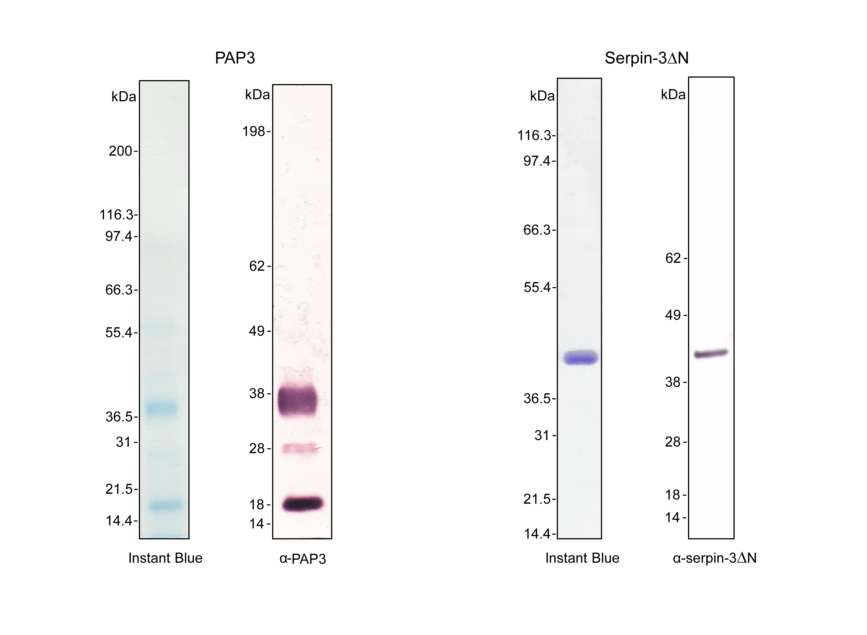
Figure S2: Inhibitory complex formed by serpin-3ΔN and PAP3. 0.0014 nmol (72 ng) purified recombinant PAP3 was incubated with 0.0014 nmol (81 ng) or 0.0007nmol (40.5 ng) purified recombinant serpin-3ΔN in 100 mM Tris, pH 8.0 at room temperature for 10 min, followed by analyzing with reducing 4-12% Bis-Tris NuPAGE gel and immunoblotting using diluted antiserum against PAP3 (a) or serpin-3 (b) as the primary antibody.
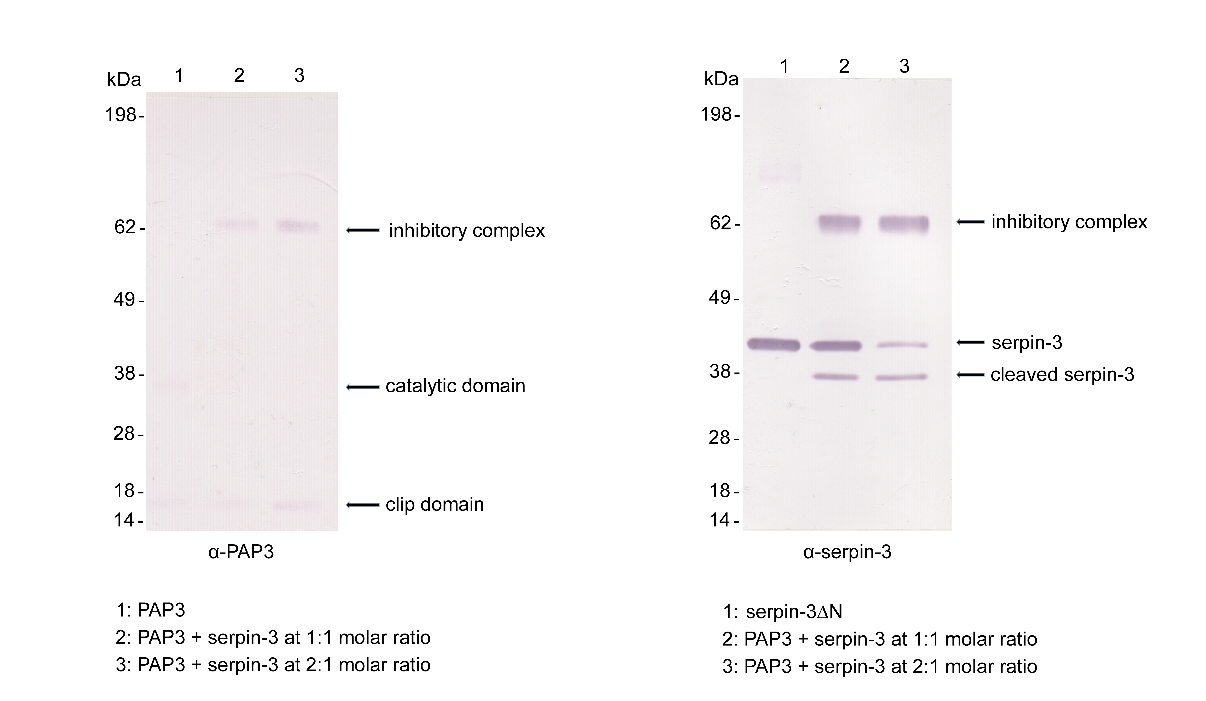
Figure S3: Interference of proPO activation in induced plasma by Ac-SVAFS-NH₂ and Ac-SVAFS-COO⁻ treated serpin-3∆N (biological replicates). (a) Ac-SVAFS-COO⁻ treated serpin-3∆N (0.1 µg) or untreated serpin-3∆N (0.1 µg) was incubated with 2 µl plasma from M. sexta larvae at room temperature for 10 min, followed by addition of 2 µg M. luteus or sterile saline and further incubation for 10 min at room temperature. PO activities were measured by adding 2 mM dopamine. (b) 1 µl plasma from M. sexta larvae was incubated with pre-dried Ac-SVAFS-NH₂ (5 nmol) or TFE in 50 mM sodium phosphate, pH 6.5 at room temperature for 1 h, followed by addition of 2 µg M. luteus or sterile saline and further incubation for 10 min at room temperature. PO activities were measured by adding 2 mM dopamine. Each graph represents results from individual plasma sample. One unit of proPO activity is defined as 0.001 change of OD₄₇₀ per minute. Means ± standard deviation are from technical replicates (n=3). Results of statistical analysis (one-way ANOVA followed by Tukey’s multiple comparison test, P<0.05) are indicated with different letters. 