Cdc42 regulates cell polarization and contractile actomyosin rings
during terminal differentiation of human erythroblasts

Kumi Ubukawa^{1#}, Tatsufumi Goto^{2#}, Ken Asanuma³, Yumi Sasaki², Yong-Mei Guo¹,
Isuzu Kobayashi¹, Kenichi Sawada⁴, Hideki Wakui², and Naoto Takahashi¹

¹Department of Hematology, Nephrology, and Rheumatology, Master’s Course at the Graduate School of Medicine, Akita University, Akita, Japan
²Department of Life Science, Graduate School of Engineering Science, Akita University, Akita, Japan
³Division of Radio Isotope, Bioscience Education and Research Support Center, Akita University, Akita, Japan
⁴Hokubukai Utsukushigaoka Hospital, Sapporo, Japan.

Supplementary Figure

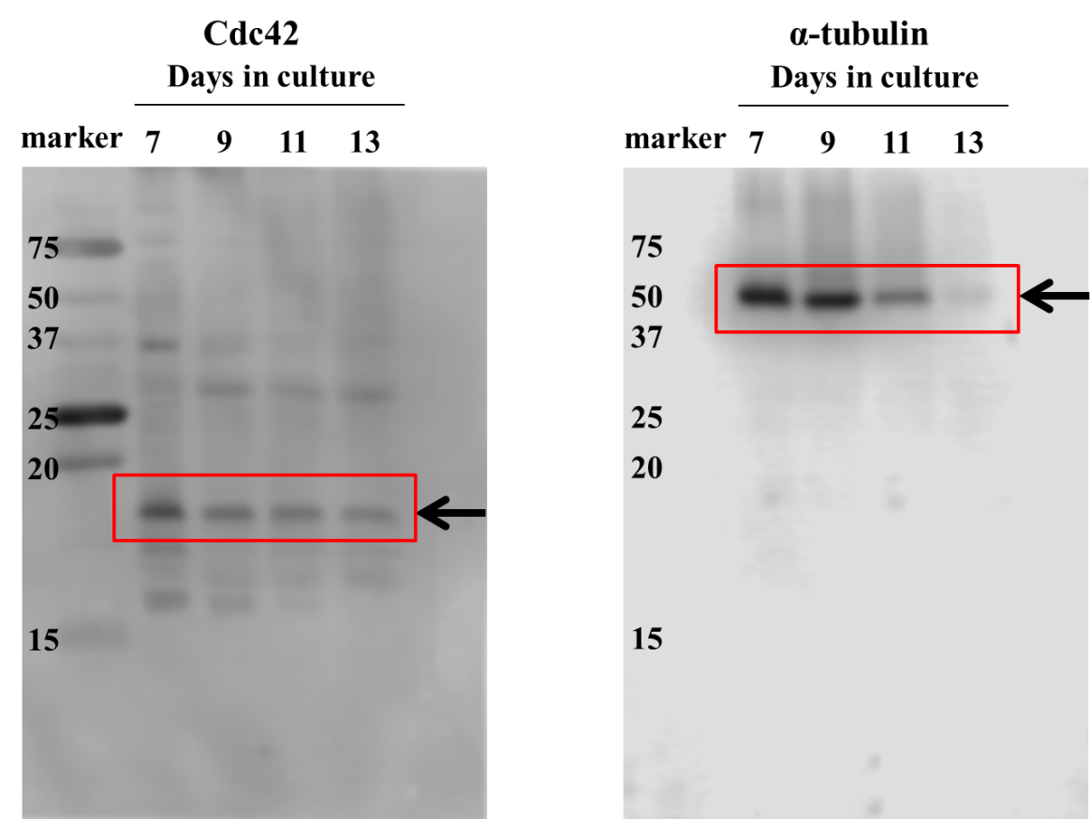
Supplementaly Fig. S1 Original immunoblots related to Fig. 1A

