Title: Dual SMAD inhibition and Wnt inhibition enable efficient and reproducible differentiations of induced pluripotent stem cells into retinal ganglion cells.
Authors: Venkata R. M. Chavali*¹, Naqi Haider¹, Sonika Rathi¹, Vrathasha Vrathasha¹, Teja Alapati¹, Jie He, Kamaljot Gill², Roman Nikonov², Thu T. Duong², Devin S. McDougald², Sergei Nikonov², Joan O’ Brien¹ and Jason A. Mills²*

Supplementary Tables 1-4: Antibodies, small molecules, media reagents and primer sequences used for generation of iPSC-RGCs.
Supplementary Table. 1. Antibodies, their source and concentration used in our study
Protein species | Antibody Source | Clone/Catalog No | Species | Concentration/  Volume | Dilution | Application
SOX2 | Cell Signaling Technology | 3579S | Rabbit |  | 1/100 | ICC
PAX6 | Biolegend | PRB-278P100 | Rabbit | 2 mg/ml | 1/100 | ICC
RAX | Abcam | ab23340 | Rabbit |  | 1/100 | ICC
THY1/CD90 | R&D Systems | AF2067 | Sheep | 25μg | 1/100 | ICC, Flow cytometry
BRN3b | Santa cruz | sc-514474 | Mouse | 200 μg | 1µg/10⁶ cells | Flow cytometry
RBPMS | Novus Biologicals | NBP2-73835AF647 | Mouse | 0.64 mg/ml | 1µL/10⁶ cells | Flow cytometry
TUJ1 | Biolegend | MRB-435P | Rabbit | 1 mg/ml | 1/250 | ICC
RBPMS | Sigma- Aldrich | ABN1362 | Rabbit | 100 μg | 1/1500 | ICC
MAP2 | Sigma | M1406 | Mouse | 2 mg/ml | 1/500 | ICC
BRN3a | Santa cruz | sc-8429 | Mouse | 200 µg/ml | 1/100 | ICC
BRN3b | Santa cruz | sc-6026 | Goat | 100 µg/ml | 1/100 | ICC
TUBB3 | Biolegend | PRB-435P | Rabbit | 1.0 mg/ml | 1/100 | ICC
CRALBP | Abcam | ab15051 | Mouse | 1.0 mg/ml | 1/1000 | ICC
GFAP | Abcam | ab7260 | Rabbit |  | 1/1000 | ICC
SSEA4-APC | Biolegend | MC-813-70 | Mouse | 25μg/ml | 1/100 | Flow cytometry
BRN3a | Santa cruz | sc-31984 | Goat | 100μg | 1/100 | ICC (after MACS)
MAP2 | Santa cruz | sc-74421 | Mouse | 200 μg | 1/100 | ICC (after MACS)
GFAP | Abcam | ab7260 | Rabbit | 50 µl | 1/1000 | ICC (after MACS)
Alexa Fluor 594 Goat Anti- Mouse | Invitrogen | A11020 | Goat | 500 μg | 1/500 | ICC
Alexa Fluor 488 Chicken anti- Goat | Invitrogen | A21467 | Chicken | 2 mg/mL | 1/500 | ICC
Alexa Fluor 488 Goat anti- Rabbit | Invitrogen | A11034 | Goat | 1 mg | 1/500 | ICC

*ICC- Immunocytochemistry

Supplementary Table. 2. Small molecules and protein source information
Small molecules/recombinant protein | Company | Cat No. | Reconstitution
Recombinant Human FGF basic (146 aa) Protein | R & D Systems | 233-FB | 0.1% BSA in PBS
Recombinant Human  Sonic Hedgehog/Shh Protein | R & D Systems | 8908-SH | 0.1% BSA in PBS
Recombinant Human/Mouse FGF-8b Protein | R & D Systems | 423-F8 | 0.1% BSA in PBS
DAPT | Stemgent | 04-0041 | DMSO
Recombinant Human Follistatin 300 Protein | R & D Systems | 669-FO | 0.1% BSA in PBS
Cyclopamine | R & D Systems | 1623/1 | DMSO
Recombinant Human BDNF Protein | R & D Systems | 248-BDB | 0.1% BSA in PBS
Forskolin | Selleckchem | S2449
Recombinant Human NT-4 Protein | R & D Systems | 268-N4 | 0.1% BSA in PBS
Recombinant Human CNTF Protein | R & D Systems | 257-NT | 0.1% BSA in PBS
cAMP  N⁶,2′-O-Dibutyryladenosine 3′,5′- cyclic monophosphate sodium salt | Sigma-aldrich | D0627 | DMSO
Y-27632 dihydrochloride | R & D Systems | 1254/1 | DMSO
LDN 193189 dihydrochloride | R & D Systems | 6053 | DMSO
SB 431542 | R & D Systems | 1614 | DMSO
CHIR 99021 | Selleckchem | S2924 | DMSO
XAV 939 | R & D Systems | 3748 | DMSO
Nicotinamide | Sigma-aldrich | N0636 | DMSO
IGF | R & D Systems | 291-G1 | 0.1% BSA in PBS
CHIR99021 | Selleckchem | S2924 | DMSO

Supplementary Table. 3. Media and reagents used in the study
Media/Reagent | Product | Catalog no.
DMEM/F12 + Glutamine + Hepes | Corning | 10-092-cm
1 x Penn/Strep | Life Technologies | 10378-016
1 x Glutamine MAX | Life Technologies | 35050-061
NEAA | Life Technologies | 11140-050
2ME | Life Technologies | 21985-023
N2 supplement | Life Technologies | 17502-048
B27 Supplement without Vitamin A | Life Technologies | 12587-010
Neurolbasal | Life Technologies | 21103049
TrypLE | Life Technologies | 12605-010

Supplementary Table. 4. Primer sequences and gene amplification probe sets used in our study
Gene | qRT-PCR Primer sequence (5'-3')
LHX2 | F-ATCGACGAGATGGACCGCAG
LHX2 | R-GGTAGTAGCGGTCCGAGATC
LHX2 | Probe-ATGCCGTCCATCAGCAGTGACC
RAX | F-GCAAGGTCAACCTACCAGAG
RAX | R-CAGCTTCATGGAGGACACTT
RAX | Probe-CACTTAGCCCGTCGGTTCTGGAAC
SIX3 | F-CACTCCCACACAAGTAGGC
SIX3 | R-GTGCTGGAGCCTGTTCTT
SIX3 | Probe-AACTGGTTTAAGAACCGGCGGCAG
PAX6 | F-GTG TCT ACC AAC CAA TTC CAC AAC
PAX6 | R-CCC AAC ATG GAG CCA GAT G
PAX6 | Probe-CCACACCGGTTTCCTCCTTCACAT
MITF | F-CCTGTATGCAGATGGATGATGT
MITF | R-CCGAGACAGGCAACGTATTT
MITF | Probe-TCTTGGGCTTGATGGATCCTGCTT
Gene | Cat no. of qRT-PCR predesigned probes from IDT
ATOH7 | Hs.PT.58.149639.g
CDH6 | Hs.PT.58.40950652
FSTL4 | Hs.PT.58.3633481
SPP1 | Hs.PT.58.19252426
ISL1 | Hs.PT.58.2143768
CARTPT | Hs.PT.58.19814336.g
SOX11 | Hs.PT.58.24529615.g
SNCG | Hs.PT.58.20259255
MMP17 | Hs.PT.58.147695
GLi3 | Hs.PT.58.25033140
GLi1 | Hs.PT.58.26486279
CRX | Hs.PT.58.40863524
CHX10 (VSX2) | hs.pt.58.15104194
B2M | Hs.PT.58v.18759587
CALB2 | Hs.PT.56a.26789839.g
RCVRN | Hs.PT.58.19903304
BRN3a | Hs.PT.58.15720815

Supplementary Table 5: Differential gene expression among five conditions. 1) L (BMP inhibitor) only, 2) X (Wnt inhibitor) only, 3) LSB (BMP + TGFb inhibitors), 4) LSBX (BMP + TGFb + Wnt) inhibitors), and 5) LSB-CHIR (BMP + TGFb inhibitors+ Wnt agonist) were evaluated in RPC cultures on day 23
Detector Name | Conditions | ΔΔCt | p value | Fold change
ATOH7 | L vs LSB | 0.962 | 0.012 | 0.513
ATOH7 | L vs LSBX | 0.409 | 0.185 | 0.753
ATOH7 | L vs LSB-CHIR | 0.435 | 0.008 | 0.740
ATOH7 | X vs LSB | 0.308 | 0.094 | 0.808
ATOH7 | X vs LSBX | -0.246 | 0.352 | 1.186
ATOH7 | X vs LSB-CHIR | -0.220 | 0.034 | 1.165
ATOH7 | LSB vs LSBX | -0.553 | 0.133 | 1.467
ATOH7 | LSB vs LSB-CHIR | -0.527 | 0.034 | 1.441
ATOH7 | LSBX vs LSB-CHIR | 0.026 | 0.910 | 0.982
BRN3a | L vs LSB | -0.417 | 0.067 | 1.335
BRN3a | L vs LSBX | -1.471 | 0.003 | 2.772
BRN3a | L vs LSB-CHIR | -1.866 | 0.008 | 3.645
BRN3a | X vs LSB | 0.026 | 0.888 | 0.982
BRN3a | X vs LSBX | -1.029 | 0.018 | 2.040
BRN3a | X vs LSB-CHIR | -1.423 | 0.016 | 2.682
BRN3a | LSB vs LSBX | -1.054 | 0.010 | 2.077
BRN3a | LSB vs LSB-CHIR | -1.449 | 0.016 | 2.730
BRN3a | LSBX vs LSB-CHIR | -0.395 | 0.141 | 1.315
CALB2 | L vs LSB | -0.849 | 0.018 | 1.801
CALB2 | L vs LSBX | -1.554 | 0.000 | 2.937
CALB2 | L vs LSB-CHIR | -1.477 | 0.002 | 2.783
CALB2 | X vs LSB | 1.000 | 0.027 | 0.500
CALB2 | X vs LSBX | 0.295 | 0.149 | 0.815
CALB2 | X vs LSB-CHIR | 0.372 | 0.036 | 0.773
CALB2 | LSB vs LSBX | -0.705 | 0.025 | 1.630
CALB2 | LSB vs LSB-CHIR | -0.628 | 0.036 | 1.545
CALB2 | LSBX vs LSB-CHIR | 0.078 | 0.304 | 0.948
CARTPT | L vs LSB | 0.860 | 0.006 | 0.551
CARTPT | L vs LSBX | 0.733 | 0.010 | 0.602
CARTPT | L vs LSB-CHIR | -0.864 | 0.005 | 1.820
CARTPT | X vs LSB | 0.942 | 0.040 | 0.520
CARTPT | X vs LSBX | 0.815 | 0.053 | 0.568
CARTPT | X vs LSB-CHIR | -0.782 | 0.000 | 1.719
CARTPT | LSB vs LSBX | -0.127 | 0.075 | 1.092
CARTPT | LSB vs LSB-CHIR | -1.724 | 0.000 | 3.303
CARTPT | LSBX vs LSB-CHIR | -1.597 | 0.000 | 3.025
CDH6 | L vs LSB | -0.215 | 0.371 | 1.160
CDH6 | L vs LSBX | -0.672 | 0.090 | 1.593
CDH6 | L vs LSB-CHIR | -1.911 | 0.012 | 3.761
CDH6 | X vs LSB | 0.049 | 0.859 | 0.967
CDH6 | X vs LSBX | -0.408 | 0.264 | 1.327
CDH6 | X vs LSB-CHIR | -1.648 | 0.004 | 3.133
CDH6 | LSB vs LSBX | -0.457 | 0.064 | 1.373
CDH6 | LSB vs LSB-CHIR | -1.697 | 0.004 | 3.241
CDH6 | LSBX vs LSB-CHIR | -1.240 | 0.015 | 2.361
CRX | L vs LSB | -2.150 | 0.003 | 4.437
CRX | L vs LSBX | -1.928 | 0.020 | 3.806
CRX | L vs LSB-CHIR | -2.775 | 0.005 | 6.843
CRX | X vs LSB | -2.550 | 0.002 | 5.855
CRX | X vs LSBX | -2.329 | 0.014 | 5.023
CRX | X vs LSB-CHIR | -3.175 | 0.081 | 9.031
CRX | LSB vs LSBX | 0.221 | 0.501 | 0.858
CRX | LSB vs LSB-CHIR | -0.625 | 0.081 | 1.542
CRX | LSBX vs LSB-CHIR | -0.846 | 0.118 | 1.798
FSTL4 | L vs LSB | -0.591 | 0.011 | 1.506
FSTL4 | L vs LSBX | -0.665 | 0.012 | 1.585
FSTL4 | L vs LSB-CHIR | -1.344 | 0.024 | 2.539
FSTL4 | X vs LSB | 0.642 | 0.081 | 0.641
FSTL4 | X vs LSBX | 0.568 | 0.104 | 0.675
FSTL4 | X vs LSB-CHIR | -0.112 | 0.074 | 1.081
FSTL4 | LSB vs LSBX | -0.074 | 0.491 | 1.053
FSTL4 | LSB vs LSB-CHIR | -0.754 | 0.074 | 1.686
FSTL4 | LSBX vs LSB-CHIR | -0.680 | 0.091 | 1.602
Gli1 | L vs LSB | -1.790 | 0.006 | 3.459
Gli1 | L vs LSBX | -1.195 | 0.002 | 2.289
Gli1 | L vs LSB-CHIR | -2.035 | 0.002 | 4.098
Gli1 | X vs LSB | -0.345 | 0.139 | 1.270
Gli1 | X vs LSBX | 0.250 | 0.069 | 0.841
Gli1 | X vs LSB-CHIR | -0.590 | 0.278 | 1.505
Gli1 | LSB vs LSBX | 0.595 | 0.054 | 0.662
Gli1 | LSB vs LSB-CHIR | -0.245 | 0.278 | 1.185
Gli1 | LSBX vs LSB-CHIR | -0.840 | 0.016 | 1.790
Gli3 | L vs LSB | -0.597 | 0.004 | 1.513
Gli3 | L vs LSBX | -0.980 | 0.025 | 1.972
Gli3 | L vs LSB-CHIR | -1.562 | 0.005 | 2.953
Gli3 | X vs LSB | 0.118 | 0.234 | 0.922
Gli3 | X vs LSBX | -0.265 | 0.255 | 1.201
Gli3 | X vs LSB-CHIR | -0.847 | 0.014 | 1.799
Gli3 | LSB vs LSBX | -0.383 | 0.136 | 1.304
Gli3 | LSB vs LSB-CHIR | -0.965 | 0.014 | 1.952
Gli3 | LSBX vs LSB-CHIR | -0.582 | 0.094 | 1.497
ISL1 | L vs LSB | -0.095 | 0.417 | 1.068
ISL1 | L vs LSBX | -0.264 | 0.063 | 1.201
ISL1 | L vs LSB-CHIR | -1.012 | 0.002 | 2.016
ISL1 | X vs LSB | -0.426 | 0.065 | 1.343
ISL1 | X vs LSBX | -0.595 | 0.025 | 1.511
ISL1 | X vs LSB-CHIR | -1.343 | 0.008 | 2.537
ISL1 | LSB vs LSBX | -0.169 | 0.225 | 1.125
ISL1 | LSB vs LSB-CHIR | -0.917 | 0.008 | 1.888
ISL1 | LSBX vs LSB-CHIR | -0.748 | 0.005 | 1.679
LHX2 | L vs LSB | -2.009 | 0.009 | 4.025
LHX2 | L vs LSBX | -0.911 | 0.033 | 1.880
LHX2 | L vs LSB-CHIR | -1.243 | 0.018 | 2.368
LHX2 | X vs LSB | -1.826 | 0.024 | 3.546
LHX2 | X vs LSBX | -0.728 | 0.118 | 1.657
LHX2 | X vs LSB-CHIR | -1.061 | 0.016 | 2.086
LHX2 | LSB vs LSBX | 1.098 | 0.008 | 0.467
LHX2 | LSB vs LSB-CHIR | 0.765 | 0.016 | 0.588
LHX2 | LSBX vs LSB-CHIR | -0.333 | 0.022 | 1.259
MMP17 | L vs LSB | -1.903 | 0.013 | 3.741
MMP17 | L vs LSBX | -1.883 | 0.014 | 3.687
MMP17 | L vs LSB-CHIR | -2.266 | 0.009 | 4.811
MMP17 | X vs LSB | -1.373 | 0.025 | 2.590
MMP17 | X vs LSBX | -1.352 | 0.027 | 2.553
MMP17 | X vs LSB-CHIR | -1.736 | 0.043 | 3.331
MMP17 | LSB vs LSBX | 0.021 | 0.842 | 0.986
MMP17 | LSB vs LSB-CHIR | -0.363 | 0.043 | 1.286
MMP17 | LSBX vs LSB-CHIR | -0.384 | 0.054 | 1.305
RCVRN | L vs LSB | -0.764 | 0.223 | 1.698
RCVRN | L vs LSBX | -2.338 | 0.017 | 5.055
RCVRN | L vs LSB-CHIR | -4.277 | 0.041 | 19.388
RCVRN | X vs LSB | -1.798 | 0.079 | 3.477
RCVRN | X vs LSBX | -3.372 | 0.016 | 10.351
RCVRN | X vs LSB-CHIR | -5.311 | 0.072 | 39.704
RCVRN | LSB vs LSBX | -1.574 | 0.097 | 2.977
RCVRN | LSB vs LSB-CHIR | -3.513 | 0.072 | 11.419
RCVRN | LSBX vs LSB-CHIR | -1.939 | 0.177 | 3.836
SIX3 | L vs LSB | -0.163 | 0.079 | 1.120
SIX3 | L vs LSBX | -0.639 | 0.006 | 1.557
SIX3 | L vs LSB-CHIR | -0.990 | 0.003 | 1.986
SIX3 | X vs LSB | 0.215 | 0.243 | 0.862
SIX3 | X vs LSBX | -0.260 | 0.184 | 1.198
SIX3 | X vs LSB-CHIR | -0.612 | 0.001 | 1.528
SIX3 | LSB vs LSBX | -0.475 | 0.001 | 1.390
SIX3 | LSB vs LSB-CHIR | -0.827 | 0.001 | 1.774
SIX3 | LSBX vs LSB-CHIR | -0.351 | 0.004 | 1.276
SNCG | L vs LSB | -0.351 | 0.235 | 1.276
SNCG | L vs LSBX | -0.354 | 0.036 | 1.278
SNCG | L vs LSB-CHIR | -0.411 | 0.025 | 1.330
SNCG | X vs LSB | 0.102 | 0.737 | 0.932
SNCG | X vs LSBX | 0.099 | 0.629 | 0.933
SNCG | X vs LSB-CHIR | 0.042 | 0.794 | 0.971
SNCG | LSB vs LSBX | -0.003 | 0.991 | 1.002
SNCG | LSB vs LSB-CHIR | -0.060 | 0.794 | 1.042
SNCG | LSBX vs LSB-CHIR | -0.057 | 0.212 | 1.040
Sox11 | L vs LSB | -2.023 | 0.005 | 4.063
Sox11 | L vs LSBX | -1.797 | 0.003 | 3.474
Sox11 | L vs LSB-CHIR | -1.833 | 0.013 | 3.564
Sox11 | X vs LSB | -2.054 | 0.002 | 4.152
Sox11 | X vs LSBX | -1.828 | 0.000 | 3.550
Sox11 | X vs LSB-CHIR | -1.865 | 0.458 | 3.642
Sox11 | LSB vs LSBX | 0.226 | 0.157 | 0.855
Sox11 | LSB vs LSB-CHIR | 0.189 | 0.458 | 0.877
Sox11 | LSBX vs LSB-CHIR | -0.037 | 0.861 | 1.026
SPP1 | L vs LSB | -0.986 | 0.094 | 1.981
SPP1 | L vs LSBX | 0.086 | 0.816 | 0.942
SPP1 | L vs LSB-CHIR | -1.270 | 0.076 | 2.412
SPP1 | X vs LSB | -1.127 | 0.007 | 2.183
SPP1 | X vs LSBX | -0.054 | 0.628 | 1.038
SPP1 | X vs LSB-CHIR | -1.411 | 0.255 | 2.659
SPP1 | LSB vs LSBX | 1.072 | 0.001 | 0.475
SPP1 | LSB vs LSB-CHIR | -0.284 | 0.255 | 1.218
SPP1 | LSBX vs LSB-CHIR | -1.357 | 0.017 | 2.561
RAX | L vs LSB | -3.264 | 0.000 | 9.607
RAX | L vs LSBX | -1.326 | 0.027 | 2.507
RAX | L vs LSB-CHIR | -1.526 | 0.002 | 2.880
RAX | X vs LSB | -2.416 | 0.000 | 5.336
RAX | X vs LSBX | -0.478 | 0.167 | 1.392
RAX | X vs LSB-CHIR | -0.678 | 0.002 | 1.600
RAX | LSB vs LSBX | 1.938 | 0.013 | 0.261
RAX | LSB vs LSB-CHIR | 1.738 | 0.002 | 0.300
RAX | LSBX vs LSB-CHIR | -0.200 | 0.473 | 1.149
MITF | L vs LSB | -1.349 | 0.001 | 2.548
MITF | L vs LSBX | -1.335 | 0.002 | 2.523
MITF | L vs LSB-CHIR | -1.567 | 0.002 | 2.963
MITF | X vs LSB | -0.355 | 0.014 | 1.279
MITF | X vs LSBX | -0.340 | 0.018 | 1.266
MITF | X vs LSB-CHIR | -0.572 | 0.107 | 1.487
MITF | LSB vs LSBX | 0.014 | 0.837 | 0.990
MITF | LSB vs LSB-CHIR | -0.218 | 0.107 | 1.163
MITF | LSBX vs LSB-CHIR | -0.232 | 0.099 | 1.175
PAX6 | L vs LSB | -1.015 | 0.003 | 2.021
PAX6 | L vs LSBX | -0.960 | 0.003 | 1.945
PAX6 | L vs LSB-CHIR | -1.303 | 0.010 | 2.467
PAX6 | X vs LSB | -0.291 | 0.028 | 1.224
PAX6 | X vs LSBX | -0.236 | 0.031 | 1.178
PAX6 | X vs LSB-CHIR | -0.579 | 0.174 | 1.493
PAX6 | LSB vs LSBX | 0.055 | 0.488 | 0.962
PAX6 | LSB vs LSB-CHIR | -0.287 | 0.174 | 1.220
PAX6 | LSBX vs LSB-CHIR | -0.343 | 0.129 | 1.268

Supplementary Fig. 1. Flow cytometry analysis showing percentage of Brn3b positive and RBPMS positive iPSC-RGCs.

Additional information: Protocol for differentiation of iPSC-RGCs using small molecules and proteins

Protocol time line:

D-3 to-1 Day 0-15 Day 16-21 Day 22-23 Day 24 Day 25-26 Day 27-36
RPC conditions RGC differentiation
Initiation RPC induction and differentiation RGC initiation cross-hatching RGC differentiation RGC maturation

iPSC initiation: day-3 to day-1
Day1: First MEFs cell depletion: When iPSC cells reach 80% confluent, apply 1ml of TrypLE solution and incubate at 37⁰C for 4-5 minutes. Remove TrypLE medium after incubation and replate iPSCs into a 100mm dish precoated with matrigel, in medium containing: 80% HES / 20% MEF-CM + 20ng/ml bFGF + 4uM Y27632. Incubate the plate in 37⁰C, 5%CO₂ and 5%O₂ incubator.

Day2: Second MEFs cell depletion: iPSC cells should be over 80% confluent in this step. 2ml of TrypLE solution was added to 100mm dish and incubated at 37⁰C for 4-5 minutes. After TrypLE treatment, iPSC cells were replated into one well of a 6 well plate, precoated with Matrigel (seeding density of 1.5X10⁶ cells per well), in medium containing: 80%HES / 20% MEF-CM + 20ng/ml bFGF + 5ng/ml stable bFGF + 4uM Y27632 and incubated in 37⁰C, 5%CO₂ and 5%O₂ incubator.
Day3: The spent medium is replaced with a fresh medium without Y27632. (80%HES / 20% MEF-CM + 20ng/ml bFGF + 5ng/ml stable bFGF). The plate is moved from the 5% O₂ incubator to the regular O₂ incubator maintained at 37⁰C, 5%CO₂ incubator (the night before) to continue with RPC induction and differentiation.

1. RPC Induction and Differentiation: day 0-21
A. Day0-d3:
Change medium daily with RPC induction media containing: 0.1µM LDN, 10µM SB, 2µM XAV, 10mM NIC, 10ng/ml IGF1. Add all small molecule and protein into each day’s medium aliquot freshly (just before medium change).

RPC induction media:
 | Reagent | Final Concentration
1 | Regular DMEM/F12
2 | 1 x Penn/Strep (P/S; 100X) | 1%
3 | 1 x Glutamine MAX (100X) | 1%
4 | NEAA (MEM Non Essential Amino Acid) | 1%
5 | 2-Mercaptoethanol (55mM stock) | 0.1mM
6 | N2 supplement (1%) | 1%
7 | B27 Supplement without Vitamin A (2%) | 2%

Day 0-3: medium components
 | Component | Final Concentration
1 | RPC induction media
2 | LDN | 0.1µM
3 | SB | 10µM
4 | XAV939 | 2µM
5 | Nicotinamide (NIC) | 10mM
6 | IGF1 | 10ng/ml

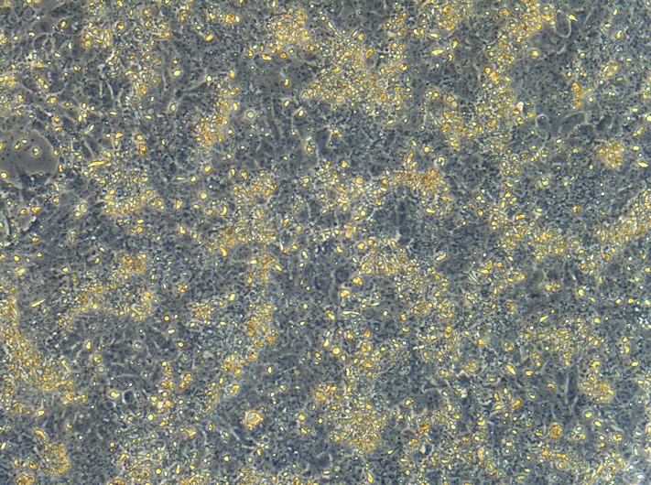

By Day3, cells continued to expand, with cells reaching more than 100% confluence (Mag- 10X).

B. Day 4-21:
Change medium daily with RPC induction media containing: 0.1µM LDN, 10µM SB, 2µM XAV, 1.5µM
CHIR, 10ng/ml IGF1, and 10ng/ml bFGF. Add all small molecule and protein into each day’s medium aliquot freshly (just before medium change).

Day 4-21: media components
 |  | Final Concentration
1 | RPC induction media
2 | LDN | 0.1µM
3 | SB | 10µM
4 | XAV939 | 2µM
5 | CHIR99021 | 1.5µM
6 | IGF1 | 10ng/ml
7 | bFGF | 10ng/ml

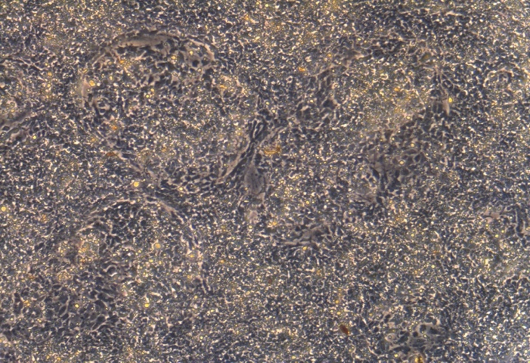
By Day19, more rosette like cell clusters formed (starting around D15), (Mag- 10X)

2. RGC initiation and differentiation Day22-36
A. Day22-23: RGC initiation
Change medium daily with RGC induction media containing: 3μM DAPT, 250ng/ml Shh, and 100ng/ml FGF8.
RGC induction media
 | Reagent
1 | Regular DMEM/F12 | 50%
2 | Neuraobasel media | 50%
3 | 1 x Penn/Strep (P/S; 100X) | 1%
4 | 1 x Glutamine MAX (100X) | 1%
7 | B27 Supplement without Vitamin A (2%) | 2%

Day22-23: medium Components
 | Component | Final Concentration
1 | RGC induction media
2 | DAPT | 3μM
3 | Shh | 250ng/ml
4 | FGF8 | 100ng/ml

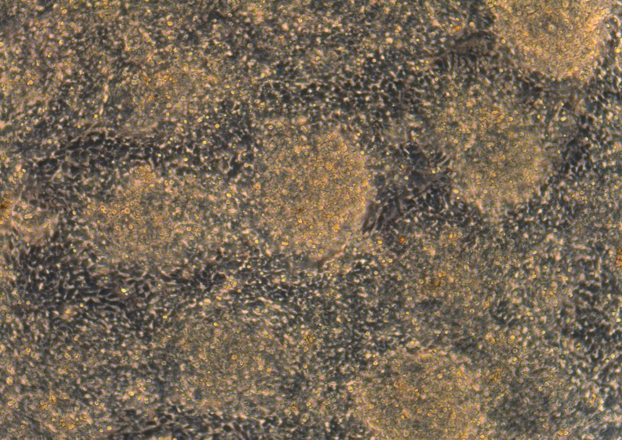
Day24 before crosshatching, abundant cell clusters with crowded packed cells forming multi layers (light yellow parts).

B. D24 RGC Differentiation: cross-hatching and replat
On the Day 24
1. On ice, add 30ml of Leibovitz’s (LM) medium L15 + 1M Glucose into 50ml tube.
2. Remove 6 well cell plate from incubator, wash the well once with cold LM + Gluc. (LMG) media (2mL/well).
3. Add 2 mL of LMG media to each well of 6-well dish and scrape using a p1000 tip with the pipette, cross the bottom firmly, cross horizontal lines parallelly and closely to the full bottom surface, then cross again vertically, to dislodge cells into small clusters. Lift dish up to ensure all cells are being removed (>90%). Draw medium up and blew down 3 times, each time to rains off cells from different bottom area, then do two more times to break cells down to even and small clusters. Check under the scope, if cell cluster still big, blew up/down cells two more times.
4. remove all cells with LM+Gluc from above into 20mL of LMG media in a 50ml tube, and spin down at 3000rpm for 3min.
5. remove supernatant and resuspend cells pellets in 8ml Day24 medium + 4uM Y27632), blew cells up and down about 4-6 times. Add enough Day24 medium + Y27632 for plating. Cell seeding density: about 1X10⁵/well of 6 well plates.

Day24: medium Components
 | Component | Final Concentration
1 | RGC induction media
2 | DAPT | 3 μM
3 | Cyclopamine | 0.5uM
3 | Follistatin | 100ng/ml
Day24, about 3 hours after crosshatching, neuron axon cell bodies start to form (Mag- 20X)

C. RGC Differentiation, Day25-26
Change medium daily with RGC induction media containing: 3μM DAPT and 100ng/ml Follistatin
Day25-26: medium components
 | Component | Final Concentration
1 | RGC induction media
2 | DAPT | 3 μM
3 | Follistatin | 100 ng/ml

3. RGC Maturation, Day27-36
Change medium every 2-3 days with RGC induction media containing: 3μM DAPT, 10μM Y27632, 400μM cAMP, 5μM Forskolin, 40ng/ml BDNF, 5ng/ml NT4 and 10ng/ml CNTF

Day27-36: medium components
 | Component | Final Concentration
1 | RGC induction media
2 | DAPT | 3μM
3 | Y27632 | 10μM
4 | cAMP | 400μM
5 | Forskolin | 5μM
6 | BDNF | 40ng/ml
7 | NT4 | 5ng/ml
8 | CNTF | 10ng/ml

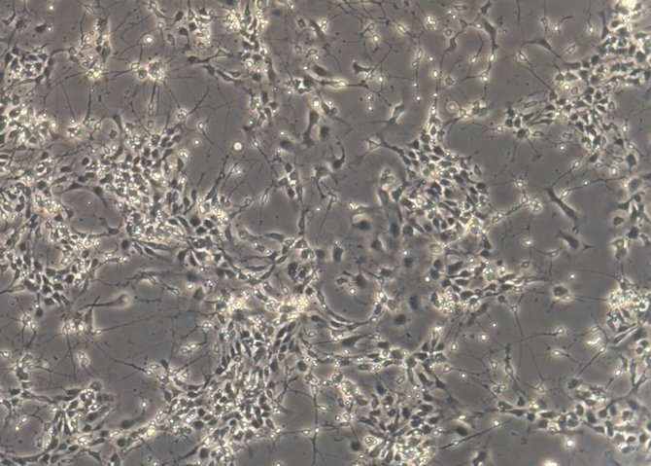
Day27, numerous ganglion cell bodies with extended axons (Mag- 10X).

4. Mature RGC maintenance (from Day37)
Change medium twice a week with RGC induction media containing: 3μM DAPT, 10μM Y27632

From D37: medium components
 | Component | Final Concentration
1 | RGC media
2 | DAPT | 3 μM
3 | Y27632 | 10 μM

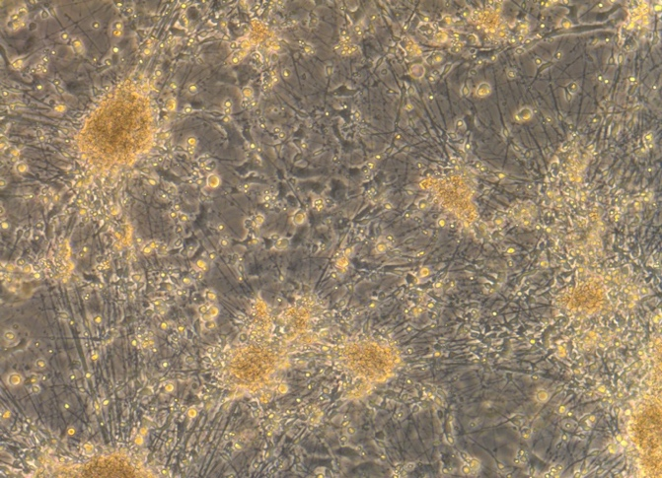

Day37, matured RGC with long axons, RGC cell bodies migrate forming clusters (Mag- 10X).

