Selective protection of human cardiomyocytes from anthracycline cardiotoxicity by small molecule inhibitors of MAP4K4
Pelin A. Golforoush^{1,4}, Priyanka Narasimhan^{2,5}, Patricia P. Chaves-Guerrero¹, Elsa Lawrence¹, Gary Newton⁶, Robert Yan², Sian E. Harding¹, Trevor Perrior², Kathryn L. Chapman^{2,7}, and Michael D. Schneider^{1,3}*
Supplemental Information
Figure S1. Original, full-length Western blots used for Figure 2E.
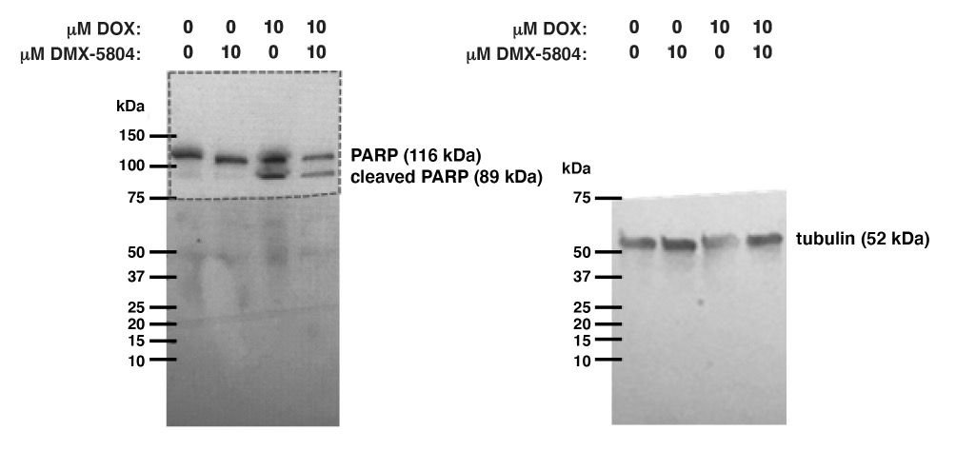

The original membrane was cut at 75 kDa and the upper section (highlighted by the dashed lines) was probed for cleaved and uncleaved PARP, and the lower section was probed unsuccessfully with a caspase-8 antibody. The lower section of the membrane was then stripped by incubation with agitation at room temperature for 10 min in 200 mM glycine, 0.1% SDS, 1% Tween-20, pH 2.2. The membrane was then washed for 10 min x 2 with PBS and for 5 min x 2 in 20 mM Tris, 150 mM NaCl, 0.1% Tween-20 (TBST). The membrane was then blocked for 1 hr in 5% milk in TBST, before being probed for tubulin.

