Anti-biofilm efficacy of a medieval treatment for bacterial infection requires the combination of multiple ingredients.

Jessica Furner-Pardoe^{1,2,+,}*, Blessing O Anonye^{1,+}, Ricky Cain^{1,#}, John Moat³, Catherine A. Ortori⁴, Christina Lee⁵, David A. Barrett ⁴, Christophe Corre^{1,6} and Freya Harrison^{1,}*

¹ School of Life Sciences, Gibbet Hill Campus, University of Warwick, Coventry, CV4 7AL
² Warwick Medical School, Gibbet Hill Campus, University of Warwick, Coventry, CV4 7AL
³ Warwick Antimicrobial Screening Facility, School of Life Sciences, Gibbet Hill Campus, University of Warwick, Coventry, CV4 7AL
⁴ Centre for Analytical Bioscience, Advanced Materials and Healthcare Technologies Division, School of Pharmacy, University of Nottingham, Nottingham NG7 2RD, UK
⁵ School of English, University of Nottingham, Nottingham NG7 2RD, UK
⁶ Department of Chemistry, University of Warwick, University of Warwick, Coventry, CV4 7AL
#Present address: Evotec (U.K.) Ltd., 114 Innovation Drive, Milton Park, Abingdon, Oxfordshire OX14 4RZ, United Kingdom

⁺ These authors contributed equally

* Corresponding authors:
JFP (j.furner-pardoe.1@warwick.ac.uk) and FH (f.harrison@warwick.ac.uk)

Supplementary Figures
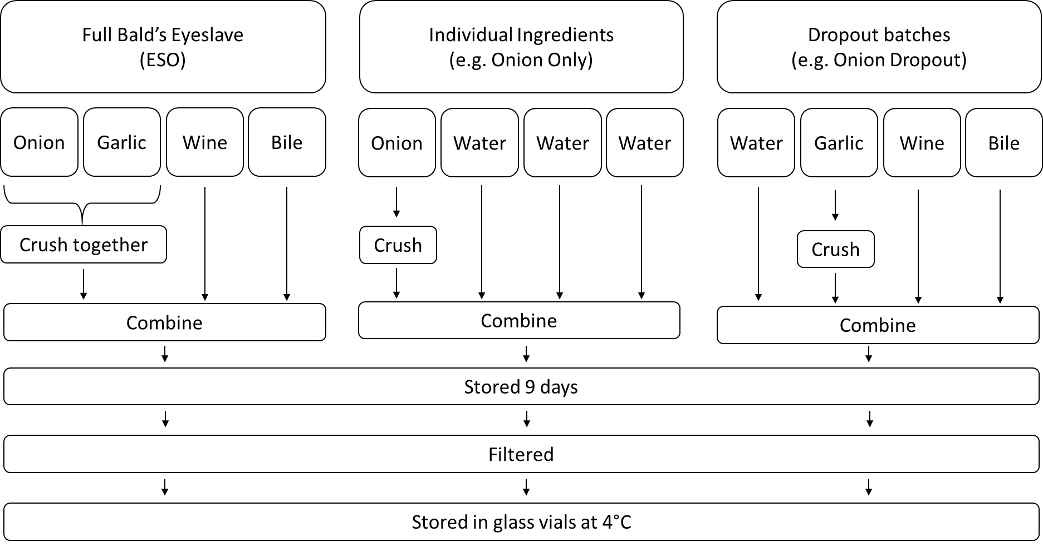
Figure S1. Schematic of the process to generate Bald’s eyesalve and various batch variations.
Figure S2. Confirmation of allicin in Bald’s eyesalve. All chromatograms were run against a 0-95% methanol gradient, with a flow rate of 1 ml·min⁻¹ on HPLC Aligent 1200 series, at 210 nm UV wavelength. A) Allicin calibration curve. External allicin standards, serially diluted in water were run and peak area was measured. A linear relationship was found between HPLC peak area and allicin concentrations between 8 - 750 μg·ml⁻¹ with a correlation coefficient R² value > 0.99. The mid-range of the curve (8-512 μg·ml⁻¹) has 2 repeats. B) Exemplary allicin external standard (128 μg·ml⁻¹) chromatogram, suspected allicin peak has a retention time of approx. 15 minutes. C-D) Bald’s eyesalve fresh batch, ESO 31 without (C) and with (D) an additional 100 μg·ml⁻¹ of allicin standard; the differences in peak area are indicated. The highlighted region is the allicin peak.

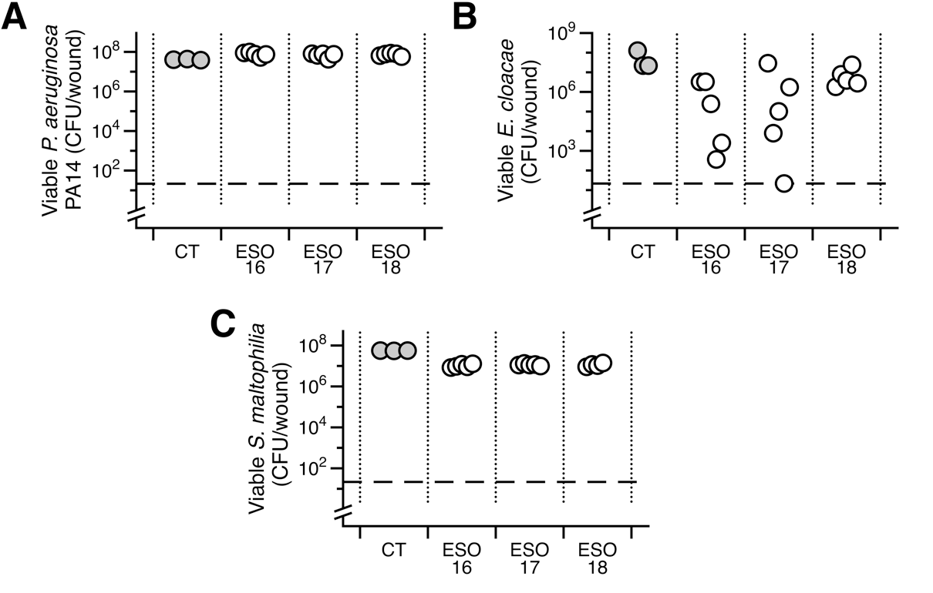
Figure S3. Bald’s eyesalve (ESO) anti-biofilm activity. Mature biofilms of various isolates were grown in a model of a soft tissue wound, then treated with either 0.5 vols sterile water (control, CT) or 0.5 vols of ESO for 24h before recovering bacteria for CFU counts (n = 3-5 replicates per treatment). The dashed line represents the limit of detection by plating. Data could not be transformed to fit assumptions of parametric tests, therefore, Kruskall-Wallis tests were used to determined that the CFU recovered from ESO-treated wounds was not significantly different from control wounds for P. aeruginosa PA14 (X² = 6.88, df = 3, p value = 0.076), S. maltophilia (X² = 7.63, df = 3, p value = 0.54) or E. cloacae (X² = 7.74, df = 3, p value = 0.051). Raw data and R scripts are supplied in the Data Supplement.

