Expression patterns of seven key genes, including β-catenin, Notch1, GATA6, CDX2, miR-34a, miR-181a and miR-93 in gastric cancer

Narjes Jafari¹, Saeid Abediankenari^{1,*}, Zahra Hosseini-Khah², Seyed Mohammad Valizadeh³, Zhila Torabizadeh⁴, Ehsan Zaboli⁵, Maryam Ghasemi⁶, Hafez Fakheri³, Vahid Hosseini³, Ramin Shekarriz⁵, Alireza Rafiei⁷, Hossein Asgarian-Omran¹, and Fatemeh Abedian⁸
¹ Immunogenetics Research Center, Department of Immunology, Faculty of Medicine, Mazandaran University of Medical Sciences, Sari, Iran
² Diabetes Research Center, Faculty of Medicine, Mazandaran University of Medical Sciences, Sari, Iran
³ Gut and Liver Research Center, Department of Internal Medicine, Faculty of Medicine, Mazandaran University of Medical Sciences, Sari, Iran
⁴ Department of Pathology, Faculty of Medicine, Mazandaran University of Medical Science, Sari, Iran

⁵ Gastrointestinal Cancer Research Center, Department of Internal Medicine, Faculty of Medicine, Mazandaran University of Medical Sciences, Sari

⁶ Immunogenetics Research Center, Department of Pathology, Faculty of Medicine, Mazandaran University of Medical Science, Sari, Iran

⁷ Molecular and Cell Biology Research Center, Department of Immunology, Faculty of Medicine, Mazandaran University of Medical Sciences, Sari, Iran
⁸ Student Research Committee, Mazandaran University of Medical Sciences, Sari, Iran

* Corresponding author: abedianlab@yahoo.co.uk

Supplementary data:

Table 1. Specific reverse transcription and quantitative real time PCR primers
Product size (bp) in RT-PCR | Sequence (5ʹ-3ʹ) | Primer
- | GTCGTATCCAGTGCAGGGTCCGAGGTATTCGCACTGGATACGACACTCAC | miR-181a-5p stem-loop (RT)
- | GTCGTATCCAGTGCAGGGTCCGAGGTATTCGCACTGGATACGACACAACC | miR-34a-5p stem-loop (RT)
- | GTC GTA TCC AGT GCA GGG TCC GAG GTA TTC GCA CTG GAT ACG ACCTACCT | miR-93-5p stem-loop (RT)
- | GAATTTGCGTGTCATCCTTG | U6 specific (RT)
⁓70 | F: GGAAACATTCAACGCTGTCG  Universal R: GTGCAGGGTCCGAGGT | miR-181a-5p
⁓70 | F: GGGATGGCAGTGTCTTAGC  Universal R: GTGCAGGGTCCGAGGT | miR-34a-5p
⁓70 | F: GGACAAAGTGCTGTTCGTGC  Universal R: GTGCAGGGTCCGAGGT | miR-93-5p
89 | F: GCTTCGGCAGCACATATACTAAAAT  R: CGCTTCACGAATTTGCGTGTCAT | U6
124 | F: CAATGTGGATGCCGCAGTTGTG  R: CAGCACCTTGGCGGTCTCGTA | Notch1
176 | F: GATACCTCCCAAGTCCTGTATGAG  R: GCATCAAACTGTGTAGATGGGATC | β- catenin
125 | F: TCTACAGCAAGATGAACGGCCTCA  R: TCTGCGCCATAAGGTGGTAGTTGT | GATA6
179 | F: AGACCAACAACCCAAACAGC  R:CCCGAACAGGGACTTGTTTA | CDX2
113 | F: CATGAGAAGTATGACAACAGCCT  R: AGTCCTTCCACGATACCAAAGT | GAPDH
F, forward; R, reverse; RT, reverse transcription

Fig. 1. Correlation patterns of the genes in gastric cancer tissues examined using quantitative RT- PCR. Curves show the correlations between the expression of the genes in 15 intestinal- and 9 diffuse-type gastric cancer tissues. Expression levels are given as Log₂^{Fold Change} (or -∆∆ ct). R and P-values were calculated by Spearman ʼs correlation method. *, and ** indicate P < 0.05, and P < 0.01, respectively.

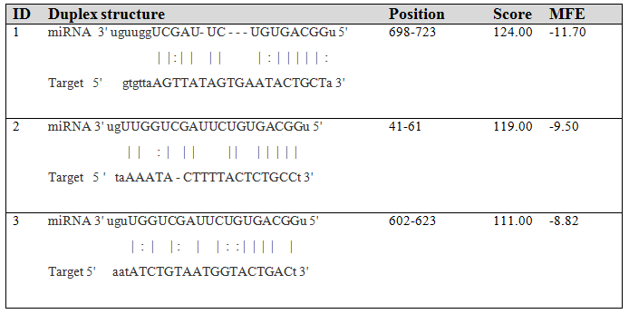
Fig 2. Complementary sequence interaction between miR-34a-5p and CTNNB1. Potential binding sites of miR-34a-5p in β-catenin mRNA (NM_001904) 3ʹ UTR and miRNA-target interactions are shown, as predicted by miRanda and presented by miRtarBase (http://mirtarbase.mbc.nctu.edu.tw). MFE; Minimum free energy.

