Comparative effectiveness of pembrolizumab vs. nivolumab in patients with recurrent or advanced NSCLC

Pengfei Cui^{a,b#}; Ruixin Li^{b#}; Ziwei Huang^{c,b#}; Zhaozhen Wu^{c,b}; Haitao Tao^{b}; Sujie Zhang^{b}; Yi Hu^{b,a,c*}

ªDepartment of Graduate Administration, Chinese PLA General Hospital, Beijing, China
^{b}Department of Medical Oncology, Chinese PLA General Hospital, Beijing, China
^{c}School of Medicine, Nankai University, Tianjin, China

#These authors contributed equally to this paper.

*Corresponding author
Prof. Yi Hu, Department of Medical Oncology, Chinese PLA General Hospital, 28 Fuxing Road, Haidian, Beijing 100853, China
Phone: (+86) 13911031186
E-mail: huyi_0912@126.com

Figure S1. Progression-free survival for patients in the first line therapy.
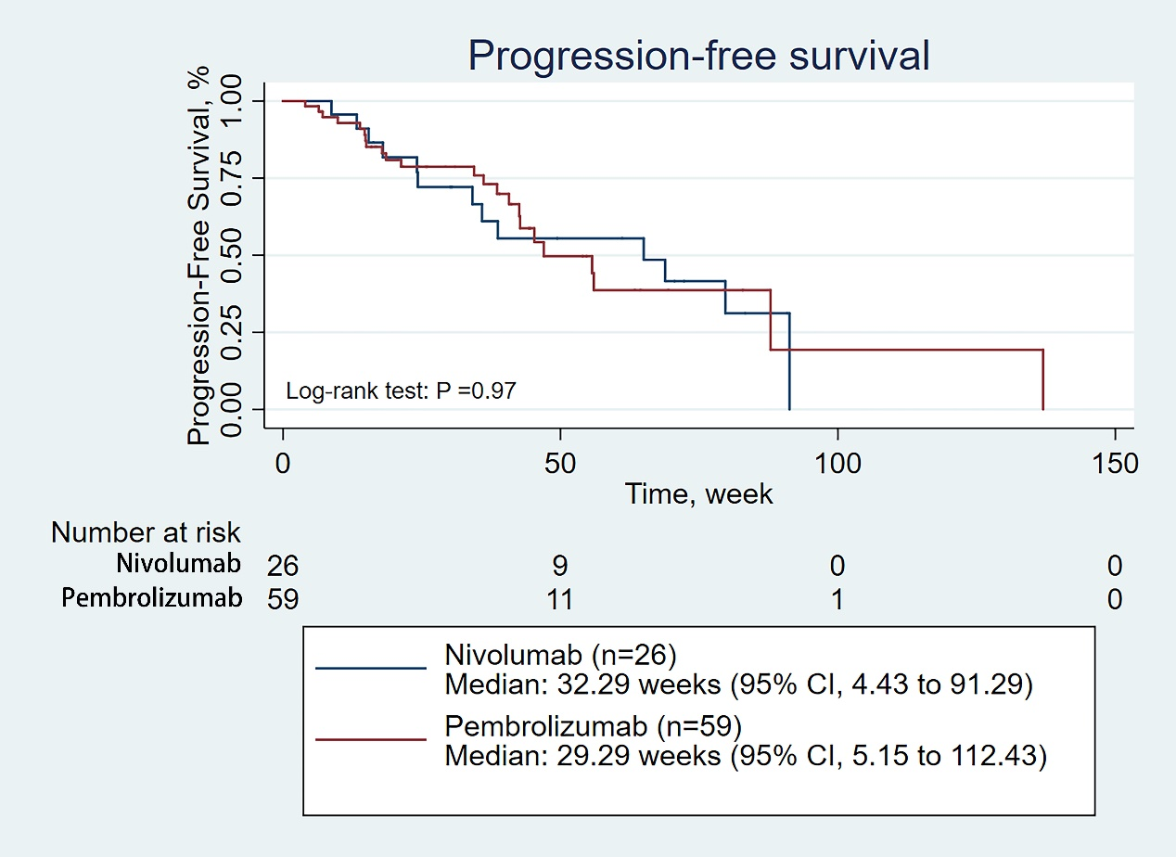
Figure S2. Progression-free survival of for patients in the second line therapy.
