Analysis of leaf morphology, secondary metabolites and proteins related to the resistance to Tetranychus cinnabarinus in cassava (Manihot esculenta Crantz)
Figure supplementary information
Yanni Yang¹, Xinglu Luo^{1,2},Wanling Wei^{1,3}, Zhupeng Fan¹, Tangwei Huang¹＆ Xiaolu Pan^{1,4}

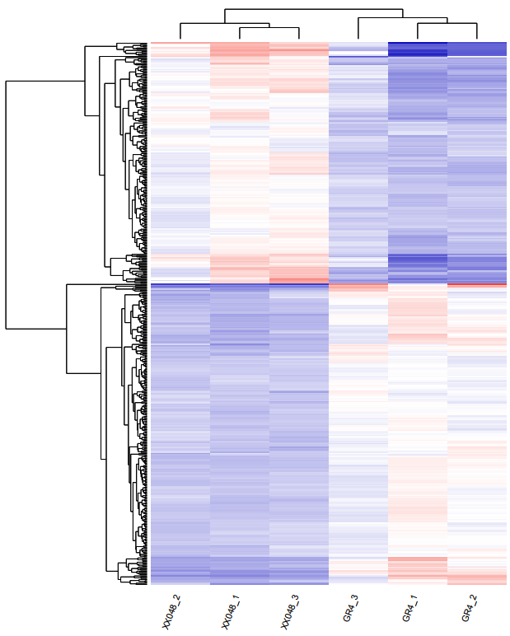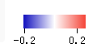
GR4_2

GR4_1

GR4_3

XX048_3

XX048_1

XX048_2
Figure S1. Hierarchical clustering of the DEPs in XX048 and GR4.

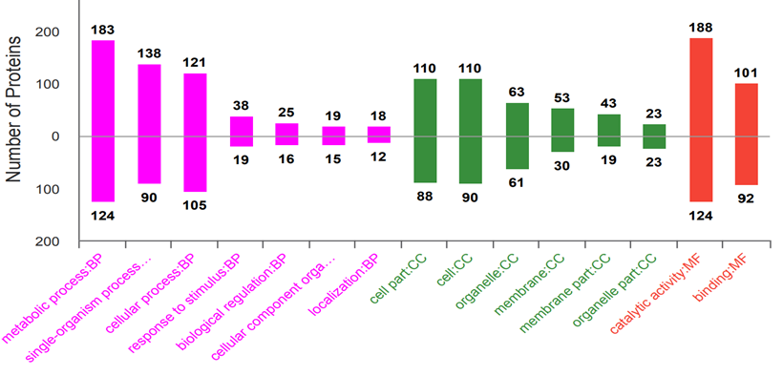
Figure S2. GO analysis of the differentially expressed proteins in cassava leaves between XX048 and GR4.
Expressed proteins involved in biological process, cellular component, and molecular function against the GO database. Above and below the ordinate zero are the number of up-regulated and down-regulated proteins, respectively.

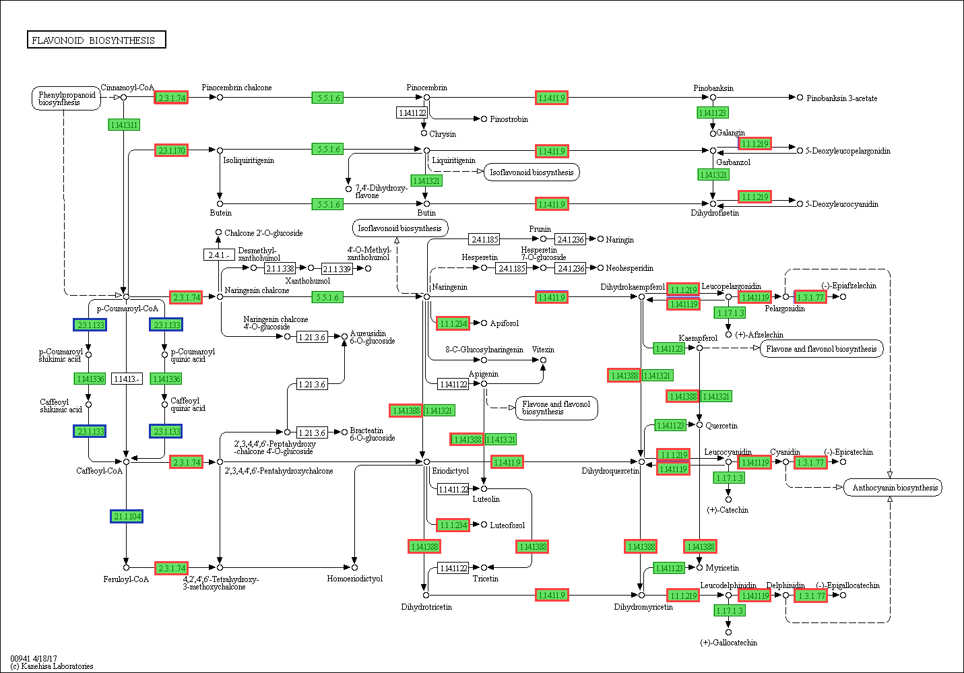

Figure S3. Changes of the differentially expressed proteins in flavonoid biosynthesis pathway of XX048 and GR4 cassava leaves. The proteins in red and blue are up-regulated and down-regulated expressed, respectively. The proteins in green background boxes are expressed at background level. The pathway map was generated using KEEG .

