Circulating cell-free DNA level predicts all-cause mortality independent of other predictors in the Health 2000 Survey

L. Kananen^{1,2} *, M. Hurme^{1,2}, M. Jylhä^{2,3}, T. Härkänen⁴, S. Koskinen⁴, S. Stenholm^{5,6}, M. Kähönen⁷, T. Lehtimäki⁸, O. Ukkola⁹, J. Jylhävä^{2,10} *
¹ Faculty of Medicine and Health Technology (MET), Tampere University, Tampere, Finland
² Gerontology Research Center (GEREC), Finland
³ Faculty of Social Sciences (Health Sciences), Tampere University, Tampere, Finland
⁴ Finnish Institute for Health and Welfare, Finland
⁵ Department of Public Health, University of Turku and Turku University Hospital, Turku, Finland
⁶ Centre for Population Health Research, University of Turku and Turku University Hospital; Turku, Finland
⁷ Faculty of Medicine and Health Technology, Tampere University, and Finnish Cardiovascular Research Center, Tampere, Finland; Department of Clinical Physiology, Tampere University Hospital, Tampere, Finland
⁸ Faculty of Medicine and Health Technology, Tampere University, and Finnish Cardiovascular Research Center, Tampere, Finland; Department of Clinical Chemistry, Fimlab Laboratories, Tampere, Finland
⁹ Research Unit of Internal Medicine, Medical Research Center Oulu, Oulu University Hospital, University of Oulu, Oulu, Finland
¹⁰ Department of Medical Epidemiology and Biostatistics, Karolinska Institutet, Stockholm, Sweden

Contact information:
L. Kananen laura.kananen@tuni.fi; *corresponding author
M. Hurme mikko.hurme@tuni.fi
M. Jylhä marja.jylha@tuni.fi
T. Härkänen tommi.harkanen@thl.fi
S. Stenholm sari.stenholm@utu.fi
S. Koskinen seppo.koskinen@thl.fi
M. Kähönen mika.kahonen@tuni.fi
T. Lehtimäki terho.lehtimaki@tuni.fi
O. Ukkola olavi.ukkola@oulu.fi
J. Jylhävä juulia.jylhava@ki.se; *corresponding author

Supplementary material
Figures

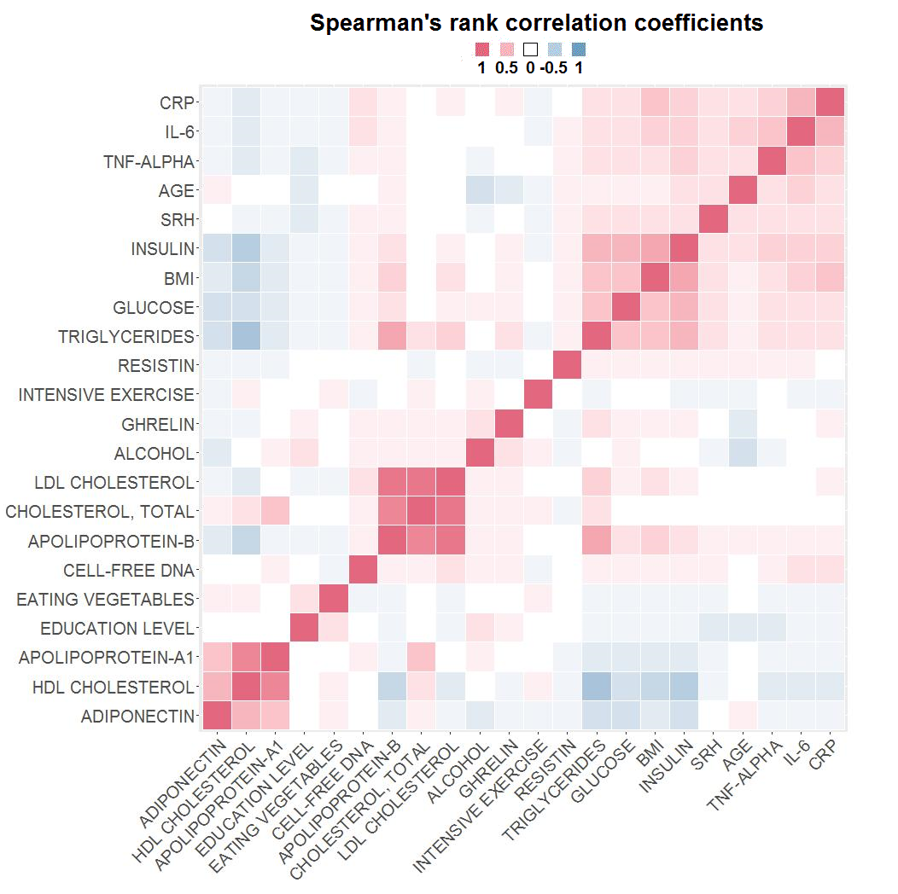
Supplementary Figure S1. Correlation analysis between cf-DNA level (residuals from the linear regression model adjusted for age and gender) and other continuous variables in the subsample of Health 2000 survey data (n=1,257) was performed using Spearman's rank correlation coefficient statistics. The correlation matrix was ordered using hierarchical clustering and visualised as a heatmap (p>0.05 with white color). Variable units are according to Table 1 and Supplementary Table S4.
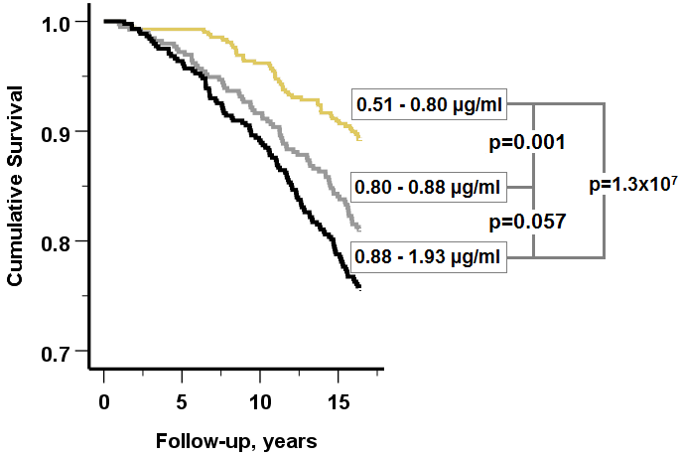
Supplementary Figure S2. The estimated survival probabilities according to the cf-DNA level divided into tertiles, and pairwise comparison statistics (log-rank test) across the cf-DNA level tertiles.

Tables

Supplementary Table S1. Primary causes of death in the sample according to ICD-10 codes.
 | ICD-10 | Frequency
Cancer | C00-C97, B21 | 77
Non-stroke CVD | I20-I25, I70, I73.9 | 41
Respiratory-related causes | J00-J99 | 12
Stroke | I60-I61, I63-I64 | 10
Other | other codes | 88
 | Total | 228
Abbreviations: CVD=cardiovascular disease,
ICD-10=International Classification of Diseases, Tenth Revision

Supplementary Table S2. Quality control analysis on the effect of ten years storage on cell-free DNA (cf-DNA) levels. The 34 samples that were first measured in 2010 (Jylhävä, J. et al. 2013) were now re-measured using the same analytical protocol and with two different Qubit Fluorometer versions (1 and 2) with version-specific assay reagents.
 | Spearman’s r (p-value) |  |  |  | Median  (interquartile range, IQR)
 | Qubit 1, in 2010 | Qubit 1, in 2020 | Qubit 2, in 2020 |  | cf-DNA, µg/ml | p-value*
Qubit 1, in 2010 | 1.000 | 0.968 (8.6x10⁻²¹) | 0.966 (1.9x10⁻²⁰) |  | 0.77 (0.22)
Qubit 1, in 2020 | 0.968 (8.6x10⁻²¹) | 1.000 | 0.961 (4.8x10⁻²⁰) |  | 1.17 (0.31) | 6.5x10⁻¹¹
Qubit 2, in 2020 | 0.966 (1.9x10⁻²⁰) | 0.961 (4.8x10⁻²⁰) | 1.000 |  | 1.15 (0.34) | 5.8 x10⁻¹¹
*p-value for Mann-Whitney U test, cf-DNA levels measured in 2010 were compared to the levels measured in 2020, after ten years storage

Supplementary Table S3. Associations of age and gender with mortality in the Health 2000 survey (n=1,257, follow-up 15 years) using Cox regression analysis. In model 1 age was analysed alone, in model 2 gender was analysed alone, and in model 3 age and gender were analysed together.
 | Variable | HR | 95% CIs for HR |  |  | p
Model 1 | Age | 1.12 | 1.10 | - | 1.13 | 4.0x10⁻³⁷
Model 2 | Gender, male | 2.06 | 1.57 | - | 2.69 | 0.0000001
Model 3 | Age | 1.12 | 1.10 | - | 1.14 | 4.0x10⁻³⁸
 | Gender, male | 2.19 | 1.67 | - | 2.86 | 0.00000001
Abbreviations: HR=Hazard ratio, CI=confidence interval

Supplementary Table S4. Association between the health variables and all-cause mortality in the Health 2000 sample (n=1,257, follow-up 15 years) were analysed one by one using the Cox regression analysis adjusted for age and gender.
Domain | Variable | HR | 95% CI for HR |  |  | p
Lifestyle | Smoking status* | 3.03 | 2.25 | - | 4.06 |  | 1.7x10⁻¹³
Blood biomarker | Cell-free DNA, 0.1 ug/ml** | 1.02 | 1.01 | - | 1.03 |  | 0.0000005
Health status | Self-rated health, five categories** | 1.44 | 1.24 | - | 1.66 |  | 0.0000007
Blood biomarker | Fasting glucose, mmol/L** | 1.20 | 1.11 | - | 1.29 |  | 0.000004
Blood biomarker | IL-6, ng/L** | 1.03 | 1.01 | - | 1.05 |  | 0.0005
Blood biomarker | CRP, mg/L** | 1.04 | 1.02 | - | 1.06 |  | 0.0007
Disease | Diabetes** | 1.98 | 1.29 | - | 3.05 |  | 0.002
Disease | Any respiratory disease* | 1.53 | 1.16 | - | 2.02 |  | 0.003
Disease | Any cardiovascular disease** | 1.51 | 1.15 | - | 1.99 |  | 0.003
Blood biomarker | Fasting insulin, mU/L** | 1.02 | 1.01 | - | 1.03 |  | 0.005
Lifestyle | Intensive exercise  (>10min/day), days in a week* | 0.92 | 0.86 | - | 0.99 | 0.018
Blood biomarker | TNF-alpha, ng/L** | 1.02 | 1.00 | - | 1.04 | 0.020
Blood biomarker | Adiponectin, ug/ml** | 1.03 | 1.00 | - | 1.05 | 0.022
Lifestyle | Eating fresh vegetables, days in a week* | 0.86 | 0.75 | - | 0.98 | 0.022
Lifestyle | Alcohol consumption, g/week* | 1.00 | 1.00 | - | 1.00 | 0.036
Socioeconomic | Education level, three categories* | 0.84 | 0.70 | - | 0.99 | 0.038
Blood biomarker | LDL cholesterol, mmol/L** | 0.87 | 0.75 | - | 1.01 | 0.067
Blood biomarker | Total cholesterol, mmol/L** | 0.89 | 0.77 | - | 1.03 | 0.111
Blood biomarker | Apolipoprotein B, g/L** | 0.64 | 0.37 | - | 1.12 | 0.118
Blood biomarker | Ghrelin, pg/ml** | 1.00 | 1.00 | - | 1.00 | 0.141
Disease | Rheumatoid arthritis* | 0.60 | 0.22 | - | 1.62 | 0.316
Blood biomarker | Resistin, ng/ml** | 1.00 | 0.99 | - | 1.00 | 0.372
Disease | Cancer* | 1.23 | 0.76 | - | 1.99 | 0.401
Physiological  parameter | Body Mass Index, kg/m2** | 0.99 | 0.96 | - | 1.02 | 0.438
Disease | Chronic disease in the gastrointestinal tract* | 0.90 | 0.61 | - | 1.32 | 0.576
Blood biomarker | Apolipoprotein A1, g/L** | 0.91 | 0.56 | - | 1.46 | 0.683
Blood biomarker | HDL cholesterol, mmol/L** | 1.05 | 0.75 | - | 1.46 | 0.775
Blood biomarker | Triglycerides, mmol/L** | 1.02 | 0.88 | - | 1.18 | 0.818
Abbreviations: BMI=Body mass index, CI=confidence interval, CRP=C-reactive protein, CVD=cardiovascular disease, GI=gastrointestinal tract, HDL=High-density lipoprotein, HR=Hazard ratio, IL=Interleukin, LDL=Low-density lipoprotein, TNF=Tumor necrosis factor. Significant predictors are shown in bold. Variables that were collected in the Health 2000 survey in 2000-2001 are indicated with *, and those collected in the survey 2001-2002 with **. The LDL cholesterol level was calculated with the Friedewald formula.

Supplementary Table S5. Association between cf-DNA levels and all-cause mortality at different time-points in the Health 2000 sample (n=1,257) using the Cox regression analysis adjusted for age and gender. At 5-years-time-point 50 participants and at 15-years-time-point, 228 participants had died.

Model | HR | 95% CI | p
5-years-follow-up | 1.028 | 1.012 - 1.044 | 0.000527
15-years-follow-up | 1.022 | 1.013 - 1.030 | 0.0000005
Abbreviations: HR=Hazard ratio, CI=confidence interval

Supplementary Table S6. The laboratory assay dates of the blood biomarkers. The samples were stored at -70°C prior to the measurements.
Biomarker | Assay date (month/year)
Cell-free DNA, µg/ml | 11/2012-12/2012
Adiponectin, µg/ml | 2/2008-6/2008
Apolipoprotein A1, g/L | 11/2003-4/2004
Apolipoprotein B, g/L | 11/2003-4/2004
CRP, mg/L | 10/2004-12/2004
Fasting glucose, mmol/L | 11/2001-12/2002
Ghrelin, pg/ml | 2/2008-6/2008
HDL cholesterol, mmol/L | 11/2003-4/2004
IL-6, ng/L | 10/2004-12/2004
Insulin, mU/L | 11/2001-1/2003
LDL cholesterol, mmol/L | 11/2003-4/2004
Resistin, ng/ml | 2/2008-6/2008
TNF-alpha, ng/L | 10/2004-12/2004
Total cholesterol, mmol/L | 11/2003-4/2004
Triglycerides, mmol/L | 11/2003-4/2004
Abbreviations: CRP=C-reactive protein, CVD=cardiovascular disease, HDL=High-density lipoprotein, IL=Interleukin, LDL=Low-density lipoprotein, TNF=Tumor necrosis factor.

References
Jylhävä, J. et al. Characterization of the role of distinct plasma cell-free DNA species in age-associated inflammation and frailty. Aging Cell. 12, 388-397 (2013).

