Scientific Reports

Title: Effects of a microbial restoration substrate on plant growth and rhizosphere bacterial community in a continuous tomato cropping greenhouse
Authors: Xuefang Zheng¹, Ziran Wang², Zhu Yujing¹, Jieping Wang¹, Bo Liu^{1*}
(¹Agrobiological Resource Research Institute, Fujian Academy of Agriculture Sciences, Fuzhou 350003, China; ²Dean of Department of Biochemistry and Biotechnology, School of Life Sciences, Xiamen University, Xiamen, 361102, China)

*Corresponding author
Bo Liu*, fzliubo@163.com; Tel.:+86-0591-87863227

Table S1. Correlation coefficients between soil properties and plant biological characteristic
Items | pH | SOC | TN | TP | TK | Exchangeable calcium | Plant height | Root activity | Yield
pH | 1
SOC | 0.998** | 1
TN | 0.965* | 0.978** | 1
TP | 0.576 | 0.606 | 0.727 | 1
TK | -0.998** | -0.994** | -0.949* | -0.521 | 1
Exchangeable calcium | 0.999** | 0.999** | 0.970* | 0.592 | -0.996** | 1
Plant height | 0.981** | 0.989** | 0.997** | 0.707 | -0.967* | 0.985** | 1
Root activity | 0.988** | 0.993** | 0.985** | 0.693 | -0.976* | 0.991** | 0.995** | 1
Yield | 0.997** | 0.997** | 0.971* | 0.630 | -0.991** | 0.998** | 0.987** | 0.996** | 1
* correlation is significant at the 0.05 level and ** correlation is significant at the 0.01 level.

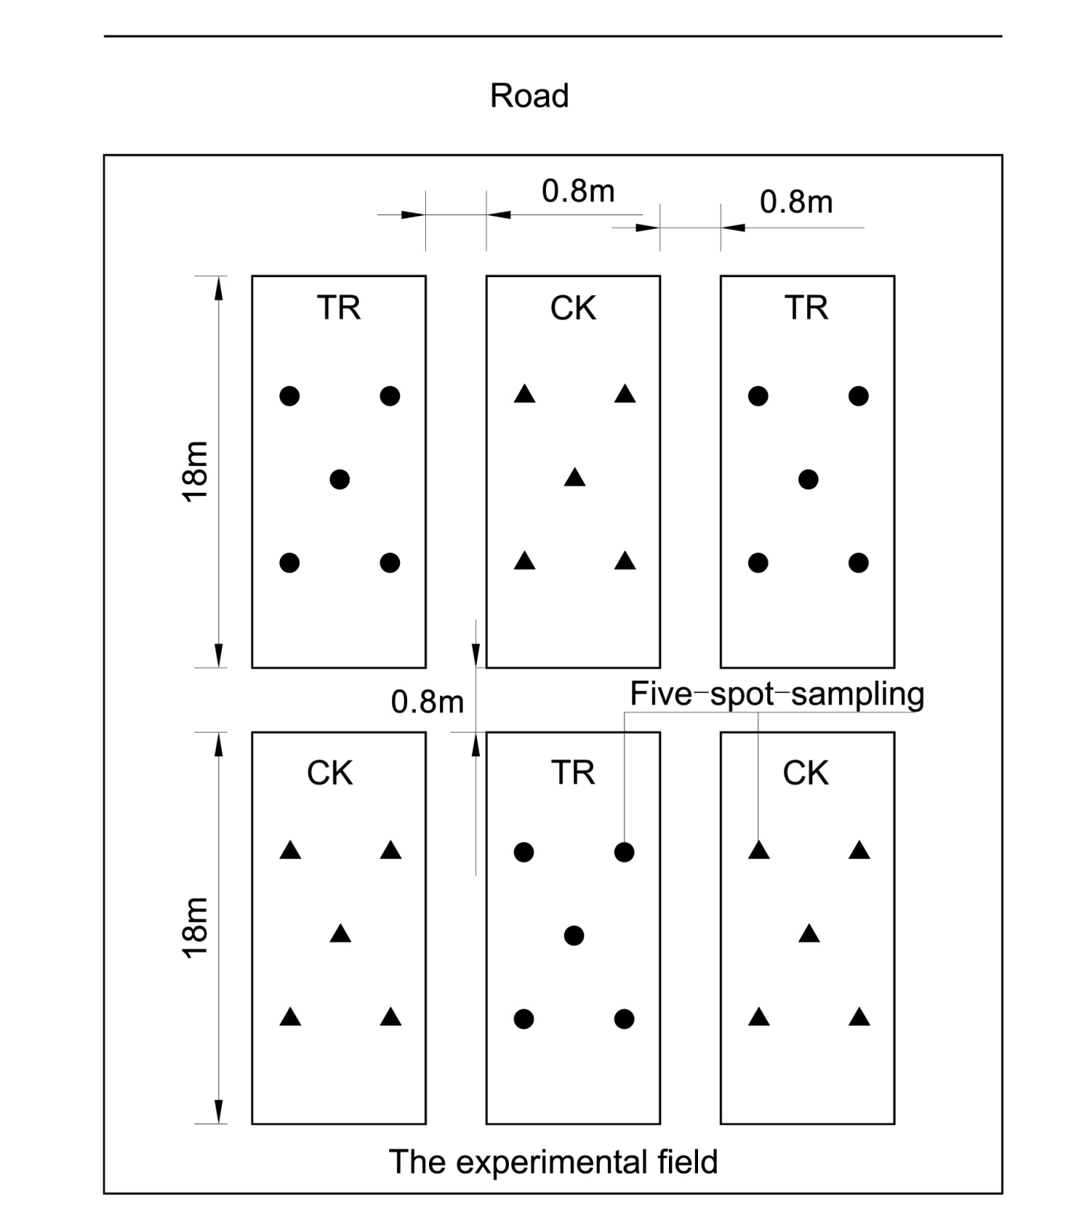
SuSupplementary Fig.S1. Diagram of different treatment plots in the field. “TR” represents microbial restoration substrate treatment; “CK” represents non- microbial restoration substrate treatment. Five solid circles in each plot of TR and five solid triangles in each plot of CK represent of five-spot-sampling of rhizosphere soils for TR and CK, respectively.

