Supplementary materials

Characterization of deep-sea benthic invertebrate megafauna of the Galapagos Islands.
Pelayo Salinas-de-León^{1,2,*}, Patricia Martí-Puig¹, Salome Buglass¹, Camila Arnés-Urgellés¹, Etienne Rastoin¹, Marie Creemers¹, Stephen Cairns³, Charles Fisher⁴, Timothy O’Hara⁵, Bruce Ott⁶, Nicole A. Raineault⁷, Henry Reiswig⁸, Greg Rouse⁹, Sonia Rowley¹⁰, Timothy M. Shank¹¹, Jenifer Suarez¹², Les Watling¹³, Mary K. Wicksten¹⁴, Leigh Marsh^{1,15}

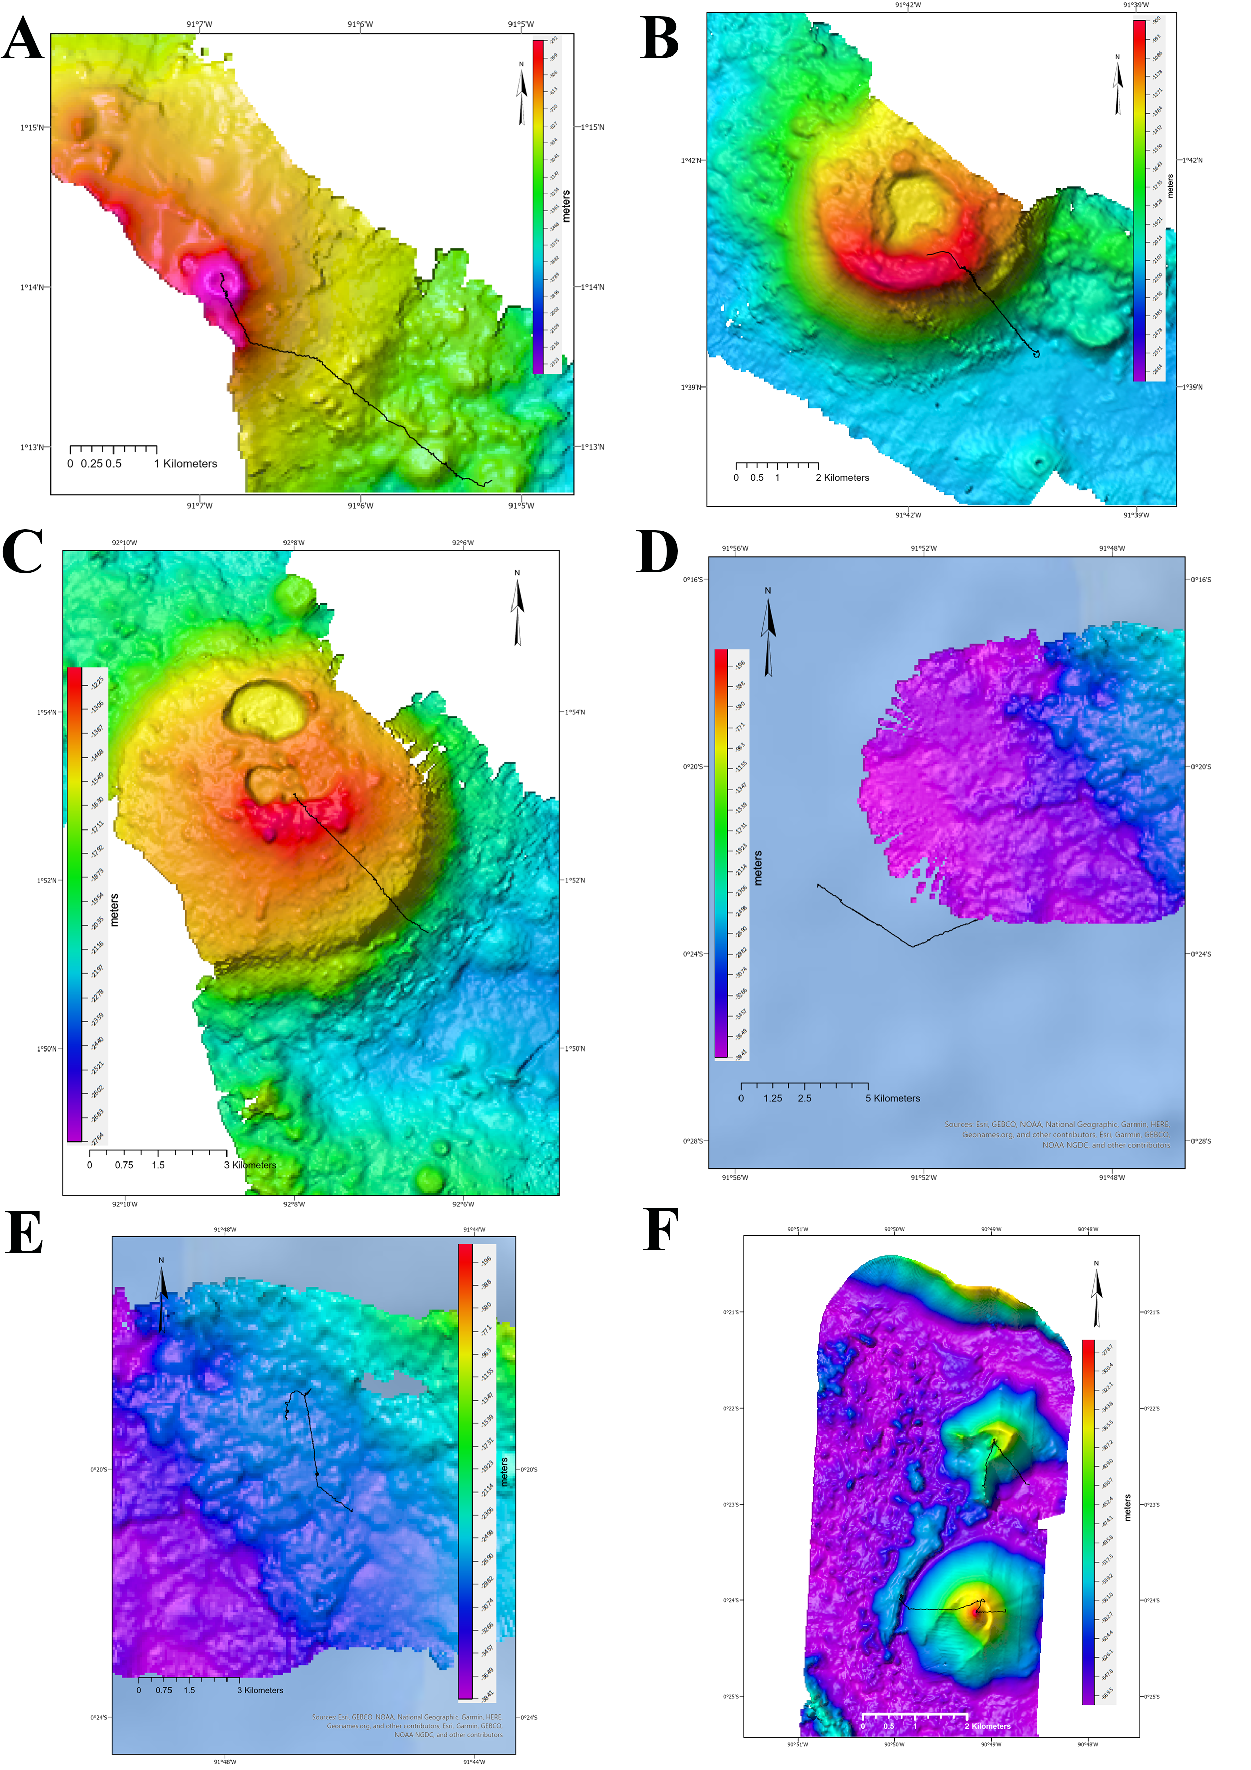

Supplementary material 1. ROV dives from the NA064 Expedition. Ship-acquired multibeam with ROV USBL navigation. Gridded background bathymetric data provided by the General Bathymetric Chart of the Oceans (GEBCO) 30 arc-second grid (accessed via http://www.gebco.net/). Map created in ESRI ArcMap (version 10.3.
Supplementary material 2. List of morphospecies recorded on ROV video transects collected on seamounts (H1435, H1436, H1440) and volcanic cones (H1443A, H1443B) of the Galapagos Marine Reserve.

Phylum | Class | Order | Lowest taxonomic rank | Morphotype or morphospecies | H1435 | H1436 | H1440 | H1443A | H1443B
Annelida | Polychaeta | Terebellida | Genus | Biremis sp. indet. | x | x | x | - | -
Arthropoda | Malacostraca | Decapoda | Infraorder | Anomura spp. stet. | x | x | x | x | x
Arthropoda | Malacostraca | Decapoda | Family | Chirostylidae spp. stet. | x | x | - | - | x
Arthropoda | Malacostraca | Decapoda | Genus | Eumnida sp. indet. | x | - | - | x | x
Arthropoda | Malacostraca | Decapoda | Family | Sternostylidae spp. indet. | x | x | - | x | x
Arthropoda | Malacostraca | Decapoda | Family | Cancridae sp. indet. | - | - | - | x | x
Arthropoda | Malacostraca | Decapoda | Family | Homolidae sp. indet. | x | - | - | - | -
Arthropoda | Malacostraca | Decapoda | Family | Lithodidae spp. indet. | x | - | - | - | -
Arthropoda | Malacostraca | Decapoda | Family | Epialtidae sp. indet. | x | - | - | - | -
Arthropoda | Malacostraca | Decapoda | Family | Mathildellidae sp. indet. | x | - | - | - | -
Chordata | Thalicea | Pyrosomatida | Family | Pyrosomatidae sp. indet. | x | - | - | - | -
Chordata | Ascidiacea | Phlebobranchia | Family | Octacnemidae sp. indet. | - | - | x | - | -
Cnidaria | Anthozoa | Actiniaria | Order | Actiniaria spp. indet. | x | x | x | x | x
Cnidaria | Anthozoa | Actiniaria | Order | Actiniaria sp. indet. | x | - | - | x | x
Cnidaria | Anthozoa | Actiniaria | Family | Actinoscyphiidae spp. indet. | x | x | - | - | -
Cnidaria | Anthozoa | Antipatharia | Genus | Stichopathes sp. indet.* | - | - | x | x | x
Cnidaria | Anthozoa | Antipatharia | Morphotype | Antipatharia (3D branching) spp. indet.* | x | x | x | x | x
Cnidaria | Anthozoa | Antipatharia | Morphotype | Schizopathidae spp. indet.* | x | x | x | x | x
Cnidaria | Anthozoa | Corallimorpharia | Family | Corallimorphidae sp. indet. | x | - | - | - | -
Cnidaria | Anthozoa | Scleractinia | Morphotype | Scleractinia (cup coral type) spp. indet. | x | x | - | x | -
Cnidaria | Anthozoa | Scleractinia | Species | Dendrophyllia californica* | x | - | - | x | x
Cnidaria | Anthozoa | Scleractinia | Species | Madrepora oculata* | x | - | - | x | -
Cnidaria | Anthozoa | Scleractinia | Morphotype | Scleractinia (branching type) spp. indet.* | x | - | - | x | x
Cnidaria | Anthozoa | Zoantharia | Family | Parazoanthidae sp. stet. | x | x | x | - | -
Cnidaria | Anthozoa | Alcyonacea | Family | Acanthogorgiidae sp. indet.* | x | x | x | x | x
Cnidaria | Anthozoa | Alcyonacea | Suborder | Alcyoniina sp. stet.* | x | - | - | x | -
Cnidaria | Anthozoa | Alcyonacea | Family | Alcyoniidae spp. indet.* | x | x | x | x | x
Cnidaria | Anthozoa | Alcyonacea | Family | Clavulariidae sp. indet.* | x | - | - | x | -
Cnidaria | Anthozoa | Alcyonacea | Family | Chrysogorgiidae spp. indet.* | x | x | x | x | x
Cnidaria | Anthozoa | Alcyonacea | Family | Isididae spp. indet.* | x | x | x | x | x
Cnidaria | Anthozoa | Alcyonacea | Family | Paragorgiidae sp. indet.* | - | x | - | - | -
Cnidaria | Anthozoa | Alcyonacea | Family | Plexauridae sp. indet.* | x | x | x | x | x
Cnidaria | Anthozoa | Alcyonacea | Family | Primnoidae spp. indet.* | x | x | x | x | x
Cnidaria | Anthozoa | Alcyonacea | Genus | Victorgorgia sp. indet.* | x | x | - | - | -
Cnidaria | Anthozoa |  | Morphotype | Anthozoa (whip-like) spp. stet.* | - | - | x | x | x
 | Anthozoa | Pennatulacea | Genus | Anthoptilum sp. indet.* | x | - | - | - | -
 | Anthozoa | Pennatulacea | Family | Halipteridae sp. indet.* | x | - | x | - | -
 | Anthozoa | Pennatulacea | Family | Pennatulidae sp. indet.* | x | x | x | - | -
 | Anthozoa | Pennatulacea | Family | Umbellulidae sp. indet.* | - | x | - | - | -
 | Hydrozoa | Anthoathecata | Family | Corymorphidae sp. stet | - | - | x | - | -
 | Hydrozoa | Anthoathecata | Genus | Crypthelia sp. indet.* | x | x | x | x | x
 | Hydrozoa | Siphonophora | Order | Siphonophora sp. stet | - | - | - | x | -
Ctenophora |  |  | Phylum | Ctenophora sp. stet | - | - | - | x | -
Echinodermata | Asteroidea |  | Class | Asteroidea spp. stet. | x | x | x | x | x
Echinodermata | Asteroidea | Brisingida | Order | Brisingida spp. indet. | x | x | x | x | x
Echinodermata | Asteroidea |  | Superorder | Valvatacea spp. indet. | x | x | x | x | x
Echinodermata | Crinoidea | Comatulida | Order | Comatulida spp. indet. | x | x | x | x | x
Echinodermata | Crinoidea |  | Morphotype | Stalked crinoids spp. indet. | x | - | - | x | -
Echinodermata | Echinoidea | Echinothurioida | Order | Echinothurioida sp. stet. | x | x | x | - | -
Echinodermata | Echinoidea | Cidaroida | Genus | Histocidaris sp. indet. | x | x | - | x | x
Echinodermata | Echinoidea | Cidaroida | Species | Centrocidaris doederleini | x | x | x | x | x
Echinodermata | Holothuroidea |  | Class | Holothuroidea spp. stet. | x | x | x | x | x
Echinodermata | Holothuroidea | Elasipodida | Family | Elpidiidae spp. indet. | - | x | x | - | -
Echinodermata | Holothuroidea | Synallactida | Family | Synallactidae sp. indet. | - | x | x | x | x
Echinodermata | Ophiuroidea | Euryalida | Family | Euryalidae sp. indet. | x | x | x | - | -
Echinodermata | Ophiuroidea | Euryalida | Family | Gorgonocephalidae sp. indet. | - | - | - | - | x
Echinodermata | Ophiuroidea | Ophiuroidea | Infraclass | Metophiurida spp. indet. | x | x | x | x | -
Foraminifera | Monothalamea |  | Superfamily | Xenophyophoroidea spp. indet.* | x | x | x | - | -
Mollusca | Bivalvia | Limida | Family | Limidae sp. indet. | x | - | - | - | -
Mollusca | Bivalvia | Pectinida | Family | Pectinidae sp. indet. | x | - | - | - | -
Porifera | Hexactinellida | Sceptrulophora | Order | Sceptrulophora spp. indet.* | x | x | x | - | -
Porifera | Hexactinellida | Lyssacinosida | Order | Lyssacinosida spp. indet.* | x | x | x | - | x
Porifera | Hexactinellida | Lyssacinosida | Genus | Regadrella sp. indet.* | x | x | x | x | x
Porifera | Hexactinellida | Lyssacinosida | Family | Rossellidae spp. indet.* | x | - | - | x | -
Porifera | Hexactinellida | Lyssacinosida | Family | Bolosominae spp. indet.* | - | - | x | - | -
Porifera | Hexactinellida | Lyssacinosida | Genus | Saccocalyx sp. indet.* | - | x | - | - | -
Porifera | Hexactinellida | Amphidiscosida | Family | Hyalonematidae sp. indet.* | x | x | x | - | x
Porifera | Demospongiae | Poecilosclerida | Family | Cladorhizidae (stalk) sp. indet.* | x | x | x | - | -
Porifera | Demospongiae | Poecilosclerida | Family | Cladorhizidae (bushy) sp. indet.* | x | - | - | - | -
Porifera | Demospongiae | Polymastiida | Order | Penicillaria sp. stet. | x | x | - | x | -

Supplementary material 3. Bathymetric variation on oxygen concentration from ROV mounted CTD and Oxygen optode. The depth distribution of the Oxygen Minimum Zone (OMZ) is highlighted in red.

