Supplementary information for the manuscript entitled “Dynamic control of heat flow using a spin-chain ladder cuprate film and an ionic liquid”

Nobuaki Terakado^{1,2},* Yoshinori Nara¹, Yuki Machida¹, Yoshihiro Takahashi¹, Takumi Fujiwara¹ *

¹Department of Applied Physics, Tohoku University, 6-6-05 Aoba, Aoba-ku, Sendai 980-8579, Japan
²PRESTO, Japan Science and Technology Agency, 4-1-8 Honcho, Kawaguchi 332-0012, Japan
*Corresponding and requests for materials should be addressed to N.T. (email: terakado@laser.apph.tohoku.ac.jp) or T.F. (email: fujiwara@laser.apph.tohoku.ac.jp)

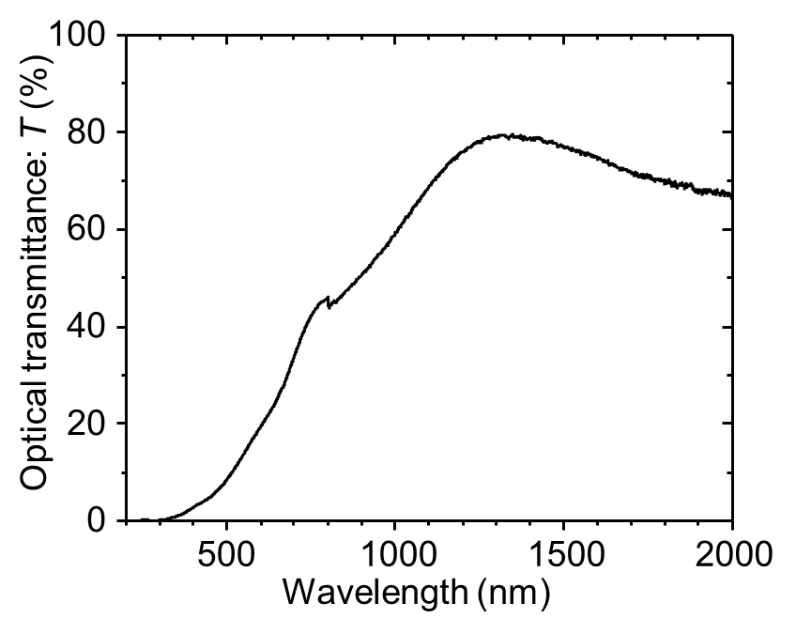
Supplementary Fig. 1. Optical transmission spectrum of a heat-treated (400 s at 700 °C) La–Ca–Cu–O (LCCO) film with a thickness d of ~250 nm deposited on a SiO₂ glass substrate obtained by UV-Vis-NIR spectrophotometry. The dip at the wavelength of 800 nm is from the instrument. The optical transmittance T is approximated by T = T₀exp(−αd), where α is the absorption coefficient of the LCCO film and T₀ is the transmittance for α = 0, which is assumed to be ~80% from the transmittance at the wavelength of ~1300 nm. For the 532-nm probe light in Raman spectroscopy, T is 12%, and accordingly, the penetration depth α⁻¹ is obtained as ~130 nm.

Supplementary Table 1. Parameters set for the analytical fitting in frequency-domain thermoreflectance (FDTR). (upper table) Wavelength and beam radius of the pump and probe light. (lower table) Thickness d, thermal conductivity K, volumetric specific heat C of each layer, and thermal conductance G_{LCCO}, where the layers and interfaces are listed in order from the top to the bottom. G_{g/Au}, G_{Au/IL}, d_{IL}, and G_{LCCO} are the initial undetermined parameters.

 | λ (nm) | w (μm)
Pump | 488 | 18*
Probe | 532 | 23*

 | d | K (W/(m K)) | C (MJ/(m³ K)) | G (MW/(m² K))
Cover glass | 150 μm | 1.0¹ | 2.1¹ | –
Interface | – | – | – | G_{g/Au} = 50
Au | 80 nm | 220* | 2.5¹ | –
Interface | – | – | – | G_{Au/IL} = 50
IL (DEME-TFSI) | d_{IL} = 700 nm | 0.13² | 1.9² | –
LCCO film | 500 nm | – | – | G_{LCCO} $≳$ 4**
Si | 500 μm | 150¹ | 1.6¹ | –

* See Methods in the main text regarding the evaluation.
** For the initial state A; see Fig. 3 in the main text.

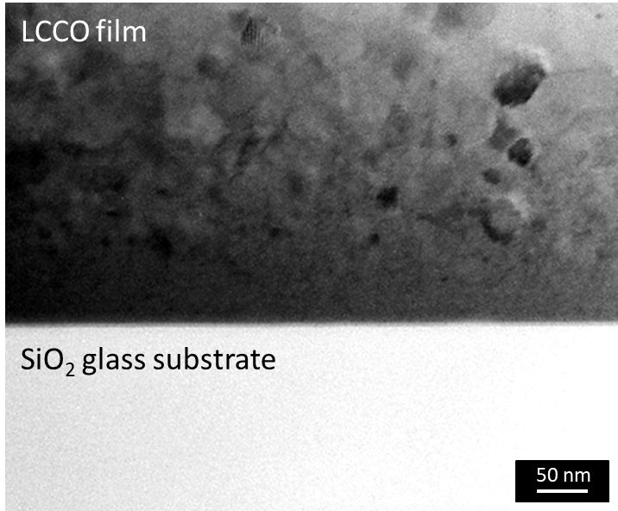

Supplementary Fig. 2. Cross-sectional transmission electron microscopy image near the substrate surface of an LCCO film sputtered on a SiO₂ glass substrate. The sputtering conditions are the same as those in the main text, except for the substrates. A homogeneous area with a thickness of ~100 nm on the substrate is observed, which is expected to be amorphous/nanocrystalline LCCO, and the subsequent deposition of the polycrystals whose size increases as the depth becomes shallower.

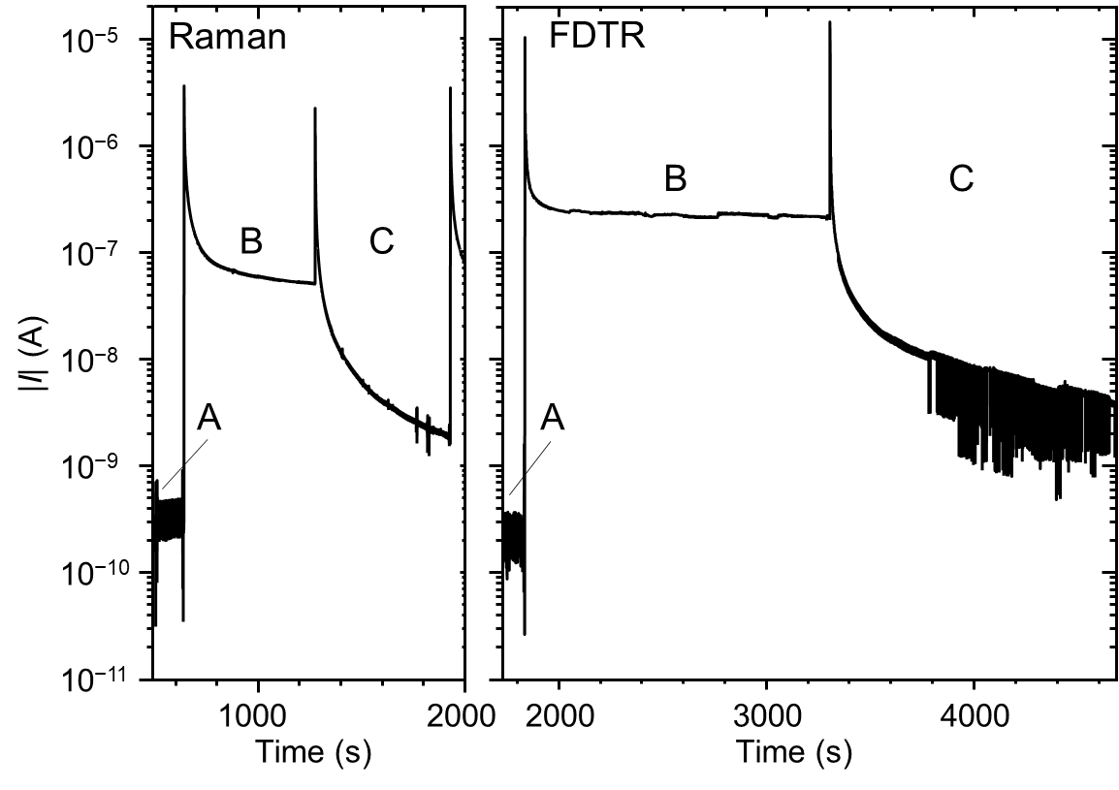

Supplementary Fig. 3. Time dependence of the charging and discharging current |I| for the voltage application, corresponding to Fig. 2c (Raman) and Fig. 3d (FDTR) in the main text. For both measurements, the charged carriers are estimated to be ~10¹⁴ cm⁻² from the transient current after switching voltages, and the leak current density is approximately 100 nA/cm².

References
1. CRC Handbook of Chemistry and Physics. (CRC Press, 2016).
2. López-Bueno, C., Bugallo, D., Leborán, V. & Rivadulla, F. Sub-μL measurements of the thermal conductivity and heat capacity of liquids. Phys. Chem. Chem. Phys. 20, 7277–7281 (2018).

