Supplementary Information

Host genetic variation explains reduced protection of commercial vaccines against Piscirickettsia salmonis in Atlantic salmon

Carolina Figueroa¹, Pamela Veloso^{1,2}, Lenin Espin³, Brian Dixon⁴, Débora Torrealba⁵, Juan Manuel Afonso³, Carlos Soto⁶, Pablo Conejeros7, José A. Gallardo¹.

¹Escuela de Ciencias del Mar, Pontificia Universidad Católica de Valparaíso, Altamirano 1424, Valparaíso, Región de Valparaíso, postal code: 2360007, Chile.
² Programa de Doctorado en Ciencias, mención Recursos Naturales Acuáticos,
Universidad de Valparaíso, Blanco 951, Valparaíso, Región de Valparaíso, postal code: 2391415, Chile.
³Facultad de Ciencias del Mar, Universidad de Las Palmas de Gran Canaria, 35017 Tafira Baja, Las Palmas, postal Code: 35017, Spain.
⁴Department of Biology, Faculty of Science, University of Waterloo, 200 University Ave W, Waterloo, ON N2L 3G1, Canada.
⁵Department of Agricultural, Food & Nutritional Science, University of Alberta, 116 St & 85 Ave, Edmonton, AB T6G 2R3, Canada.
⁶Salmones Camanchaca Diego Portales 2000, Puerto Montt, postal code: 5503642, Chile.
⁷Centro de Investigación y Gestión de Recursos Naturales (CIGREN), Facultad de Ciencias, Universidad de Valparaíso, Blanco 951, Valparaíso, Región de Valparaíso, postal code: 2391415, Chile.

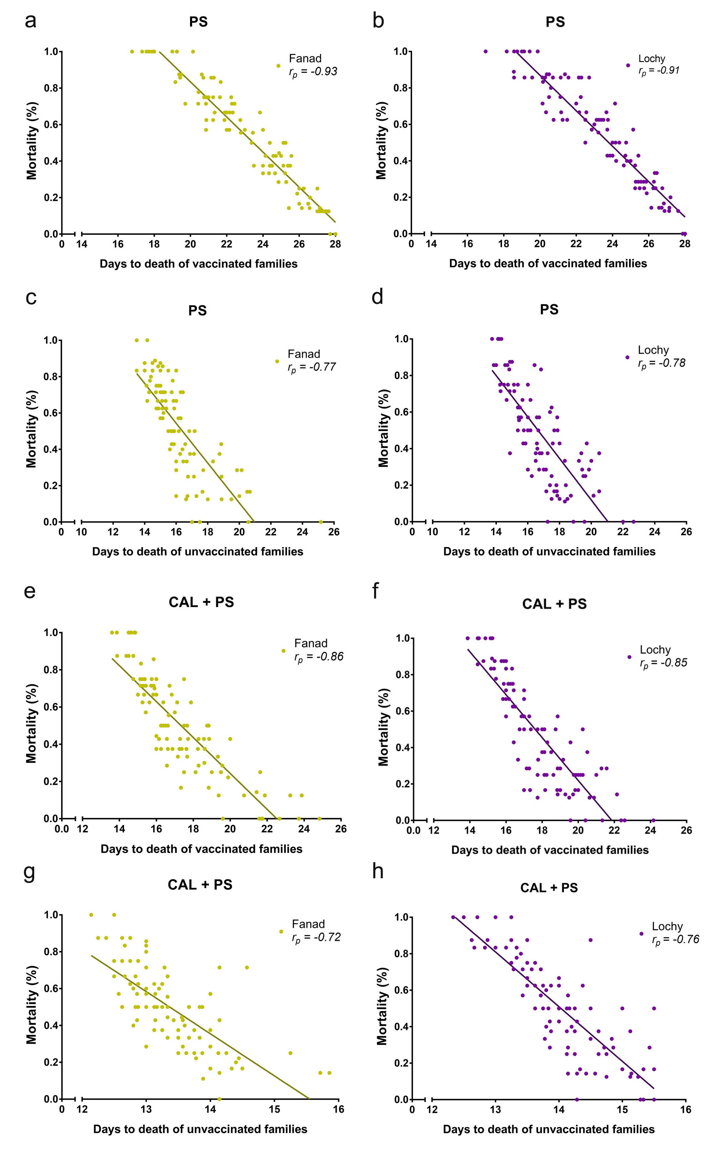

Figure S1. Phenotypic correlation between days to death and mortality. Correlation for vaccinated fish families (a-b-e-f) and unvaccinated fish families (c-d-g-h) of the populations Fanad (yellow) and Lochy (purple) that were exposed to single infection with P. salmonis (PS) or coinfection with C. rogercresseyi and P. salmonis (CAL + PS).

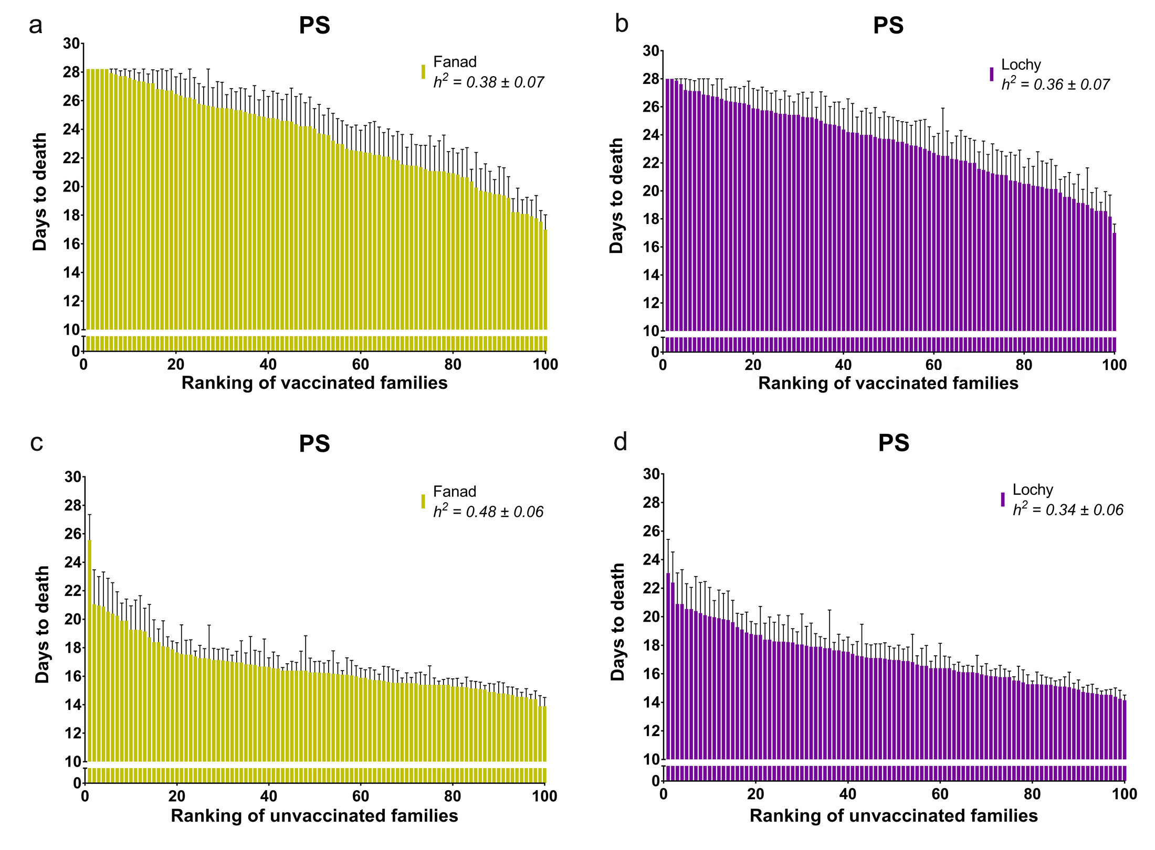
Figure S2. Variation of family resistance to P. salmonis in a single infection. Genetic resistance against P. salmonis as days to death in vaccinated (a-b) and unvaccinated (c-d) fish of the populations Fanad (yellow) and Lochy (purple) that were exposed to single infection with P. salmonis (PS).

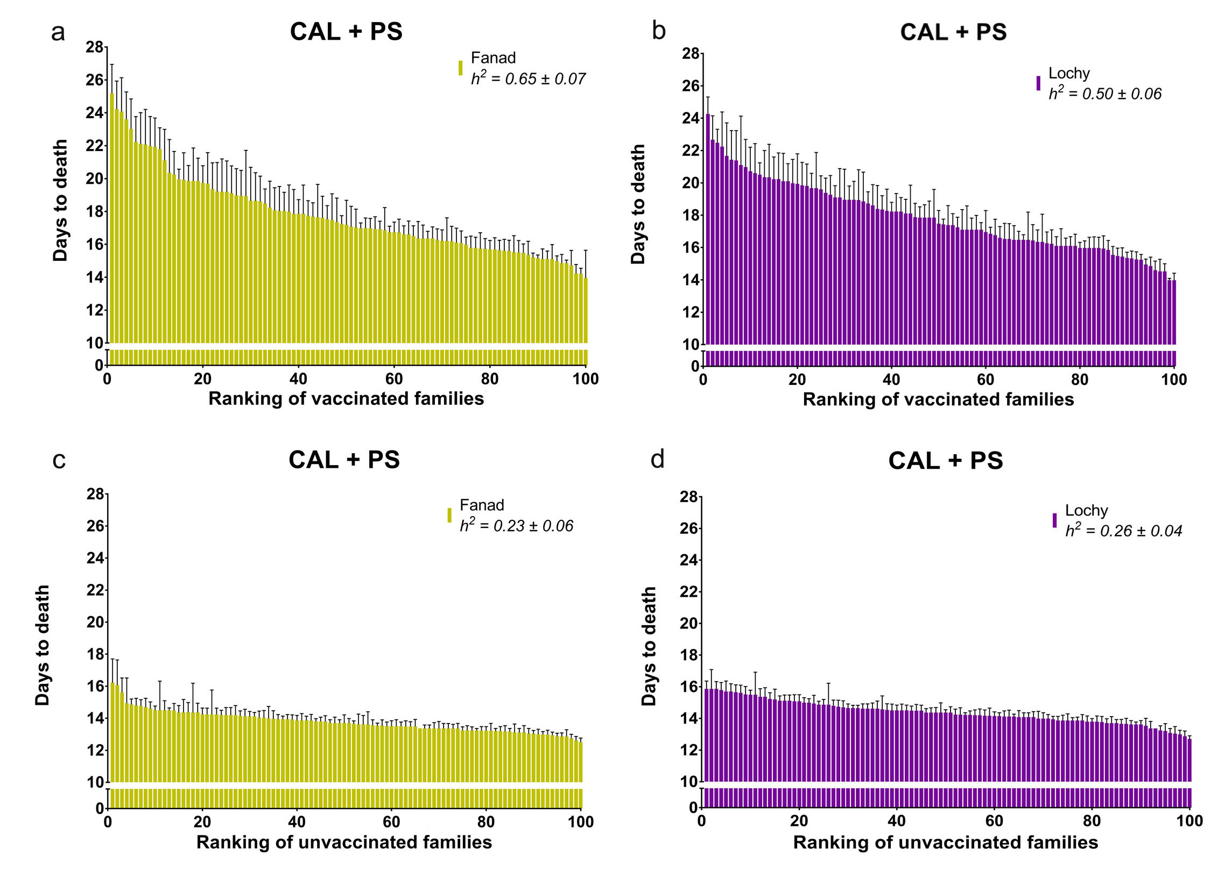
Figure S3. Variation of family resistance to P. salmonis in coinfection. Genetic resistance against P. salmonis as days to death in vaccinated (a-b) and unvaccinated (c-d) fish of the populations Fanad (yellow) and Lochy (purple) that were exposed to coinfection with C. rogercresseyi and P. salmonis (CAL + PS).

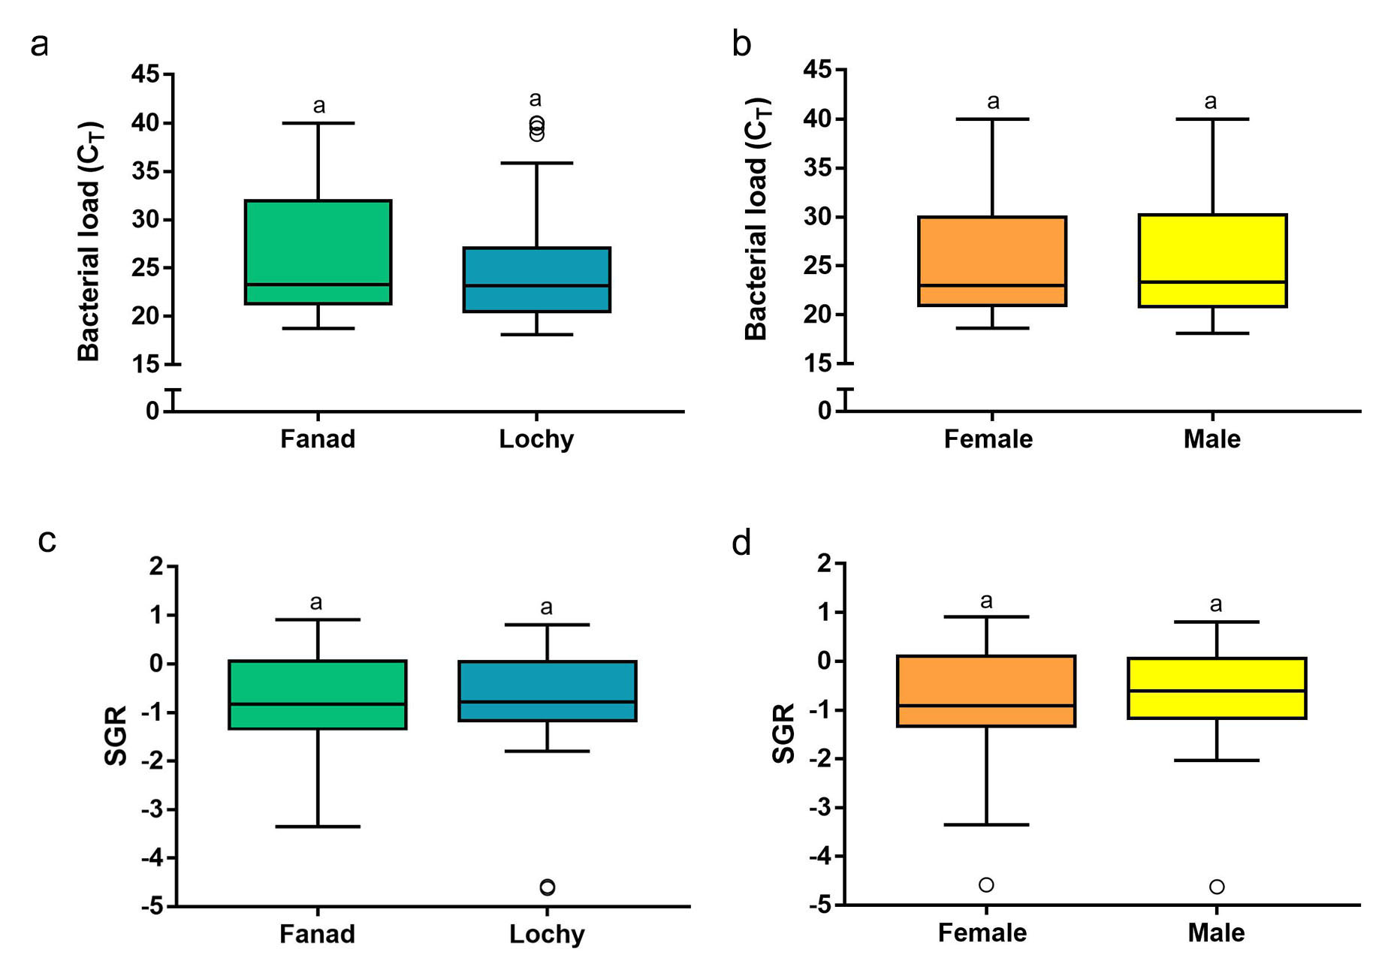
Figure S4. Comparison of P. salmonis bacterial load (C_{T} value) between populations (a) and sex of fish (b), and comparison of SGR between populations (c) and sex of fish (d). Data represent mean ± SD. Statistical significance was obtained from the non-parametric Kruskal-Wallis test followed by a Dunn post-hoc test.

